DIR DIVING — MAIN BRANCH COMPLETE READINESS AUDIT
Date: 2026-05-22 · Branch: main · HEAD: 800bfa855512ecbb3013ff4c4c5181b5595be88c
Audit-only: no code changes. Scope: Apple Watch MAIN + iOS Companion MAIN on unified main. Re-audit at 800bfa8 supersedes 20260520 report at 9def114.

A. Branch Confirmed
- Branch: main · HEAD: 800bfa855512ecbb3013ff4c4c5181b5595be88c
- project.yml valid; xcodegen generate: PASS.
- Experimental sources excluded (Apnea, Snorkeling, Buddy, Exploration).
- xcodebuild Watch (Ultra 3 sim) + iOS (iPhone 17): BUILD SUCCEEDED (2026-05-22).
- Generic iOS Simulator build: FAILED (duplicate DIR DIVING.app product).
- Bundle IDs: com.egopfe.dirdiving / com.egopfe.dirdiving.ios.
- Reference UI: Docs/ReferenceUI/*.png present.

B. Executive Summary
Dimension | Readiness %
Overall MAIN | 83%
Apple Watch MAIN | 87%
iOS Companion MAIN | 85%
UX completeness | 79%
Safety / disclaimers | 82%
Compile readiness | 90%
Verdict: ready for internal/simulator testing and developer-led device QA. Not 100% for average consumer or App Store until Ultra depth validation, physical sync QA, i18n on hardcoded screens, and release legal/assets.

Visual benchmarks
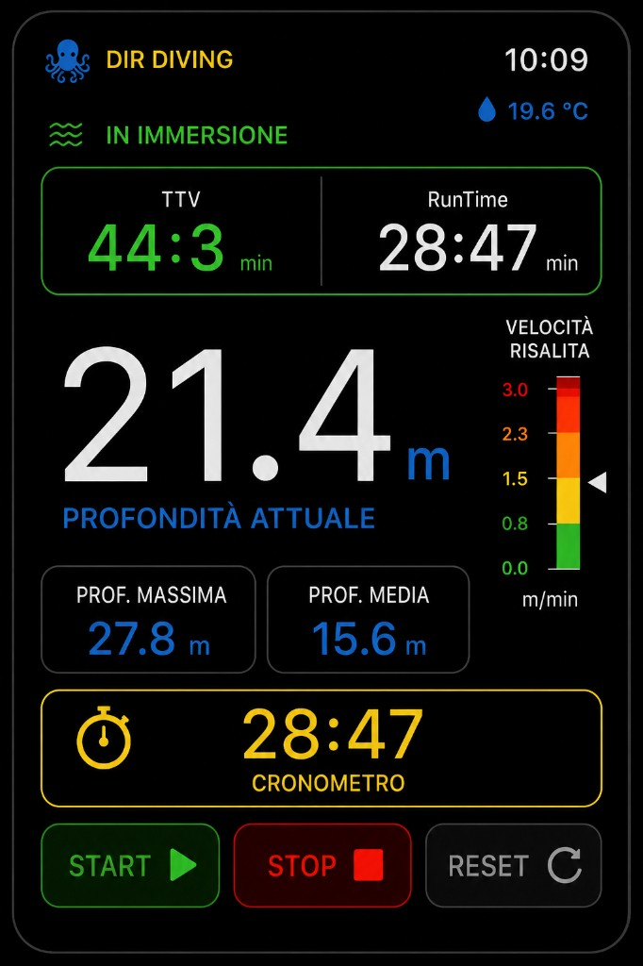
Watch reference: Watch_LIVE_reference.png
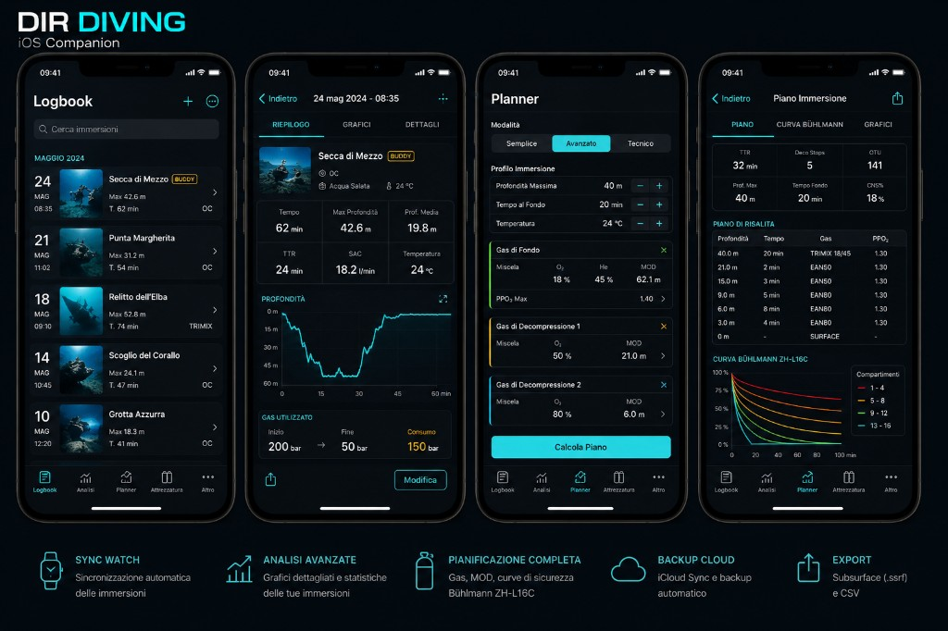
iOS reference: iOS_Companion_reference.png

C. Feature Inventory (summary)
Platform | Feature | Complete | Severity | Notes
Watch | Live dive + ascent banner | Y | — | Inline banner; gauge visible
Watch | BUSSOLA / bearing | Y | — | BUSSOLA terminology
Watch | GPS start/end | Y | — | Compact banner ~1.4s
Watch | iPhone inbound WC | Partial | MED | Handlers OK; iOS never pushes sessions
Watch | Settings i18n | Partial | MED | Hardcoded IT blocks
iOS | Logbook / detail / export | Y | —
iOS | Planner + Bühlmann | Partial | MED | Indicative; share icon inert
iOS | Sync conflicts | Partial | MED | Service only; no UI
Both | Tombstones | Partial | MED | Code OK; device QA needed

D. Navigation Map
Watch: Mode Selection → Live; tabs: Mode | Live | BUSSOLA | Settings | Images | Log.
iOS: Logbook | Analisi | Planner | Attrezzatura | Altro.
Unreachable in MAIN: Exploration, Buddy, Experimental views (project.yml excludes).

E. UI Consistency
- Watch: high match to black/neon DiveUI; Settings IT hardcoding lowers score.
- iOS: high match to DIRTheme; More disclaimer and Planner IT hardcoded.
- Watch AppIcon: unassigned icon_92_2x.png warning.

F. Settings
- Watch: ascent, alarms, haptics, language — persisted; not synced to iPhone.
- iOS: language editable; units/export read-only; cloud sync; demo logbook.
- Planner mode persisted but not used in calculations.

G. Haptics / Tones
- Watch: all paths via HapticService; gated by toggle; ascent/alarm/GPS covered.
- iOS: no alert sounds; visual feedback only.

H. Hardware
Crown: vertical TabView paging. Side button not mapped. App Intents: stopwatch promoted; manual dive/bearing/alarm defined but not in default shortcuts.

I. Sync
- Watch → iPhone: outbound queue + HMAC — implemented.
- Tombstones: dirdiving_shared_deleted_session_ids + WC broadcast — implemented.
- iPhone → Watch sessions: Watch can ingest; iOS does not send — gap.
- iOS sync conflicts: persisted; no resolution UI.
- Physical device QA: required before TestFlight.

J. Export
Subsurface CSV on Watch and iOS. GPX/KML not on MAIN. More EXPORT card is display-only.

K. Safety
- Not presented as certified dive computer.
- Planner/TTV indicative; no mandatory planner ack before calculate.
- Water submersion entitlement configured; real Ultra validation required.

L. Error / Empty states
Logbook/Analysis empty states with actions. iOS conflicts silent. Depth may show 0 m without strong no-sensor state.

M. Bugs To Fix (top)
# | Title | Sev. | Fix type
1 | Depth entitlement not validated on real Ultra | HIGH | Process / QA
2 | Physical sync + tombstone QA | HIGH | Process / QA
3 | iPhone does not push sessions to Watch | MED | Small functional
4 | iOS sync conflict UI missing | MED | UI-only
5 | Hardcoded IT Settings/More/Planner | MED | UI-only
6 | Watch AppIcon warning | MED | Assets
7 | Generic iOS sim build fails | LOW | Build config
Resolved: Watch inbound WC, tombstones, GPS banner, alarm dismiss (a75a6c3).
Stale: MAIN_BRANCH_ISSUES_AND_PRIORITIES still lists P0-SYNC-01 open — incorrect.

N. Priority Roadmap
- Before compile/use: named-simulator builds; portal entitlements.
- Before TestFlight: Ultra depth + physical sync/tombstone QA.
- Before App Store: legal/privacy, i18n/assets, conflict UI or docs.
- Post-release: Mode Selection skip, GPX, settings sync, PlanResult share.

O. Final Verdict
Question | Answer
Ready to compile? | Yes (named simulators)
Ready for internal test? | Yes with playbook + device QA gaps
Ready for average user? | Conditional
Ready for TestFlight? | After device depth + sync QA
Ready for App Store? | No
Full markdown: Docs/MAIN_BRANCH_COMPLETE_READINESS_AUDIT_20260522.md

