DIR DIVING — MAIN BRANCH COMPLETE READINESS AUDIT
Date: 2026-05-23 · Branch: main · HEAD: 6cda004520855d9558b6a99862b6287276ceebcf
Audit-only: no code changes. Scope: Apple Watch MAIN + iOS Companion MAIN on unified main. Visual benchmarks: Docs/ReferenceUI/*.png.

A. Branch Confirmed
- Branch: main · HEAD: 6cda004520855d9558b6a99862b6287276ceebcf
- project.yml valid; experimental sources excluded from MAIN targets.
- xcodegen generate: PASS.
- xcodebuild Watch (Ultra 3 sim), iOS (iPhone 17), generic iOS Simulator: BUILD SUCCEEDED.
- Bundle IDs: iOS com.egopfe.dirdiving.ios; Watch com.egopfe.dirdiving.ios.watch.
- Entitlements: Watch water submersion + iCloud KVS; iOS iCloud KVS only.

B. Executive Summary
Dimension | Readiness %
Overall MAIN | 86%
Apple Watch MAIN | 88%
iOS Companion MAIN | 87%
UX completeness | 82%
Safety / disclaimers | 88%
Compile readiness | 97%
Verdict: Ready to compile and for internal/paired-device QA. Not 100% for average consumer or App Store without Ultra depth entitlement on com.egopfe.dirdiving.ios.watch, physical sync QA, and store assets.

C. Feature Inventory (summary)
Full table in MAIN_BRANCH_COMPLETE_READINESS_AUDIT_20260523.md.
Area | Status
Watch live dive + depth safety 35/38/40m | Complete in code; hardware partial
Watch compass, log, export, settings | Complete / partial i18n
Watch sync | Implemented; device QA required
iOS logbook, analysis, planner, equipment, more | Mostly complete
iOS sync push + conflict UI | Implemented
Experimental modes | Excluded from MAIN binary

D–L. Detailed Sections
- D. Navigation: Watch vertical pages; iOS 5 tabs; no critical dead ends.
- E. UI: Matches reference screenshots; planner tab chrome partial on iOS.
- F. Settings: Local persistence; no Watch↔iOS settings sync.
- G. Haptics: Watch yes; audio tones intentionally absent.
- H. Hardware: Crown page navigation; Action Button partial.
- I. Sync: Bidirectional sessions; HMAC; conflict card on iOS.
- J. Export: Subsurface CSV Watch + iOS; import CSV iOS only.
- K. Safety: Legal gate, depth limits, planner ack; entitlement external.
- L. Empty/error states: Present on primary surfaces.

M. Top Bugs To Fix
Title | Severity | Impact
Ultra depth + entitlement not field-proven | CRITICAL | No real depth without Apple approval
Physical sync/tombstone QA | HIGH | Trust in companion sync
CSV import hidden when logbook non-empty | MEDIUM | Import discoverability
Planner result tabs display-only | MEDIUM | Confusing UX

N. Priority Roadmap
- Before TestFlight: entitlement on .ios.watch, physical QA, legal/assets.
- Before App Store: all above + planner polish + marketing review.
- Post-release: settings cross-sync, Action Button catalog, dead code cleanup.

O. Final Verdict
Question | Answer
Ready to compile? | YES
Ready for internal test? | YES (with playbook)
Ready for average user? | CONDITIONAL
Ready for TestFlight? | CONDITIONAL
Ready for App Store? | NO

Reference UI
Watch LIVE reference:
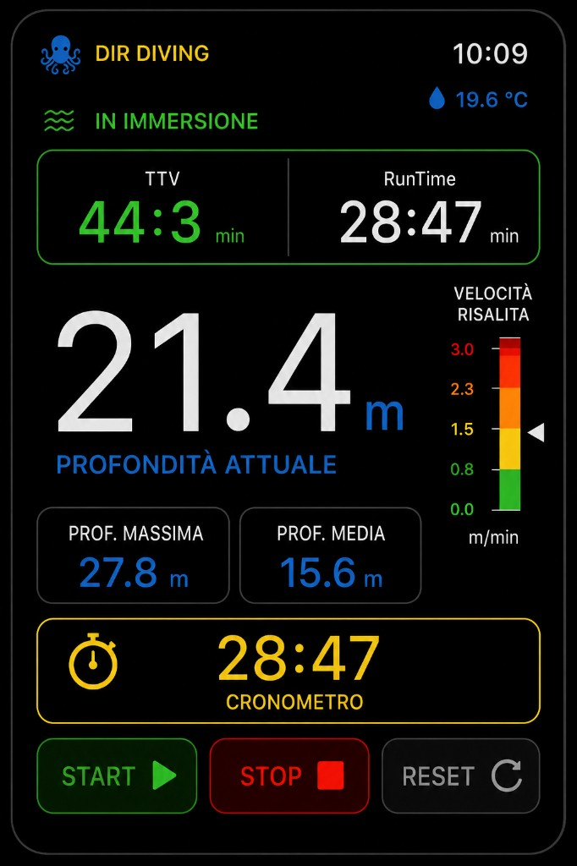
iOS Companion reference:
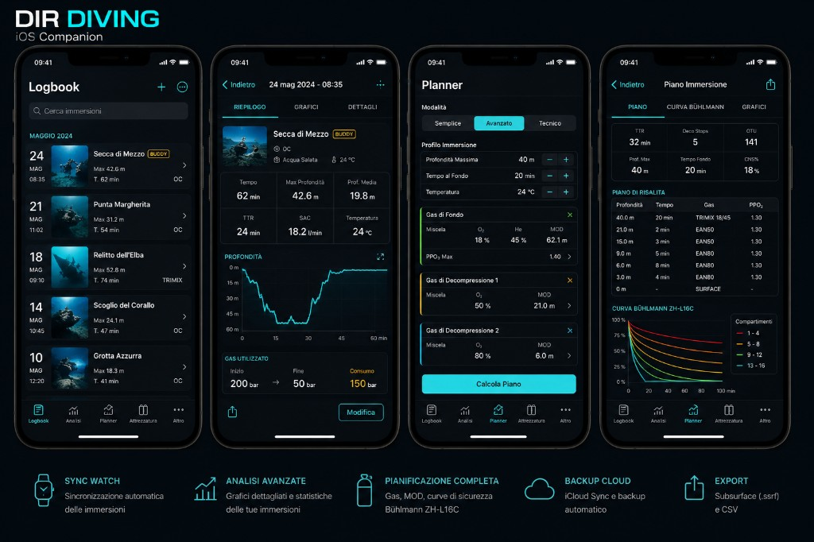
Full markdown report: Docs/MAIN_BRANCH_COMPLETE_READINESS_AUDIT_20260523.md

