DIR DIVING — MAIN Branch Complete Readiness Audit
Date: 2026-05-24 · Branch: main · HEAD: db72dce6b88aa45f9fa694ad33dde4d4aa8b2589
Audit-only (no code changes). Scope: Apple Watch MAIN + iOS Companion MAIN. Benchmarks: Docs/ReferenceUI/Watch_LIVE_reference.png and iOS_Companion_reference.png.

B. Executive Summary
Dimension | Readiness %
Overall | ~91%
Compile | 100%
Apple Watch MAIN | ~93%
iOS Companion MAIN | ~92%
UX completeness | ~94%
Safety | ~88%
UI vs reference | ~90%

A. Branch & Build
- Branch main @ db72dce6b88aa45f9fa694ad33dde4d4aa8b2589; origin/main in sync.
- xcodegen + Watch + iOS builds: SUCCEEDED.
- Experimental targets excluded in project.yml.
- Bundle IDs and entitlements coherent.

O. Final Verdict
Question | Answer
Ready to compile? | YES
Ready for internal test? | YES
Ready for average user? | MOSTLY (~91%)
Ready for TestFlight? | YES after Ultra depth QA
Ready for App Store? | CONDITIONAL
Blocks 100% | Hardware depth QA, store review, i18n/cloud polish

M. Top Bugs To Fix
ID | Severity | Issue
R1 | HIGH | Physical depth/submersion QA on Apple Watch Ultra
R2 | MED | Planner safety ack not persisted (session @State)
R3 | MED | iCloud decode errors may be silent
R4 | LOW | Mixed IT/EN strings on iOS main screens

Prior audit fixes (landed)
- 876bcd2: manual edit, merge fields, planner mock row, disclaimer persist, sync fixes.
- db72dce: ascent gauge imperial, 7 App Shortcuts, side-button copy, detail refresh.

Reference UI
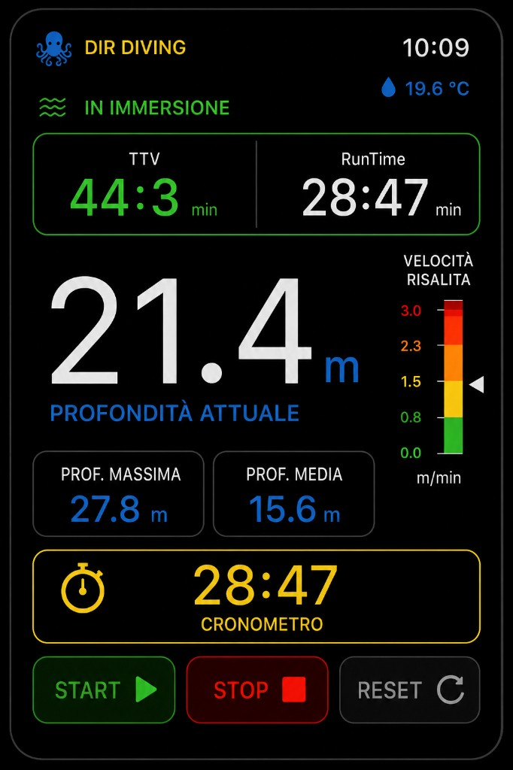
Watch LIVE reference
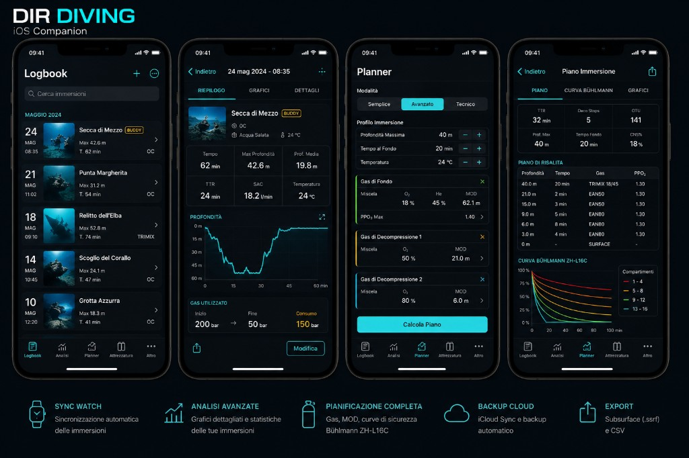
iOS Companion reference
Full markdown: MAIN_BRANCH_COMPLETE_READINESS_AUDIT_20260524.md

