DIR DIVING — MAIN BRANCH UX / INTERACTION / FEATURE ACCESSIBILITY AUDIT
Date: 2026-05-23 · Branch: main · HEAD: 6cda004520855d9558b6a99862b6287276ceebcf
Pre-modification audit only — no code changes. Scope: Apple Watch MAIN + iOS Companion MAIN. Experimental branches/files excluded.

1. Feature Inventory (summary)
Feature area | Watch | iOS
Live dive + depth safety 35/38/40 m | Reachable, complete | Review in logbook/detail
Compass / BUSSOLA | Reachable (Crown page) | N/A on Watch-only surface
Dive log + export | Complete | Complete + Subsurface export
CSV import | N/A | Hidden when Analysis non-empty
Planner | N/A | Calculate OK; tabs/mode misleading
Settings | Rich tab; export row non-actionable | More tab; no units picker
Sync Watch↔iPhone | Status + retry | Push + conflict UI
Mode Selection | Implemented, hidden | N/A
HR / notifications | Not in MAIN | Not in MAIN

2. Navigation Map
Watch (Digital Crown vertical pages):
- Legal gate → LIVE ↔ COMPASS ↔ SETTINGS ↔ [USER IMAGES if assets] ↔ DIVE LOG
- Settings children: Ascent, Alarms, Legal, Shortcuts help, Info — all return via back
- DIVE LOG → Detail → ExportView; delete with confirmation
- Mode Selection: unreachable (hasMultipleStableModes = false)
iOS (5 tabs):
- Legal gate → Logbook | Analysis | Planner | Equipment | More
- Logbook → DiveDetail; Planner → PlanResult on calculate
- No deep links; CSV import only from empty Analysis

3. Settings Report
Gap | Platform | Severity
Export row looks tappable but is informational | Watch | MEDIUM
Units @AppStorage with no UI picker | iOS | MEDIUM
Alarms / haptics only on Watch | Both | LOW (by design)
No Watch↔iOS settings sync | Both | LOW post-release
Depth safety thresholds not user-configurable | Watch | LOW (fixed policy)

4. Hardware Interaction Report
- Digital Crown: vertical page navigation + scroll in lists — OK
- Side button / Action Button: only stopwatch intents in catalog; dive/bearing need on-screen or user Shortcuts
- Long press: not used on MAIN (context menu delete on log only)
- Haptics: ascent, depth 35/38/40, alarms, GPS, export, compass set — gated by master toggle
- iOS: no haptic layer for sync/export

5. UX Blockers
Blocker | Severity
CSV import only when Analysis empty | HIGH
Simulator depth requires manual dive (user confusion) | HIGH
Planner result tabs display-only | MEDIUM
Planner mode picker does not affect calculation | MEDIUM
Watch Settings Export row non-actionable | MEDIUM
iOS units preference has no UI | MEDIUM
Legal scroll-to-bottom honor system | MEDIUM
Decorative logbook +/⋯ buttons | LOW
Plan share button inert | LOW
resetPairingTrust not in UI | LOW

6. Safety Issues (UX)
- Depth limit 35/38/40 m UI + throttled haptics: mitigated
- Ascent alarm + acknowledge banner: OK
- Planner requires safety acknowledgment: OK
- Silent sync when WC inactive: MEDIUM — status exists but easy to miss
- User depth alarm at 40 m may overlap safety exceeded state: LOW

7. Recommended Priority Order
Immediate:
- CSV import entry in More or Logbook
- Fix or label planner tabs and mode picker
- Watch Settings Export row — link or remove chevron
- iOS units picker in More
Pre-release (TestFlight):
- Legal scroll detection (optional)
- Expose Watch pairing reset in More (advanced)
- Physical device QA for sync and depth
Post-release:
- Expand App Intents catalog
- Settings cross-sync if product requires
- Mode Selection product decision

8. Code Impact Report
Fix | Estimate
Import button, units picker, export row | Small UI / small functional
Planner tab wiring or labels | UI-only or small
Settings cross-sync | Medium refactor
No architectural UX blocker on MAIN | —

9. Final Summary
Metric | Estimate
Release readiness (UX) | 82%
UX completeness (Watch) | 84%
UX completeness (iOS) | 80%
Interaction completeness | 78%
Stability (UX flows) | 85%
Safety UX completeness | 86%
Verdict: Core dive → log → export on Watch and sync/review on iPhone are reachable for informed users. Not at App Store UX bar until CSV import discoverability and misleading planner chrome are addressed. Audit-only — no repository code modified.

Reference UI
Watch LIVE reference:
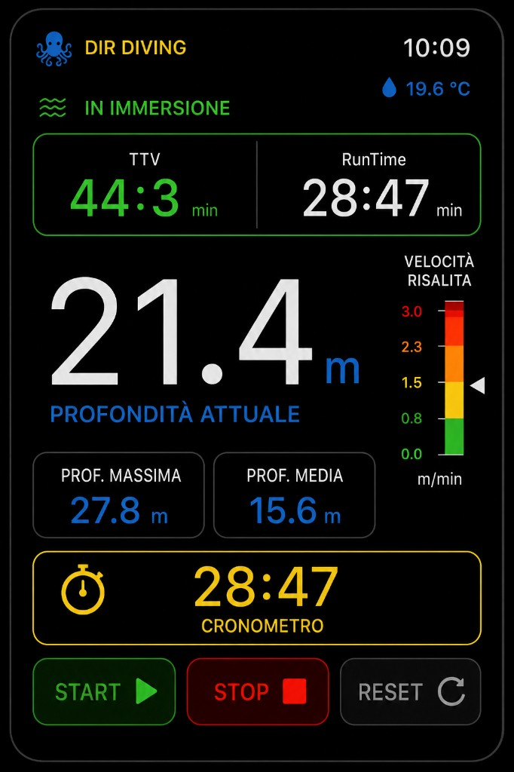
iOS Companion reference:
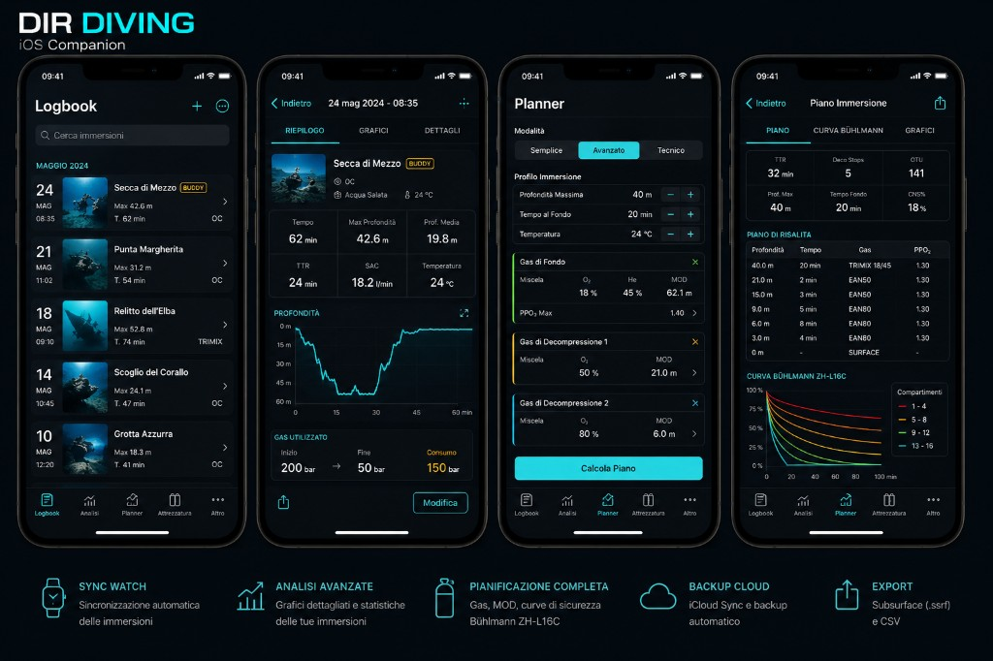
Full markdown: Docs/MAIN_BRANCH_UX_INTERACTION_ACCESSIBILITY_AUDIT_20260523.md

