DIR DIVING — MAIN Branch UX / Interaction / Feature Accessibility Audit
Date: 2026-05-24 · Branch: main · HEAD: 13b4a16b239762c75dfae5cda474161fe00eff89
Pre-modification audit only — no code changes. Scope: Apple Watch MAIN + iOS Companion MAIN. Experimental branches and excluded targets (Snorkeling, Apnea, Buddy) not audited.

9. Final Summary
Dimension | Estimate | Notes
Release readiness (UX) | ~78% | Core flows usable; planner/manual gaps
UX completeness | ~72% | Unreachable edit + display inconsistencies
Stability (interaction) | ~85% | Sync/conflict mostly surfaced
Safety completeness (UX) | ~80% | Strong ascent/legal; planner mock row risk
Verdict: Continue TestFlight testing on MAIN. Resolve 3 CRITICAL blockers before claiming planner/manual-dive production-complete.

1. Feature Inventory (highlights)
Watch MAIN
- Live, BUSSOLA, Settings, Log, conditional User Images — Crown vertical tabs.
- Mode Selection implemented but hidden (single stable mode).
- Units picker does not drive Live depth labels.
- Runtime alarm UI default 30 min vs engine fallback 60 min until key set.
iOS MAIN
- Tabs: Planner (default), Logbook, Analysis, Equipment, More.
- Manual dive add OK; edit implemented but unreachable.
- Planner result includes hardcoded ascent row; share icon non-functional.
- Launch companion disclaimer on every cold start.

2. Navigation Map
Watch: NavigationStack → TabView (Live, Compass, Settings, [Images], Log) with Settings pushes. iOS: TabView per surface; Logbook → Detail | Manual add only; Planner → PlanResult.

3. Settings Report
Platform | Exposed | Hidden / partial
Watch | Units, language, haptics, ascent limits, alarms, legal | Skip mode selection; depth 35/38/40; always-on
iOS | Units, language, sync, cloud, demo, legal in More | resetPairingTrust; planner ack session-only

4. Hardware Interaction
- Digital Crown: Watch tab paging + scroll (system).
- Side button: not mapped (documented).
- Haptics: ascent, depth limits, alarms, stopwatch, compass — respect toggle.
- App Intents: only Toggle/Reset stopwatch in Shortcuts catalog (Watch).

5. UX Blockers
ID | Severity | Issue
B1 | CRITICAL | iOS manual dive edit unreachable
B2 | CRITICAL | iCloud merge drops manual dive metadata
B3 | CRITICAL | Planner hardcoded ascent row misleads user
H1 | HIGH | Companion disclaimer every launch
H5 | HIGH | Watch runtime alarm 30 vs 60 default mismatch
H6 | HIGH | Watch units not applied on Live

6. Safety Issues
- Mock planner row undermines indicative-planning disclaimer (HIGH).
- Manual metadata loss on iCloud merge (HIGH).
- Ascent inline banner + depth limits + legal gates: strong (LOW risk).

7. Recommended Priority
- Immediate: B1, B2, B3, H5, H2 (manual pressures UI).
- Pre-release: H1, H3 share, H4 pairing reset, H6 units display.
- Post-release: App Intents catalog, dead GPS views, i18n cleanup.

8. Code Impact
Most fixes are small UI/wiring (navigation link, merge fields, delete mock row, defaults). Medium: unit formatting across Watch views; planner export share. No architectural rewrite required.

Reference UI
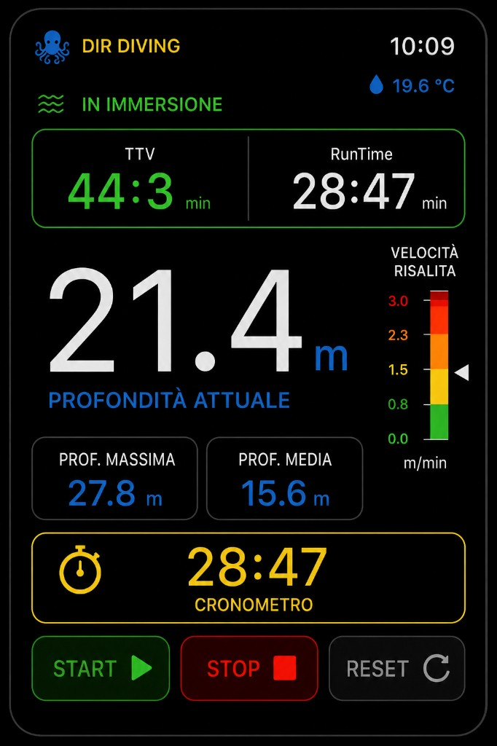
Watch reference
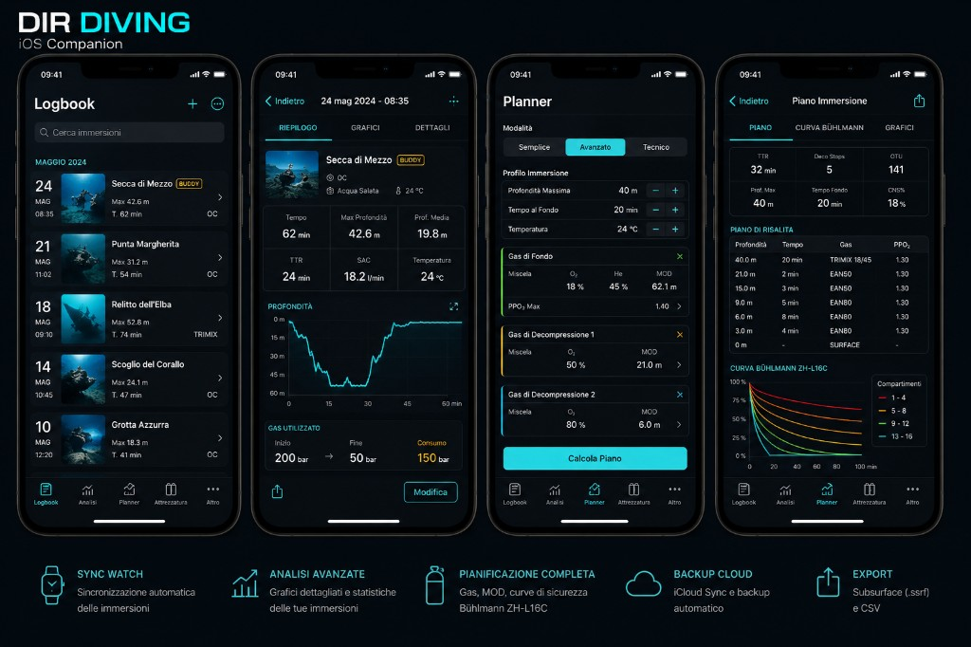
iOS reference
Full markdown source: MAIN_BRANCH_UX_INTERACTION_ACCESSIBILITY_AUDIT_20260524.md

