DIR DIVING — MAIN Branch Complete Readiness Audit
Current pre-modification readiness audit export. Source: MAIN_BRANCH_COMPLETE_READINESS_AUDIT_CURRENT.md
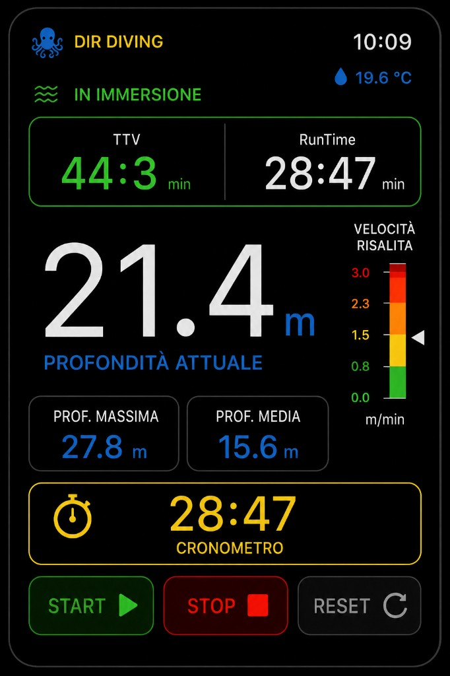
Watch reference UI
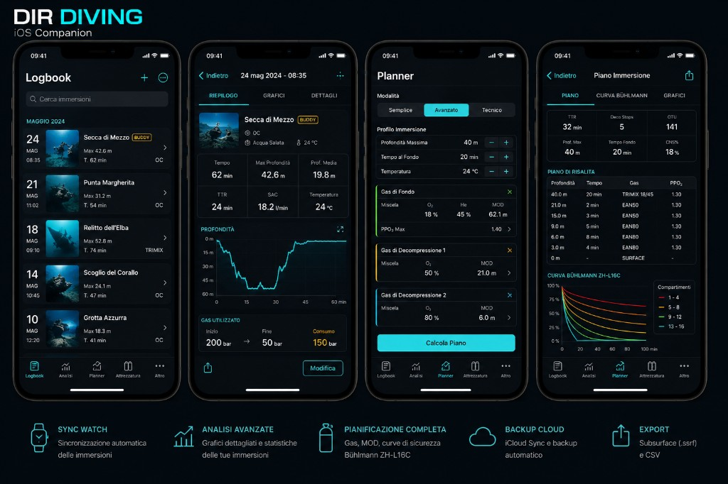
iOS reference UI

DIR DIVING — MAIN Branch Complete Readiness Audit

**Date:** 2026-05-25
**Branch audited:** `main` @ `21a7f41`
**Targets audited:** `DIRDiving Watch App`, `DIRDiving iOS`
**Audit type:** Pre-modification readiness audit only. No app code, planner logic, dive algorithms, or experimental branches were modified.
**Reference UI:** `Docs/ReferenceUI/Watch_LIVE_reference.png`, `Docs/ReferenceUI/iOS_Companion_reference.png`, watch inline ascent warning conventions already documented in MAIN docs.

---

A. Branch Confirmed

Item | Result
Branch | `main`
Local vs remote | `main...origin/main` with no ahead/behind markers at audit time
HEAD | `21a7f41`
Watch target | `DIRDiving Watch App`
iOS target | `DIRDiving iOS`
Watch bundle ID | `com.egopfe.dirdiving.ios.watch`
iOS bundle ID | `com.egopfe.dirdiving.ios`
Watch companion bundle ID | `WKCompanionAppBundleIdentifier = com.egopfe.dirdiving.ios`
Experimental source exclusion | Confirmed in `project.yml` for watch (`Apnea`, `Snorkeling`, `Buddy Assist`, experimental concepts) and iOS (`ExplorationCenterView`, `ExperimentalFutureConceptsView`, `BuddyExperimentalView`, related models/stores)
Accidental experimental imports | Not found in current MAIN entry points: `Views/ContentView.swift` and `iOSApp/Views/ContentView.swift` reference only stable MAIN screens
WatchConnectivity | Declared in `project.yml`; sync services present on both targets
iCloud / KVS | Present in watch and iOS entitlements; `CloudSyncStore` exists on iOS
Water-submersion entitlement | Present only in watch entitlements, not in iOS entitlements
iOS misuse of submersion entitlement | Not found

Build / project validation

Fresh validation on the current `main` checkout:

- `xcodegen generate` -> **PASS**
- `xcodebuild -scheme "DIRDiving Watch App" -destination 'generic/platform=watchOS' -configuration Debug build` -> **FAIL**
- `xcodebuild -scheme "DIRDiving Watch App" -destination 'platform=watchOS Simulator,name=Apple Watch Ultra 3 (49mm)' -configuration Debug build` -> **PASS**
- `xcodebuild -scheme "DIRDiving iOS" -destination 'generic/platform=iOS' -configuration Debug build` -> **FAIL**
- `xcodebuild -scheme "DIRDiving iOS" -destination 'platform=iOS Simulator,name=iPhone 17' -configuration Debug build` -> **PASS**

Current generic device build blocker:

`Entitlement com.apple.developer.coremotion.water-submersion not found and could not be included in profile.`

Interpretation:

- Source-level compile readiness is **good enough for simulator validation**
- Signed/generic device readiness is **blocked by provisioning / entitlement approval**
- The embedded watch app causes the same blocker to surface for generic iOS builds too

Assets / Info / app relationship

- `project.yml` sets `GENERATE_INFOPLIST_FILE = YES` and overlays the required bundle keys
- Watch target also sets `INFOPLIST_KEY_WKCompanionAppBundleIdentifier = com.egopfe.dirdiving.ios`
- `Resources/Assets.xcassets/AppIcon.appiconset/Contents.json` and `iOSApp/Resources/Assets.xcassets/AppIcon.appiconset/Contents.json` both reference existing image files
- No broken AppIcon references were found in the current asset catalogs

Entitlement status

Target | Entitlement status
Watch | `Config/DIRDiving.entitlements` includes iCloud, KVS, and `com.apple.developer.coremotion.water-submersion`
iOS | `iOSApp/Config/DIRDivingiOS.entitlements` includes iCloud and KVS only
Readiness verdict | Correct separation of capability by target, but physical/signed build use is blocked until the watch entitlement is approved in the active provisioning context

---

B. Executive Summary

These percentages are engineering estimates based on current code, current build outputs, and current UI/accessibility review. They are not marketing scores.

Area | Readiness | Summary
Overall readiness | **76%** | MAIN is coherent and mostly reachable on simulator, but not yet release-ready because generic device builds are blocked and a few UX/legal/localization gaps remain.
Watch readiness | **82%** | The watch Diving MAIN flow is strong: Live, BUSSOLA, alarms, sync, export, settings, and images are all present. Remaining blockers are mostly entitlement/device QA and a few mixed-language labels.
iOS readiness | **80%** | The iOS companion has full stable tabs and good flow coverage: Planner, Logbook, Analysis, Equipment, More, sync, import/export. Remaining gaps are planner honesty polish, mixed-language strings, and release-process checks.
UX readiness | **85%** | Core flows are reachable and understandable. No serious dead-end navigation was found. Most remaining issues are clarity/polish, not broken flow.
Safety readiness | **80%** | Safety positioning is mostly correct: non-certified wording, inline underwater alarms, GPS surface-only framing, planner caution. Biggest missing piece is real Watch Ultra depth/submersion validation.
Compile readiness | **86%** | `xcodegen` and both simulator builds pass. Signed/generic device builds fail on entitlement/provisioning, so compile readiness is not yet release compile readiness.
TestFlight readiness | **63%** | Blocked by generic device build failure, missing physical Watch Ultra QA, and legal-link/reviewer polish gaps.
App Store readiness | **54%** | Blocked by the same device/entitlement issue, plus legal destination quality and final bilingual cleanup.

Executive verdict

`main` is **simulator-ready and structurally healthy**, but **not yet TestFlight-ready or App Store-ready**. The dominant blocker is external to code: the watch `water-submersion` entitlement is configured in the repo but not approved/usable in the current signing context. After that blocker is resolved, the remaining work is mostly small: legal destination cleanup, mixed-language cleanup, planner honesty polish, and physical Watch Ultra QA.

---

C. Feature Inventory

Legend:

- `Implemented`: present in MAIN target
- `Reachable`: reachable through normal user navigation
- `Usable`: operable without developer-only steps
- `Complete`: production-complete enough for average-user expectation
- `Severity`: release impact if incomplete

Platform | Feature | Implemented | Reachable | Usable | Complete | Notes | Severity
Watch | Legal onboarding | Yes | Yes | Yes | Yes | `WatchLegalOnboardingView` hard-gates entry until accepted | Low
Watch | Launch disclaimer | Yes | Yes | Yes | Yes | Shown once per cold launch after legal onboarding | Low
Watch | Live Dive primary screen | Yes | Yes | Yes | Yes | Default main screen when only Diving is stable | Low
Watch | Automatic dive lifecycle | Yes | Conditional | Partial | Partial | Code path exists, but real validation depends on Watch Ultra hardware plus approved entitlement | High
Watch | Manual dive fallback | Yes | Yes | Yes | Partial | Good fallback when automatic depth is unavailable; still needs device QA for real-world clarity | Medium
Watch | Depth display | Yes | Yes | Yes | Yes | Remains visually dominant in Live | Low
Watch | Runtime | Yes | Yes | Yes | Yes | Co-visible with TTV | Low
Watch | TTV | Yes | Yes | Yes | Yes | Informational wording is generally safe | Low
Watch | Stopwatch START / STOP / RESET | Yes | Yes | Yes | Partial | Functional and exposed via App Intents; no long-press/reset safeguard | Low
Watch | Average / max depth | Yes | Yes | Yes | Yes | Visible in Live and detail surfaces | Low
Watch | Temperature | Yes | Yes | Yes | Partial | Code path exists; still needs physical validation with real depth session | Low
Watch | Ascent gauge | Yes | Yes | Yes | Yes | Still visible while inline warning is shown | Low
Watch | Inline ascent warning | Yes | Yes | Yes | Yes | Correct inline non-modal philosophy | Low
Watch | Depth safety warnings 35 / 38 / 40 | Yes | Yes | Yes | Yes | Visual + haptic coordination present | Low
Watch | GPS compact banners | Yes | Yes | Yes | Yes | Compact banner does not replace main metrics | Low
Watch | BUSSOLA / bearing | Yes | Yes | Yes | Partial | Core flow works; some controls remain mixed-language / hardcoded | Medium
Watch | SET / CLEAR BEARING | Yes | Yes | Yes | Partial | Works, but `SET BEARING` / dynamic bearing line should be fully localized | Medium
Watch | Dive Log | Yes | Yes | Yes | Yes | Clean list, empty state, delete access | Low
Watch | Dive Detail | Yes | Yes | Yes | Yes | Export and delete reachable; back affordance present | Low
Watch | Delete confirmation | Yes | Yes | Yes | Yes | Proper confirmation dialog | Low
Watch | Manual dive edit | No | No | No | No | Not implemented on Watch MAIN; only manual fallback lifecycle exists | Low
Watch | CSV export | Yes | Yes | Yes | Yes | Subsurface-oriented export flow present | Low
Watch | ShareLink / share flow | Yes | Yes | Yes | Yes | Export route and share handoff exist | Low
Watch | User Images | Yes | Yes | Yes | Yes | MAIN now exposes a real empty state and detail view outside dives | Low
Watch | Settings hub | Yes | Yes | Yes | Yes | Rich and mostly honest settings surface | Low
Watch | Alarm settings | Yes | Yes | Yes | Yes | Surface-only editing during dive is clearly explained | Low
Watch | Language setting | Yes | Yes | Yes | Yes | Watch-local, clearly scoped | Low
Watch | Units setting | Yes | Yes | Yes | Partial | Applied broadly; still needs physical QA and some polish wording | Low
Watch | Haptics toggle | Yes | Yes | Yes | Yes | Global toggle is respected by `HapticService` | Low
Watch | Sync status | Yes | Yes | Partial | Partial | Aggregate status is good; no per-dive delivery ledger | Medium
Watch | Retry queue / clear failed queue | Yes | Yes | Yes | Yes | Queue actions are visible and understandable | Low
Watch | InfoView / diagnostics | Yes | Yes | Yes | Partial | Helpful, but entitlement wording can overstate readiness | Medium
Watch | App Intents | Yes | Partial | Partial | Partial | Implemented and extracted in build; needs hardware QA | Medium
Watch | Shortcut help | Yes | Yes | Yes | Yes | Honest about Action Button / Side Button limitations | Low
iOS | Legal onboarding | Yes | Yes | Yes | Yes | Hard-gates entry until accepted | Low
iOS | Launch disclaimer | Yes | Yes | Yes | Yes | Session-based overlay appears after legal onboarding | Low
iOS | Tab navigation | Yes | Yes | Yes | Yes | Stable tabs only: Planner, Logbook, Analysis, Equipment, More | Low
iOS | Planner | Yes | Yes | Yes | Partial | Broad feature coverage; remaining issue is honesty/polish, not absence | Medium
iOS | Planner safety acknowledgment | Yes | Yes | Yes | Yes | Proper gate before planning inputs | Low
iOS | PlanResultView | Yes | Yes | Yes | Partial | Functional, but still has several mixed-language labels in result cards | Medium
iOS | Logbook | Yes | Yes | Yes | Yes | Good list, sections, add manual, delete non-demo entries | Low
iOS | DiveDetailView | Yes | Yes | Yes | Yes | Metrics, charts, GPS, export, edit for manual dives | Low
iOS | Manual dive add | Yes | Yes | Yes | Yes | Reachable from Logbook `+` | Low
iOS | Manual dive edit | Yes | Yes | Yes | Yes | Proper return path and refresh behavior | Low
iOS | DiveDetail refresh after edit | Yes | Yes | Yes | Yes | Confirmed by current code path and earlier UX audit | Low
iOS | Analysis | Yes | Yes | Yes | Yes | Good empty state and useful actions | Low
iOS | Charts | Yes | Yes | Yes | Yes | Present in Analysis and DiveDetail | Low
iOS | CSV import | Yes | Yes | Yes | Yes | Available from Analysis, Logbook, and More | Low
iOS | CSV export | Yes | Yes | Yes | Yes | Per-dive export works from detail view | Low
iOS | Equipment | Yes | Yes | Yes | Partial | Functional templates/checklist/gas toggle, but a few strings remain mixed-language | Medium
iOS | More / settings | Yes | Yes | Yes | Yes | Good centralization of sync/cloud/legal/demo controls | Low
iOS | Cloud sync | Yes | Yes | Partial | Partial | Clear visibility, but still needs real iCloud account-state QA | Medium
iOS | Reset pairing trust | Yes | Yes | Yes | Yes | Explicit confirmation flow | Low
iOS | Push to Watch | Yes | Yes | Yes | Yes | Clearly exposed in More | Low
iOS | Conflict handling | Yes | Yes | Yes | Yes | Conflict card is actionable and understandable | Low
iOS | Language | Yes | Yes | Yes | Yes | App-wide locale environment applied | Low
iOS | Units | Yes | Yes | Partial | Partial | Broadly supported, but planner still stays metric internally by design | Medium
iOS | Demo logbook | Yes | Yes | Yes | Yes | Helpful reviewer/testing feature | Low
iOS | Legal / safety surface | Yes | Yes | Yes | Partial | Good visibility, but Terms/Privacy links still point to repository root | Medium

---

D. Navigation Map

Watch flows

DIRDivingApp
└─ NavigationStack
├─ [if needed] WatchLegalOnboardingView
└─ ContentView (vertical TabView)
├─ [dormant in MAIN] ModeSelectionView
├─ DiveLiveView
├─ CompassView (BUSSOLA)
├─ SettingsView
│ ├─ AscentRateSettingsView
│ ├─ AlarmSettingsView
│ ├─ WatchLegalOnboardingView legal destinations
│ ├─ WatchShortcutHelpView
│ └─ InfoView
├─ UserImagesView
└─ DiveLogListView
├─ DiveDetailView
└─ ExportView

Overlay after legal gate:
└─ LaunchCompanionDisclaimerOverlay

Underwater restrictions

- `DiveLiveView` remains the primary underwater destination
- During an active dive, `ContentView` forces navigation back to `Live` unless the page is `Live` or `Compass`
- Result: Settings, User Images, and Dive Log are intentionally blocked during active diving
- This is safe and consistent with underwater UX goals

iOS flows

DIRDivingiOSApp
├─ [if needed] IOSLegalOnboardingView
└─ ContentView (TabView)
├─ Planner
│ └─ PlanResultView
├─ Logbook
│ ├─ DiveDetailView
│ │ └─ ManualDiveEditorView (manual dives)
│ └─ ManualDiveEditorView (add)
├─ Analysis
├─ Equipment
│ └─ EquipmentTemplatesSheet / EquipmentTemplateEditorView
└─ More
└─ IOSLegalOnboardingView legal section / More actions

Overlay after legal gate:
└─ LaunchCompanionDisclaimerOverlay

Dead ends / hidden routes

- No critical dead ends were found in current MAIN navigation
- Watch `ModeSelectionView` is intentionally dormant because MAIN exposes only stable Diving
- Watch `UserImagesView` is no longer hidden behind content existence; it now has a real empty state
- iOS planner shows non-advanced modes visually, but only `advanced` is selectable; this is not a broken route, but it is a clarity issue

---

E. UI Consistency Report

Area | Deviation | Severity | Recommended fix
Watch Live | Strong match with premium black/neon reference; no serious drift found in code | Low | Keep current structure; verify screenshots on physical devices
Watch Compass | Core screen fits the style, but remaining hardcoded labels (`SET BEARING`, bearing/delta string) weaken bilingual consistency | Medium | Localize the remaining literal controls/format strings
Watch Info | Useful diagnostics fit the style, but title/rows still use some direct literals and entitlement wording can overstate readiness | Medium | Localize literals and soften entitlement certainty
Watch legal/help surfaces | Side Button wording is truthful and consistent with product philosophy | Low | Keep
iOS Companion overall | Dark marine / cyan visual system remains consistent across tabs | Low | Keep
iOS Planner | Strong structure, but result cards still contain mixed-language labels and disabled future modes remain visible | Medium | Finish localization pass and visually reframe non-active modes
iOS More | Feature-dense but understandable; a few labels remain mixed-language (`Planner safety`, `Legal & Safety` keying style) | Low | Normalize copy
Legal destinations | Terms / Privacy are visible, but destination quality is not release-grade because both currently point to the repo root | Medium | Replace with real reviewer-facing legal destinations

Terminology consistency

- `BUSSOLA` terminology is preserved in MAIN
- No `COMPASSO` regression was found in MAIN watch-facing UX
- Some iOS surfaces still mix Italian and English in the same screen, especially planner/result/legal labels

---

F. Settings Report

Watch settings

Setting | UI available | Persisted | Applied | Synced | Notes
Units | Yes | Yes | Yes | Yes | Published to paired iPhone
Language | Yes | Yes | Yes | No | Watch-local by design
Haptics | Yes | Yes | Yes | No | Global toggle respected
Ascent limits | Yes | Yes | Yes | No | Good watch-local behavior
Alarm toggles / thresholds | Yes | Yes | Yes | No | Surface-only editing is honest
GPS status | Yes | Runtime | Yes | No | Surface-only behavior explained
Depth diagnostics | Yes | Runtime | Yes | No | Useful but wording too optimistic on entitlement readiness
Sync queue | Yes | Runtime | Yes | N/A | Aggregate counters only
Export info | Info-only | N/A | N/A | No | Action lives in log/detail, not Settings
Display / Always-On copy | Info-only | N/A | N/A | No | Honest watchOS-managed messaging
Shortcut help | Yes | N/A | Yes | No | Good discoverability

Watch settings verdict:

- Reachable, honest, and mostly complete
- No deceptive tappable rows were found
- Biggest remaining issue is not missing settings, but diagnostic honesty around entitlement readiness

iOS settings

Setting | UI available | Persisted | Applied | Synced | Notes
Language | Yes | Yes | Yes | No | App-wide locale environment
Units | Yes | Yes | Yes | Partial | Sent to Watch; planner stays metric internally
Watch sync state | Yes | Runtime | Yes | N/A | Good visibility but aggregate only
Push to Watch | Yes | Runtime action | Yes | N/A | Clear action
Reset pairing trust | Yes | Runtime action | Yes | N/A | Good destructive confirmation
iCloud sync | Yes | Runtime action | Yes | iCloud | Availability surfaced
Demo logbook | Yes | Yes | Yes | No | Testing/reviewer helper
Planner safety acknowledgment | Yes | Yes | Yes | No | Honest gate
Legal / safety | Yes | Yes | Yes | No | Good visibility; destination quality still weak
Import / export access | Yes | Runtime action / route | Yes | N/A | Good reachability

iOS settings verdict:

- Reachable and understandable
- Main gap is **sync visibility depth** rather than missing actions
- Planner metric-only behavior is disclosed, but it still creates mixed expectation for imperial users

---

G. Haptics / Hardware Report

Crown / touch / buttons

Interaction | Status | Notes
Digital Crown vertical navigation | Implemented | `TabView` vertical page style on watch
Crown scrolling on long watch screens | Implemented | Native scroll behavior
Crown threshold adjustment for alarms | Implemented | `AlarmSettingsView` uses crown rotation
Crown threshold adjustment for ascent settings | Implemented | `AscentRateSettingsView` uses crown rotation
Touch navigation | Implemented | Primary fallback everywhere
Side Button direct control | Not supported | Correctly documented as system-controlled
Action Button support model | Implemented via App Intents | Honest and within platform limits
Long press behavior | Mostly absent | No notable long-press guard on stopwatch reset

App Intents audit

All requested MAIN intents are implemented in `Services/ActionButtonIntents.swift`:

- `ToggleStopwatchIntent`
- `ResetStopwatchIntent`
- `StartManualDiveIntent`
- `EndManualDiveIntent`
- `SetBearingIntent`
- `ClearBearingIntent`
- `AcknowledgeAlarmIntent`

App Intents verdict:

- **Implemented:** yes
- **Exposed in build metadata:** yes (`ExtractAppIntentsMetadata` occurs in simulator build)
- **Documented:** yes
- **Safe in concept:** yes
- **Physical Watch QA required:** yes

Haptic audit

Event | Status | Notes
Dive start | Implemented | Confirmation pattern
Dive stop | Implemented | Confirmation pattern
Stopwatch start / stop / reset | Implemented | Generic confirmation haptic
Ascent warning | Implemented | Initial + repeated throttled warning haptic
Depth safety warnings | Implemented | Coordinated through depth-limit haptic path
GPS confirmation | Implemented | Confirmation feedback on successful lifecycle points
Bearing SET / CLEAR | Implemented | Confirmation feedback
Alarm acknowledge | Implemented | Notify feedback
Export success / failure | Implemented | Distinct success/failure behavior
Sync retry / success / failure | Partial | Retry action confirms; not every state transition has a unique haptic
Delete confirmation | Partial | Confirmation dialog exists; delete action itself has no dedicated distinct haptic

Haptic verdict:

- Global haptics toggle is respected
- Safety events still have visual fallback when haptics are off
- No evidence of excessive repeated haptics beyond the intended repeat interval

---

H. Sync Report

Watch -> iPhone

- `WatchSyncService` queues pending sessions and tracks pending, sent, acknowledged, and failed counts
- It uses direct message when reachable and transfer fallback when needed
- Signed-ack / peer-trust flows are present from prior work and still represented in current services

iPhone -> Watch

- More screen exposes push-to-watch
- Tombstones and photo transfer flows are present
- Units are propagated via app context

Failure / duplicate / queue handling

Area | Status | Notes
Duplicate suppression | Present | Service-level logic exists
Conflict UI | Present | iOS conflict card is actionable
Offline handling | Present in design | Needs paired-device QA
Queue handling | Present | Aggregate counts/actions exposed
Keep-local re-push | Present | Resolved through current sync service path
Silent failure risk | Reduced | User-visible last event/status exists, but still aggregate rather than per-session

Sync verdict:

- Architecturally solid enough for MAIN
- Biggest UX gap is **per-dive traceability**
- Biggest release gap is **paired-device QA**, not missing code structure

---

I. Export Report

Formats and behavior

- Watch export: Subsurface-oriented CSV
- iOS export: Subsurface-oriented CSV with additional manual-dive metadata
- Share flow exists on both sides

File naming and temporary file handling

Confirmed in current export services:

- filenames use opaque UUID-based names like `DIRDiving_Export_<UUID>.csv`
- files are written to temporary directory
- files use `.atomic` and `.completeFileProtection`
- stale CSV files older than 24 hours are cleaned up

Empty / failure handling

Platform | Empty / invalid handling
Watch | Export returns unavailable/failure states cleanly; share flow depends on generated URL
iOS | `SubsurfaceExportService.ExportError` reports `emptySamples` and write failures clearly

Export verdict:

- Export pipeline is solid and appropriately conservative
- No major export blocker was found inside MAIN code
- Remaining validation need is UI QA of share sheets on real devices

---

J. Localization Report

Localization is substantially healthier than older audits suggested. Many literal SwiftUI strings are backed by entries in `Resources/*.lproj` and `iOSApp/Resources/*.lproj`. The remaining **confirmed** MAIN gaps are mostly mixed-language strings or direct literals in high-visibility areas.

Remaining notable gaps

File | String | Screen | Severity | Suggested key
`Views/CompassView.swift` | `SET BEARING` | Watch `BUSSOLA` | Medium | `compass.bearing.set`
`Views/InfoView.swift` | `INFO` | Watch Info | Low | `info.title`
`Views/InfoView.swift` | `Sync` | Watch Info | Low | `info.sync`
`Views/InfoView.swift` | `Richiede validazione reale su Apple Watch Ultra...` | Watch Info | Medium | `info.depth.validation_note`
`iOSApp/Views/PlannerView.swift` | `GF Low` / `GF High` | iOS Planner | Low | `planner.field.gf_low`, `planner.field.gf_high`
`iOSApp/Views/PlannerView.swift` | `SAC %@ L/min` | iOS Planner | Low | `planner.team.sac_format`
`iOSApp/Views/PlannerView.swift` | `GAS RESERVE` | iOS Planner | Low | `planner.card.reserve`
`iOSApp/Views/PlannerView.swift` | `Rock bottom` | iOS Planner | Low | `planner.metric.rock_bottom`
`iOSApp/Views/PlannerView.swift` | `Turn` | iOS Planner | Low | `planner.metric.turn_pressure`
`iOSApp/Views/PlannerView.swift` | `WARNING` | iOS Planner warnings | Low | `planner.warning.title`
`iOSApp/Views/PlannerView.swift` | `TEAM GAS MATCHING` | iOS Planner | Low | `planner.team.matching_title`
`iOSApp/Views/PlannerView.swift` | `TEAM GAS MATCH` | iOS Plan Result | Low | `planner.team.match_title`
`iOSApp/Views/PlannerView.swift` | `BRIEFING` | iOS Plan Result | Low | `planner.briefing.title`
`iOSApp/Views/PlannerView.swift` | `CURVA BUHLMANN ZH-L16C` | iOS Plan Result | Low | `planner.buhlmann.curve_title`
`iOSApp/Views/MoreView.swift` + `iOSApp/Resources/it.lproj/Localizable.strings` | `Planner safety` | iOS More | Low | `more.planner_safety.title`
`iOSApp/Resources/it.lproj/Localizable.strings` | `Subsurface CSV metrico; altri formati planned` | iOS units/export copy | Low | split into fully localized Italian phrasing
`iOSApp/Resources/it.lproj/Localizable.strings` | `BACKUP CLOUD`, `REVIEWER` | iOS More headers | Low | fully localized section labels if desired

Mixed-language screen summary

- Watch `BUSSOLA`: still the most visible remaining watch localization gap
- Watch `InfoView`: mostly small polish issue
- iOS `Planner` / `PlanResultView`: biggest remaining localization debt in stable iOS UX
- iOS `More`: mostly localized, but a few labels still mix English and Italian in Italian mode

Terminology check

- `BUSSOLA` is preserved
- No `COMPASSO` regression found in MAIN

---

K. Safety / Legal Report

Area | Status | Severity | Notes
Non-certified dive computer wording | Good | Low | Present in onboarding/legal surfaces and docs
TTV wording | Good | Low | Framed as informational, not decompression authority
Planner disclaimers | Good | Low | Safety acknowledgment gate and metric notice exist
Ascent warning philosophy | Good | Low | Inline and non-blocking
Depth-limit warnings | Good | Low | Inline + visual + haptic support
GPS limitation framing | Good | Low | Surface-only behavior is consistently explained
Silent GPS/depth failure risk | Partial | Medium | UI gives status, but real underwater/device behavior still needs field QA
Terms / Privacy destination quality | Weak | Medium | Visible but both point to repository root, not reviewer-grade legal pages
Entitlement/device blocker | Critical | Critical | Generic device builds fail until water-submersion entitlement is approved in active provisioning
App Store rejection risk | Real | High | Current legal-link quality and lack of entitlement/device evidence remain submission risks

Safety / legal verdict:

- Product positioning is mostly responsible
- The current release blocker is **not unsafe copy drift**, but missing real signed-device proof for the watch depth capability
- Legal destinations should still be improved before submission

---

L. Error / Empty State Report

Scenario | Current behavior | Verdict
No GPS | Watch and iOS expose unavailable/fallback/fix status messaging | Good
No depth automation | Watch exposes manual fallback path and diagnostic status | Good
No temperature | Metrics handle missing values conservatively | Good
No paired Watch / iPhone | Sync status and reset trust flows are visible | Good
Sync fails | Aggregate retry/failed state is surfaced | Partial
Export fails | Failure message / no-URL handling exists | Good
Permissions denied | GPS and legal/status copy exist; full permission-guidance polish could still improve | Partial
No User Images | Real empty state now exists on watch | Good
No peer secret | Sync state messaging exists | Good
No entitlement | Device build fails before field QA; InfoView wording is more optimistic than actual provisioning result | Partial
Haptics disabled | Visual fallback badge remains available | Good
No dives / empty logbook | Empty states exist on watch and iOS | Good

Error / empty-state verdict:

- No major crash-shaped empty state problem was found in MAIN
- The remaining gap is **specificity**, especially around sync and entitlement readiness

---

M. Bugs To Fix

Title | Platform | File / screen | Severity | User impact | Recommended fix | Estimated impact
Water-submersion entitlement not usable in current signing context | Watch + iOS release pair | Signing / Apple Developer / provisioning | Critical | Blocks generic device build, TestFlight, and physical dive automation validation | Enable/approve capability for watch App ID, regenerate profiles, re-test generic builds | External QA/process
Generic iOS device build blocked by embedded watch entitlement failure | iOS release pair | Build / signing | Critical | Prevents release-grade iOS build with embedded watch target | Resolve the same watch entitlement/profile blocker | External QA/process
Automatic dive lifecycle not validated on real Watch Ultra | Watch | Physical device behavior | High | Core underwater automation is still not release-certified by evidence | Run real Watch Ultra field/device QA using updated profiles | External QA/process
Terms and Privacy links point to repository root | Watch + iOS legal screens | `WatchLegalOnboardingView.swift`, `IOSLegalOnboardingView.swift` | Medium | Weak legal/reviewer experience; potential submission concern | Replace with dedicated legal destinations | Copy-only / UI-only
Watch Info entitlement diagnostics overstate readiness | Watch | `Views/InfoView.swift` | Medium | Testers may read “Configured” as “release-ready” even when signed builds fail | Reword diagnostics to distinguish static config from provisioning approval | Copy-only
Compass bearing controls still mixed-language | Watch | `Views/CompassView.swift` | Medium | Core navigation screen still looks partially unfinished in EN/IT audit | Localize control labels and formatted bearing line | UI-only
Planner result cards still mixed-language | iOS | `iOSApp/Views/PlannerView.swift` | Medium | High-value planning flow feels less polished and less reviewer-ready | Finish localization of remaining literal labels | UI-only
Planner shows disabled non-advanced modes | iOS | `iOSApp/Views/PlannerView.swift` | Medium | Users can see future modes that are not actually available | Keep visible but reframe as planned, or hide until active | UI-only
Planner metric-only behavior can feel inconsistent with global units | iOS | `iOSApp/Views/PlannerView.swift`, related strings | Medium | Imperial users encounter mixed expectations | Keep honest note and consider clearer framing or full presentation conversion later | Small functional or UI-only
Sync status is aggregate, not per-session | Watch + iOS | Sync surfaces | Medium | Harder to verify a specific dive/photo transfer | Add per-item delivery trace later | Small functional
Stopwatch reset lacks extra safeguard | Watch | `Views/DiveLiveView.swift` | Low | Surface/underwater accidental reset risk | Consider long-press or confirm flow after UX review | UI-only / small functional
More/legal copy still partially mixed-language | iOS | `iOSApp/Views/MoreView.swift`, localized strings | Low | Polish issue in stable settings surface | Normalize Italian/English labels | UI-only

---

N. Priority Roadmap

1. Must fix before compile/use

1. Resolve the Apple Developer / provisioning approval for `com.apple.developer.coremotion.water-submersion`
2. Re-run generic device builds for both schemes
3. Confirm that the Watch companion app pair archives/signs cleanly after profile regeneration

2. Must fix before TestFlight

1. Execute physical Apple Watch Ultra QA for automatic dive lifecycle, depth display, safety bands, and haptics
2. Run paired Watch <-> iPhone sync QA for dives, tombstones, conflicts, units, and photo transfer
3. Replace repo-root Terms / Privacy destinations with real reviewer-grade legal pages
4. Tighten `InfoView` wording so entitlement status is honest

3. Must fix before App Store

1. Finish remaining planner / compass / More mixed-language cleanup
2. Reconfirm bilingual screenshots and clipping on real device sizes
3. Keep all underwater/device claims aligned only to behavior verified on real hardware

4. Post-release improvements

1. Add per-session sync visibility instead of aggregate-only state
2. Revisit stopwatch reset safeguard
3. Decide whether disabled planner modes should remain visible in stable MAIN

---

O. Final Verdict

Question | Verdict | Why
Ready to compile? | **Yes for simulator, no for signed/generic device release builds** | `xcodegen` passes and both simulator builds pass, but generic watch/iOS builds fail on the watch water-submersion entitlement provisioning context
Ready for internal QA? | **Yes, conditionally** | Simulator and code-level UX are strong enough to continue QA, but physical watch QA is still required for the core dive automation path
Ready for average user? | **Not yet** | Too much release confidence still depends on unverified Watch Ultra behavior and unresolved legal/reviewer polish
Ready for TestFlight? | **No** | Blocked by generic device build failure and missing physical Watch Ultra validation
Ready for App Store? | **No** | Same entitlement/device blocker, plus legal destination quality and final localization cleanup still need attention
What blocks 100% readiness? | **Provisioning approval + device evidence + polish** | The primary blocker is external signing/provisioning, followed by real device proof and a smaller cleanup pass on planner/compass/legal strings

Bottom line

The current `main` branch is **substantially ready from a stable-UI and simulator-readiness perspective**. This is no longer a branch suffering from major MAIN navigation collapse or accidental experimental dependency. The remaining blockers are narrower and well-defined:

1. the watch water-submersion entitlement must be usable in the active signing context
2. the automatic dive lifecycle must be validated on real Apple Watch Ultra hardware
3. a final polish pass should close mixed-language planner/compass/legal issues before release

No evidence from this audit suggests a required architectural rewrite, planner algorithm rewrite, or dive/depth/ascent/TTV logic rewrite.

