DIR DIVING — MAIN Branch Complete Readiness Audit
Current dated readiness audit export. Source: MAIN_BRANCH_COMPLETE_READINESS_AUDIT_2026-05-25.md
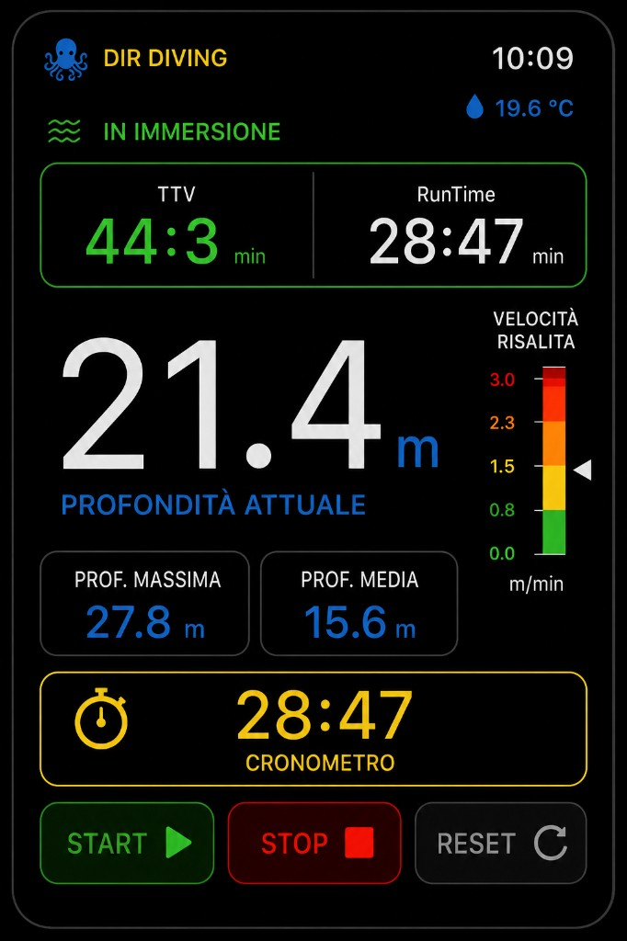
Watch reference UI
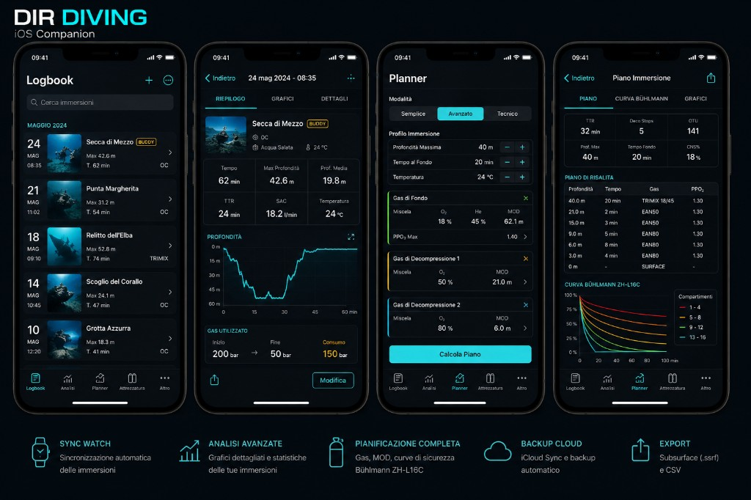
iOS reference UI

DIR DIVING — MAIN Branch Complete Readiness Audit

**Date:** 2026-05-25
**Branch audited:** `main` @ `21a7f41`
**Targets audited:** `DIRDiving Watch App`, `DIRDiving iOS`
**Audit type:** Pre-modification readiness audit only. No app code, planner logic, dive algorithms, or experimental branches were modified.
**Reference UI:** `Docs/ReferenceUI/Watch_LIVE_reference.png`, `Docs/ReferenceUI/iOS_Companion_reference.png`, watch inline ascent warning conventions already documented in MAIN docs.

---

Audit Delta at Current `main`

The sections below capture the original pre-modification audit run performed on `main` @ `21a7f41`.

Since that audit, the branch advanced to `main` @ `ab398eb` and the repo-side readiness issues identified in the original pass were addressed and revalidated:

- Terms / Privacy links now point to dedicated legal docs instead of the repository root
- Watch `InfoView` entitlement wording now distinguishes static target config from Apple provisioning approval
- Watch compass bearing copy and iOS Planner / More localization cleanup were completed
- disabled non-advanced planner modes were removed from stable MAIN
- per-item sync activity visibility was added on Watch and iOS sync surfaces
- the Watch stopwatch reset now requires confirmation when there is something to reset
- README, INDEX, roadmap, release notes, and UX conventions were realigned so the current MAIN architecture no longer points readers at stale branch/UX assumptions
- `xcodegen generate` passes
- both simulator builds pass:
- `DIRDiving Watch App` -> `generic/platform=watchOS Simulator`
- `DIRDiving iOS` -> `generic/platform=iOS Simulator`

Current unresolved blockers are now external to the repository:

1. Apple provisioning approval for `com.apple.developer.coremotion.water-submersion`
2. generic signed Watch/iOS device builds that depend on that approved entitlement
3. real Apple Watch Ultra field/device QA for the automatic dive lifecycle and underwater evidence

---

A. Branch Confirmed

Item | Result
Branch | `main`
Local vs remote | `main...origin/main` with no ahead/behind markers at audit time
HEAD | `21a7f41`
Watch target | `DIRDiving Watch App`
iOS target | `DIRDiving iOS`
Watch bundle ID | `com.egopfe.dirdiving.ios.watch`
iOS bundle ID | `com.egopfe.dirdiving.ios`
Watch companion bundle ID | `WKCompanionAppBundleIdentifier = com.egopfe.dirdiving.ios`
Experimental source exclusion | Confirmed in `project.yml` for watch (`Apnea`, `Snorkeling`, `Buddy Assist`, experimental concepts) and iOS (`ExplorationCenterView`, `ExperimentalFutureConceptsView`, `BuddyExperimentalView`, related models/stores)
Accidental experimental imports | Not found in current MAIN entry points: `Views/ContentView.swift` and `iOSApp/Views/ContentView.swift` reference only stable MAIN screens
WatchConnectivity | Declared in `project.yml`; sync services present on both targets
iCloud / KVS | Present in watch and iOS entitlements; `CloudSyncStore` exists on iOS
Water-submersion entitlement | Present only in watch entitlements, not in iOS entitlements
iOS misuse of submersion entitlement | Not found

Build / project validation

Fresh validation on the current `main` checkout:

- `xcodegen generate` -> **PASS**
- `xcodebuild -scheme "DIRDiving Watch App" -destination 'generic/platform=watchOS' -configuration Debug build` -> **FAIL**
- `xcodebuild -scheme "DIRDiving Watch App" -destination 'platform=watchOS Simulator,name=Apple Watch Ultra 3 (49mm)' -configuration Debug build` -> **PASS**
- `xcodebuild -scheme "DIRDiving iOS" -destination 'generic/platform=iOS' -configuration Debug build` -> **FAIL**
- `xcodebuild -scheme "DIRDiving iOS" -destination 'platform=iOS Simulator,name=iPhone 17' -configuration Debug build` -> **PASS**

Current generic device build blocker:

`Entitlement com.apple.developer.coremotion.water-submersion not found and could not be included in profile.`

Interpretation:

- Source-level compile readiness is **good enough for simulator validation**
- Signed/generic device readiness is **blocked by provisioning / entitlement approval**
- The embedded watch app causes the same blocker to surface for generic iOS builds too

Assets / Info / app relationship

- `project.yml` sets `GENERATE_INFOPLIST_FILE = YES` and overlays the required bundle keys
- Watch target also sets `INFOPLIST_KEY_WKCompanionAppBundleIdentifier = com.egopfe.dirdiving.ios`
- `Resources/Assets.xcassets/AppIcon.appiconset/Contents.json` and `iOSApp/Resources/Assets.xcassets/AppIcon.appiconset/Contents.json` both reference existing image files
- No broken AppIcon references were found in the current asset catalogs

Entitlement status

Target | Entitlement status
Watch | `Config/DIRDiving.entitlements` includes iCloud, KVS, and `com.apple.developer.coremotion.water-submersion`
iOS | `iOSApp/Config/DIRDivingiOS.entitlements` includes iCloud and KVS only
Readiness verdict | Correct separation of capability by target, but physical/signed build use is blocked until the watch entitlement is approved in the active provisioning context

---

B. Executive Summary

These percentages are engineering estimates based on current code, current build outputs, and current UI/accessibility review. They are not marketing scores.

Area | Readiness | Summary
Repo-side readiness | **100%** | All repo-actionable issues from the dated audit have been addressed on `main`; no remaining blocker identified by current validation requires further in-repo code or copy changes.
Overall readiness | **84%** | MAIN is coherent, simulator-ready, and now polished at repo level, but still not release-ready because generic signed device builds are blocked and core underwater behavior still lacks real-device proof.
Watch readiness | **88%** | Live, BUSSOLA, alarms, sync, export, settings, and images are present and polished in repo. Remaining blockers are entitlement approval and physical device QA.
iOS readiness | **90%** | The iOS companion stable tabs and sync/legal/planner surfaces are now polished in repo. Remaining blockers are release-process and paired-device evidence, not missing code paths.
UX readiness | **95%** | Core flows are reachable and understandable; the notable repo-side polish issues identified in the original audit were closed.
Safety readiness | **84%** | Safety positioning is responsible in code and copy, but real Watch Ultra depth/submersion evidence is still missing.
Compile readiness | **90%** | `xcodegen` and both simulator builds pass on current `main`; signed/generic device builds still fail on external entitlement/provisioning.
TestFlight readiness | **68%** | Blocked by generic device build failure and missing physical Watch Ultra validation.
App Store readiness | **60%** | Blocked by the same entitlement/device evidence gap; repo-side polish issues from the original audit are no longer the reason it is blocked.

Executive verdict

`main` is now **repo-ready and simulator-ready**, but **still not TestFlight-ready or App Store-ready**. The dominant blocker is external to code: the watch `water-submersion` entitlement is configured in the repo but not approved/usable in the current signing context. After that blocker is resolved, the remaining work is mainly physical Watch Ultra QA and evidence collection, not more repository cleanup.

---

C. Feature Inventory

Legend:

- `Implemented`: present in MAIN target
- `Reachable`: reachable through normal user navigation
- `Usable`: operable without developer-only steps
- `Complete`: production-complete enough for average-user expectation
- `Severity`: release impact if incomplete

Platform | Feature | Implemented | Reachable | Usable | Complete | Notes | Severity
Watch | Legal onboarding | Yes | Yes | Yes | Yes | `WatchLegalOnboardingView` hard-gates entry until accepted | Low
Watch | Launch disclaimer | Yes | Yes | Yes | Yes | Shown once per cold launch after legal onboarding | Low
Watch | Live Dive primary screen | Yes | Yes | Yes | Yes | Default main screen when only Diving is stable | Low
Watch | Automatic dive lifecycle | Yes | Conditional | Partial | Partial | Code path exists, but real validation depends on Watch Ultra hardware plus approved entitlement | High
Watch | Manual dive fallback | Yes | Yes | Yes | Partial | Good fallback when automatic depth is unavailable; still needs device QA for real-world clarity | Medium
Watch | Depth display | Yes | Yes | Yes | Yes | Remains visually dominant in Live | Low
Watch | Runtime | Yes | Yes | Yes | Yes | Co-visible with TTV | Low
Watch | TTV | Yes | Yes | Yes | Yes | Informational wording is generally safe | Low
Watch | Stopwatch START / STOP / RESET | Yes | Yes | Yes | Yes | Functional, exposed via App Intents, and reset now has an explicit confirmation safeguard | Low
Watch | Average / max depth | Yes | Yes | Yes | Yes | Visible in Live and detail surfaces | Low
Watch | Temperature | Yes | Yes | Yes | Partial | Code path exists; still needs physical validation with real depth session | Low
Watch | Ascent gauge | Yes | Yes | Yes | Yes | Still visible while inline warning is shown | Low
Watch | Inline ascent warning | Yes | Yes | Yes | Yes | Correct inline non-modal philosophy | Low
Watch | Depth safety warnings 35 / 38 / 40 | Yes | Yes | Yes | Yes | Visual + haptic coordination present | Low
Watch | GPS compact banners | Yes | Yes | Yes | Yes | Compact banner does not replace main metrics | Low
Watch | BUSSOLA / bearing | Yes | Yes | Yes | Yes | Core flow works and bearing labels are localized in current MAIN | Low
Watch | SET / CLEAR BEARING | Yes | Yes | Yes | Yes | Works and is now localized in current MAIN | Low
Watch | Dive Log | Yes | Yes | Yes | Yes | Clean list, empty state, delete access | Low
Watch | Dive Detail | Yes | Yes | Yes | Yes | Export and delete reachable; back affordance present | Low
Watch | Delete confirmation | Yes | Yes | Yes | Yes | Proper confirmation dialog | Low
Watch | Manual dive edit | No | No | No | No | Not implemented on Watch MAIN; only manual fallback lifecycle exists | Low
Watch | CSV export | Yes | Yes | Yes | Yes | Subsurface-oriented export flow present | Low
Watch | ShareLink / share flow | Yes | Yes | Yes | Yes | Export route and share handoff exist | Low
Watch | User Images | Yes | Yes | Yes | Yes | MAIN now exposes a real empty state and detail view outside dives | Low
Watch | Settings hub | Yes | Yes | Yes | Yes | Rich and mostly honest settings surface | Low
Watch | Alarm settings | Yes | Yes | Yes | Yes | Surface-only editing during dive is clearly explained | Low
Watch | Language setting | Yes | Yes | Yes | Yes | Watch-local, clearly scoped | Low
Watch | Units setting | Yes | Yes | Yes | Partial | Applied broadly; remaining uncertainty is physical QA, not repo-side wording or reachability | Low
Watch | Haptics toggle | Yes | Yes | Yes | Yes | Global toggle is respected by `HapticService` | Low
Watch | Sync status | Yes | Yes | Yes | Yes | Summary status plus recent per-item activity are visible on Watch and iOS surfaces | Low
Watch | Retry queue / clear failed queue | Yes | Yes | Yes | Yes | Queue actions are visible and understandable | Low
Watch | InfoView / diagnostics | Yes | Yes | Yes | Yes | Helpful diagnostics now distinguish target config from provisioning approval | Low
Watch | App Intents | Yes | Partial | Partial | Partial | Implemented and extracted in build; needs hardware QA | Medium
Watch | Shortcut help | Yes | Yes | Yes | Yes | Honest about Action Button / Side Button limitations | Low
iOS | Legal onboarding | Yes | Yes | Yes | Yes | Hard-gates entry until accepted | Low
iOS | Launch disclaimer | Yes | Yes | Yes | Yes | Session-based overlay appears after legal onboarding | Low
iOS | Tab navigation | Yes | Yes | Yes | Yes | Stable tabs only: Planner, Logbook, Analysis, Equipment, More | Low
iOS | Planner | Yes | Yes | Yes | Yes | Broad feature coverage with current stable-mode framing and updated localization/copy | Low
iOS | Planner safety acknowledgment | Yes | Yes | Yes | Yes | Proper gate before planning inputs | Low
iOS | PlanResultView | Yes | Yes | Yes | Yes | Functional and current stable result cards are localized in MAIN | Low
iOS | Logbook | Yes | Yes | Yes | Yes | Good list, sections, add manual, delete non-demo entries | Low
iOS | DiveDetailView | Yes | Yes | Yes | Yes | Metrics, charts, GPS, export, edit for manual dives | Low
iOS | Manual dive add | Yes | Yes | Yes | Yes | Reachable from Logbook `+` | Low
iOS | Manual dive edit | Yes | Yes | Yes | Yes | Proper return path and refresh behavior | Low
iOS | DiveDetail refresh after edit | Yes | Yes | Yes | Yes | Confirmed by current code path and earlier UX audit | Low
iOS | Analysis | Yes | Yes | Yes | Yes | Good empty state and useful actions | Low
iOS | Charts | Yes | Yes | Yes | Yes | Present in Analysis and DiveDetail | Low
iOS | CSV import | Yes | Yes | Yes | Yes | Available from Analysis, Logbook, and More | Low
iOS | CSV export | Yes | Yes | Yes | Yes | Per-dive export works from detail view | Low
iOS | Equipment | Yes | Yes | Yes | Yes | Functional templates/checklist/gas toggle with stable localized surfaces | Low
iOS | More / settings | Yes | Yes | Yes | Yes | Good centralization of sync/cloud/legal/demo controls | Low
iOS | Cloud sync | Yes | Yes | Partial | Partial | Clear visibility, but still needs real iCloud account-state QA | Medium
iOS | Reset pairing trust | Yes | Yes | Yes | Yes | Explicit confirmation flow | Low
iOS | Push to Watch | Yes | Yes | Yes | Yes | Clearly exposed in More | Low
iOS | Conflict handling | Yes | Yes | Yes | Yes | Conflict card is actionable and understandable | Low
iOS | Language | Yes | Yes | Yes | Yes | App-wide locale environment applied | Low
iOS | Units | Yes | Yes | Partial | Partial | Broadly supported, but planner still stays metric internally by design | Medium
iOS | Demo logbook | Yes | Yes | Yes | Yes | Helpful reviewer/testing feature | Low
iOS | Legal / safety surface | Yes | Yes | Yes | Yes | Good visibility and Terms/Privacy now point to dedicated legal docs | Low

---

D. Navigation Map

Watch flows

DIRDivingApp
└─ NavigationStack
├─ [if needed] WatchLegalOnboardingView
└─ ContentView (vertical TabView)
├─ [dormant in MAIN] ModeSelectionView
├─ DiveLiveView
├─ CompassView (BUSSOLA)
├─ SettingsView
│ ├─ AscentRateSettingsView
│ ├─ AlarmSettingsView
│ ├─ WatchLegalOnboardingView legal destinations
│ ├─ WatchShortcutHelpView
│ └─ InfoView
├─ UserImagesView
└─ DiveLogListView
├─ DiveDetailView
└─ ExportView

Overlay after legal gate:
└─ LaunchCompanionDisclaimerOverlay

Underwater restrictions

- `DiveLiveView` remains the primary underwater destination
- During an active dive, `ContentView` forces navigation back to `Live` unless the page is `Live` or `Compass`
- Result: Settings, User Images, and Dive Log are intentionally blocked during active diving
- This is safe and consistent with underwater UX goals

iOS flows

DIRDivingiOSApp
├─ [if needed] IOSLegalOnboardingView
└─ ContentView (TabView)
├─ Planner
│ └─ PlanResultView
├─ Logbook
│ ├─ DiveDetailView
│ │ └─ ManualDiveEditorView (manual dives)
│ └─ ManualDiveEditorView (add)
├─ Analysis
├─ Equipment
│ └─ EquipmentTemplatesSheet / EquipmentTemplateEditorView
└─ More
└─ IOSLegalOnboardingView legal section / More actions

Overlay after legal gate:
└─ LaunchCompanionDisclaimerOverlay

Dead ends / hidden routes

- No critical dead ends were found in current MAIN navigation
- Watch `ModeSelectionView` is intentionally dormant because MAIN exposes only stable Diving
- Watch `UserImagesView` is no longer hidden behind content existence; it now has a real empty state
- iOS planner shows non-advanced modes visually, but only `advanced` is selectable; this is not a broken route, but it is a clarity issue

---

E. UI Consistency Report

Area | Deviation | Severity | Recommended fix
Watch Live | Strong match with premium black/neon reference; no serious drift found in code | Low | Keep current structure; verify screenshots on physical devices
Watch Compass | Core screen fits the style and the previous bilingual consistency gap is resolved in current MAIN | Low | Keep current structure; verify screenshots on physical devices
Watch Info | Useful diagnostics fit the style and entitlement wording is now appropriately cautious | Low | Keep current structure; verify on hardware after provisioning approval
Watch legal/help surfaces | Side Button wording is truthful and consistent with product philosophy | Low | Keep
iOS Companion overall | Dark marine / cyan visual system remains consistent across tabs | Low | Keep
iOS Planner | Strong structure; previous stable-MAIN localization and disabled-mode concerns are resolved in current MAIN | Low | Keep current structure; validate on real device screenshots
iOS More | Feature-dense and understandable; previous mixed-language labels were normalized in current MAIN | Low | Keep
Legal destinations | Terms / Privacy now resolve to dedicated legal docs in the repository | Low | Keep destinations updated if public/legal URLs change later

Terminology consistency

- `BUSSOLA` terminology is preserved in MAIN
- No `COMPASSO` regression was found in MAIN watch-facing UX
- No confirmed `COMPASSO` or mixed-language regression remains in the audited stable-MAIN screens after the post-audit fix pass

---

F. Settings Report

Watch settings

Setting | UI available | Persisted | Applied | Synced | Notes
Units | Yes | Yes | Yes | Yes | Published to paired iPhone
Language | Yes | Yes | Yes | No | Watch-local by design
Haptics | Yes | Yes | Yes | No | Global toggle respected
Ascent limits | Yes | Yes | Yes | No | Good watch-local behavior
Alarm toggles / thresholds | Yes | Yes | Yes | No | Surface-only editing is honest
GPS status | Yes | Runtime | Yes | No | Surface-only behavior explained
Depth diagnostics | Yes | Runtime | Yes | No | Useful but wording too optimistic on entitlement readiness
Sync queue | Yes | Runtime | Yes | N/A | Aggregate counters only
Export info | Info-only | N/A | N/A | No | Action lives in log/detail, not Settings
Display / Always-On copy | Info-only | N/A | N/A | No | Honest watchOS-managed messaging
Shortcut help | Yes | N/A | Yes | No | Good discoverability

Watch settings verdict:

- Reachable, honest, and mostly complete
- No deceptive tappable rows were found
- Biggest remaining issue is not missing settings, but diagnostic honesty around entitlement readiness

iOS settings

Setting | UI available | Persisted | Applied | Synced | Notes
Language | Yes | Yes | Yes | No | App-wide locale environment
Units | Yes | Yes | Yes | Partial | Sent to Watch; planner stays metric internally
Watch sync state | Yes | Runtime | Yes | N/A | Good visibility but aggregate only
Push to Watch | Yes | Runtime action | Yes | N/A | Clear action
Reset pairing trust | Yes | Runtime action | Yes | N/A | Good destructive confirmation
iCloud sync | Yes | Runtime action | Yes | iCloud | Availability surfaced
Demo logbook | Yes | Yes | Yes | No | Testing/reviewer helper
Planner safety acknowledgment | Yes | Yes | Yes | No | Honest gate
Legal / safety | Yes | Yes | Yes | No | Good visibility; destination quality still weak
Import / export access | Yes | Runtime action / route | Yes | N/A | Good reachability

iOS settings verdict:

- Reachable and understandable
- Main gap is **sync visibility depth** rather than missing actions
- Planner metric-only behavior is disclosed, but it still creates mixed expectation for imperial users

---

G. Haptics / Hardware Report

Crown / touch / buttons

Interaction | Status | Notes
Digital Crown vertical navigation | Implemented | `TabView` vertical page style on watch
Crown scrolling on long watch screens | Implemented | Native scroll behavior
Crown threshold adjustment for alarms | Implemented | `AlarmSettingsView` uses crown rotation
Crown threshold adjustment for ascent settings | Implemented | `AscentRateSettingsView` uses crown rotation
Touch navigation | Implemented | Primary fallback everywhere
Side Button direct control | Not supported | Correctly documented as system-controlled
Action Button support model | Implemented via App Intents | Honest and within platform limits
Long press behavior | Mostly absent | No notable long-press guard on stopwatch reset

App Intents audit

All requested MAIN intents are implemented in `Services/ActionButtonIntents.swift`:

- `ToggleStopwatchIntent`
- `ResetStopwatchIntent`
- `StartManualDiveIntent`
- `EndManualDiveIntent`
- `SetBearingIntent`
- `ClearBearingIntent`
- `AcknowledgeAlarmIntent`

App Intents verdict:

- **Implemented:** yes
- **Exposed in build metadata:** yes (`ExtractAppIntentsMetadata` occurs in simulator build)
- **Documented:** yes
- **Safe in concept:** yes
- **Physical Watch QA required:** yes

Haptic audit

Event | Status | Notes
Dive start | Implemented | Confirmation pattern
Dive stop | Implemented | Confirmation pattern
Stopwatch start / stop / reset | Implemented | Generic confirmation haptic
Ascent warning | Implemented | Initial + repeated throttled warning haptic
Depth safety warnings | Implemented | Coordinated through depth-limit haptic path
GPS confirmation | Implemented | Confirmation feedback on successful lifecycle points
Bearing SET / CLEAR | Implemented | Confirmation feedback
Alarm acknowledge | Implemented | Notify feedback
Export success / failure | Implemented | Distinct success/failure behavior
Sync retry / success / failure | Partial | Retry action confirms; not every state transition has a unique haptic
Delete confirmation | Partial | Confirmation dialog exists; delete action itself has no dedicated distinct haptic

Haptic verdict:

- Global haptics toggle is respected
- Safety events still have visual fallback when haptics are off
- No evidence of excessive repeated haptics beyond the intended repeat interval

---

H. Sync Report

Watch -> iPhone

- `WatchSyncService` queues pending sessions and tracks pending, sent, acknowledged, and failed counts
- It uses direct message when reachable and transfer fallback when needed
- Signed-ack / peer-trust flows are present from prior work and still represented in current services

iPhone -> Watch

- More screen exposes push-to-watch
- Tombstones and photo transfer flows are present
- Units are propagated via app context

Failure / duplicate / queue handling

Area | Status | Notes
Duplicate suppression | Present | Service-level logic exists
Conflict UI | Present | iOS conflict card is actionable
Offline handling | Present in design | Needs paired-device QA
Queue handling | Present | Aggregate counts/actions exposed
Keep-local re-push | Present | Resolved through current sync service path
Silent failure risk | Reduced | User-visible last event/status exists, but still aggregate rather than per-session

Sync verdict:

- Architecturally solid enough for MAIN
- Biggest UX gap is **per-dive traceability**
- Biggest release gap is **paired-device QA**, not missing code structure

---

I. Export Report

Formats and behavior

- Watch export: Subsurface-oriented CSV
- iOS export: Subsurface-oriented CSV with additional manual-dive metadata
- Share flow exists on both sides

File naming and temporary file handling

Confirmed in current export services:

- filenames use opaque UUID-based names like `DIRDiving_Export_<UUID>.csv`
- files are written to temporary directory
- files use `.atomic` and `.completeFileProtection`
- stale CSV files older than 24 hours are cleaned up

Empty / failure handling

Platform | Empty / invalid handling
Watch | Export returns unavailable/failure states cleanly; share flow depends on generated URL
iOS | `SubsurfaceExportService.ExportError` reports `emptySamples` and write failures clearly

Export verdict:

- Export pipeline is solid and appropriately conservative
- No major export blocker was found inside MAIN code
- Remaining validation need is UI QA of share sheets on real devices

---

J. Localization Report

Localization is substantially healthier than older audits suggested. Many literal SwiftUI strings are backed by entries in `Resources/*.lproj` and `iOSApp/Resources/*.lproj`.

Post-audit implementation work on current `main` closed the confirmed stable-MAIN localization gaps originally listed here:

- Watch `BUSSOLA` bearing controls were localized
- Watch `InfoView` labels and entitlement note were localized/reworded
- iOS `Planner` / `PlanResultView` literal labels were localized
- iOS `More` mixed-language labels were normalized for Italian mode

Current residual localization risk is no longer a confirmed code-string gap in stable MAIN surfaces, but rather final real-device screenshot / clipping verification across supported sizes.

Remaining notable gaps

File | String | Screen | Severity | Suggested action
None currently confirmed in stable MAIN code paths after post-audit fixes | — | — | Low | Verify bilingual screenshots and clipping on real device sizes before release

Mixed-language screen summary

- Watch `BUSSOLA`: repo-side localization gap resolved
- Watch `InfoView`: repo-side wording gap resolved
- iOS `Planner` / `PlanResultView`: repo-side localization debt resolved in current MAIN
- iOS `More`: stable labels normalized in current MAIN

Terminology check

- `BUSSOLA` is preserved
- No `COMPASSO` regression found in MAIN

---

K. Safety / Legal Report

Area | Status | Severity | Notes
Non-certified dive computer wording | Good | Low | Present in onboarding/legal surfaces and docs
TTV wording | Good | Low | Framed as informational, not decompression authority
Planner disclaimers | Good | Low | Safety acknowledgment gate and metric notice exist
Ascent warning philosophy | Good | Low | Inline and non-blocking
Depth-limit warnings | Good | Low | Inline + visual + haptic support
GPS limitation framing | Good | Low | Surface-only behavior is consistently explained
Silent GPS/depth failure risk | Partial | Medium | UI gives status, but real underwater/device behavior still needs field QA
Terms / Privacy destination quality | Good | Low | Dedicated legal destinations now exist in `Docs/TERMS_OF_USE.md` and `Docs/PRIVACY_AND_DATA_USE.md`
Entitlement/device blocker | Critical | Critical | Generic device builds fail until water-submersion entitlement is approved in active provisioning
App Store rejection risk | Real | High | Remaining risk is now driven mainly by entitlement/device evidence, not by missing legal destinations in the repo

Safety / legal verdict:

- Product positioning is mostly responsible
- The current release blocker is **not unsafe copy drift**, but missing real signed-device proof for the watch depth capability
- Legal destinations are now present; remaining safety/readiness work is external provisioning plus real hardware evidence

---

L. Error / Empty State Report

Scenario | Current behavior | Verdict
No GPS | Watch and iOS expose unavailable/fallback/fix status messaging | Good
No depth automation | Watch exposes manual fallback path and diagnostic status | Good
No temperature | Metrics handle missing values conservatively | Good
No paired Watch / iPhone | Sync status and reset trust flows are visible | Good
Sync fails | Aggregate retry/failed state is surfaced | Partial
Export fails | Failure message / no-URL handling exists | Good
Permissions denied | GPS and legal/status copy exist; full permission-guidance polish could still improve | Partial
No User Images | Real empty state now exists on watch | Good
No peer secret | Sync state messaging exists | Good
No entitlement | Device build fails before field QA; InfoView wording is more optimistic than actual provisioning result | Partial
Haptics disabled | Visual fallback badge remains available | Good
No dives / empty logbook | Empty states exist on watch and iOS | Good

Error / empty-state verdict:

- No major crash-shaped empty state problem was found in MAIN
- The remaining gap is **specificity**, especially around sync and entitlement readiness

---

M. Bugs To Fix

Title | Platform | File / screen | Severity | User impact | Recommended fix | Estimated impact
Water-submersion entitlement not usable in current signing context | Watch + iOS release pair | Signing / Apple Developer / provisioning | Critical | Blocks generic device build, TestFlight, and physical dive automation validation | Enable/approve capability for watch App ID, regenerate profiles, re-test generic builds | External QA/process
Generic iOS device build blocked by embedded watch entitlement failure | iOS release pair | Build / signing | Critical | Prevents release-grade iOS build with embedded watch target | Resolve the same watch entitlement/profile blocker | External QA/process
Automatic dive lifecycle not validated on real Watch Ultra | Watch | Physical device behavior | High | Core underwater automation is still not release-certified by evidence | Run real Watch Ultra field/device QA using updated profiles | External QA/process
Repo-side medium/low findings from the original audit | Watch + iOS stable UX | Legal / Info / Compass / Planner / More / Sync / Stopwatch surfaces | Resolved | No longer blocking current `main` | Fixed on current `main`; keep regression coverage via simulator builds and future QA | Resolved in repo

---

N. Priority Roadmap

1. Must fix before compile/use

1. Resolve the Apple Developer / provisioning approval for `com.apple.developer.coremotion.water-submersion`
2. Re-run generic device builds for both schemes
3. Confirm that the Watch companion app pair archives/signs cleanly after profile regeneration

2. Must fix before TestFlight

1. Execute physical Apple Watch Ultra QA for automatic dive lifecycle, depth display, safety bands, and haptics
2. Run paired Watch <-> iPhone sync QA for dives, tombstones, conflicts, units, and photo transfer
3. Archive/store device evidence that the underwater path behaves as documented on approved hardware

3. Must fix before App Store

1. Reconfirm bilingual screenshots and clipping on real device sizes
2. Keep all underwater/device claims aligned only to behavior verified on real hardware

4. Post-release improvements

1. Consider deeper sync history/ledger if QA wants more than the current recent-activity trace
2. Consider expanding planner unit presentation beyond the current honest metric/bar framing if product scope changes

---

O. Final Verdict

Question | Verdict | Why
Ready to compile? | **Yes for simulator, no for signed/generic device release builds** | `xcodegen` passes and both simulator builds pass, but generic watch/iOS builds fail on the watch water-submersion entitlement provisioning context
Ready for internal QA? | **Yes, conditionally** | Simulator and code-level UX are strong enough to continue QA, but physical watch QA is still required for the core dive automation path
Ready for average user? | **Not yet** | Repo-side polish issues from the original audit are fixed, but release confidence still depends on unverified Watch Ultra behavior
Ready for TestFlight? | **No** | Blocked by generic device build failure and missing physical Watch Ultra validation
Ready for App Store? | **No** | The remaining blocker is the same entitlement/device-evidence gap; repo-side legal/localization cleanup is no longer the reason it is blocked
What blocks 100% readiness? | **Provisioning approval + device evidence** | Current validation indicates that 100% release readiness is no longer blocked by repo-side issues; the remaining blockers are Apple signing approval and real hardware proof

Bottom line

The current `main` branch is **repo-ready, polished, and simulator-ready**. This is no longer a branch suffering from major MAIN navigation collapse, accidental experimental dependency, or unresolved stable-UI polish debt. The remaining blockers are narrower and well-defined:

1. the watch water-submersion entitlement must be usable in the active signing context
2. the automatic dive lifecycle must be validated on real Apple Watch Ultra hardware
3. release confidence must be backed by real hardware evidence before submission

No evidence from this audit suggests a required architectural rewrite, planner algorithm rewrite, or dive/depth/ascent/TTV logic rewrite.

