DIR DIVING — UX / Interaction / Feature Accessibility Audit (PRE-MODIFICATION)
Date: 2026-05-24 · Branch: main · HEAD: 8a4d10e77c5a4dcab18250354a96472bfe5cd2ab
Read-only audit. Scope: Watch MAIN + iOS MAIN. No code changes in this pass.

9. Final Summary
Dimension | Estimate
UX / feature accessibility | ~82%
Navigation | ~88%
Settings | ~78%
Hardware | ~75%
Haptics | ~85%
Sync UX | ~80%
Compile readiness | 0% — BUILD FAILED
CRITICAL: AscentRateSettingsView.swift:41 — limitControl missing return. Fix before QA.

1. Feature Inventory (highlights)
Platform | Feature | Reachable | Gap
Watch | Live dive + ascent | Y | Device depth
Watch | BUSSOLA | Y | —
Watch | ASC SET limits | P | Build broken
Watch | 7 App Shortcuts | P | Not device-tested
Watch | Side button dive | N | Shortcuts only
iOS | Planner + ack | Y | Persisted
iOS | Logbook/detail/export | Y | Units in list OK
iOS | Sync + conflicts | Y | Aggregate status only
iOS | Alarms settings | N | Watch-local

2. Navigation Map
- Watch: Legal → TabView (Live, BUSSOLA, Settings, [Images], Log) → sub-screens.
- During dive: only Live, BUSSOLA, Log; Settings blocked.
- iOS: Planner | Logbook | Analysis | Equipment | More.
- No dead ends found statically.

3. Settings Report
- Watch: units, language, haptics, ascent, alarms, legal, sync status — OK.
- Watch: brightness/tones/export — informational only.
- iOS: units, language, sync, cloud, demo, legal — OK.
- iOS: no alarm/haptic editors (by design).

4. Hardware & Haptics
- Crown: vertical paging + steppers in alarm/ascent settings.
- Side button: not mapped; WatchShortcutHelpView documents Shortcuts.
- 7 App Intents registered.
- Haptics gated; ascent/depth/confirm/export covered.
- No audio tones.

5. UX Blockers
ID | Severity | Issue
UX-CR-01 | CRITICAL | Watch build fail AscentRateSettingsView
UX-H-01 | HIGH | Ultra depth / entitlement QA
UX-H-02 | MED | Side button not mapped
UX-M-03 | MED | Planner metric-only vs units

6–8. Safety, Priority, Code Impact
- Safety: disclaimers strong; build blocks device haptic QA.
- Immediate: fix compile, then builds + simulator smoke.
- Pre-release: Ultra QA, intents, sync on device.
- Impact: one small functional fix; rest UI/i18n/QA.

Reference UI
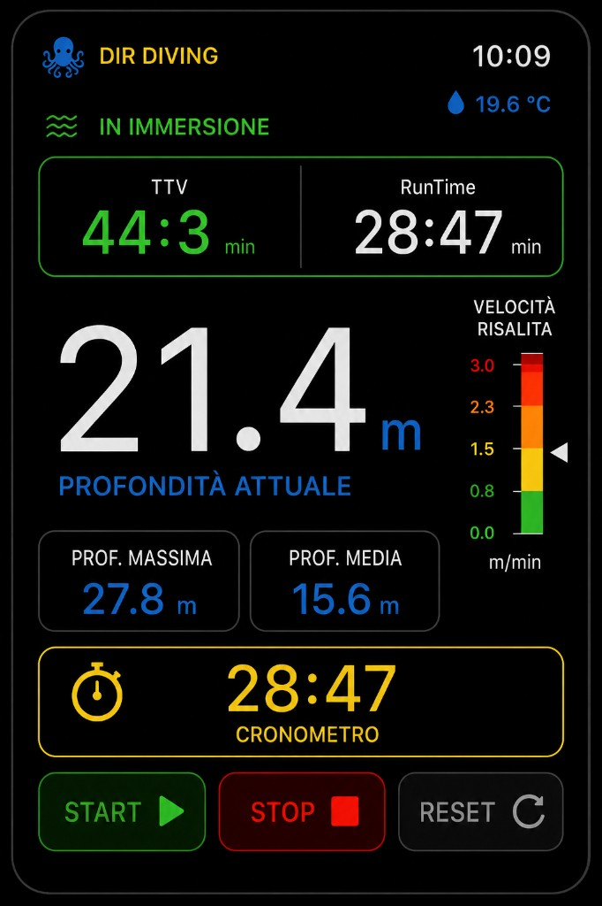
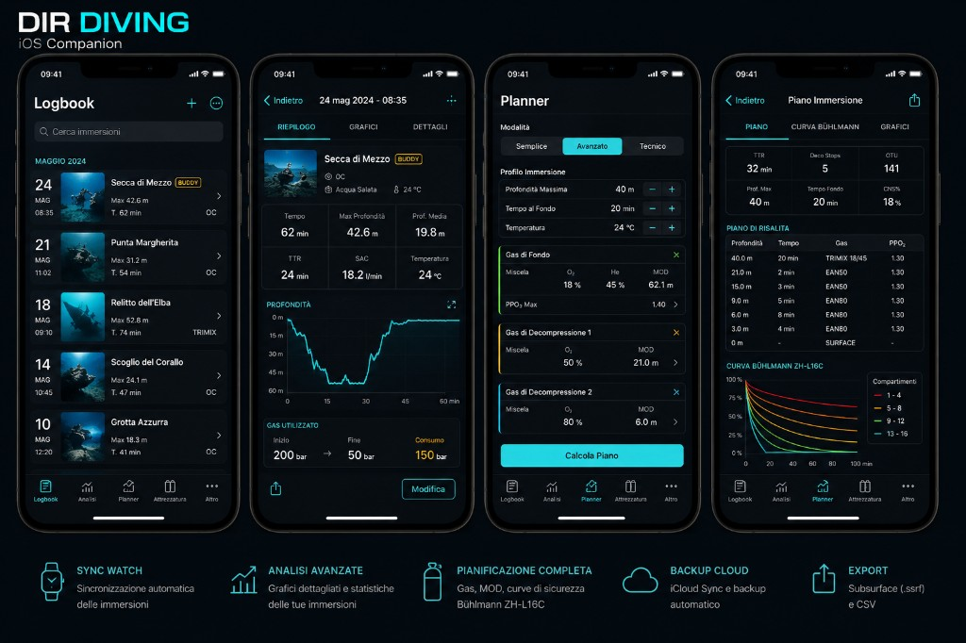
Full markdown: MAIN_BRANCH_UX_INTERACTION_ACCESSIBILITY_AUDIT_20260524_CURRENT_PRE_MODIFICATION.md

