DIR DIVING — MAIN UX / Interaction / Feature Accessibility Audit
Post development-notes pass · Date: 2026-05-24 · Branch: main · HEAD: c23d4d4
Pre-modification audit only. Scope: Apple Watch MAIN + iOS Companion MAIN. Experimental targets excluded per project.yml.

9. Final Summary
Dimension | Estimate | Notes
Release readiness (UX) | ~84% | Core flows usable on c23d4d4
UX completeness | ~80% | Dev-notes features reachable
Stability (interaction) | ~88% | Sync/conflict mostly surfaced
Safety completeness (UX) | ~85% | Legal/ascent/MOD strong
Verdict: Suitable for continued TestFlight. Remaining work is polish (planner units, launch disclaimer, dive-start affordance), not missing core navigation.

1. Feature Inventory (summary)
Watch MAIN — highlights
- Vertical TabView: Live, Compass, Settings, [User Images], Dive Log.
- Dive lifecycle sensor-driven; manual fallback when depth API unavailable.
- Back affordances on pushed settings, log detail, export, info (c23d4d4).
- Units applied on Live and Log via WatchDepthFormatting.
- Mode Selection / Apnea / Snorkeling excluded or hidden.
iOS MAIN — highlights
- Tabs: Planner, Logbook, Analysis, Equipment, More.
- Equipment templates + editor; planner cylinders/MOD validation.
- Manual dive edit reachable for manual sessions.
- Planner advanced-only; metric notice shown.
- Watch photo preprocess + localized conversion warning.

2. Navigation Map
Watch: NavigationStack → TabView with Settings pushes and log export destinations. Active dive restricts tabs to Live, Compass, Log. iOS: TabView per surface; Planner → PlanResult; Logbook → Detail → Manual editor.

3. Settings Report
Platform | Exposed | Not in UI / not synced
Watch | Units, language, haptics, alarms, ASC SET, legal | Depth 35/38/40 bands; alarms not WC-synced
iOS | Units, language, sync, iCloud, demo, legal, pairing reset | Bulk export (info only); planner ack session

4. Hardware Interaction
- Crown: tab paging (system); threshold tuning on Alarms + ASC SET only.
- Side button: not mapped; 7 App Intents via Shortcuts (documented).
- Haptics: dive, alarms, ascent, depth limits, confirmations — master toggle respected.

5. UX Blockers
ID | Severity | Issue
B1 | HIGH | No Start Dive button when automation active
B3 | MEDIUM | Companion disclaimer every launch
B4 | MEDIUM | Planner metric-only vs global units
B5 | MEDIUM | Disabled planner mode tabs visible
B6 | MEDIUM | Manual editor weak back navigation

6. Safety Issues
- No CRITICAL safety UX blockers at c23d4d4.
- Max-depth alarm disabled by default — user must enable (MEDIUM).
- MOD warnings informative only — Calculate not blocked.
- Strong: legal gates, ascent banner, depth limit UI, MOD validation display.

7. Recommended Priority
- Immediate: dive-start affordance, disclaimer persistence, alarm default UX.
- Pre-release: planner units/modes, manual editor toolbar, dive-active log gating.
- Post-release: team planner edit, i18n sweep, device QA intents/sync.

8. Code Impact
Most remaining fixes are small UI/product decisions. No architectural rewrite required.

Reference UI
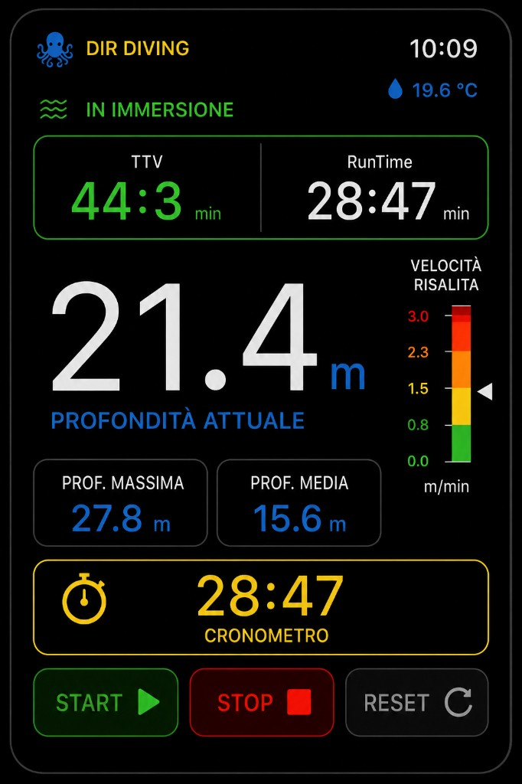
Watch reference
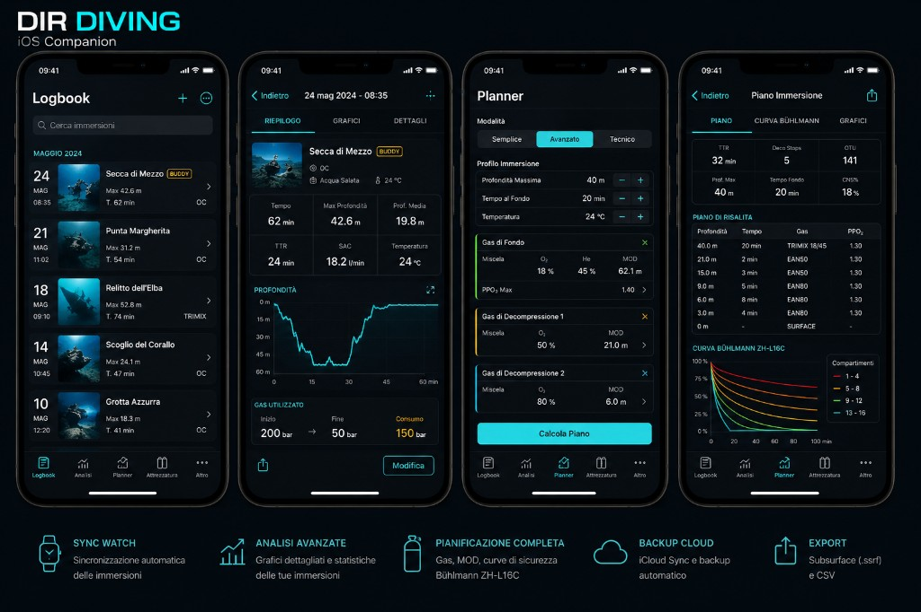
iOS reference

Full report (markdown source)
Complete tables and appendices: MAIN_BRANCH_UX_INTERACTION_ACCESSIBILITY_AUDIT_20260524_POST_DEV_NOTES.md

DIR DIVING — MAIN Branch UX / Interaction / Feature Accessibility Audit
Date: 2026-05-24
Branch audited: `main` @ `c23d4d4`
Scope: Apple Watch MAIN target + iOS Companion MAIN target only
Excluded: Experimental branches (`codex/experimental-features`, `codex/ios-experimental-features`) and all paths excluded in `project.yml` (Snorkeling, Apnea, Buddy Assist, Exploration Lab, etc.)
Audit type: Pre-modification, read-only static code review. No application code was changed for this report.
Method: Navigation graph tracing, SwiftUI view / `@AppStorage` inventory, `WatchConnectivity` / iCloud flows, haptics and App Intents review, cross-check with `Docs/DIR_Diving_Complete_Development_Notes_25_05_2026.md` implementation (`c23d4d4`).
Downloadable Word report: `Docs/MAIN_BRANCH_UX_INTERACTION_ACCESSIBILITY_AUDIT_20260524_POST_DEV_NOTES.docx`
Generate: `python3 Docs/generate_main_branch_ux_interaction_accessibility_audit_20260524_post_dev_notes_docx.py`
---

1. Feature Inventory
Legend: I implemented in MAIN binary · R reachable without dev tricks · C user can complete the flow · Status: Complete / Partial / Hidden / Broken / Excluded

1.1 Apple Watch MAIN
|---------|:-:|:-:|:-:|--------|-------|

1.2 iOS Companion MAIN
|---------|:-:|:-:|:-:|--------|-------|
---

2. Navigation Map

2.1 Watch MAIN
DIRDivingApp
└─ NavigationStack
├─ [if legal required] WatchLegalOnboardingView → Accept → ContentView
└─ ContentView (TabView .verticalPage)
├─ [hidden] ModeSelectionView → .live
├─ DiveLiveView ← default / forced when dive active
├─ CompassView
├─ SettingsView ← root tab (no back)
│ ├─ push → AscentRateSettingsView [← watchSubscreenBackToolbar]
│ ├─ push → AlarmSettingsView [← watchSubscreenBackToolbar]
│ ├─ push → WatchLegalSafetyView [← WatchDetailBackButton]
│ ├─ push → WatchShortcutHelpView [← watchSubscreenBackToolbar]
│ └─ push → InfoView [← WatchDetailBackButton]
├─ [if images] UserImagesView
│ └─ detail state [← WatchDetailBackButton → list]
└─ DiveLogListView
├─ push → DiveDetailView [← WatchDetailBackButton]
│ └─ dest → ExportView [← WatchDetailBackButton + dismiss]
└─ dest → ExportView (export latest)
Overlays: LaunchCompanionDisclaimer (fullScreenCover, each launch)
Active-dive gating (`ContentView`): While `dive.isDiveActive`, only `.live`, `.compass`, `.diveLog` allowed; Settings and User Images redirect to Live.
Dead ends: None critical. `ExportView` and pushed settings have explicit back. Tab roots use vertical swipe only.
Missing routes: Mode Selection, Apnea, Snorkeling (excluded). No in-app path to bulk-export from Settings (by design).

2.2 iOS MAIN
DIRDivingiOSApp
├─ [legal] IOSLegalOnboardingView

