HASH TABLE OPTIMIZATION

1_Sandart. The original version of Hash Table without any optimizations.

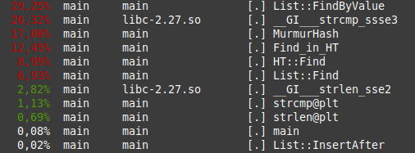

Optimization | Time (sec.)
-O0 | 30
-O1 | 24,2
-O3 | 16,9

2_Strcmp_asm_opt. Change standard strcmp() function on inline assembler code. Reduced time for Find by 4%. It’s not bad because standard strcmp uses SSE. We have around 27 seconds now.

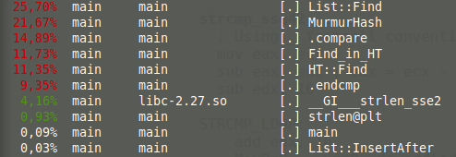

3_Strcmp_sse_opt. Optimize Find function with inline SSE compare instructions. Full time is around 22 seconds now.
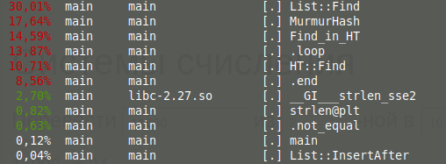
Optimization | Time (sec.)
ASM | 27,4
+SSE | 22,4

4_Hash_asm_opt. Optimize MurMurHash function with inline assembler.

