React Exercise - Routing

Component Separation
Separate all major views from the skeleton (e.g., Home, Catalogue, Login, Register, Create, Details, Edit) into individual, reusable React components (e.g., Home.jsx, Login.jsx).

Overview
Implement client-side routing using React Router, covering both static and dynamic routes, utilizing modern features like Nested Routes and request management with the AbortController. Configure the application structure with <BrowserRouter>, <Routes>, and <Route> to define all necessary views.

Navigation Bar
Replace static navigation elements in the Navigation Bar with the <Link> component for seamless client-side transitions.

Catalog
This page displays a list of all games in the system, with their title and genre. Clicking on any of the cards details button leads to the details page for the selected game.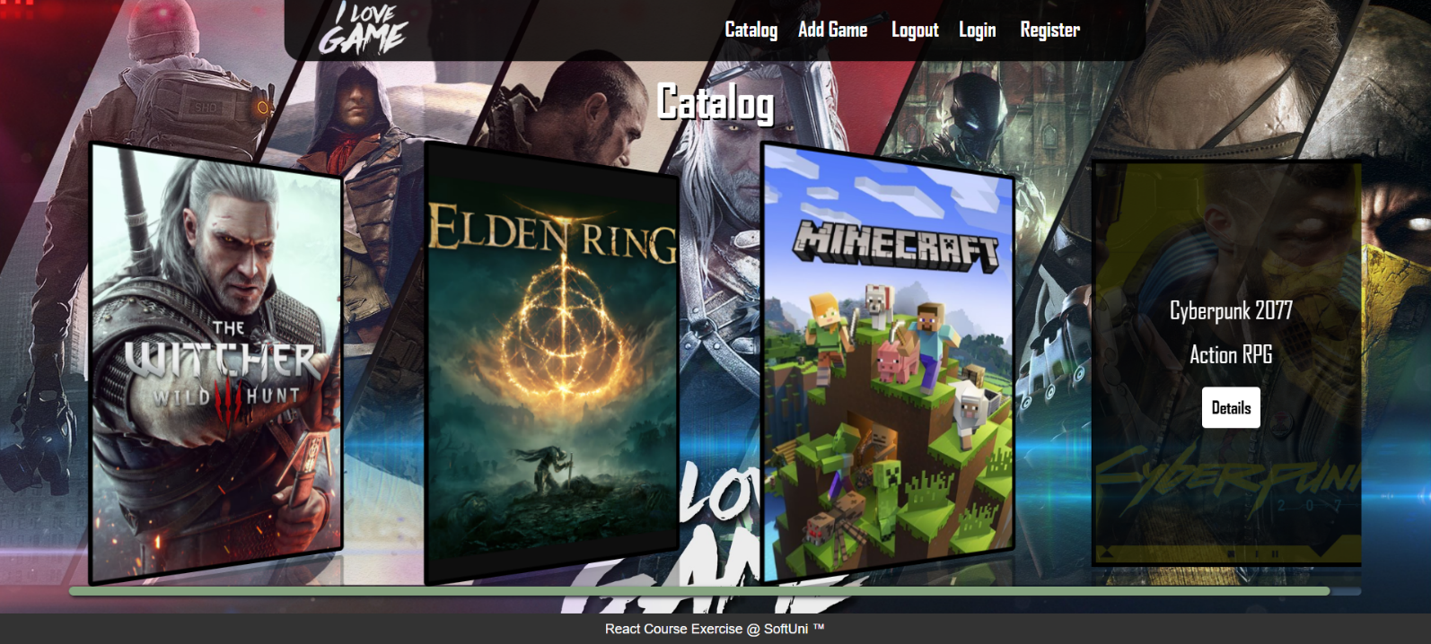

If there are no games, the following view should be displayed:

Send the following request to read the list of games:
Method: GET
URL: /rest/v1/games?order=created_at.desc
Required headers are described in the documentation. The service will return an array of games.

Home Page
All users should be greeted from the homepage, where they should be able to see the three most recently added games. Clicking on the details links leads to the details page for the selected game. 

If no games have been added yet, show the text "No games yet" instead.

Send the following request to read the new games:
Method: GET
URL: /rest/v1/games?order=created_at.desc&limit=3
Required headers are described in the documentation. The service will return an array of games.

Details
All users should be able to view details about games. Clicking the Details link in a game should display the Details page:
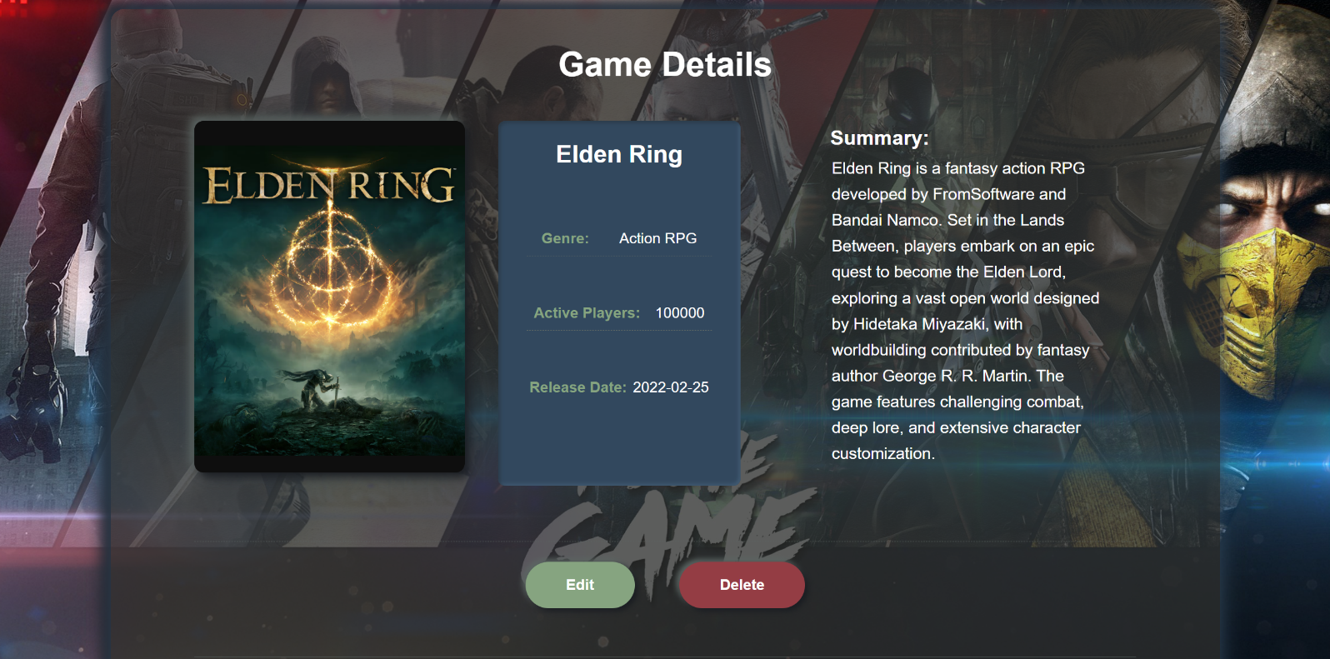

Send the following request to read a single game:
Method: GET
URL: /rest/v1/games?id=eq.{gameId}
Replace {gameId} with the id of the desired game. Required headers are described below. Supabase returns an array containing the matching game — read the first element (data[0]). An empty array means the game was not found.

Delete Game
To delete a game, send the following request:
Method: DELETE
URL: /rest/v1/games?id=eq.{gameId}
Replace {gameId} with the id of the desired game. Required headers are described below. A successful DELETE returns 204 No Content with an empty body; do not call response.json(). Upon success, redirect the user to the Home page.

Setting up Supabase
Create a free account at supabase.com and start a new Project.

Creating the Games Table
In the Table Editor, create a table named “games” in the public schema. Keep the automatically generated id column as the primary key and add the following columns:
title, genre, imageUrl, summary: text
activePlayers: int8
releaseDate: date
created_at: timestamptz (default: now())
Use these column names exactly, including capitalization, and match them in your React components. Use id for React keys, route parameters and API filters. Add a few sample games in the Table Editor to test the Catalog, Home and Details pages.

Allowing Access for the Exercise
Row Level Security (RLS) blocks access until suitable policies are added. For this exercise, disable RLS on the games table in the Table Editor so the GET and DELETE requests work without user authentication. Use only sample data: disabling RLS makes the table publicly accessible. A real application should use RLS policies.

Project URL and API Key
Copy your Project URL from the project Connect dialog and your publishable API key from Settings → API Keys. Add the Project URL before each relative URL shown above. For example:
https://<project-ref>.supabase.co/rest/v1/games?order=created_at.desc
Replace <project-ref> with your project reference. No local server or node server.js command is needed.

Required Headers
Include the publishable API key in every request:
apikey: <your-publishable-key>
Send a publishable key in the apikey header only. Authorization: Bearer is used for a signed-in user’s access token (JWT), which is not needed in this exercise. Never put a secret or service_role key in the React application.
If you send a JSON request body, encode it with JSON.stringify() and include:
Content-Type: application/json

Server Responses
GET requests return a JSON array. The Catalog request sorts all games by created_at, newest first; the Home request uses limit=3 to return only the three latest games. The Details request filters by id and returns an array with at most one game.
DELETE requests return an empty response by default. Check response.ok before handling a successful result. For failed requests, read the JSON error response and display its message to the user.

