React Exercise – Components Deep Dive

Task Requirements
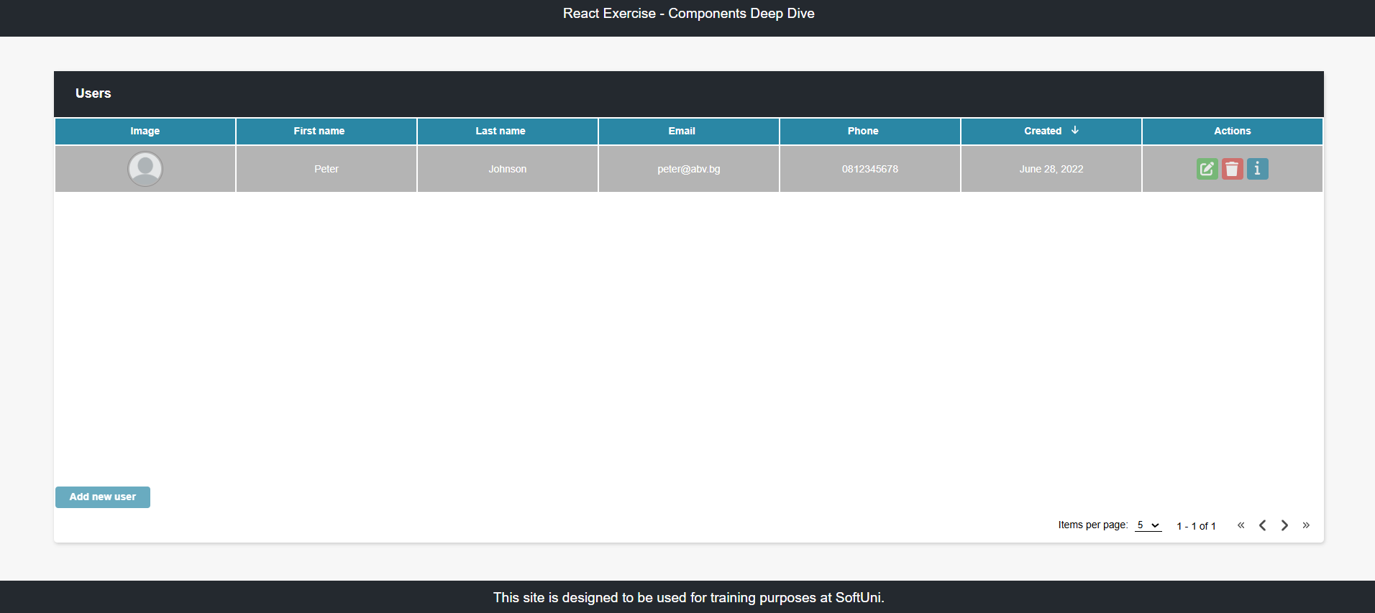
Use the provided html structure and styles to create a page with the following functionalities:

Create user
Clicking on the Add new user button should display a form for creating users.
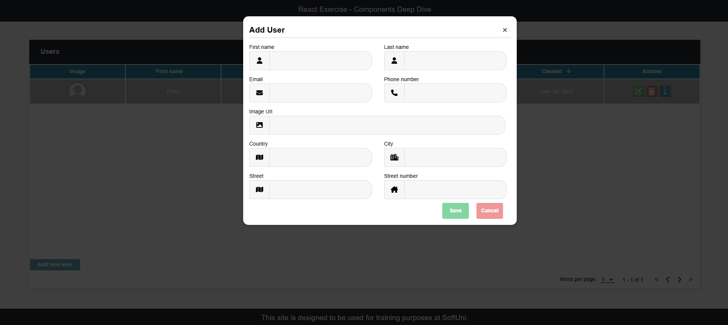
Send the following request:
Method: POST
URL: https://<project-ref>.supabase.co/rest/v1/users
Required headers:
apikey: <your-publishable-key>
Authorization: Bearer <your-publishable-key>
Content-Type: application/json
Prefer: return=representation
The service expects a body with the following shape:

{
firstName,
lastName,
email,
imageUrl,
phoneNumber,
createdAt,
updatedAt,
address: {
country,
city,
street,
streetNumber
}
}
Then the service will return the newly created record.

User info
Clicking the [i] button in the Actions section should display a window containing the information for the selected user.
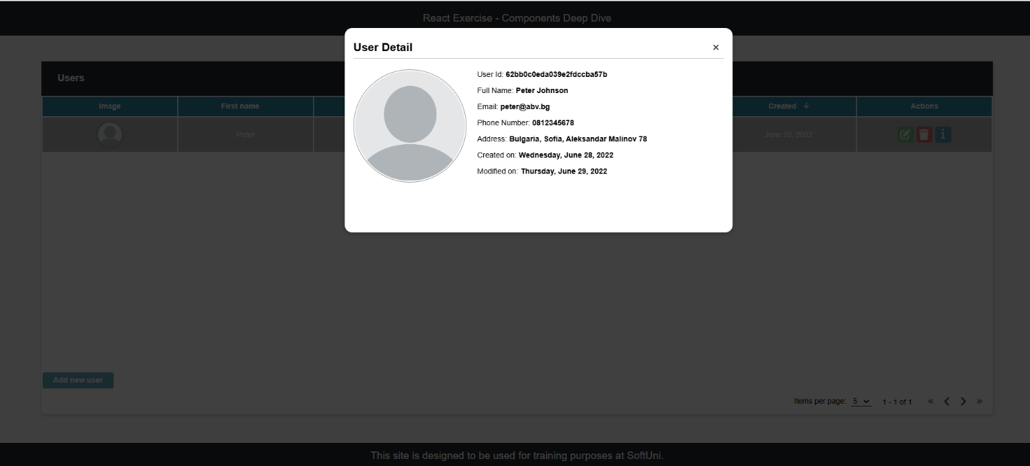
To retrieve the information, send the following request:
Method: GET
URL: https://<project-ref>.supabase.co/rest/v1/users?id=eq.{userId}
Required headers:
apikey: <your-publishable-key>
Authorization: Bearer <your-publishable-key>
Note: Supabase returns an array containing the matching row — read the first element (e.g. data[0]).

Edit user
Clicking the [Edit] button in the Actions section should display a form for editing the user information.
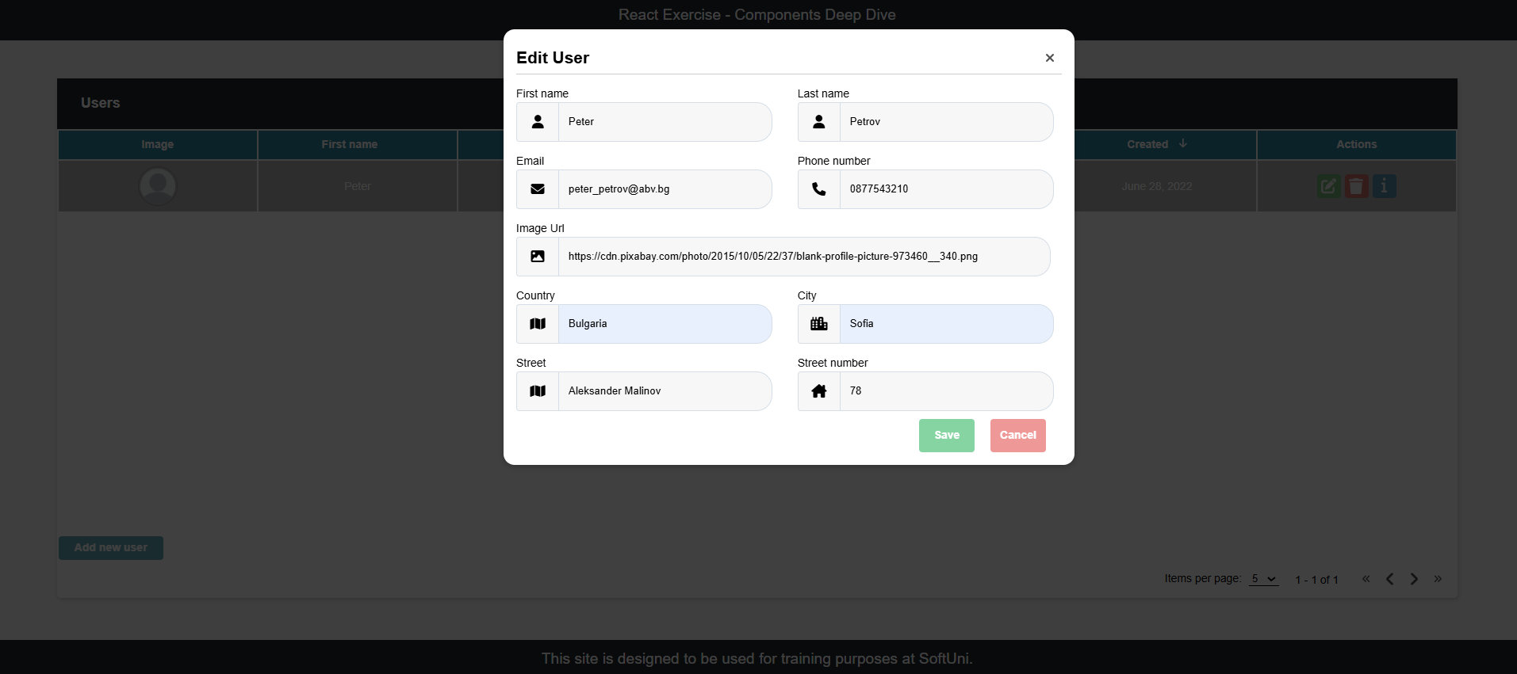
If the form is filled correctly send the following request:
Method: PATCH
URL: https://<project-ref>.supabase.co/rest/v1/users?id=eq.{userId}
Required headers:
apikey: <your-publishable-key>
Authorization: Bearer <your-publishable-key>
Content-Type: application/json
Prefer: return=representation
The service expects a body with the following shape:

{
firstName,
lastName,
email,
imageUrl,
phoneNumber,
createdAt,
updatedAt,
address: {
country,
city,
street,
streetNumber
}
}
Then the service will return the newly modified record.

Delete user
Clicking the [Delete] button in the Actions section should display a confirmation window.
‘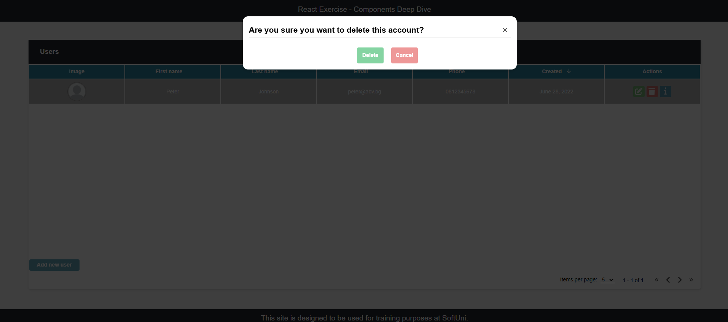
Clicking the [ Save ] button should send the following request:
Method: DELETE
URL: https://<project-ref>.supabase.co/rest/v1/users?id=eq.{userId}
Required headers:
apikey: <your-publishable-key>
Authorization: Bearer <your-publishable-key>

Then the record with the given id will be deleted.

Pagination*
Selecting how many items a page must include, implement a pagination
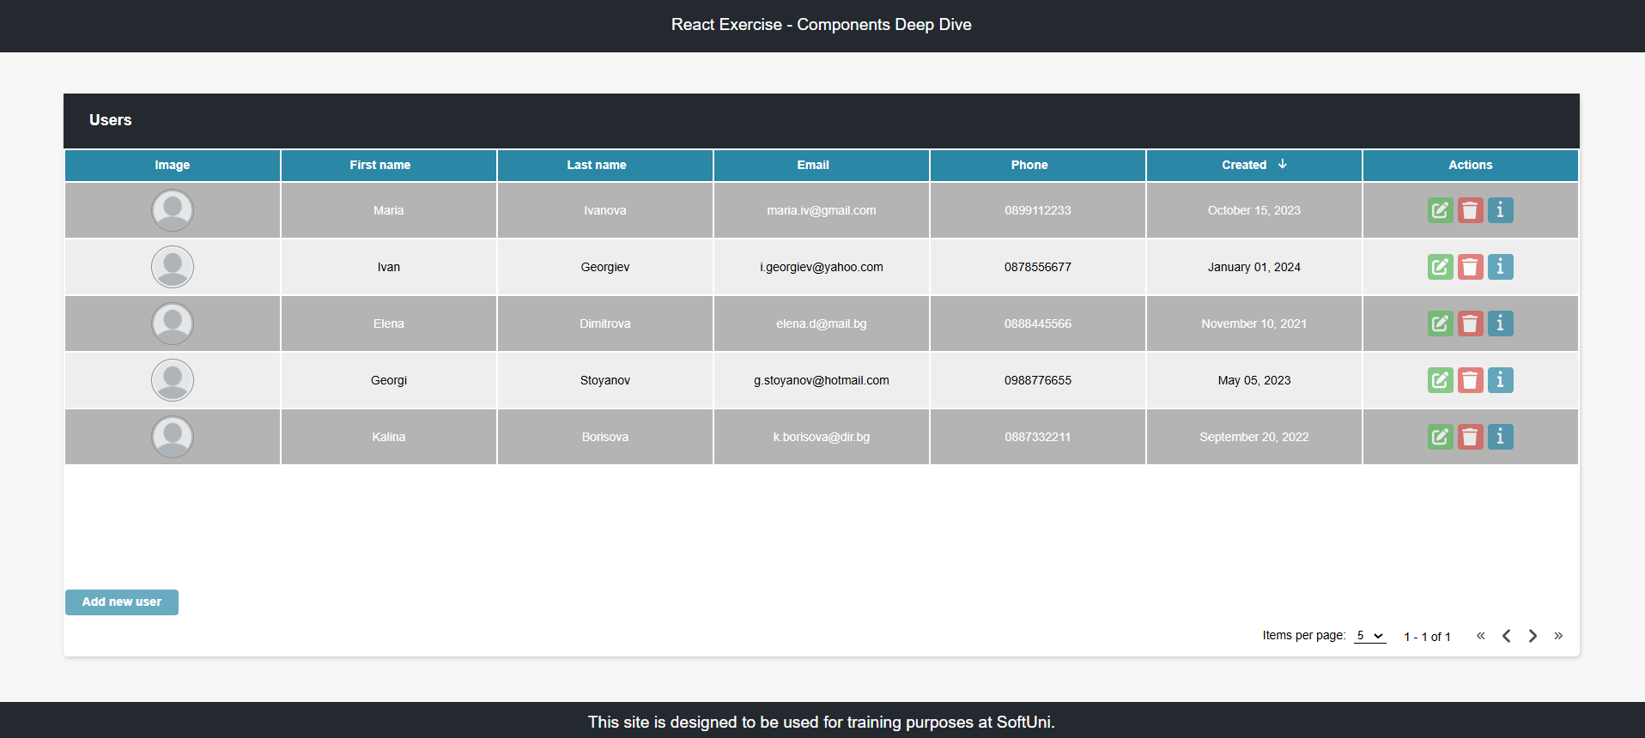
If there are more records than the maximum items per page, a second page must become active.
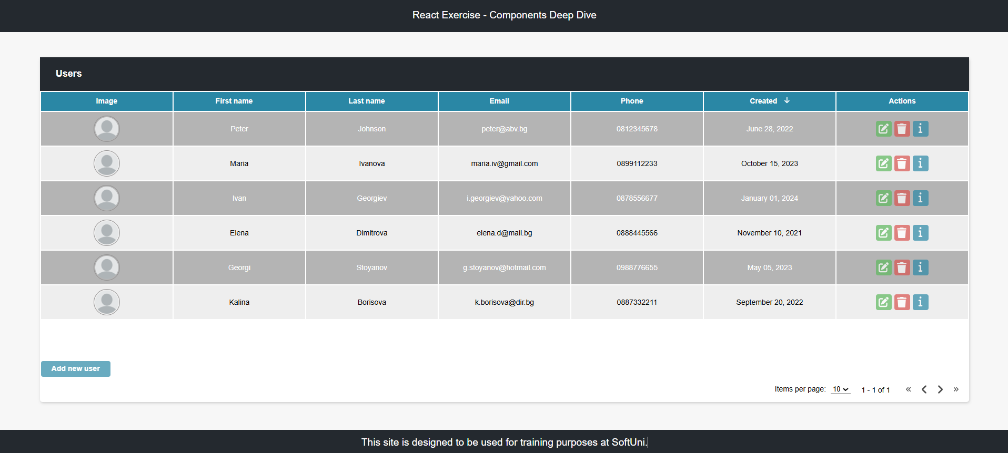

Sorting*
Clicking on some of the main fields should sort the records in an ascending or descending order, depending on how many times it is clicked.
Ascending by ‘Last name’:
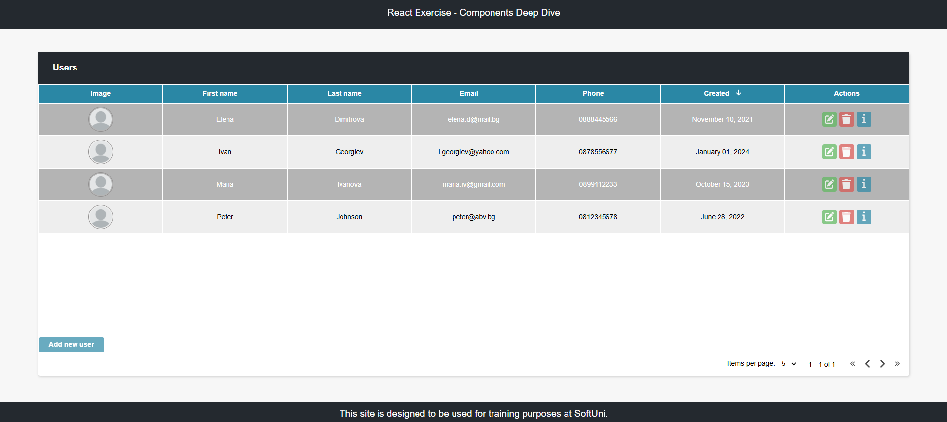
Descending by ‘Last name’:
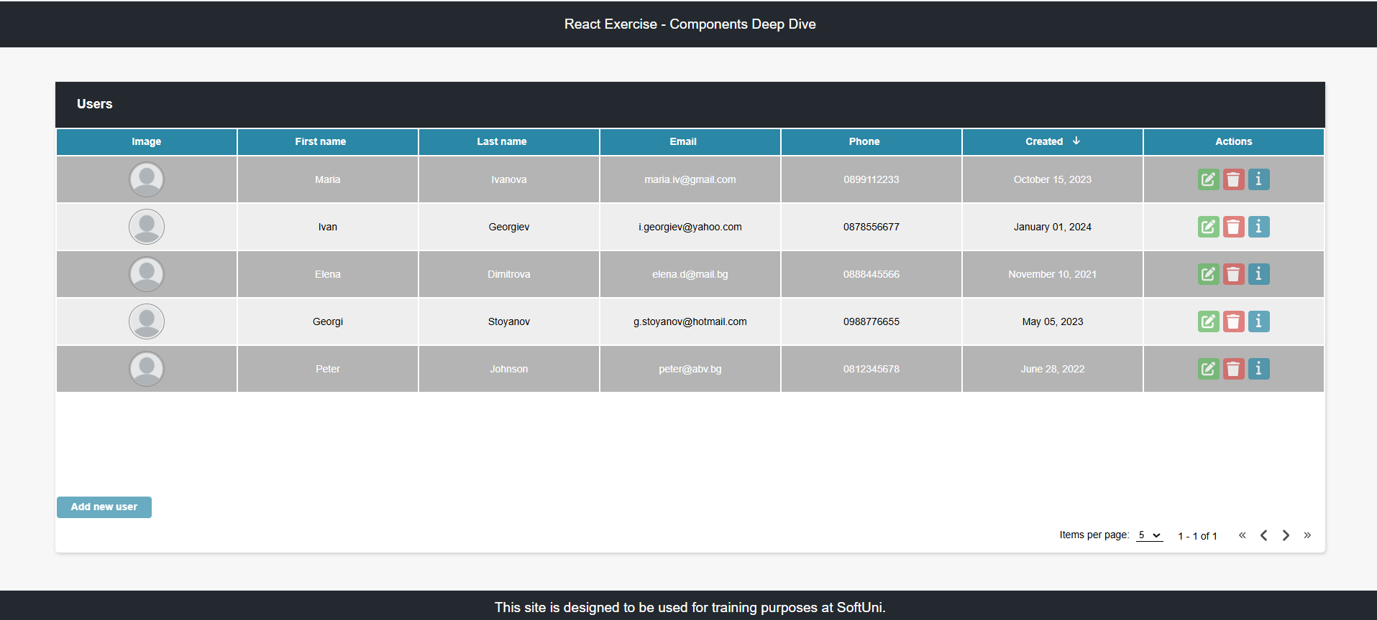

Spinner*
While waiting a response from a request, a spinner should be displayed:
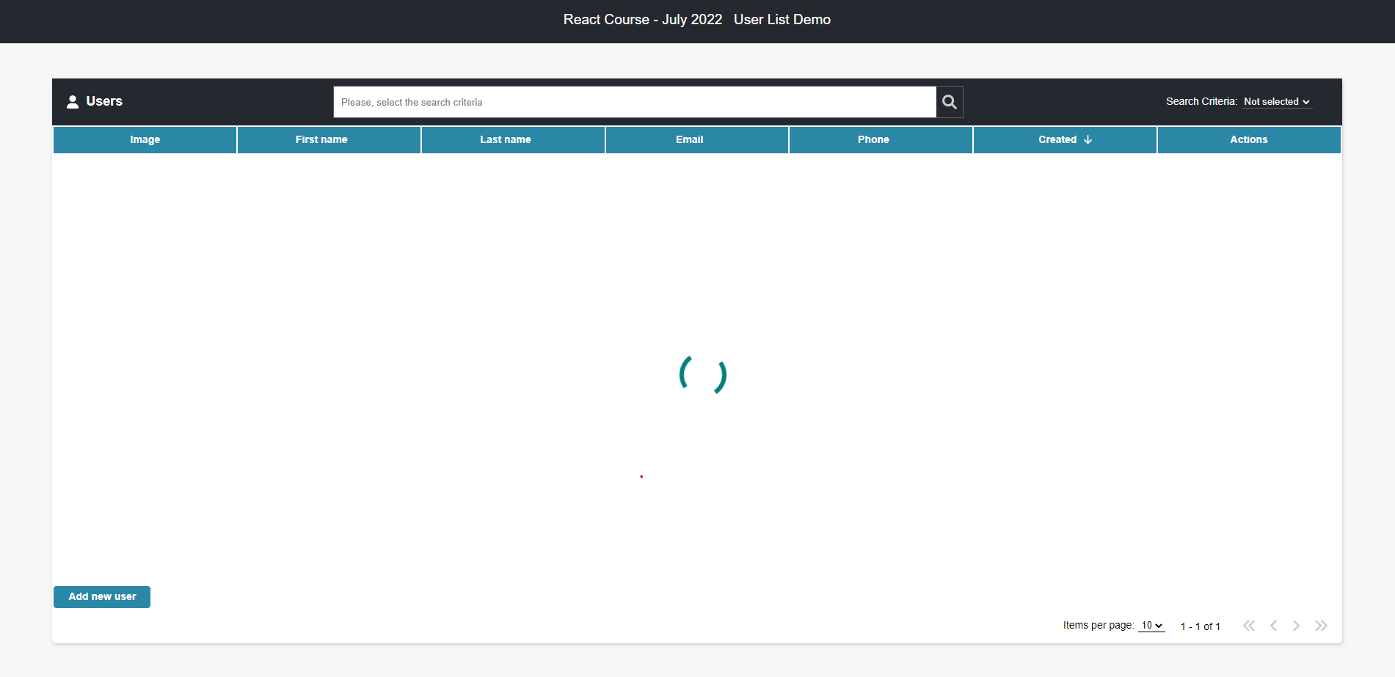

Errors
If a request failed, the following error should be displayed:
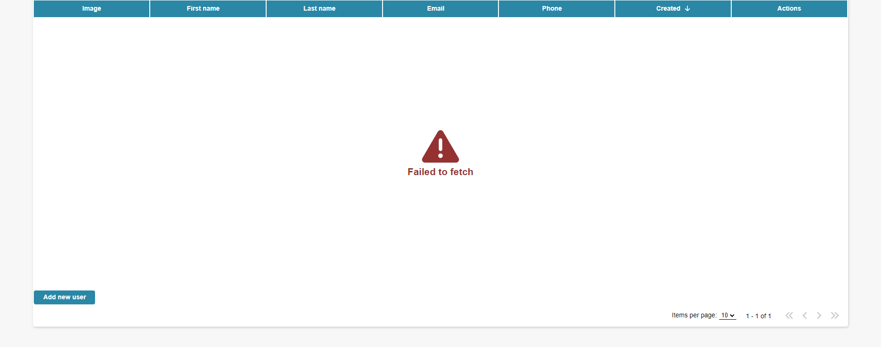
If there are no records yet, the following error should be displayed:
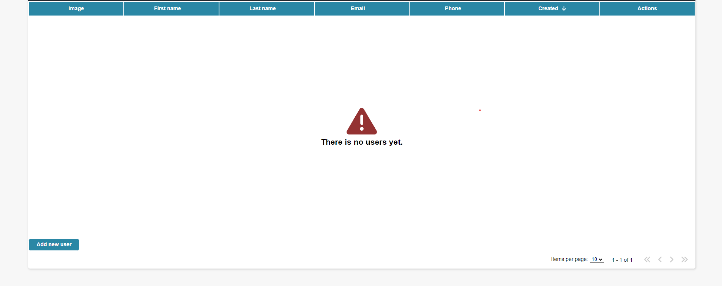

Initialize the App
Use the "npm create vite user-list-demo" command to create a new React App.

Setting up Supabase
Create a free account at supabase.com and start a new Project.

In the Table Editor, create a table named “users” with the following columns: firstName, lastName, email, imageUrl, phoneNumber (all text), createdAt, updatedAt (timestamptz), and address (jsonb, to hold the nested country / city / street / streetNumber object). Supabase adds the id column automatically.

Row Level Security is enabled by default and blocks all access until a policy is added. For this exercise, disable RLS on the users table (Table Editor → users → RLS toggle) so the CRUD requests above work without needing authentication.

Get your Project URL and publishable API key from Project Settings → API. Both are required on every request above — the URL replaces <project-ref>, and the key goes in both the apikey and Authorization: Bearer headers.

