React Exercise – JSX & Components

Overview
Transition the provided static HTML and CSS template ("Tale SEO Agency") into a hierarchy of React functional components, correctly applying JSX syntax .

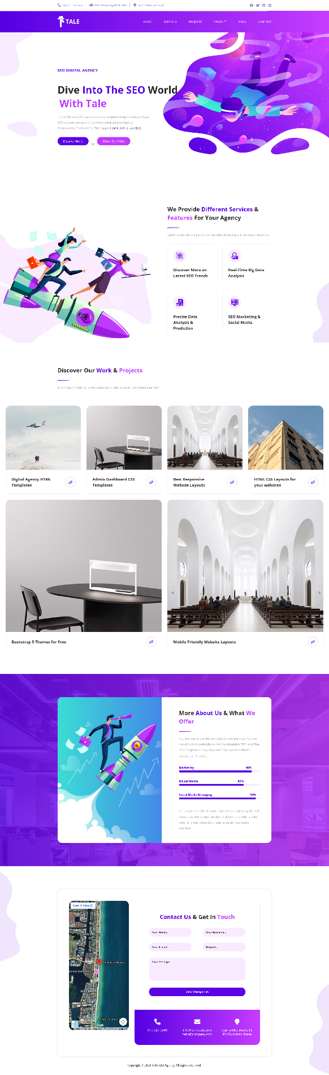

JSX Corrections
Fix all syntactic differences between HTML and JSX before anything else compiles. Go through the whole template — these differences appear repeatedly across every section, not just once:
- class → className — every element in the template uses class; JSX requires className.
- Self-closing tags — tags with no children (<img>, <input>) must be self-closed: <img /> instead of <img>.
As in the lecture: standard HTML elements stay lowercase (div, section, a), while every component you create must start with an uppercase letter (PascalCase), and every JSX tree must return a single root element.

Root Component
Create a main App component that renders the overall page structure by composing the section-level components described below, in the same order as the original template (Topbar, Header, Hero, Services, Projects, Infos, Contact, Footer).
This is the composition pattern from the lecture: App does not contain the page's markup directly — it assembles smaller, independent components, exactly like <ComponentBlender> nesting <Welcome /> and <Cya />.

Suggested Component Breakdown
The template has eight visually distinct sections. Each should become its own component, kept in a components folder:
- Topbar — contact details and social icons (a separate block above the main header, not part of it)
- Header — logo and navigation menu
- Hero — the top banner with the main heading and call-to-action buttons
- Services — heading + a list of ServiceCard components (see below)
- Projects — heading + a list of ProjectCard components (see below)
- Infos — the "About Us" text block together with the three skill progress bars
- Contact — the contact form and the Google Map embed
- Footer — the copyright line
This mirrors how a real React project is organized: one component per meaningful section of the page, not one giant component holding everything.

Reusable Component Definition
Two sections repeat the same visual block several times. Both are reusable-component candidates, using the same technique from the lecture: extract the repeating block into its own component, then render it multiple times, passing each instance's data manually as props — the same way we used <Book title="..." author="..." /> multiple times for different books.

ServiceCard Component
The Services section repeats the same small block (icon + title) four times. Extract it into a ServiceCard component, and render it four times directly inside Services, with different props each time.

ProjectCard Component
The Projects section repeats the same block (image + title + link) six times. Extract it into a ProjectCard component, and render it six times directly inside Projects, the same way as ServiceCard above — one line per project, with its own image, title and link passed in as props.

