Workshop: Movie Magic - Part 1
Your team at work is tasked with creating a website that will attract movie enthusiasts. The site is called "Movie Magic". Its purpose is to create an attractive and interactive platform for movie fans that offers a unique and enriching experience.
If you want, you can try to create the workshop in GitHub.

Install Dependencies
Run 'npm init' to create a new project and 'npm install express express-handlebars path' to install all the dependencies.

Create Files

index.js
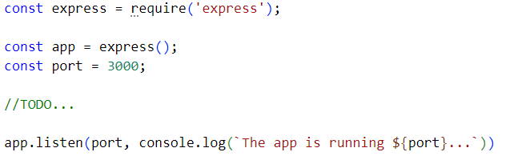

hbsConfig.js
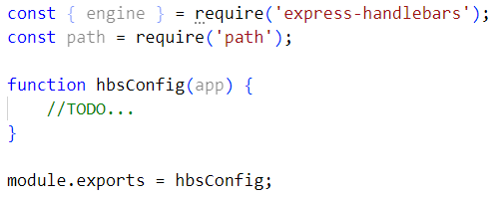

expressConfig.js
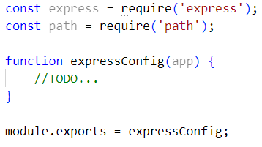

routes.js
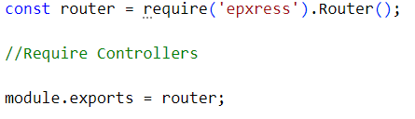

Create Models

Movie Model
Each movie should have the following properties (for now it could be an ES6 class):
- id – number
- title – string
- category– string
- genre – string
- director – string
- year – number
- imageURL – string
- rating – number
- description – string

Storage
Store the movies inside a /config/database.json

Create Routes
You should implement the following routes:
- / – the main page (should visualize all the movies in the database).
- /about – should render the about page.
- /create – should render the create movie form.
- /details/:id – should render the details page about the selected movie.
- Any other – should render the 404 not found page.

Main Page
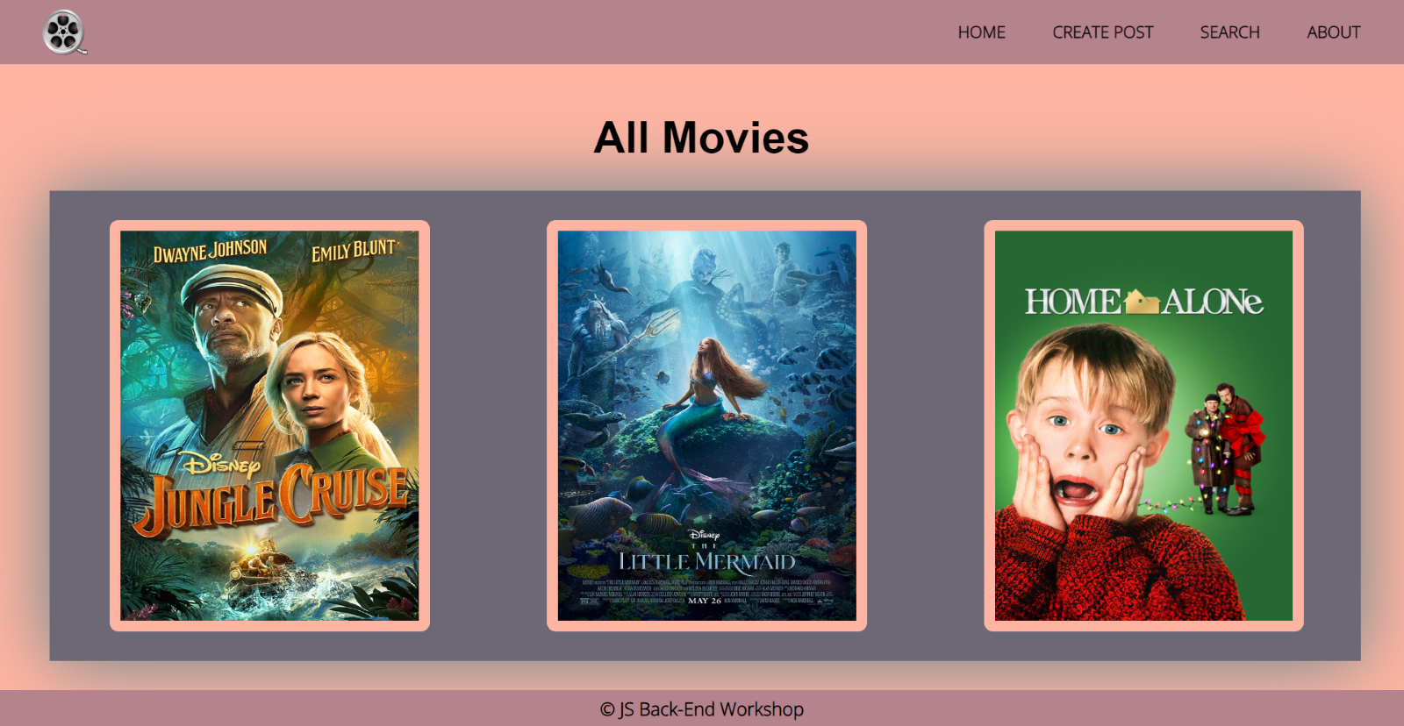

About Page
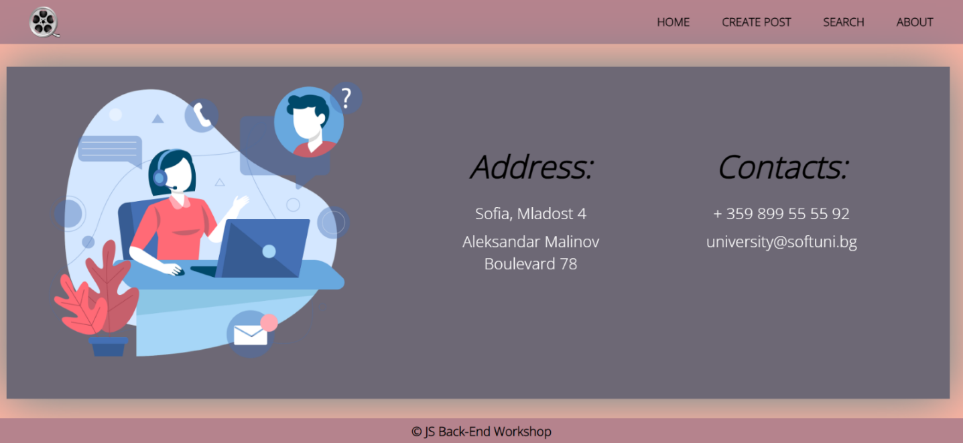

Create Page
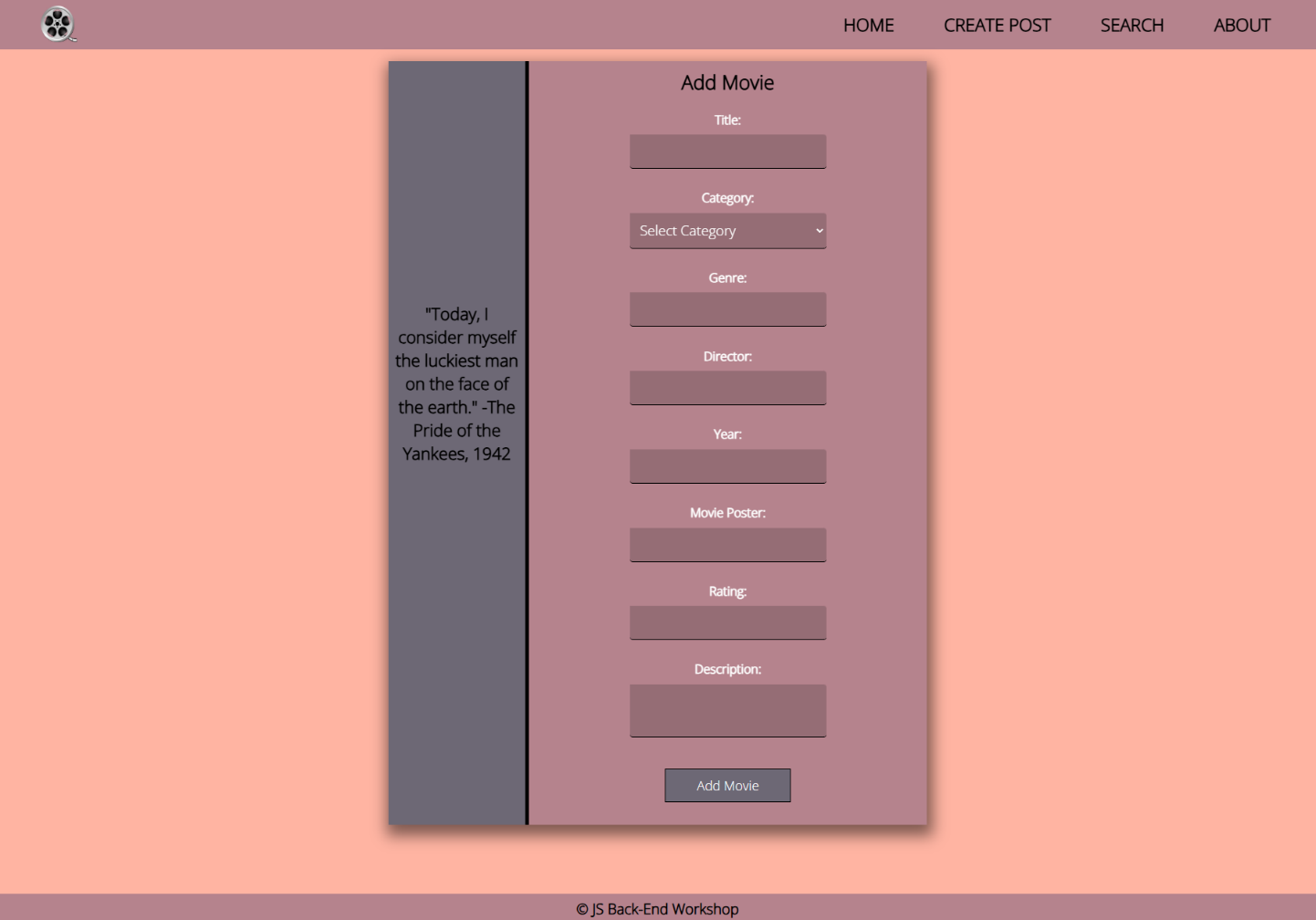

Details Page
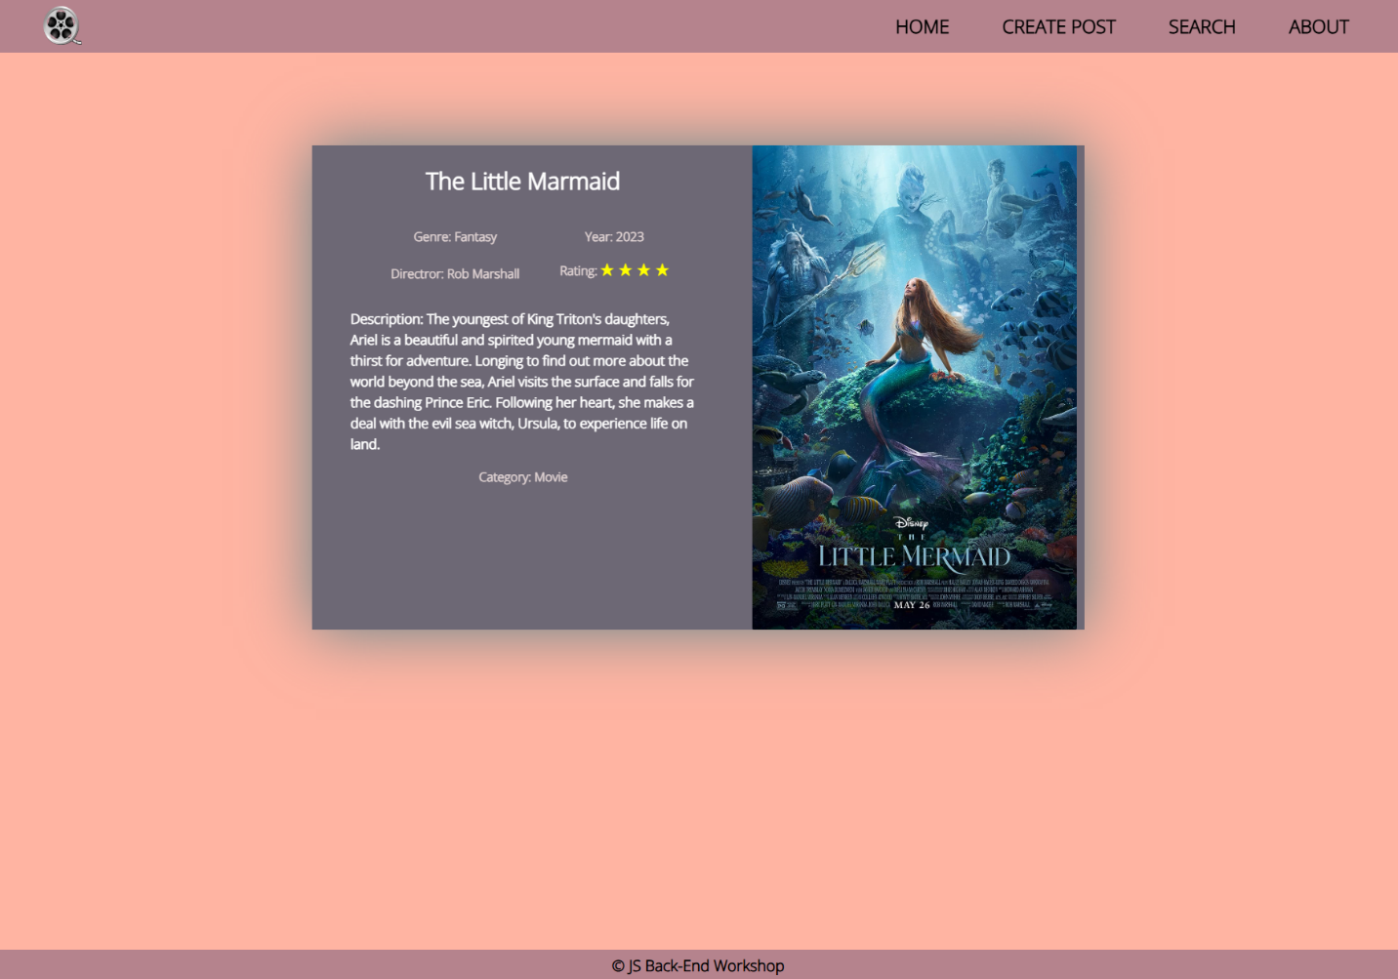

Not Found Page
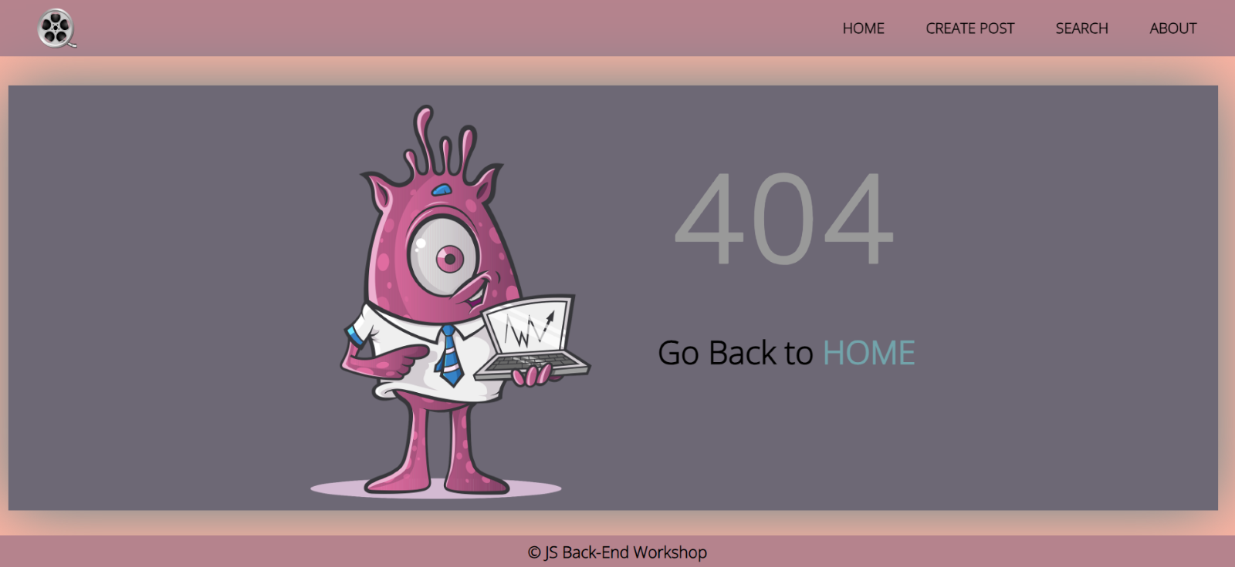

2. Create Templates
Use the provided HTML to create templates using Handlebars. Identify the dynamic parts and use appropriate syntax for interpolating and rendering the application context.

*Search
Search for a specific movie. When you first access the search page using the route /search, you should be able to see all the movie offers. Filter all matches by (part of) the title, genre, and year (case-insensitive). If the search fields are empty, show all movies.
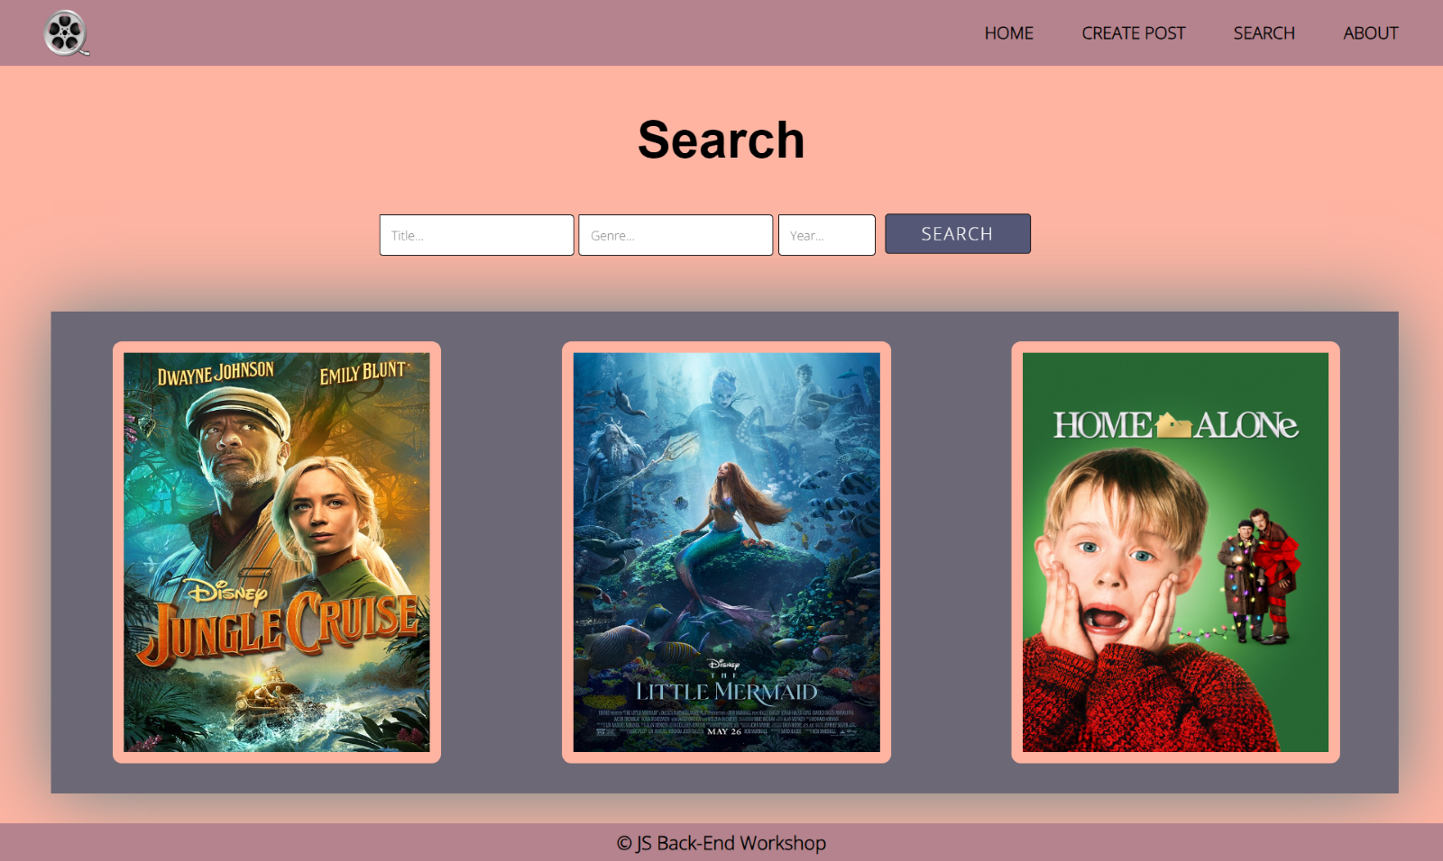
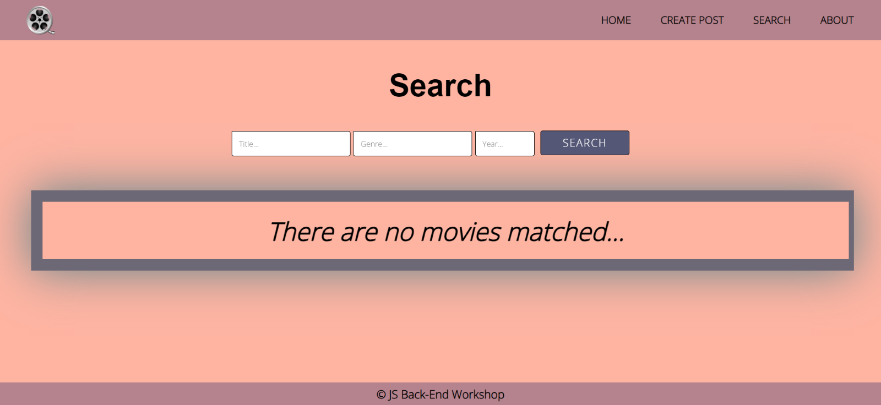
Good Luck! 😊

