Workshop: Movie Magic – Part 3
Your team at work is tasked with creating a website that will attract movie enthusiasts. The site is called "Movie Magic". Its purpose is to create an attractive and interactive platform for movie fans that offers a unique and enriching experience.
If you missed the first two parts of this workshop, make sure you complete them before you continue because all parts of this workshop are related to each other.

Main Task
Now it's time to implement user service in your app, so people can register, log in and log out, as well as be able to edit or delete their movies. Some of the functionalities must require authentication (such as create a movie, create a cast) and authorization (such as edit and delete). Also, all routes should be protected!

Installing Dependencies
You should install a few more packages which you will use. They are:
- jsonwebtoken – allows you to decode, verify and generate JWT
- bcrypt – a library to help you hash passwords
- cookie-parser – parses the cookie header and populates req.cookies with an object keyed by the cookie names (if you choose to store the jwt as а cookie)

Model
The User model structure:
- email – String
- password – String: hash it in the auth service. Use bcrypt to hash and compare the password.
When you successfully create a new user into the database, make sure you generate a jsonwebtoken and use it later for authentication and authorization.
Also, you have to add a property to the Movie model, which is creatorId (type: Int and it's required), so you can keep tracking every movie's creator.

Routes Protection
Make sure the anonymous (guest) users can't reach the functionality which requires authentication, such as creating a movie view. Already logged-in users must have generated and stored jwt, can see the correct navigation, and can't reach the login and register form. If some of these scenarios happen, make sure the current user is redirected to the home page.

Authentication
Guest users can see and access the following URLs:

- Home Page
- About Page
- Search Page
- Login Page
- Register Page
They can't access anything else.
Logged-in users can see and access the following URLs:
- Home Page
- About Page
- Search Page
- Details Page
- Create Post
- Create Cast
- Attach Cast
- Logout

Authorization
Only the creator of the current movie should be able to see the [Edit] and [Delete] buttons. Otherwise, the buttons should be hidden. 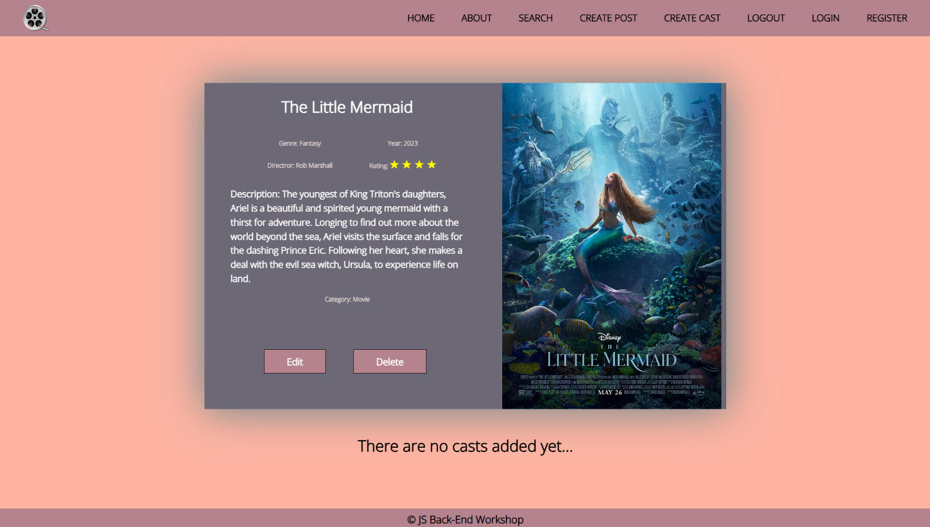

Additional Pages
You should implement 4 new routes:
- /login – should render the login form
- /register – should render the register form
- /edit/:id – should render the edit form
Make sure that when you access edit page, it shows the current movie information.

Login Page
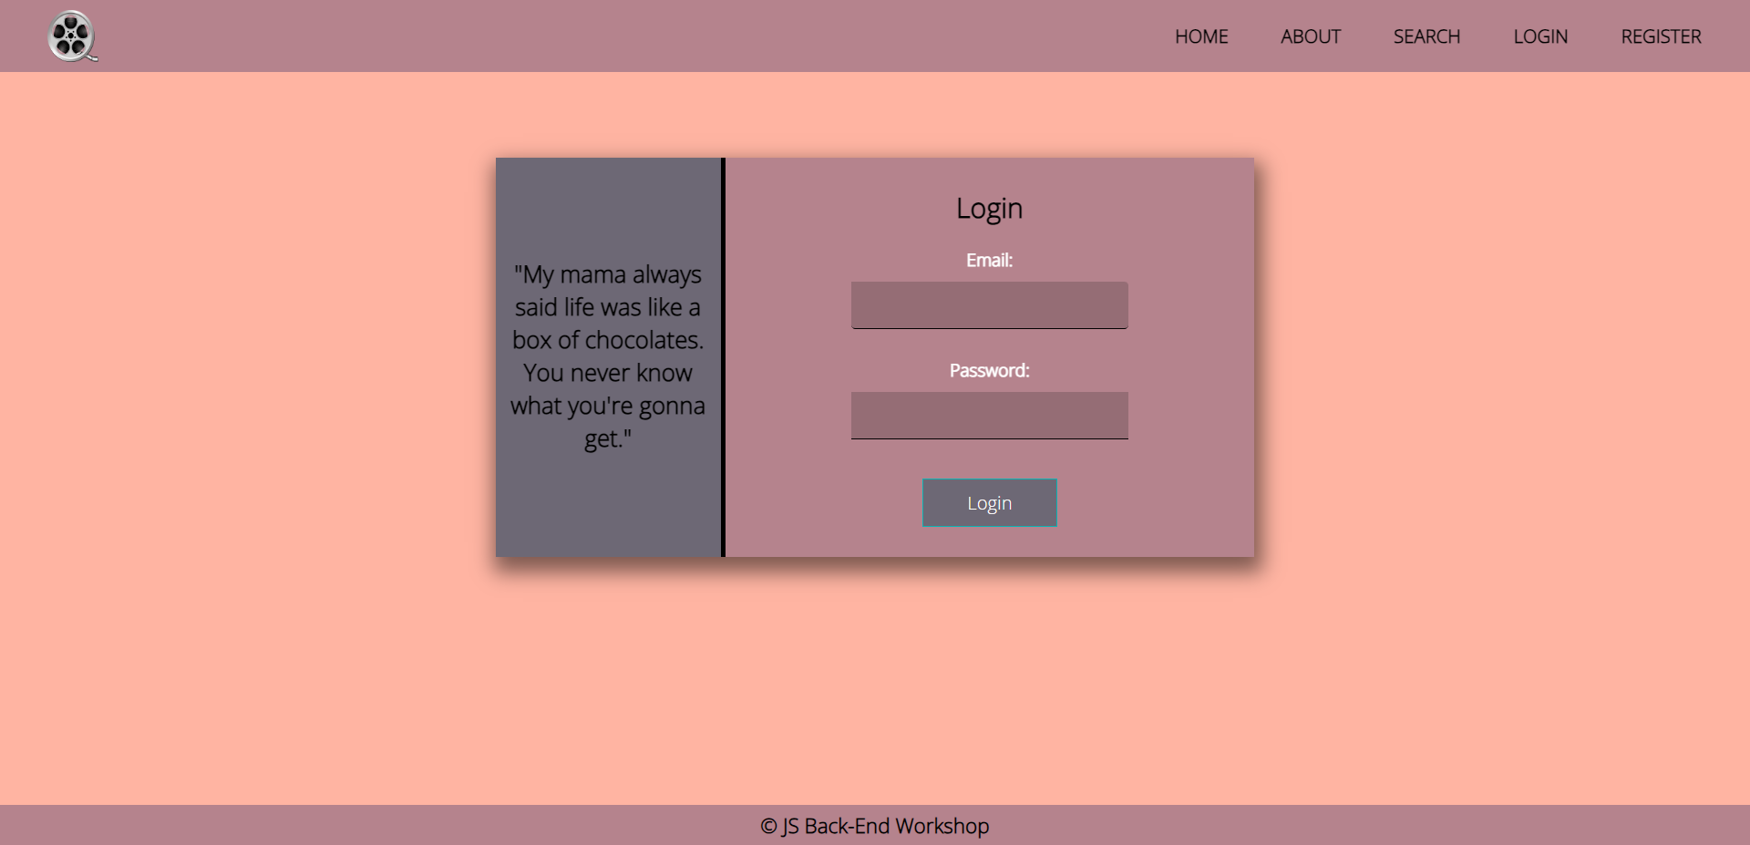
Register Page
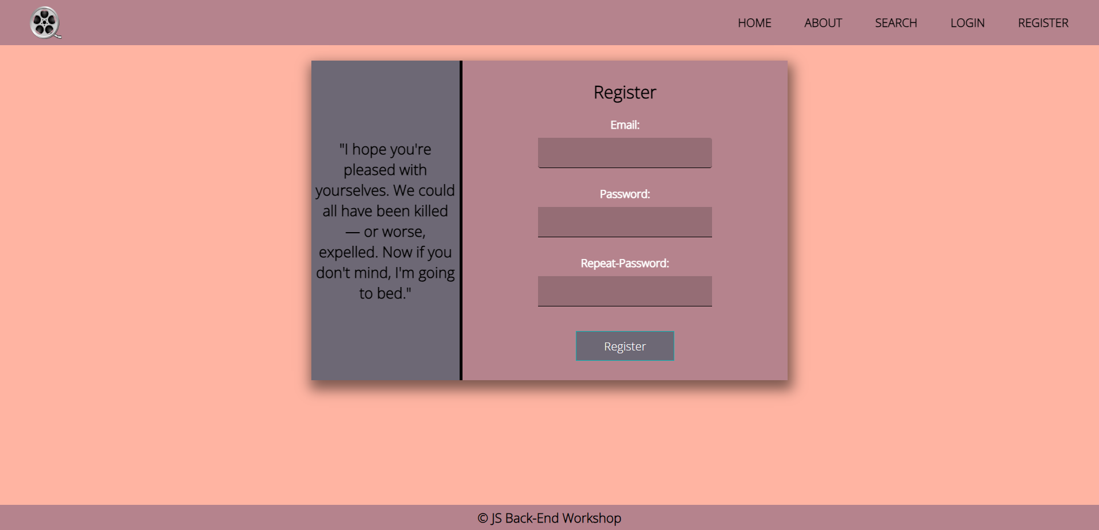

Edit Movie Page
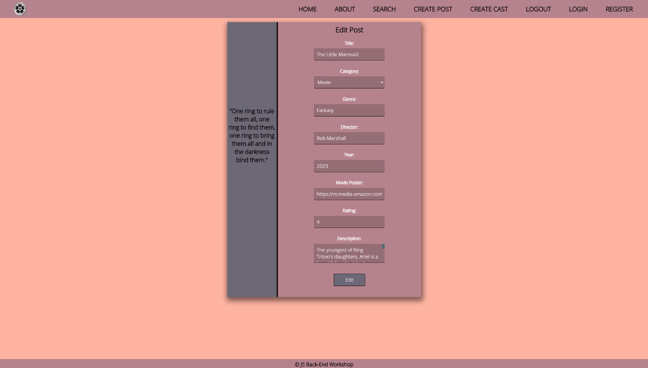
Good Luck! 😊

