Workshop: Movie Magic – Part 2
Your team at work is tasked with creating a website that will attract movie enthusiasts. The site is named "Movie Magic". Its purpose is to create an attractive and interactive platform for movie fans that offers a unique and enriching experience.

Main Task
If you have completed the previous task, good job! Now it's time to upgrade your app and implement a few new features. For instance, change the way you store data by using PostgreSQL and Prisma, create and attach cast to each movie, make some relations between them, and include a few more pages.

Installing Dependencies
As you already know, you should install a bunch of new things so you could be able to continue with this part of the workshop.
Here's the list:
- PostgreSQL Downloads – You can check the Installation Instructions as well
- Prisma ORM
- Prisma – Very useful Prisma Documentation
- pgAdmin

Database Connection with ExpressJS
Create a prisma/schema.prisma file. Define the datasource (PostgreSQL) and the generator (prisma-client-js), then create a reusable Prisma Client (e.g. in lib/prisma.js) that is exported for the whole app.
The index.js file should require the exported Prisma Client before the server starts.

Model
If you follow the previous structure, you probably created ES6 class Model for each movie in this format:
- id – number
- title – string
- category– string
- genre – string
- director – string
- year – number
- imageURL – string
- rating – number
- description – string
Now it's time to refactor this ES6 class into a Prisma model, so each Movie has the following fields (input validation is added later in Part 4 using Zod):
- title – String
- category – String
- genre – String
- director – String
- year – Int
- rating – Int
- description – String
- imageUrl – String
- casts – MovieCast[], a many-to-many relation to Cast via the MovieCast join table
And create another model (Cast) in the following format:
- name – String
- age – Int
- born – String
- imageUrl – String
- movies – MovieCast[], a many-to-many relation to Movie via the MovieCast join table
Your prisma/schema.prisma should define the Movie, Cast and MovieCast models.
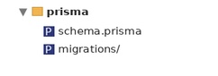

Migrations
After defining the schema, run npx prisma migrate dev --name init to create the database tables. Prisma generates the SQL, applies it, and regenerates the Prisma Client automatically.

Database Persistence
All pages in the application should persist data to PostgreSQL & work with PostgreSQL.

Additional Pages
You should implement 2 new routes:
- /create/cast – should render the form for creating a cast form
- /attach/cast/:id – should render the cast page about attaching new cast to a movie,
and update the view on the /details/:id route that renders the movie details.
Use the provided resources to create the additional templates (and update the navigation accordingly) using Handlebars. Identify the dynamic parts and use appropriate syntax for interpolating and rendering the application context.
Add Cast Page View

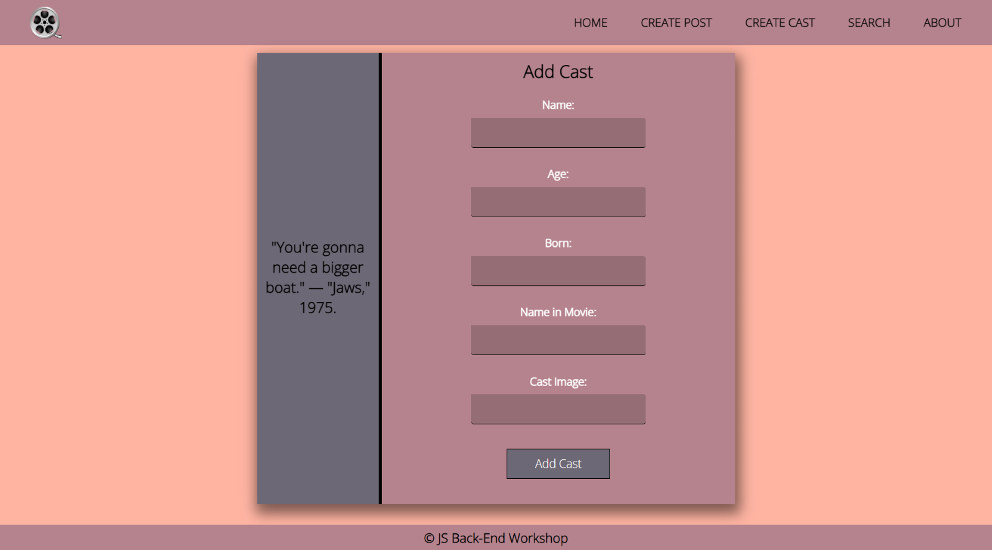Attach New Cast View
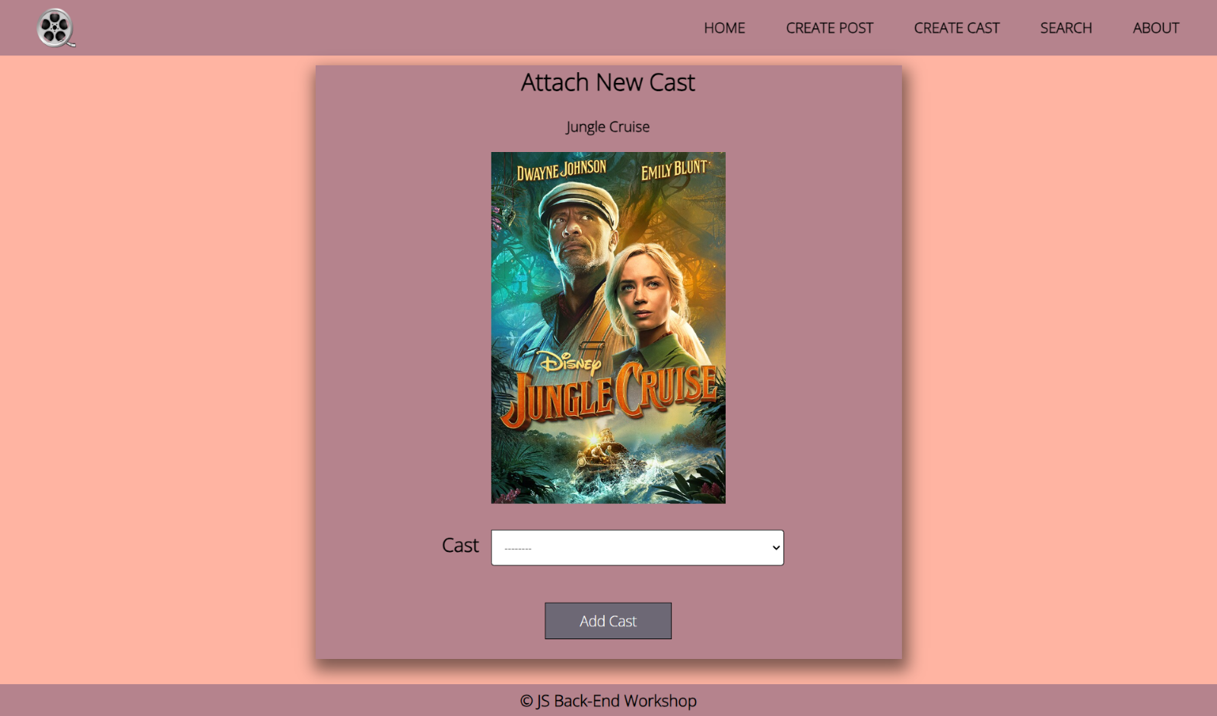

Updated Details Page View
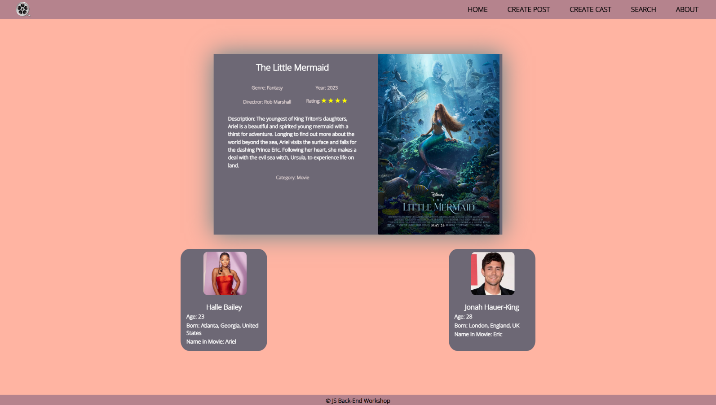
Good Luck! 😊

