Workshop: Movie Magic – Part 4
Your team at work is tasked with creating a website that will attract movie enthusiasts. The site is named "Movie Magic". To create an attractive and interactive platform for movie fans that offers a unique and enriching experience.
This is the final part of the workshop, so if you missed some parts, make sure you complete them before you continue because all parts of this workshop are related to each other.

Main Task
As a final step, you should implement some validation, notification to improve the user experience and protect the data that is stored in the database.

Installing Dependencies
You can use Zod to do some validation and sanitization or continue using Zod schemas to do validations as well.

Validations

User
Before some users register or login, implement the following validations:
- Email
- Should be unique (add "unique: true" property to each User Model email)
- Should end in @x.x, where x is one or more English letters/digits
- Should be at least 10 characters long
- Password
- Should consist only of English letters and digits
- Should be at least 6 characters long
- Password Confirmation (only in Register Page)
- Should be the same as the given password

Movie and Cast
The movie and cast forms also should have some validation:
- title – At least 5 characters long, which could be English letters, digits, and whitespaces
- genre – A t least 5 characters long, which could be English letters, digits, and whitespaces
- director – At least 5 characters long, which could be English letters, digits, and whitespaces
- year – Between 1900 and 2024
- imageURL (movie poster) – Referring to an actual picture (should start with http://... or https://...)
- rating – Between 1 and 5
- description – At least 20 characters, which could be English letters, digits, and whitespaces
- name – At least 5 characters long, which could be English letters, digits, and whitespaces
- age – Between 1 and 120
- born – At least 10 characters, which could be English letters, digits, and whitespaces
- character – At least 5 characters, which could be English letters, digits, and whitespaces
- imageURL (actor) – Referring to an actual picture (starts with http://... or https://...)

Error Handling
In case of errors, for instance, if the given email is already taken, does not exist or the given password (during the login process) is incorrect, handle the error properly and show an appropriate notification.
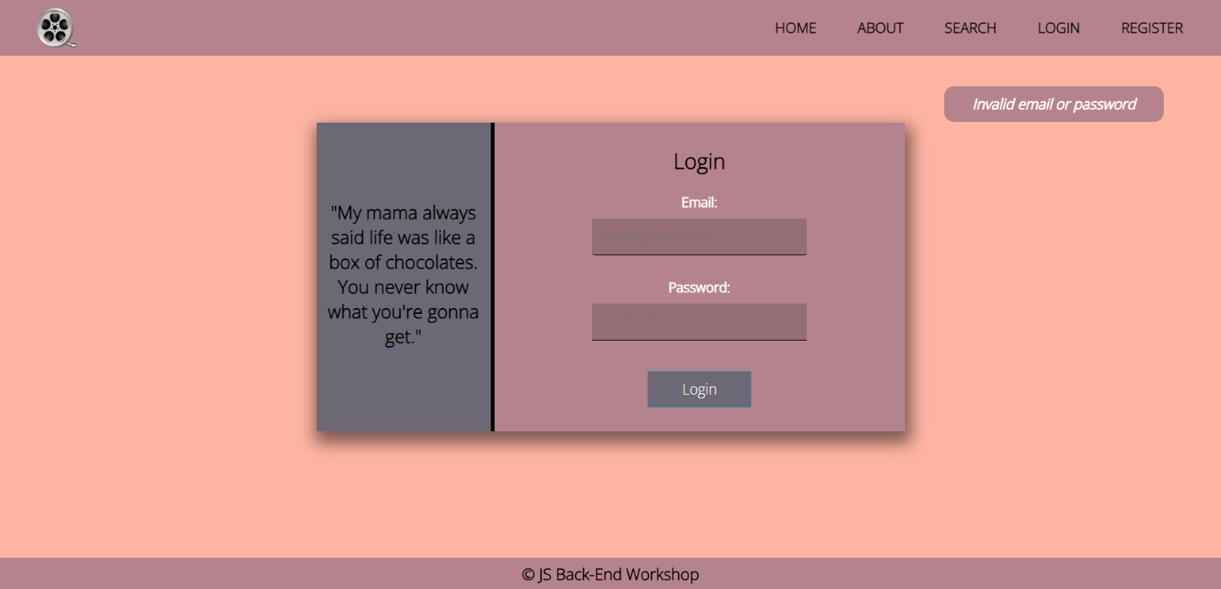
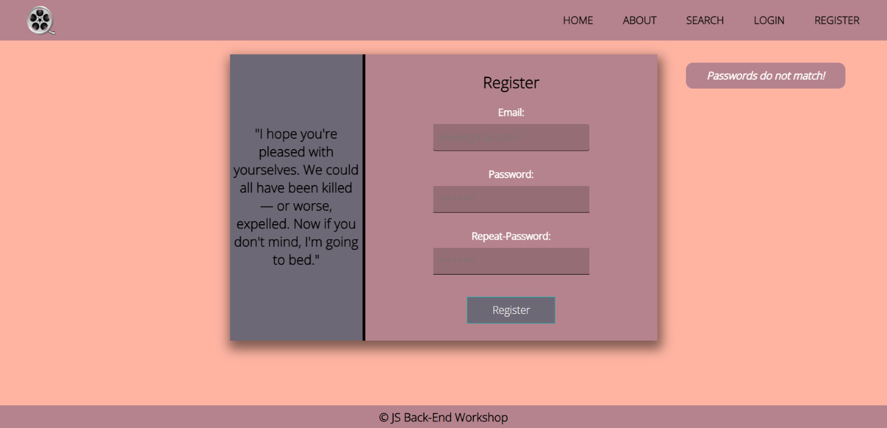

Template Update
If you want to use the notifications which are shown in the pictures, you should modify a little your main layout .hbs file. Create a div with class="error-container" with a single paragraph inside before the nav element. Check the picture below:
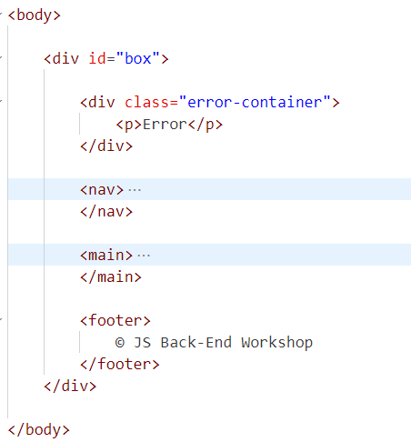
Good Luck! 😊

