Quantitative Assessment of the Impact of Neural Networks on Russian IT Companies (2018–2025): A Difference-in-Differences Approach
E.A. Gurtyakin
Siberian Federal University
Krasnoyarsk, Russian Federation

Abstract — The rapid diffusion of large language models and generative neural networks after the public release of ChatGPT at the end of 2022 has reshaped competitive conditions across the global software industry. In the Russian IT sector this transition coincided with macroeconomic shocks, capital control restrictions, and a partial exit of foreign vendors, which jointly distort any naive year-on-year comparison of firm performance. This paper proposes a quasi-experimental design for measuring the causal effect of artificial intelligence (AI) specialization on the financial dynamics of Russian IT firms over the period 2018–2025.
A panel of 45 Russian IT and AI companies is constructed from publicly available statutory accounting reports, central bank macroeconomic series, and labour market data. Firms whose primary product line is centred on machine learning, computer vision, natural language processing, or generative models are assigned to the treated group; the remaining IT firms form the control group. A Difference-in-Differences (DiD) estimator with company and year fixed effects is applied to log real revenue, net margin, and headcount, with the treatment date fixed at the end of 2022. The labour market block is treated as descriptive evidence due to incomplete coverage of historical hh.ru series.
The empirical results indicate no statistically significant differential growth of revenue for AI-focused firms relative to the control group in the two-year horizon following the shock (DiD coefficient −0.102 log-points, p = 0.774). The net margin specification yields a positive but statistically insignificant point estimate. The descriptive labour market block shows a doubling of vacancies that explicitly mention AI between 2021 and 2024, while the share of such vacancies in total IT demand remains below one percent under the narrow definition. The proposed framework formalizes the data pipeline and the identification strategy and provides a reproducible foundation for further evaluation of AI adoption effects in industries with limited disclosure.
Keywords — neural networks, generative AI, Russian IT sector, Difference-in-Differences, panel data, event study, labour market, quasi-experiment, ChatGPT shock

Introduction
The release of ChatGPT at the end of November 2022 is widely regarded as the inflection point at which generative neural networks transitioned from a research instrument into a general-purpose technology accessible to mass corporate users. The diffusion of large language models, multimodal systems, and code generation tools has since been associated with measurable changes in software development productivity, labour demand structure, and the competitive landscape of digital services. The empirical question of whether firms whose core product line is centred on machine learning capture excess returns relative to their non-AI peers after such a technology shock remains open, particularly outside the United States and the European Union.
The Russian IT sector represents a methodologically informative case for this question. During the observation window the industry simultaneously experienced (i) a global generative AI shock, (ii) a partial withdrawal of foreign software vendors after February 2022, (iii) state-level import substitution programmes and preferential tax regimes for accredited IT companies, and (iv) substantial macroeconomic volatility expressed in the exchange rate, the central bank key rate, and consumer price inflation. A naive year-on-year comparison of revenue growth in AI-focused versus non-AI firms therefore conflates the technology effect with several confounding shocks of comparable magnitude.
Existing analytical reports on the Russian IT market are predominantly descriptive: they aggregate revenue, headcount, and vacancy statistics but rarely apply formal causal inference. At the same time, statutory accounting reports of Russian legal entities are publicly disclosed through the Federal Tax Service portal bo.nalog.ru, which enables the construction of firm-year panels covering both publicly listed companies and private IT firms. Combining these microdata with labour market indicators from hh.ru and macroeconomic series from the Central Bank of the Russian Federation makes it possible to apply panel-data identification techniques borrowed from applied microeconometrics.
This paper proposes a reproducible quasi-experimental design for measuring the differential financial performance of AI-focused Russian IT firms after the end-of-2022 technology shock. The contribution is threefold. First, a firm-level panel is assembled from heterogeneous open sources with a documented treatment assignment rule. Second, a Difference-in-Differences specification with two-way fixed effects is estimated and complemented by an event-study check of the parallel-trends assumption. Third, the labour market component is integrated as a descriptive block in order to characterize the demand side of the AI labour market in the absence of fully comparable historical series.

Problem Statement
Let the set of observed firms be denoted as $F=\{f_{1},...,f_{n}\}$ and the set of years as T = {2018, ..., 2025}. For each firm-year pair (i, t) a vector of financial and structural indicators is observed:
$$y_{it}=({revenue}_{it}, {net_profit}_{it}, {headcount}_{it},$$
$${presonell_expenses}_{it}, {R\&D_expenses}_{it}).$$
A binary treatment indicator Treated_i takes the value one if firm i is classified as AI-focused on the basis of its product portfolio, registered software products, and public technical disclosures, and zero otherwise. A binary post-treatment indicator Post_t equals one for t ≥ 2023 and zero otherwise.
The research question is formulated as: does the interaction Treated_i × Post_t generate a statistically and economically significant differential change in real revenue and profitability after controlling for firm-specific time-invariant heterogeneity, common year shocks, and observable macroeconomic conditions?
Four operational hypotheses are tested:
- H1 — real revenue of AI-focused firms grows faster than that of control firms after 2022;
- H2 — net margin of AI-focused firms does not exhibit a positive differential change in the two-year horizon, reflecting the investment phase of AI adoption;
- H3 — the share of ML and AI vacancies in total IT demand increases after 2022;
- H4 — the wage premium of ML roles over Backend roles increases after 2022.
Hypotheses H1 and H2 are tested using the firm-level panel and the DiD estimator. Hypotheses H3 and H4 are reported as descriptive evidence because of incomplete coverage of historical hh.ru and Habr Career series under a single consistent methodology.

Data

Firm-Level Financial Panel
The core of the empirical analysis is a long-format panel (company, year) covering 45 Russian IT and AI companies over the period 2020–2025, comprising 203 firm-year observations. Twenty firms are classified as AI-focused (treated) and twenty-five as non-AI IT firms (control). Thirteen companies in the sample are publicly traded on the Moscow Exchange; the remainder are private limited liability companies.
Firm-level financial indicators are obtained from statutory accounting reports filed under the Russian Accounting Standards (RAS / RSBU) and disclosed through the Federal Tax Service portal bo.nalog.ru/organizations-card/. The portal does not expose a documented open API, therefore reports are downloaded as archived statutory forms per legal entity and parsed into a normalized firm-year format. Publicly listed firms additionally cross-validate their RAS data with consolidated IFRS reports disclosed through e-disclosure.ru and the investor relations sections of their corporate websites. The following indicators are extracted: revenue, net profit, average headcount, personnel expenses, and reported R&D expenses, all in million roubles.

Macroeconomic Controls
Macroeconomic series are obtained from the Central Bank of the Russian Federation. The daily USD/RUB exchange rate is collected from the CBR open XML interface and aggregated to annual averages and end-of-year values. The CBR key interest rate at end of year and the consumer price index are taken from the CBR statistical bulletins and the Bank of Russia inflation and key rate publication for the period 2014–2026. A composite CPI index with base year 2018 is reconstructed from year-on-year inflation rates and used to deflate nominal revenue into real terms.

Labour Market Data
The labour market block combines two complementary sources. Aggregate IT demand on hh.ru is taken from publicly reported research collaborations: hh.ru × Tekhnokratiya for 2022 (555 thousand IT positions opened) and 2023 (634 thousand), and the hh.ru annual review reported by Skillbox Media for 2024 (708 thousand active IT vacancies). The number of vacancies that explicitly mention artificial intelligence is taken from the hh.ru × MTS Link release for 2021 (1.7 thousand) and 2024 (3.7 thousand).
Median offered salaries for machine learning roles for the period June 2023 – June 2024 (183 300 ₽) and June 2024 – June 2025 (217 700 ₽) are taken from the hh.ru × Matemarketing research published by Forbes in November 2025. Median backend salaries by qualification level are obtained from the career.hh.ru profession card career.hh.ru/profession/43. Cross-validation against the Habr Career semi-annual salary reports is performed for 2P2023 (overall IT median 141 thousand ₽), 1P2024 (151.7 thousand ₽), 1P2025 (182.7 thousand ₽), and 2P2025 (183.3 thousand ₽), as well as the dedicated Habr Career ML article of March 2026.

AI Activity Proxies
Two open APIs are used to construct AI activity proxies at the firm level: the GitHub REST API for public repositories of corporate organizations, including programming language, topic labels, stars, and creation date; and the arXiv API for publications associated with Russian IT organizations. Patent filings under IPC class G06N (computing arrangements based on specific computational models) are referenced through the Federal Institute of Industrial Property (FIPS / Rospatent) search interface; due to the absence of an open API the patent block is treated as supplementary evidence rather than a primary regressor.

Panel Construction
The processed panel is stored as data/processed/panel.csv and is built from the following normalized inputs: companies.csv (45 firms with treatment assignment and segment classification), financials.csv (firm-year financial indicators from RAS), macro_yearly.csv (annual macroeconomic controls), hh_historical.csv (labour market series), and salaries_by_role.csv (median salaries by role and qualification). Derived variables include real revenue (nominal revenue deflated by the reconstructed CPI index), log real revenue, log headcount, net margin in percent, personnel and R&D ratios, revenue per employee, and an indicator did = Treated × Post with Post equal to one for years 2023–2025.

Methodology

Difference-in-Differences with Two-Way Fixed Effects
The baseline specification for outcome $Y_{it}$ (log real revenue, net margin, or log headcount) is:
$Y_{it}=α_{i}+λ_{t}+β·({Treated}_{i}×{Post}_{t})+γ·X_{it}+ε_{it}$,
where α_i denotes firm fixed effects, λ_t denotes year fixed effects, X_it is a vector of time-varying controls (log headcount, the annual key rate, and the log USD/RUB rate), and β is the coefficient of interest measuring the average treatment effect on the treated. Standard errors are clustered at the firm level to account for within-firm serial correlation. Three specifications are estimated: a pooled OLS regression without fixed effects, a two-way fixed effects model without controls, and a two-way fixed effects model with the full control vector.

Event Study and Parallel Trends
The identifying assumption of DiD is that, conditional on the included fixed effects and controls, the average outcome of the treated group would have followed the same trajectory as that of the control group in the absence of treatment. To assess the plausibility of this assumption, an event-study specification is estimated where the single Treated × Post interaction is replaced by a full set of leads and lags relative to 2022. Pre-2022 coefficients indistinguishable from zero are interpreted as evidence consistent with parallel pre-trends. The event-study estimates are visualized in figure below.
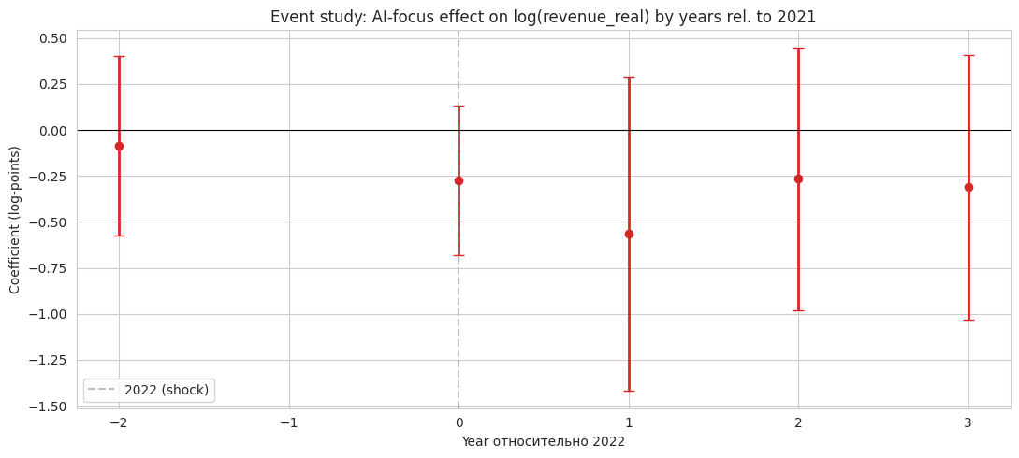
Fig. 1. Event-study estimates

Descriptive and Survival Analysis
In addition to the DiD specification, the panel is summarized through descriptive statistics on revenue, profitability, and headcount conditional on treatment status, segment, and listing status.
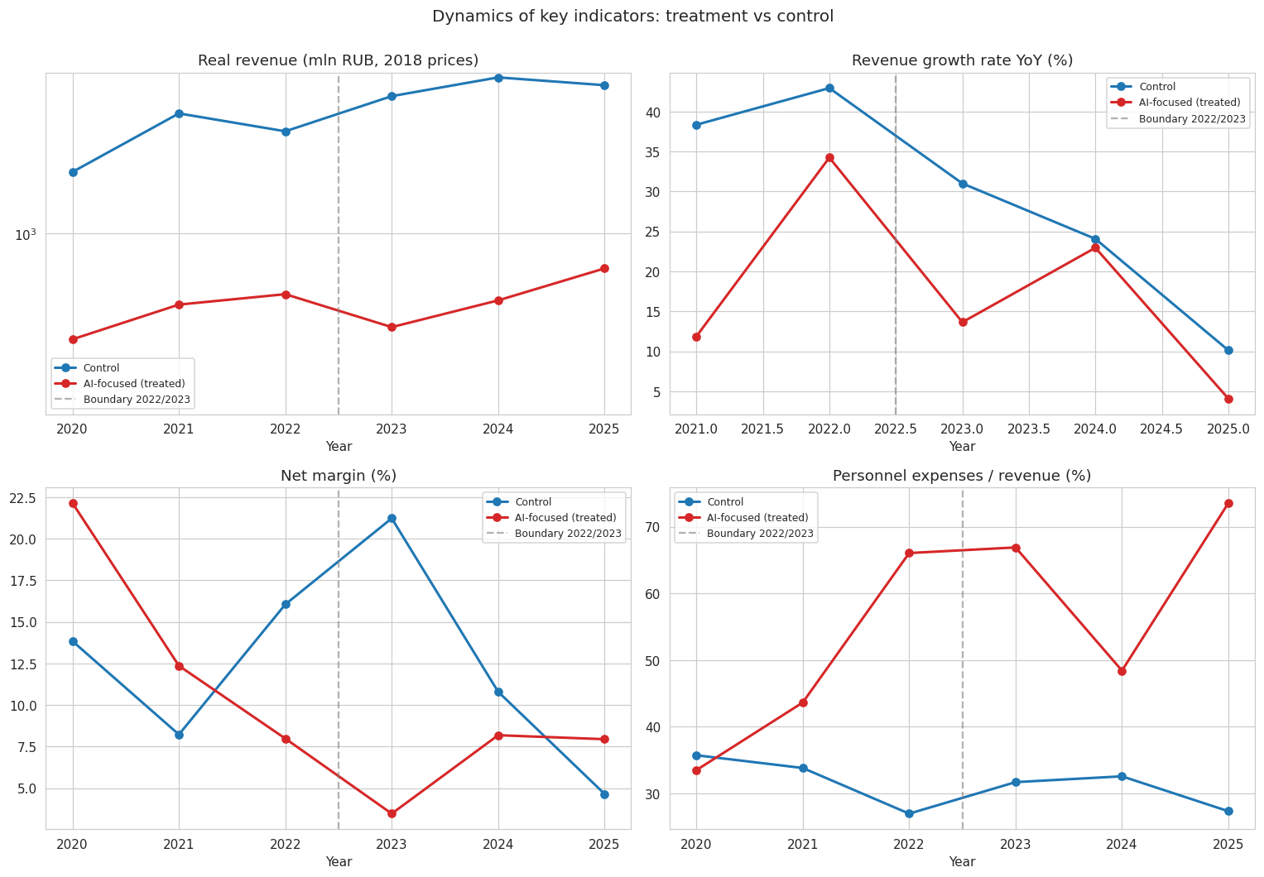Fig. 2. Descriptive diagramm

Reproducibility
The full data pipeline and the estimation routines are implemented in a single Jupyter notebook (reserch.ipynb) using Python with pandas and statsmodels. Data extraction scripts for the statutory financial archive (scripts/extract_bfo.py) and for the Habr / hh.ru pipeline (scripts/process_hh_kaggle.py) are stored separately. All processed CSV files and figures are version-controlled under data/processed/ and results/.

Results

Main Difference-in-Differences Estimates
Table 1 reports the DiD coefficient for log real revenue across the three specifications. In the pooled specification the point estimate is −0.515 log-points with a clustered standard error of 0.537 and a p-value of 0.338. The introduction of two-way fixed effects shrinks the point estimate to −0.102 log-points and increases the R² to 0.964, indicating that most of the cross-sectional variation in revenue levels is absorbed by firm fixed effects. Adding the macroeconomic and size controls leaves the point estimate unchanged at −0.102 log-points with a p-value of 0.774. Across all specifications the null hypothesis of a zero treatment effect on log real revenue cannot be rejected at conventional significance levels.
The corresponding net margin specification yields a positive but statistically insignificant DiD coefficient with a p-value of 0.426, consistent with H2: in the two-year horizon following the technology shock, AI-focused firms in the sample do not exhibit a measurable profitability advantage relative to the control group. Together, the H1 and H2 results suggest that the financial returns to AI specialization in the Russian IT sector, if present, are not detectable in the available short post-treatment window after accounting for firm-level heterogeneity and common year shocks.

Event Study
The event-study coefficients on log real revenue for years prior to 2022 are individually statistically insignificant and small in magnitude, which is consistent with the parallel-trends assumption underlying the DiD identification. Post-2022 coefficients fluctuate around zero with overlapping confidence intervals across the treated and control groups. The event study therefore corroborates the conclusion of the pooled DiD estimates and provides no evidence of a delayed treatment effect within the observation window.

Labour Market Block
The descriptive labour market evidence shows that the absolute number of hh.ru vacancies that explicitly mention artificial intelligence increased from 1.7 thousand in 2021 to 3.7 thousand in 2024, while total IT demand on hh.ru grew from approximately 555 thousand opened positions in 2022 to 708 thousand active vacancies in 2024. Under the narrow definition the share of AI-mentioning vacancies in total IT demand is estimated at 0.52% in 2024, which is roughly an order of magnitude smaller than the figure reported in earlier non-comparable studies. Hypotheses H3 and H4 are therefore reported as descriptive: a strict statistical test would require a homogeneous panel of vacancy and salary observations under a single methodology, which is not available in open sources for the full 2018–2025 window.

Summary of Hypotheses
The hypotheses are summarized in results/hypotheses_summary.csv. H1 is rejected: no statistically significant differential revenue effect of AI focus is detected after 2022. H2 is consistent with the data: the net margin DiD coefficient is statistically insignificant, in line with an investment phase rather than an immediate profitability gain. H3 and H4 are documented descriptively and indicate a doubling of AI vacancies in absolute terms accompanied by a still very low share of such vacancies in total IT demand.

Discussion
Three observations follow from the empirical results. First, the absence of a detectable revenue premium for AI-focused firms after 2022 should be interpreted in light of the composition of the treated group, which mixes mature AI service providers such as Yandex with smaller specialized firms whose absolute revenue is at least an order of magnitude lower. Two-way fixed effects absorb the level differences, but the resulting estimator is sensitive to the heterogeneity of growth trajectories within the treated group. Second, the short post-treatment window (three calendar years, with 2025 only partially closed at the moment of data extraction) limits the statistical power of the DiD estimator and the precision of the event-study leads and lags. Third, the contemporaneous macroeconomic shocks during the observation period, especially the 2022 exchange rate dislocation and the redirection of demand caused by the exit of foreign software vendors, introduce common year-specific effects that the year fixed effects absorb but cannot fully neutralize at the level of compositional change.
The descriptive labour market block highlights a methodological caveat that affects the interpretation of any quasi-experimental study of AI adoption in Russia: there is no single open data source that publishes a consistent series of vacancies and salaries by role under a fixed methodology for the entire 2018–2025 horizon. Reports by hh.ru, hh.ru × MTS Link, hh.ru × Tekhnokratiya, hh.ru × Matemarketing, Habr Career, and aggregators such as Skillbox Media, Forbes, Proglib, and Talent-Move each use partially incompatible definitions of “IT vacancy”, “ML vacancy”, and “offered” versus “received” salary. The descriptive treatment of H3 and H4 reflects this constraint rather than a limitation of the chosen estimator.
The proposed pipeline is not without limitations. The statutory accounting data exposed through bo.nalog.ru reflects single-entity RAS reports and may differ from consolidated IFRS figures for groups; cross-validation against e-disclosure.ru mitigates this gap only for publicly listed firms. The classification of firms as AI-focused is based on product portfolios and public disclosures rather than on a verifiable share of AI-related revenue, which introduces a measurement error in the treatment indicator. Finally, the GitHub and arXiv proxies of AI activity capture the externally visible component of firms’ technological output and may understate the contribution of closed in-house development.

Conclusion
This paper proposed a reproducible quasi-experimental framework for assessing the impact of the post-2022 neural network adoption wave on the financial performance of Russian IT companies. A panel of 45 firms covering the period 2020–2025 was constructed from statutory accounting reports, central bank macroeconomic series, labour market data, and open AI activity proxies, and a Difference-in-Differences specification with two-way fixed effects was estimated alongside an event-study check of pre-trends.
The empirical results indicate that, within the available observation window and the constructed sample, AI focus is not associated with a statistically significant differential change in real revenue or net margin after the end-of-2022 technology shock. The labour market block documents a doubling of AI-related vacancies in absolute terms, while their share in total IT demand remains below one percent under the narrow definition. The pipeline, the treatment assignment rule, and the result tables (data/processed/panel.csv, results/did_results.csv, results/hypotheses_summary.csv) provide a transparent foundation for replication and extension.
Future work may focus on extending the post-treatment window beyond 2025, on enriching the treatment assignment with verifiable measures of AI revenue share, on integrating consolidated IFRS data for the listed segment, and on synthesising a consistent vacancy and salary series under a single methodology to enable formal testing of the labour market hypotheses.

References
- Federal Tax Service of the Russian Federation. State information resource of accounting (financial) reports. https://bo.nalog.ru/
- Disclosure of information by issuers (Interfax). https://www.e-disclosure.ru/
- Central Bank of the Russian Federation. Official exchange rates of foreign currencies. https://www.cbr.ru/currency_base/
- Central Bank of the Russian Federation. Key rate of the Bank of Russia. https://www.cbr.ru/hd_base/KeyRate/
- Central Bank of the Russian Federation. Inflation and the key rate of the Bank of Russia, statistical publication for the period from 01.11.2014 to 08.05.2026.
- hh.ru and MTS Link. The number of vacancies mentioning artificial intelligence has doubled, 2025. https://mts-link.ru/blog/kolichestvo-vakansij-s-upominaniem-ii-vyroslo-v-dva-raza/
- hh.ru and Tekhnokratiya. IT labour market analytics, RBC Trends, March 2024. https://trends.rbc.ru/trends/education/66052c2f9a7947665a87d8be
- hh.ru and Matemarketing. The problem of the redundant person: ML specialists’ résumés outnumber vacancies threefold, Forbes, November 2025. https://www.forbes.ru/tekhnologii/549732-problema-lisnego-celoveka-rezume-ml-specialistov-vtroe-bol-se-cem-vakansij
- Skillbox Media. The number of vacancies in large Russian IT companies is decreasing, January 2025. https://skillbox.ru/media/code/kolichestvo-vakansiy-v-krupnyh-rossiyskih-it-kompaniyah-sokraschaetsya/
- hh.ru. Ten years of ML, RBC Trends, March 2025. https://trends.rbc.ru/trends/education/67e3da189a79477c942d8554
- career.hh.ru. Backend developer profession card. https://career.hh.ru/profession/43
- hh.ru. IT salary review (offered median 53 254 ₽). https://hh.ru/article/31783
- Forbes / hh.ru. Skills shortage, AI, and remote work: hh.ru year in review 2025. https://www.forbes.ru/biznes/552424-deficit-navykov-ii-i-udalenka-hh-ru-podvel-itogi-goda-na-rossijskom-rynke-truda
- Proglib. IT market has collapsed to one vacancy per 2383 applications, October 2025. https://proglib.io/p/it-rynok-obvalilsya-na-odnu-vakansiyu-teper-2383-otklika-2025-10-15
- Talent-Move. The IT industry in 2025 and the labour market in 2026. https://talent-move.ru/it-industriya-2025-goda-i-rynok-truda-v-2026/
- Sense-IT. Salaries of IT specialists in the Russian Federation: key trends of the third quarter of 2025. https://sense-it.ru/mediacenter/zarplaty-it-spetsialistov-v-rf-osnovnye-trendy-iii-kvartala-2025-goda
- Habr Career. Semi-annual IT salary report for the second half of 2021. https://www.seonews.ru/events/issledovanie-zarplat-v-rossiyskoy-it-otrasli-vo-vtorom-polugodii-2021-goda/
- Habr Career. Semi-annual IT salary report for the second half of 2022, RBC Trends. https://trends.rbc.ru/trends/industry/63db65479a7947412eb2a824
- Habr Career. Salary report for the first half of 2023. https://habr.com/ru/specials/748058/
- Habr Career. Salary report for the second half of 2023, RBC Trends. https://trends.rbc.ru/trends/education/65c1ec8d9a7947774e8c405f
- Habr Career. Salary report for the first half of 2024. https://habr.com/ru/specials/827990/
- Habr Career. Salary report for the second half of 2024. https://habr.com/ru/specials/883242/
- Habr Career. Salary report for the first half of 2025. https://habr.com/ru/specials/936618/
- Habr Career. Salary report for the second half of 2025. https://habr.com/ru/specials/994308/
- Habr Career. How to become an ML engineer, March 2026. https://habr.com/ru/companies/habr_career/articles/1008512/
- Habr Career. Backend salary calculator. https://career.habr.com/salaries?qualification=All&spec_aliases%5B%5D=backend
- The Code. Career-23-Q1: data scientist salary review, 2023. https://thecode.media/career-23-q1/
- GitHub REST API. Public repository metadata. https://docs.github.com/en/rest
- arXiv API. Open repository of scientific preprints. https://info.arxiv.org/help/api/
- Federal Institute of Industrial Property (FIPS / Rospatent). Information retrieval system for patent search, IPC class G06N. https://new.fips.ru/iiss/

