Goal: Fully design and develop the database component for an Application
Area of development: Hotel Booking system

Design and development all needed DB objects to support functionality of application

1.OLTP The OLTP database stores all operational data of the hotel booking platform. It records the entire booking process — from searching available rooms to payment confirmation — and supports the day-to-day operations of hotel management.
Logical schema
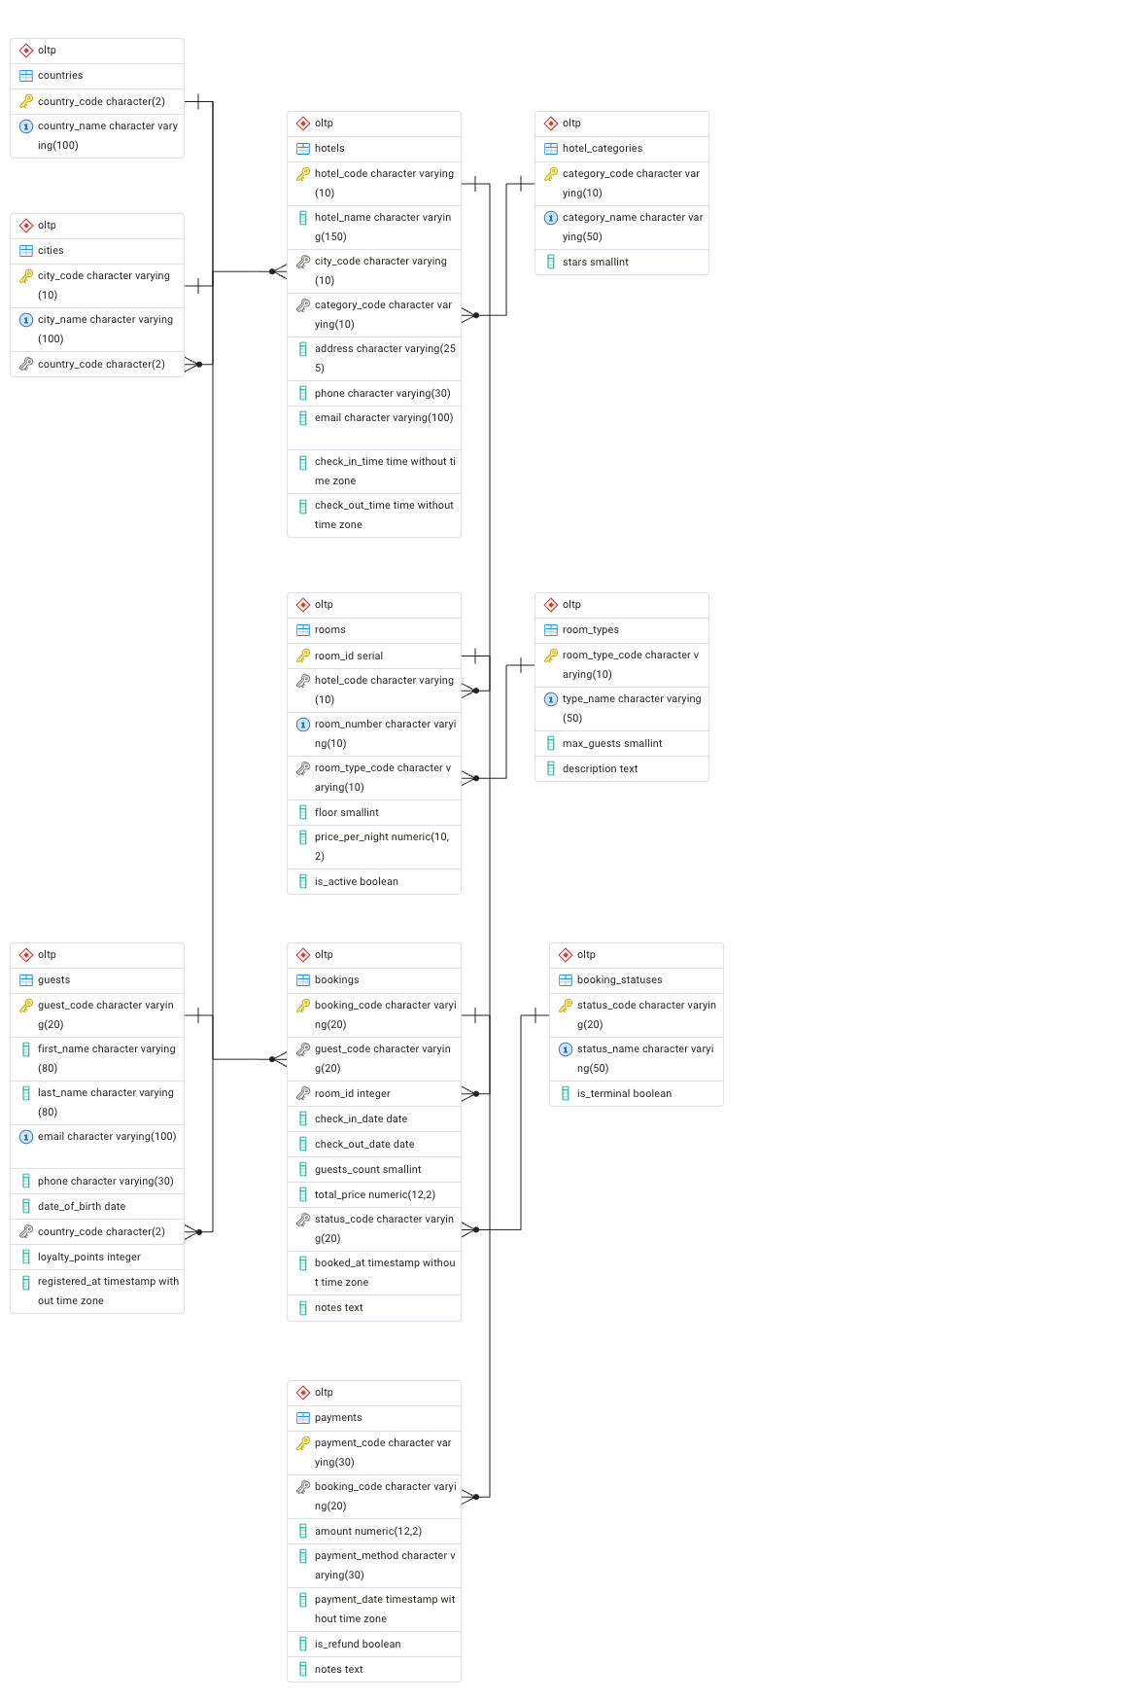

Key business processes covered:
• Guest registration and profile management
• Hotel and room catalog management
• Real-time room availability checking and booking creation
• Booking status updates (pending - confirmed - checked-in - completed)
• Payment processing and refund handling

2. Data CSV Files
Ten CSV files are provided, one per OLTP table. Files contain no surrogate keys; natural business keys are used throughout.
File | Rows | Notes
countries.csv | 10 | ISO-3166 codes
cities.csv | 12 | Natural key: city_code
hotel_categories.csv | 4 | 3–5stars + Boutique
hotels.csv | 10 | One hotel per major city
room_types.csv | 5 | SGL/DBL/TWN/SUT/FAM
rooms.csv | 200 | 4 floors 5 types 10 hotels
booking_statuses.csv | 6 | PENDING/CONFIRMED/CHECKED_IN/COMPLETED/CANCELLED/NO_SHOW
guests.csv | 50 | Synthetic guest data; email is unique
bookings.csv | 150 | 2024 bookings; realistic status distribution
payments.csv | ~118 | Payments for non-cancelled bookings; ~10% include partial refund

Design and development data analytical components for application

1. OLAP
The OLAP schema is stored separately in the 'olap' PostgreSQL schema. It denormalises and aggregates OLTP data for analytical workloads.
Analytical Questions
- Which hotels and cities generate the most revenue each quarter?
- How does revenue vary by room type and star category?
- Do Gold/Platinum loyalty guests book more frequently and spend more?
- Which payment methods are growing year-over-year?
- What is the monthly occupancy rate per hotel?
- What is the refund rate, and which hotels/methods have the highest?
Logical Schema OLAP
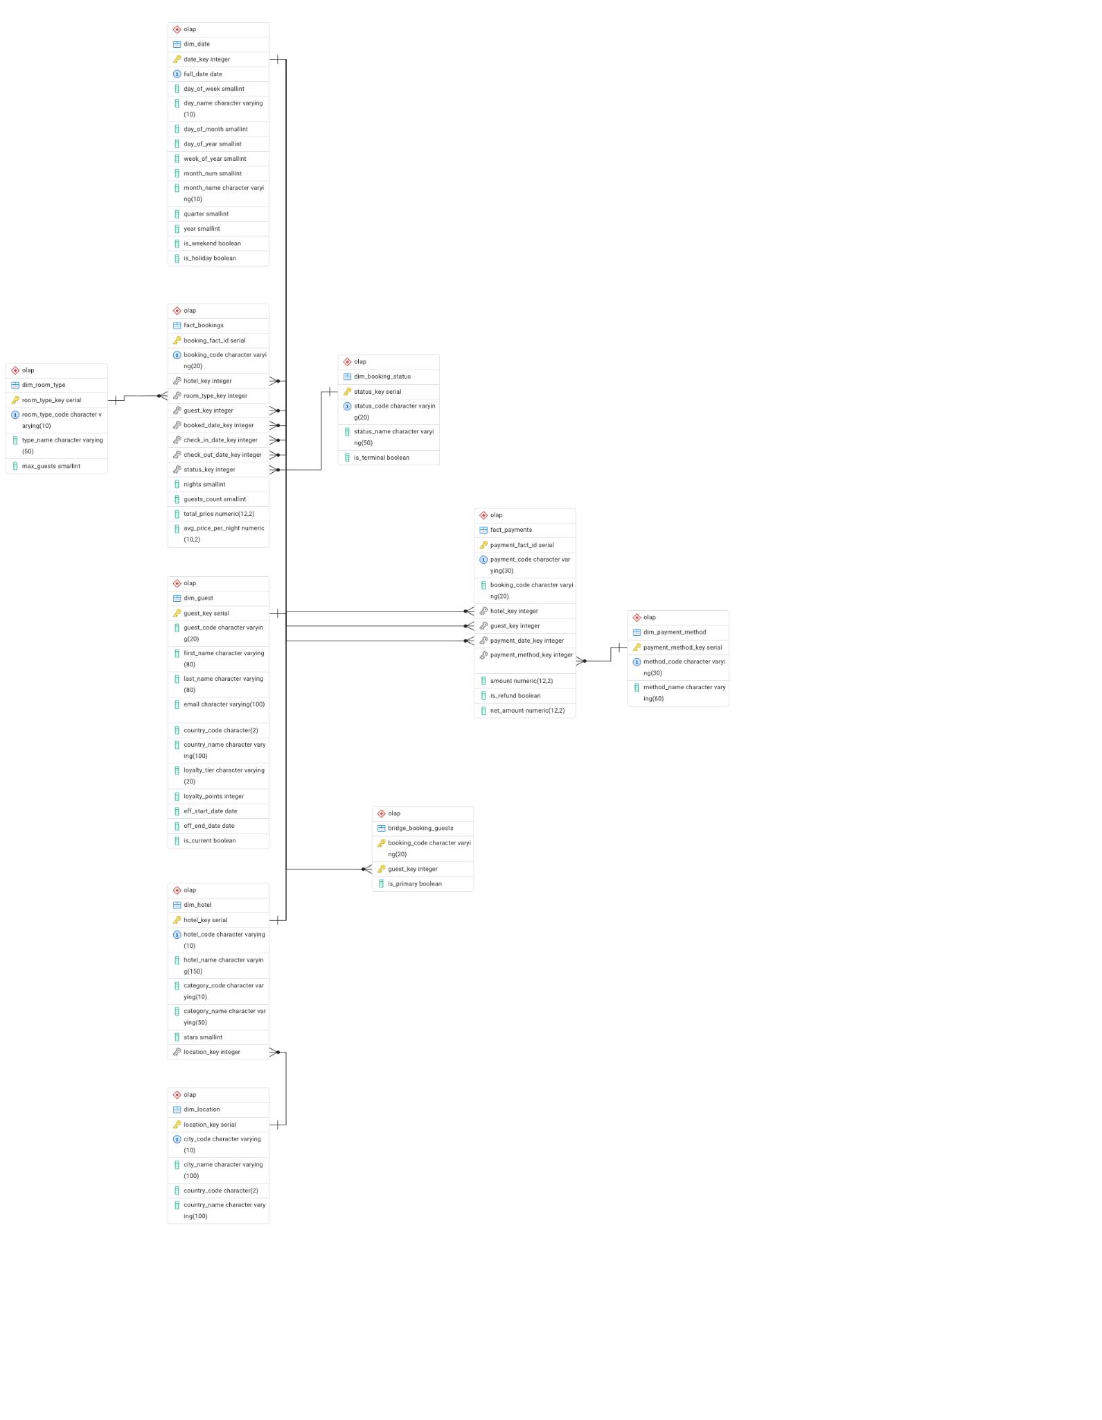

SCD Type 2 — dim_guest
When a guest's loyalty tier changes (Bronze / Silver / Gold / Platinum), the ETL closes the existing dim_guest row by setting eff_end_date = yesterday and is_current = FALSE, then inserts a new row with eff_start_date = today and is_current = TRUE. Historical fact rows continue to reference the old guest_key, preserving the tier valid at booking time.

Bridge Table — bridge_booking_guests
A booking may include multiple guests (guests_count > 1). The bridge table links a booking_code to one or more guest_keys, with is_primary = TRUE for the person who made the booking. This allows per-guest analysis without duplicating fact rows

ETL development
- ETL Steps
Step 1 — dim_date: generate date spine 2023-01-01 to 2027-12-31 using generate_series
Step 2 — dim_location: join cities + countries
Step 3 — dim_hotel: join hotels + categories + dim_location
Step 4 — dim_room_type: copy from OLTP room_types
Step 5 — dim_guest (SCD2): insert new guests; detect tier changes; close old rows; open new rows
Step 6–7 — dim_booking_status, dim_payment_method: copy reference data
Step 8 — bridge_booking_guests: link primary guest to booking
Step 9 — fact_bookings: join OLTP bookings + rooms + all dimension keys; compute nights & avg nightly rate
Step 10 — fact_payments: join payments + bookings + dimensions; compute net_amount

SQL Queries

OLTP Queries
Query | Question | Technique
Query 1 | Monthly revenue & bookings by hotel | GROUP BY hotel + month, SUM/COUNT, date_trunc
Query 2 | Top 10 most loyal / high-spend guests | LEFT JOIN bookings, GROUP BY guest, ORDER BY lifetime_spend
Query 3 | Room availability for a date range | NOT IN subquery checking booking date overlaps
Query 4 | Cancellation rate by hotel & room type | COUNT FILTER, ROUND percentage
Query 5 | Payment method & refund analysis | COUNT/SUM FILTER on is_refund flag

OLAP Queries
Query | Question | Technique
Query 1 | Revenue by quarter, country, category | Multi-dim GROUP BY across fact + 3 dims
Query 2 | Loyalty tier analysis (SCD2) | JOIN dim_guest on is_current; aggregated per tier
Query 3 | Payment trends year-over-year | GROUP BY year + month + method; net_amount
Query 4 | Monthly hotel occupancy rate | CTE + estimated room capacity; percentage calc
Query 5 | Room type revenue mix | Window function: SUM() OVER () for % share

PowerBI

Visuals
Slicer 1 — Year (from dim_date.year)
Slicer 2 — Country (from dim_location.country_name)
Line chart — Monthly revenue trend (dim_date[month_name] vs SUM(fact_bookings[total_price]))
Bar chart — Revenue by hotel (dim_hotel[hotel_name] vs SUM)
Donut chart — Bookings by room type (dim_room_type[type_name])

