Common Remoting
Standard Document
Version 0.0.1

Document History

Changes
Version | Date | Author | Description
0.0.1 | 2008-11-21 | Egor Pushkin | Initial draft.  - Document structure created and main definitions were given.

Scope
The purpose of this document is to define standard for remote communication middleware. This document describes the following aspects of middleware architecture:
- Platform and programming language (including coding standard and core architectural principles);
- Middleware public interface;
- Middleware network interaction protocol format;
- CommonKit high level architecture.

References
C++ Standard & a few good books
Concurrency patterns
Networking patterns
Middleware standards and implementations

Basic Concepts

Definitions
Network Middleware – This is a kind of software which encapsulates interaction between different components of the software over TCP/IP network. TCP/IP is used in the definition given above to underline an importance of granted delivery of raw (or ) data over the wire.
Common Remoting – This is a standard giving definition to building network middleware. This standard defines set of development platforms and public interface for components intended to wrap and hide implementation details (low level network interaction mechanisms (network sockets), platform-dependent concurrency shared libraries APIs). This document also defines format for network interaction protocol. Common Remoting standard allows setting custom protocol to extend a variety of potential applications and provide higher level of flexibility.
This standard does not include any implementation details. This is one of the main concept provided to give birth for multiple implementations of the standard. The document also discuss potential problems which may occur with compliancy of different 3rd party implementations and gives detailed description of open binary format for cross thread/process/host data exchange.
CommonKit – Cross platform implementation of Common Remoting standard. This library implements all components of middleware .
This document also briefly describes .

Common Remoting

Platform Requirements
This standard relies on C++ development platform. It may be extended with documents .

Basic Development Concepts

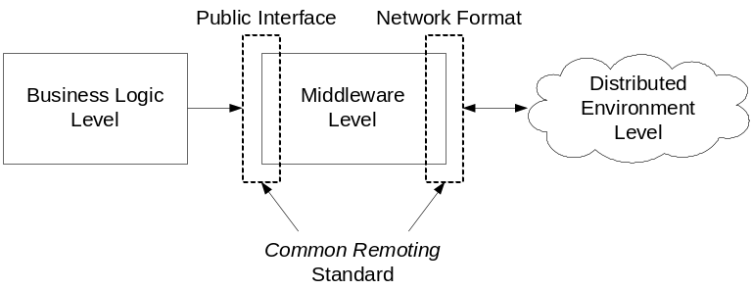
Figure 1. This diagram demonstrates the role of Common Remoting in software solutions.

