RemotePC Help

- About

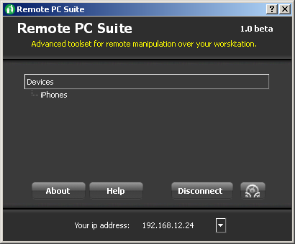
Screenshot. Main application window.

- Managing Connections

  - You will see confirmation dialog when anyone attempts to connect to your host application.

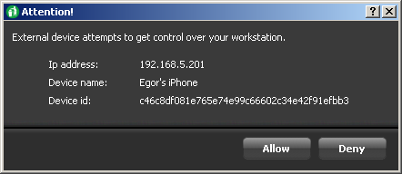
Screenshot. Confirmation dialog.

Note: RemotePC allows the only device running iRemote to be connected at the time.

  - You may disconnect user by clicking on “Disconnect” button on main application window.

Screenshot. Peace of RemotePC window with “Disconnect” button highlighted.

- Configuring the Application

  - Spreading screenshots
  - Port value

Note: As soon as you apply port changes application restarts service and this causes disconnection of all clients.

- Restrictions and Limitations

  - Application settings are stored in Config.xml file. You should not modify this file directly. Use application UI for this purposes.

