iRemote Help

- About

- Requirements

  - Network neighborhood

WiFi.
Brief explanation of ip/port.
On Bluetooth??

  - Host application

Before you launch your mobile client you have to download and install host application on your desktop system. You may found latest binaries for your platform at
http://www.scientific-soft.com/iphone/iremote
Note: Binaries for your desktop system are always FREE. And what is much more important is that you should not download binaries from third-party mirrors. The only authorized distributor of Remote PC Suite is Scientific Software. Please, use authorized mirror
http://www.scientific-soft.com/iphone/iremote
to protect your system.

- Connecting to Host

  - Over TCP

Howto acquire host ip.

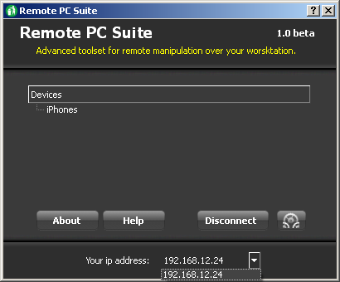
Screenshot. Part of host application window with ip combo.

Advanced
When do you usually need to change port.

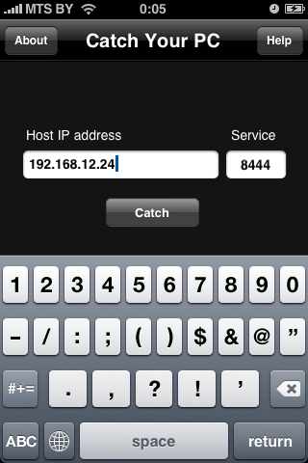
Screenshot. iRemote login page with ip and port populated.

Press ‘Catch’ button to establish connection with host application which should be launched on your workstation.

- Using TouchPad.

  - Pan Feature

Use pan gestures to move mouse cursor over the screen of your desktop. Mouse events are inverted. This means the following. Imagine that when you move you finger along the screen of your device you literally move visible area along your desktop screen.

  - Scroll Feature

Screenshot. Peace of screen with scrollable area on it.

Touch screen with two fingers simultaneously and pan to scroll active window vertically..

  - Clicks Feature

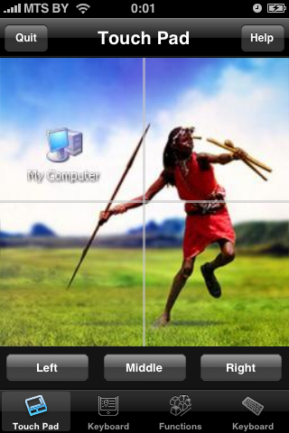
Screenshot. Area of iRemote TouchPad with mouse buttons.

Use buttons to simulate mouse clicks.
Note: These (as well as all other both mouse and keyboard) buttons behave as natural ones. Application distinguishes button down and button up events. This allows you to drag windows and select regions by combining pan and button down gestures.

Screenshot. Selecting area on the desktop.

- Using default keyboard

You may use it to input everything you want using any keyboard layout use might need to use.

Screenshot. Demo of Chinese input in Mozilla.
Screenshot. Demo of Skype conversation in Russian.

- Using Hot Keys

Use this tab to simulate most common combination of keys.

- Using Full Screen Keyboard

This feature provides you with a chance to do almost everything you can do with your regular keyboard. Of course, due to its size it may not efficiently replace desktop one.

- Limitations

  - Application (by means of Host Application) does not simulate DirectInput events.

