Лаба2

Рыжевский

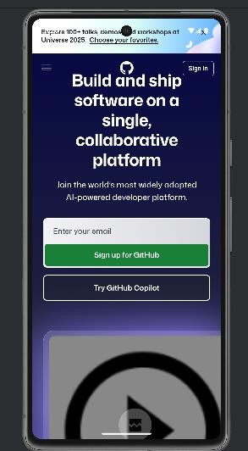

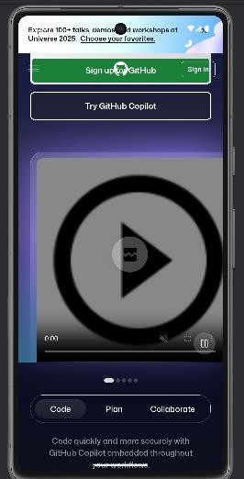

Activity_main.xml

<?xml version="1.0" encoding="utf-8"?>

<LinearLayout xmlns:android[="http://schemas.android.com/apk/res/android"](http://schemas.android.com/apk/res/android) xmlns:app[="http://schemas.android.com/apk/res-auto"](http://schemas.android.com/apk/res-auto) xmlns:tools[="http://schemas.android.com/tools"](http://schemas.android.com/tools) android:id="@+id/main"

android:layout_width="match_parent" android:layout_height="match_parent" android:orientation="vertical" tools:context=".MainActivity">

<ProgressBar

android:id="@+id/progressBar" style="?android:attr/progressBarStyleHorizontal" android:layout_width="match_parent" android:layout_height="4dp" android:visibility="gone" />

<WebView

android:id="@+id/wvMain" android:layout_width="match_parent" android:layout_height="match_parent"/>

</LinearLayout>

AndroidManifest.xml

<?xml version="1.0" encoding="utf-8"?>

<manifest xmlns:android[="http://schemas.android.com/apk/res/android"](http://schemas.android.com/apk/res/android) package="com.example.laba2">

<uses-permission android:name="android.permission.INTERNET" />

<application

android:allowBackup="true" android:icon="@mipmap/ic_launcher" android:label="@string/app_name" android:theme="@style/Theme.Laba2">

<activity

android:name=".MainActivity" android:exported="true">

<intent-filter>

<action android:name="android.intent.action.MAIN" />

<category android:name="android.intent.category.LAUNCHER" />

</intent-filter>

</activity>

</application>

</manifest>

MainActivity.kt

package com.example.laba2 import android.os.Bundle import android.webkit.WebView

import android.webkit.WebViewClient

import androidx.appcompat.app.AppCompatActivity class MainActivity : AppCompatActivity() {

override fun onCreate(savedInstanceState: Bundle?) { super.onCreate(savedInstanceState) setContentView(R.layout.*activity_main*)

val webView = findViewById<WebView>(R.id.*wvMain*) webView.*webViewClient* = WebViewClient() webView.loadUrl("https://github.com/")

}

}