**Abstract**

This work discusses the relationship between Fake news detection performance, Personality traits, and Political leaning. We have studied a sample of mostly undergraduate young people with Liberal to Centrist political views. In this study, we found that for this subgroup Personality traits do not impact Fake News detection performance, in contrast to Political Leaning, for which Liberals resolve fakes better than Centrists. The relations between Political leaning and Personality traits were found only for Agreeableness and Extraversion. The presence of relation for Agreeableness was already shown in the previous articles, whereas for Extraversion we suggest that the relation might be present due to a confounding factor, namely that Extraverts and Liberals consume news from more sources than the others.

**1.Introduction**

The fake news (FN) spreading always has been a problem for those who want to see the world as it is avoiding other people’s ignorance. For some people, though, it is but an opportunity to manipulate the others. Given the current pandemic, one can easily find plenty of examples. For instance, vaccine hesitancy in the USA or sky-high increase of ginger’s price in Russia due to the belief that it prevents coronavirus disease, or, once again, ideological and political manipulations before elections in the USA. These events emphasize the importance and relevance of the problem studied.

Society graph



Fig. 1. Representation of society as a graph with people being points and matters of social interaction being edges.

Fake news spreading is much alike a virus spreading. In a mathematical sense, people may be considered as points of a graph (Fig. 1), the matters of person-to-person interaction as edges. The number and qualities of these matters define the speed of spreading of contamination regardless of it being virulent or informational. The efficiency of these matters, in turn, depends on many factors, which in the case of fake news have a predominantly psychological nature based on properties of sender and receiver. In these terms, the probability of the fake news receiver resisting becoming a new fake news source depends on two general factors: way of information consumption and ability to resolve false from true. The possible ways are: from social networks, from distant or close people, etc. It was shown that subjects rely their analysis mainly on source reliability (Flintham et al. 2018). The performance of news detection, in turn, can depend on person’s character, knowledge, and preferences concerning topic of the news considered. For instance, there was found a link between schizotypal traits and beliefs in conspirational Fake News (Anthony and Moulding 2019) or fitting information interest to own’s attitudes by Right Wing Authoritarians (Sindermann et al. 2020). Our experiment will be targeted on detection of fake news referred to some political topics. It will be concerned with the three general properties of participants: personality traits, political leaning, and fake news detection performance. Personality traits are collected using Big Six test (Thalmayer and Saucier 2014). Big Six tests split human personality into six traits: Honesty, Resiliency, Originality, Extraversion, Conscientiousness, Agreeableness. For presenting participants with fake news we would use a model of a social network (i.e. Facebook), as this way has been already successfully used for such purposes (Flintham et al. 2018). Research of a similar kind to ours has been carried out in 2020 (Sindermann et al. 2020). Our research is to develop their ideas and to use more sophisticated means of statistical analysis. According to the graph social interactions model (Fig. 1), in process of spreading information from one graph point to another, we have three general variables: properties of fake news source (i.e. president of USA Donald Trump), method of information transmission (i.e. social network “Twitter”), receiver of fake news (i.e. a student of EPFL). In this work, we study relationship between specific properties of fake news receivers and their fake news detection performance. Therefore, we need to fix all the other variables to exclude confounding correlations. We chose most natural for a modern person method of receiving news, which is a social network feed, namely feed of “Facebook”. The information will be presented from Facebook accounts of fake news-like sources, to avoid the case when a participant falls for source’s authority, since one is more likely to believe “The Guardian”, than an unknown newspaper. Fake news detection performance may depend not only on personality traits but also on participant’s knowledge and preferences concerning the topic (Sindermann et al. 2020). The topic of fake news was chosen to be politics since for politics-related news, this knowledge and preferences are likely to have a significant correlation with a political leaning (Lee et al. 2018). Therefore, we can use learning as a representation of these factors, that can be more easily collected and understood.

Given previous research on similar topics, we can pose several hypotheses. Firstly, Originality and resiliency are positively related to ability to detect fake news. Originality and Emotional Stability appear to be positively and strongly associated with interest in and knowledge of politics (Chirumbolo and Leone 2010). We suppose that interest and knowledge of politics improve fake news detection performance. Secondly, we predict that fake news detection capabilities are not influenced by (moderate) political leaning as was found by Van Bavel and Pereira (Van Bavel and Pereira 2018). Finally, Conscientiousness, Agreeableness, and Openness are supposed to predict political criteria as has been found by Chirumbolo et al. (Chirumbolo and Leone 2010; Alan and Kabadayı 2016).

**2.Method**

**2.1. Participants**

People participated in research voluntarily. They were relatives, friends, or those who were reached by experimentators in social networks. The number of participants required for obtaining significant results was estimated using F-test with linear multiple regression with an 80% power and 5% error. In the result, a sample with 80 or more participants was claimed large enough for our models to give significant results. G*Power Software from HHU was used (Faul, Erdfelder,Lang, et al. 2007; Faul, Erdfelder, Buchner, et al. 2009)

**2.2. Materials**

The experiment was conducted in a form of a questionnaire, which was targeted to collect a participant’s answers referring to four different domains: demographic information, personality traits, political leaning, and fake news detection. The questionnaire was created using PsyToolkit (Stoet 2010, Stoet 2017)

**2.2.1 Demographic features**

The 4 demographic features asked are age, nationality, gender, and education level. Age was asked in form of a number, gender in binary form with possibility to pick a non-binary option. For education 5 options were presented: Primary school, GCSEs or equivalent, A-Levels or equivalent, Undergraduate, University post-graduate program.

**2.2.2 Fake News detection**

For estimation of Fake news detection performance, we present 5 sets of articles in a form of a FaceBook feed (Fig. 2). The use of FaceBook feed proved itself worthy for simulating natural situation of news consumption (Flintham et al. 2018). In our experiment, each of 5 feeds contained 7 posts, one of which was a news article selected by us with 2 True news and 3 Fakes. The news articles corresponded to one of controversial questions discussed in Political leaning test. The other posts were created to be as usual as possible, for example, memes, announcements achievements or item sales. In feed News posts were published by fake news agencies like "EU News", the other posts were published by regular people, whose profile images were generated by *thispersondoesnotexist.com*, and name was also generated by *name-generator.org.uk* using racial and gender features, corresponding to the profile picture. Facebook posts were generated using *Facebook posts generator*. After each feed, sets of two questions were asked on three posts of feed. All the answers were scaled from 0 to 10 with step of 1.

The first question was always "How much do you trust the content of the post?". The other question asked about the sentiment, for example: "How much did it make you feel hopeful?".

FaceBook feed example

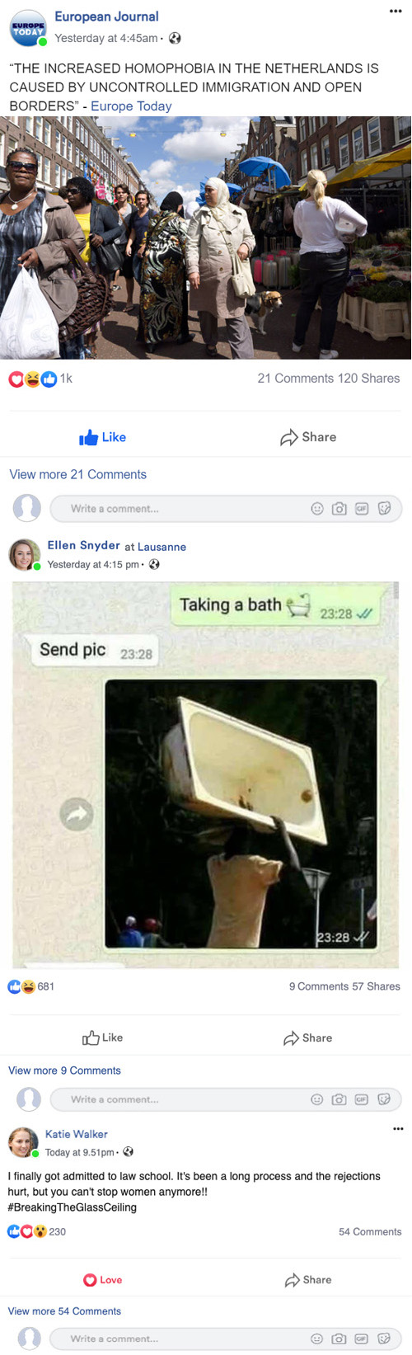

Fig. 2. Example of FaceBook feed part, that was used for Fake News Detection. The first post is the Fake News piece, the others just make the feed look natural.

**2.2.3 Political leaning**

The political leaning was inferred from 10 questions regarding specific social and controversial issues. Participants were additionally asked to provide an estimation of their political leaning from liberal to conservative. All answers in this section scaled from 1 to 10 with step 1.

Political leaning question example:

It should be possible for same-sex couples to adopt children.

(1 - Strongly disagree, 10 - Strongly agree, step - 1)

**2.2.4 Personality traits**

The personality traits were collected using reduced short Big 6 questionnaire (Thalmayer and Saucier 2014). It splits personality into 6 traits: Honesty, Resiliency, Originality, Extraversion, Conscientiousness, Agreeableness. Each feature is determined by result of 5 specific questions with answers scaling from 1 to 5, step 1 makes 30 questions on personality in total.

Resiliency question example:

1. I get stressed out easily. 2. I panic easily. 3. I am often worried about things I said or did. 4. am afraid of many things. 5. I rarely worry

**2.3 Procedure**

Fatigue from answering questions may affect Fake News detection but is not supposed to change other personal features. Therefore, Fake news-related domain of the experiment was posted at beginning of questionnaire to eliminate this confounding factor. The questionnaire started by asking 4 questions about demographic features. Then participants were presented with an example of a Facebook post and questions asked. 5 Facebook feeds with 6 questions each about regular posts and news followed. Then 11 Political learning questions and 30 short Big Six questions were asked (Thalmayer and Saucier 2014). The test had 75 questions. A participant was supposed to spend approximately 18 minutes on it.

**2.4 Statistical analysis**

To test the veracity of our hypotheses we calculated cumulative Fake news detection scores and Political learning scores. In the analysis of partial and cumulative scores, we used an approach based on Spearman rank correlation and an approach based on Linear Regression.

**2.4.1 Fake News detection performance score**

During the questionnaire, participants were asked to estimate their trust to present pieces of news on a scale from 0 to 10 with step 1. In other terms, they were asked to classify the piece as either True or False, by answering with probability of the piece being True. Such a task can be naturally named as a task of binary classification, hence the cost of deviation from correct answer can be measured as informational entropy between distribution of correct answers and distribution of predicted probabilities. Such logic brings us to conclusion that Fake News score detection should be measured as Binary Crossentropy (Eq. 1).

Fake news detection score



Eq. 1. *y* is target answer (True or False) and *x* is predicted probability of answer being True.

**2.4.2 Political leaning score**

The answers to the Political leaning questions were split into Pro-Liberal and Pro-Conservative. Then Political score was calculated as a mean of related questions in such a way that Pro-Liberal summed up as negatives and Pro-Conservative as positives.

**2.4.3 Spearman rank correlation**

The first method of data analysis was considering Spearman rank correlations between different features of a participant. However, Spearman correlation is based on simple covariance, therefore it may be biased by presence of unaccounted confounding factors. In following considerations, we use an alpha level of .05 for all statistical tests.

**2.4.4 Linear regression**

The second method partially eliminates this problem when several features from one domain, say Big 6, are examined for correlation with one target parameter, say Fake News score. In this method we normalize all features to have *M*=0, *SD*=1, so that they all have the same initial impact. Next, we try to predict target parameter using linear regression over considered features. In this case linear coefficients mark an impact of a given feature on target excluding confounding impact of the other features.

**3. Results**

**3.1. Data collection**

93 people participated in experiment, yet only 70 people have managed to finish test. It is 12.5 % less than needed volume of sample, which was calculated by Power analysis. Nevertheless, number of participants is close to the desired one, hence careful consideration of *p* values should still ensure proximity of estimated significance to true one.

**3.2. Data exploration**

All of participants stated their gender in binary form. 47 of them were women making this group a majority (*M*=0.43, *SD*=0.95 with -1 for man and 1 for woman). The participants’ age was on average 22.23 years (*SD*=5.64), and they were mostly undergraduate (*M*=3.59, *SD*=0.91 on scale 1 to 5 as in Fig. 3). 93% of participants were from Europe, 54% were Swiss.

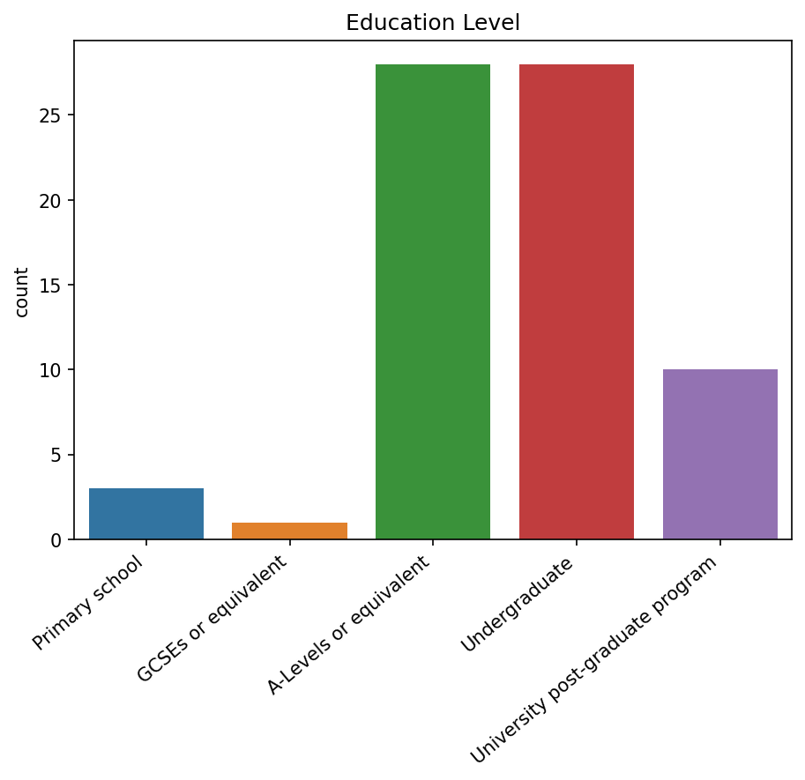

Fig. 3. Histogram of the education level of experiment participants

**3.2.1. Fake news**

The table 1 depicts that Fake News prediction performance highly depends on topic of a piece of news, and probably on information in the piece itself. Yet we see that mean of total score marginally exceeds 0.5 (95% confidence interval [0.56,0.6]), which indicates that our sample of news has no drastic bias towards very high or very low complexity for fake

recognition. Moreover, a high variance of scores for each piece of news (*SD* 0.2 out of 1) indicates that we may find impact of personality features on fake detection performance for each piece of news.

Mean and standard deviations of Fake News prediction scores

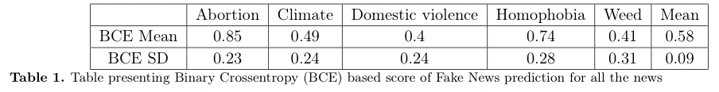

**3.2.2. Political leaning**

The figure 5 presents that there is a significant correlation (*R*=0.43,*P*<.01) between one’s Self-estimated Political leaning and Political leaning estimated by our method. Considering it as a sanity check, we can state that our method of Political leaning estimation proves itself sensible. However, the sample of participants appears to be disbalanced towards Liberal leaning (*M*=0.2, *SD*=0.14 in scale from 0 to 1 with 0 being Liberal). This disbalance leads us to a conclusion that extremes of Political Score are Liberal and Centrist.

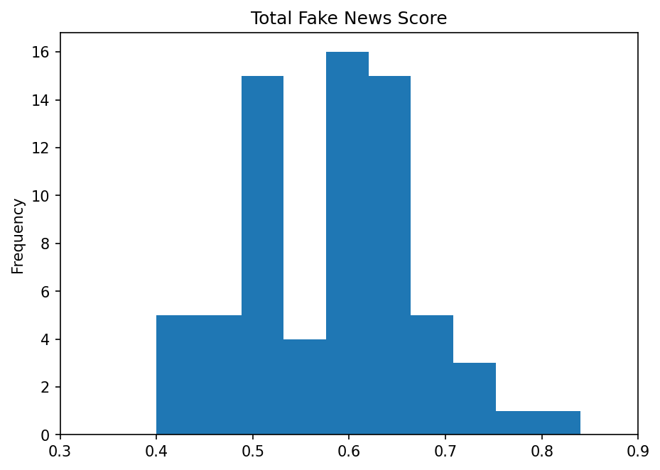

Fig. 4. Total Fake news detection score histogram. The score is calculated as the mean of Binary Crossentropy scores for all the Fake news.

Relation between estimated Political leaning and Self-evaluated

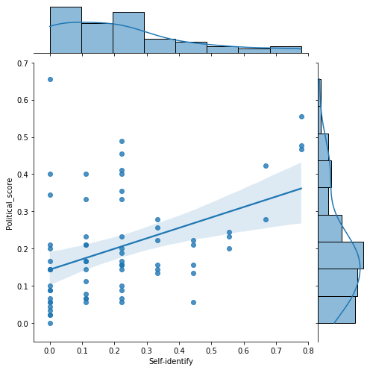

Fig. 5. Scatterplot representing the relation between Political leaning score estimated on related questions and self-estimated by participants

**3.2.3. Personality traits**

Means of Big 6 traits are concentrated near the middle of the range (*M* ~0.5) and have a variance of order of 25% of scores range. It outlines that our set of participants is nicely balanced in terms of personality features.

Statistics of Big 6 Personality traits

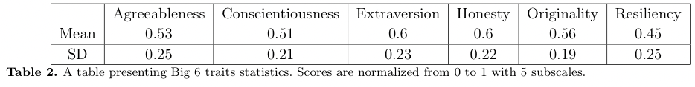

**3.3. Spearman rank correlation**

**3.3.1. Political leaning vs Fake News**

For Political Leaning, we considered correlations between answers on all the Political Leaning questions and all the pieces of news Fake detection performance. All significant correlations (*P*<.05) are presented in Fig. 6.

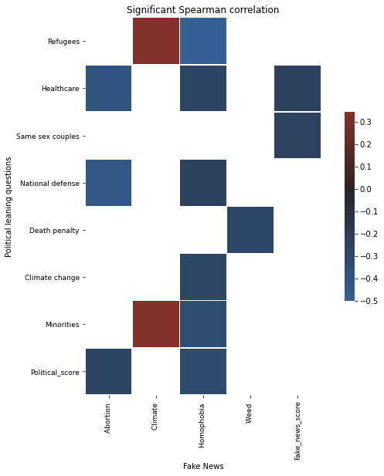

Fig. 6. Spearman rank correlations between answers on Political leaning questions and performance of different Fake News detection.

We do not see a significant correlation between overall Political leaning and overall Fake News score. However, we find a lot of correlations between specific topics of Political leaning and specific Fake News. Moreover, we find significant correlation for two Political leaning features with overall Fake News score and for two specific Fake News scores with overall Political leaning.

Yet specific features concerned in these correlations appear to have mostly disbalanced distribution, since most of participants voted for one border value.

To test whether significance is caused by disbalance we excluded people answered border values and estimated correlations again (Tab. 3). For balanced dataset both overall Fake news score-related correlations became insignificant, therefore we can conclude that they are due to disbalance, rather than natural impact of specific political leaning aspects.

Comparison of P values for original and balanced datasets

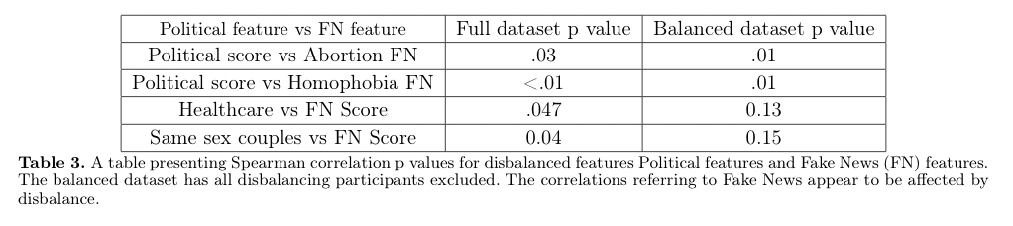

**3.3.2. Personality traits vs Fake News**

There is only one Personality trait significantly (*P*=.03) correlating with only one Fake News piece detection (Fig. 7).

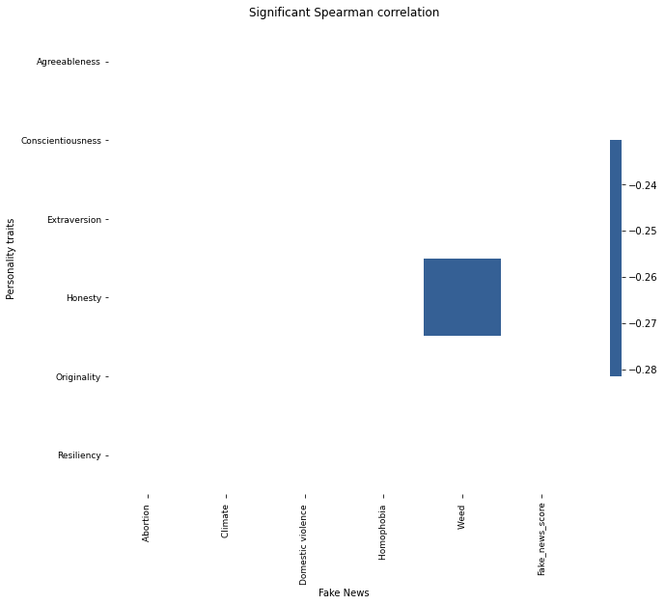

Fig. 7. Significant correlations between personality traits and Fake News performance detection. Only one significant correlation is present.

**3.3.3. Personality traits vs Political leaning**

In this section, we got several significant and logically sensible correlations

For instance, extroverts empathize more to mothers who don’t want to have a child, hence extroverts approve abortion.

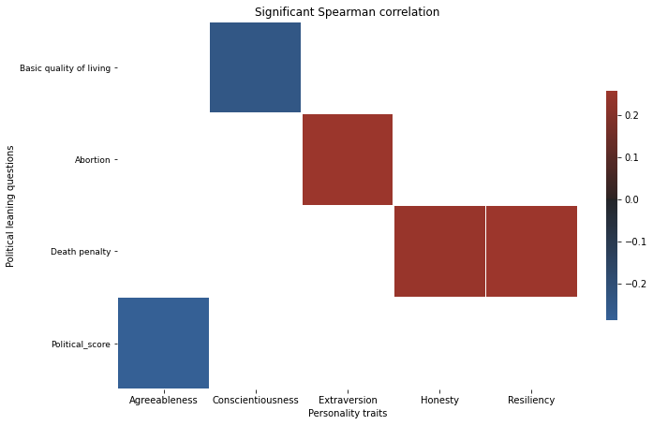

Fig. 8.

Significant correlations between personality traits and answers and political leaning questions. A positive answer to the question means that person approves the given act. A positive political score means the person lean towards the centrist, rather than the left. Only one significant correlation is present.

**3.4. Linear regressions**

In this part data on all features were normalized to have *M*=0, *SD*=1. All figures and Tables have same scales. Since linear coefficients vary near zero and we are interested in their signs (positive or negative), we consider 95% confidence intervals to be sure in the sign.

Statistics for significant linear coefficients

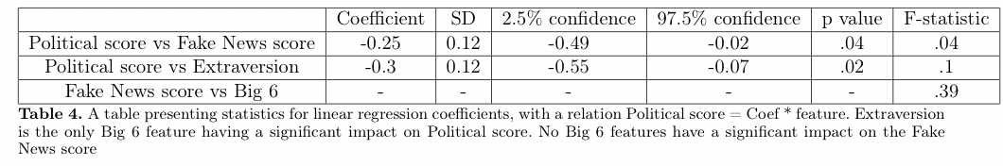

Scatter plots for Significant linear relations

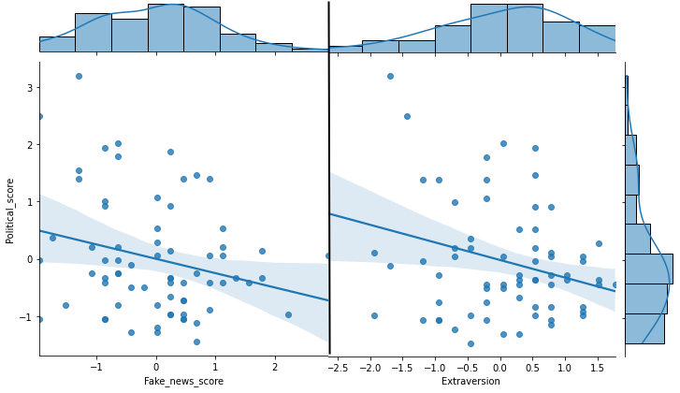

Fig. 9.

Scatterplots showing the relation between Political Leaning score, Fake News score and the only significant for linear regression Big 6 feature - extraversion

**4. Discussion**

**4.1. Personality traits vs Fake News**

In this section the hypothesis was “Originality and Resiliency are positively related to the ability to detect fake news”.

However, in practice, no strong correlation for either Originality (*P*=.31 for Spearman correlation and *P*=.5 for Linear regression) or Resiliency (*P*=.66 for Spearman correlation and *P*=.9 for Linear regression) were found. None of Big 6 features showed significance in either correlation or linear impact. Therefore, we can conclude that on the given data we find our first hypothesis disproved. Moreover, we can suggest that Personality traits may not affect Fake News detection at all. Our hypothesis was drawn from a diverse political spectrum research whereas our sample of participants has political views from liberal to centrists (*M*=0.2, *SD*=0.14 with 0 for Liberal and 1 for Conservative), moreover, average age was 22.23 years (*SD*=5.64). The fact that our sample was disbalanced in these features implies that our results may be applied only on these people subclasses, yet they can’t be certainly extrapolated on any given sample of people.

**4.2. Political leaning vs Fake News**

In this section out hypothesis was “Fake news detection capabilities are not influenced by (moderate) political leaning”.

However, using method based on linear regression we significantly (*P*=.04) find that Liberals are better in resolving Fake News then Centrists (*M*=-0.25, *SD*=0.12, Tab. 4, Fig. 9). Sindermann et al. 2020 showed that Right-Wing Authoritarianism is associated with selective interest in information fitting with one’s attitudes. From our results, we may conclude that this effect may propagate on centrists resulting in worse performance in Fake News detection. On the other hand, in same article, there was small evidence on the fact that liberals tend to consume a higher number of news sources. It may improve their ability to resolve Fake News due to considering information coming from different sources. Both of these explanations may work as they coincide with the findings of our study.

**4.3. Personality traits vs Fake News**

In this section the hypothesis was drawn from Chirumbolo and Leone 2010, namely “Conscientiousness, agreeableness, and originality are typically found to predict political criteria”. Unlikely, analysis of Spearman correlations confirmed only agreeableness to predict political criteria (*R*=-0.28, *P*=.02). The other method rejects this hypothesis altogether. The analysis of linear regression has shown only Extraversion to be a predictive factor for Political leaning (*M*=-0.3, *SD*=0.12, *P*=.02 for linear coefficient). In the article Gerber et al. 2011 it was shown that extraverts are likely to report that they are interested in politics, watching political talk shows and network news. In a turn, Sindermann et al. 2020 showed a small evidence on the fact that liberals tend to consume a higher number of news sources. From this, we conclude that for Extraversion and Political leaning number of news usually consumed is a correlating trait and may work as a confounding factor for relation between these features. In following work, given more data the information may be propagated through correlating features in order to reduce the confounding variables for considered features.

**5. Conclusion**

In this work, we have studied a sample of mostly undergraduate young people with Liberal to Centrist political views. We found that for this subgroup Personality traits do not impact Fake News detection performance, in contrast to Political Leaning, for which Liberals resolve fakes better than Centrists. The relations between Political leaning and Personality traits were found only for Agreeableness and Extraversion. The presence of relation for Agreeableness was already shown in previous articles, whereas for Extraversion we suggest this relation might be present due to a confounding factor, namely that Extraverts and Liberals consume news from more sources than the others.

The findings of this research may help social networks to understand how susceptible to fake news their audience is. Given this data, social networks will gain possibility to distribute resources of news validation more efficiently. Moreover, during election campaigns, it is always important to understand the electorate’s susceptibility to unconfirmed statements to build a sensitive strategy of opposing accusations of the other political side and creating their announcements.

We also find that the correlation is present between performance of detection specific topics and specific Political related questions or specific Personality traits. The findings seem sensible however, they need to be tested on a higher number of Fake News questions and a more vast sample of participants. Furthermore, variety of age, education level, and political leaning should also be extended to validate possibility to extrapolate results found in this study on a more general sample of participants.

**6. References**

Faul, F., E. Erdfelder, A.-G. Lang, et al. (2007). “G*Power 3: A flexible statistical power analysis program for the social, behavioral, and biomedical sciences.” In: Behavior Research Methods 39, pp. 175–191. doi : 10.1177/0098628316677643 . eprint: [https://doi.org/10.1177/0098628316677643](https://doi.org/10.1177/0098628316677643.url) url: https://doi.org/10.1177/0098628316677643

Faul, F., E. Erdfelder, A. Buchner, et al. (2009). “Statistical power analyses using G*Power 3.1: Tests for correlation and regression analyses.”In: Behavior Research Methods 41, pp. 1149–1160. doi : 10.1177/0098628316677643 . eprint: <https://doi.org/10.1177/0098628316677643> . url : <https://doi.org/10.1177/0098628316677643> .

Chirumbolo, Antonio and Luigi Leone (July 2010). “Personality and politics: The role of the HEXACO model of personality in predicting ideology and voting”. In: Personality and Individual Differences 49, pp. 43–48. doi : 10.1016/j.paid.2010.03.004 .

Stoet, Gijsbert (2010). “A software package for programming psychological experiments using Linux”. In: Behavior Research Methods 42, pp. 1096–1104. doi : <https://doi.org/10.3758/BRM.42.4.1096> .

Gerber, Alan et al. (Jan. 2011). “Personality Traits and the Consumption of Political Information”. In: American Politics Research 24. doi : 10.1177/1532673X10381466 .

Thalmayer, Amber and Gerard Saucier (Sept. 2014). “The Questionnaire Big Six in 26 Nations: Developing Cross-Culturally Applicable Big Six, Big Five and Big Two Inventories”. In: European Journal of Personality 28. doi : 10.1002/per.1969 .

Alan, Alev Ko ̧cak and Ebru T ̈umer Kabadayı (2016). “The Effect of Personal Factors on Social Media Usage of Young Consumers”. In: Procedia - Social and Behavioral Sciences 235. 12th International Strategic Management Conference, ISMC 2016, 28-30 October 2016, Antalya, Turkey, pp. 595–602. issn : 1877-0428. doi : <https://doi.org/10.1016/j.sbspro.2016.11.086> . url : <https://www.sciencedirect.com/science/article/pii/S1877042816316202> .

Stoet, Gijsbert (2017). “PsyToolkit: A Novel Web-Based Method for Running Online Questionnaires and Reaction-Time Experiments”. In: Teaching of Psychology 44.1, pp. 24–31. doi : 10.1177/0098628316677643 . eprint: <https://doi.org/10.1177/0098628316677643> . url : <https://doi.org/10.1177/0098628316677643> .

Flintham, Martin et al. (2018). “Falling for Fake News: Investigating the Consumption of News via Social Media”. In:

Proceedings of the 2018 CHI Conference on Human Factors in Computing Systems . CHI ’18. Montreal QC, Canada: Association for Computing Machinery, pp. 1–10. isbn : 9781450356206. doi : 10.1145/3173574.3173950 . url : <https://doi.org/10.1145/3173574.3173950> .

Lee, Kibeom et al. (2018). “Personality, Religion, and Politics: An Investigation in 33 Countries”. In: European Journal of Personality

32.2, pp. 100–115. doi : 10.1002/per.2142 . eprint: <https://doi.org/10.1002/per.2142> . url : <https://doi.org/10.1002/per.2142> .

Van Bavel, Jay and Andrea Pereira (Feb. 2018). “The Partisan Brain: An Identity-Based Model of Political Belief”. In: Trends in Cognitive Sciences 22. doi : 10.1016/j.tics.2018.01.004 .

Anthony, Angela and Richard Moulding (2019). “Breaking the news: Belief in fake news and conspiracist beliefs”. In:

Australian Journal of Psychology 71.2, pp. 154–162. doi : 10.1111/ajpy.12233 . eprint: <https://doi.org/10.1111/ajpy.12233> . url : <https://doi.org/10.1111/ajpy.12233> .

Facebook posts generator (2019). url : zeoob.com .

thispersondoesnotexist.com (2019). url : <https://thispersondoesnotexist.com> .

Sindermann, Cornelia, Morten Moshagen, and Christian Montag (Jan. 2020). “Age, gender, personality, ideological attitudes and individual differences in a person’s news spectrum: how many and who might be prone to “filter bubbles” and “echo chambers” online?” In: Heliyon 6, e03214. doi : 10.1016/j.heliyon.2020.e03214 .

name-generator.org.uk (2021). url : https://www.name-generator.org.uk/?i=oz5fmnp