Практ работа №1

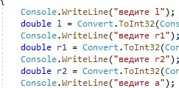

Convert.ToInt32(ConsoIe.

ReadLine());

Convert.ToInt32(ConsoIe.

ReadLine());

Convert.ToInt32(ConsoIe.

ReadLine());

double a = Convert.ToInt32(ConsoIe. ReadLine());

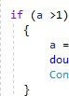rl / r2; double res

Console. WriteLine (+res) ;

Console. ReadKey ;[1]

1. <https://github.com/egoryakunin1?tab=repositories>