## Ranking-Oriented Evaluation Metrics&PopRank

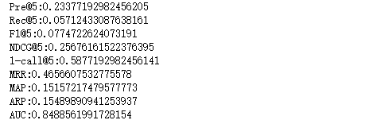

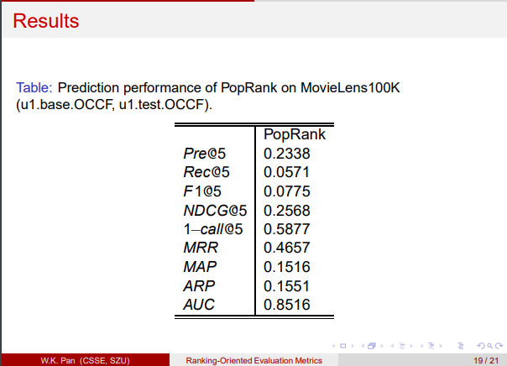

## Memory-Based One-Class Collaborative Fitering

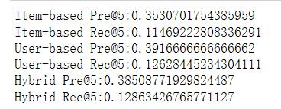

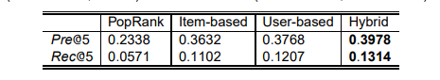

## Bayesian Personalized Ranking



