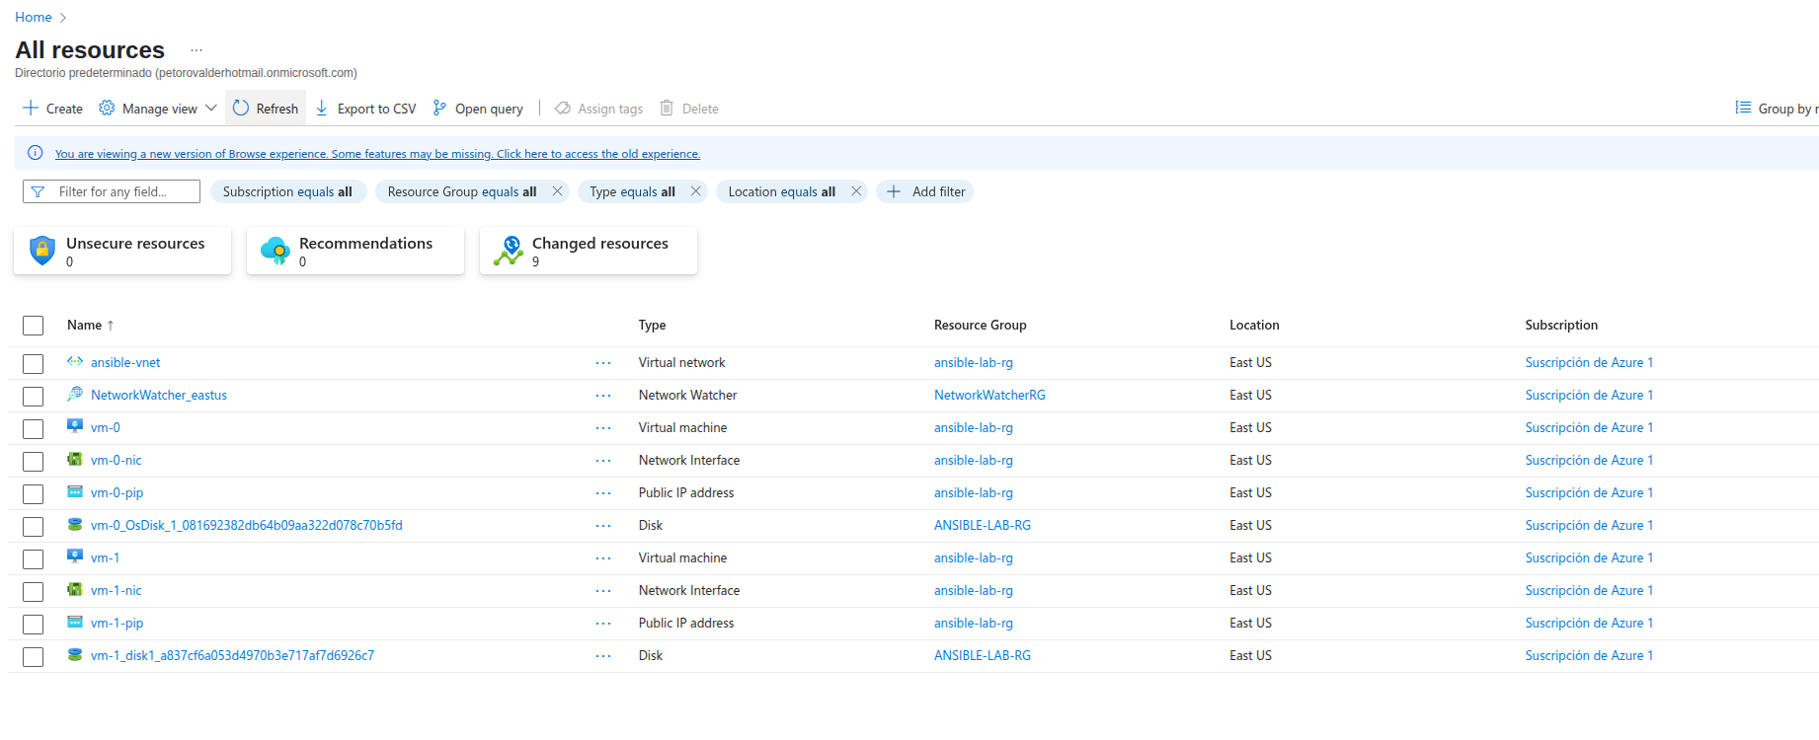
Conclusion:

This lab demonstrated my ability to configure and manage infrastructure in Azure using Ansible, implementing both static and dynamic inventories, and executing ad-hoc commands to manage resources. I deployed and configured services such as Nginx and MySQL on remote servers, troubleshooting permission issues, and validating the results with specific tests. The project demonstrated my understanding of basic automation, configuration management, and working with cloud environments, highlighting my ability to solve technical problems and efficiently document processes.

