Vm instances:

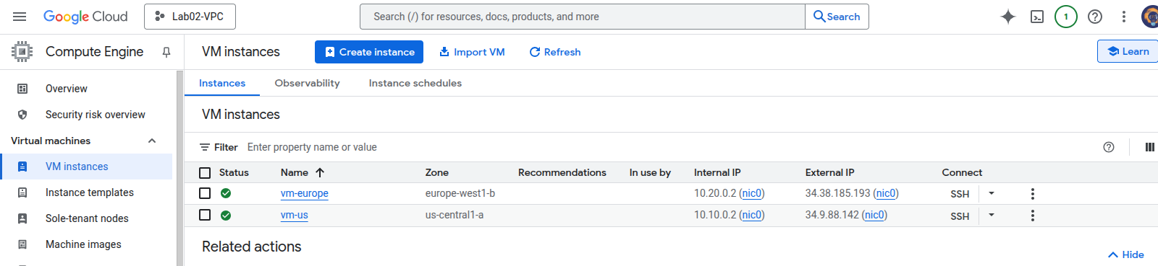
VPC:

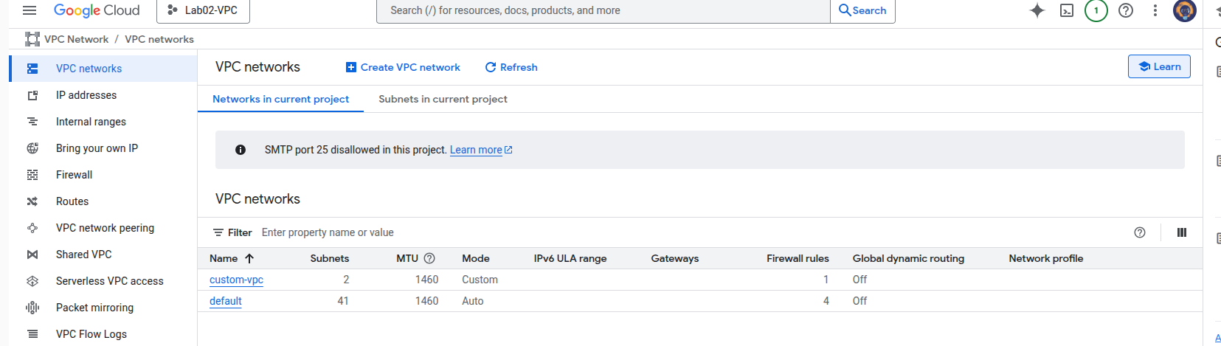
Firewall:

