VPC
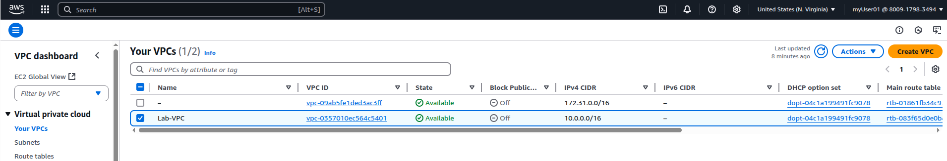
EC2

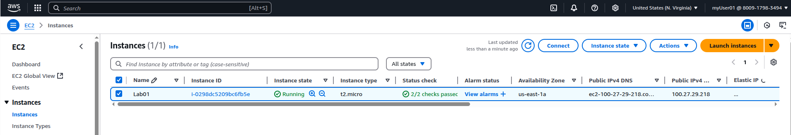
SG

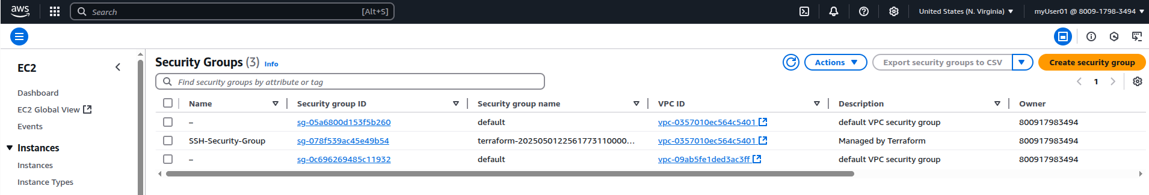
Internet GW:

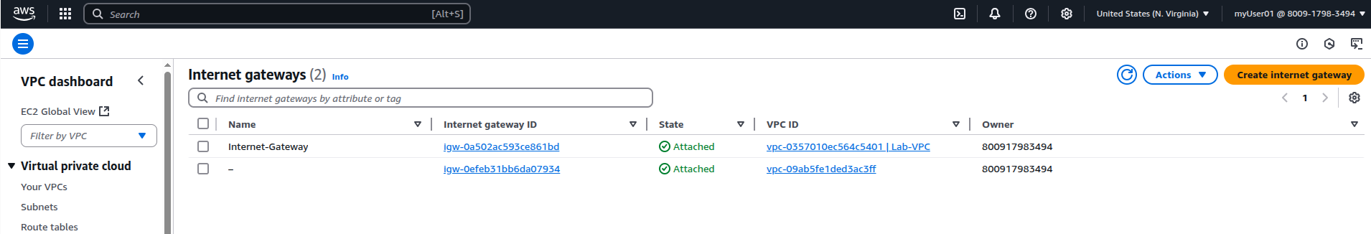
Route table

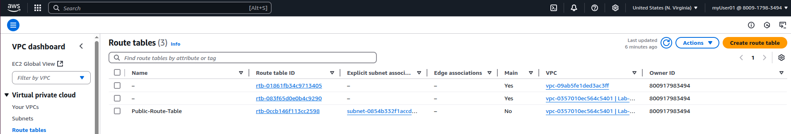

Subnets

