VPC:

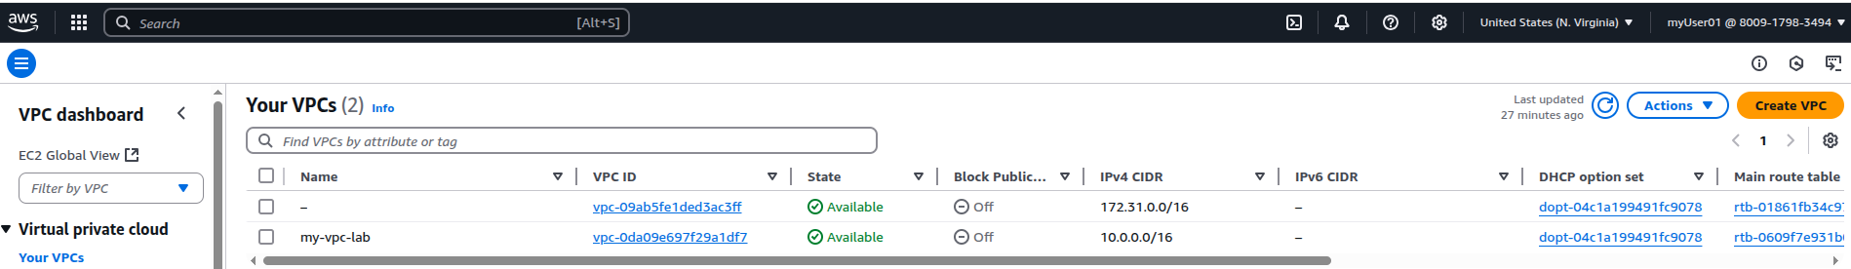
EC2:

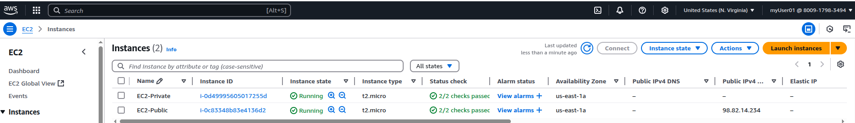
EC2 Private:

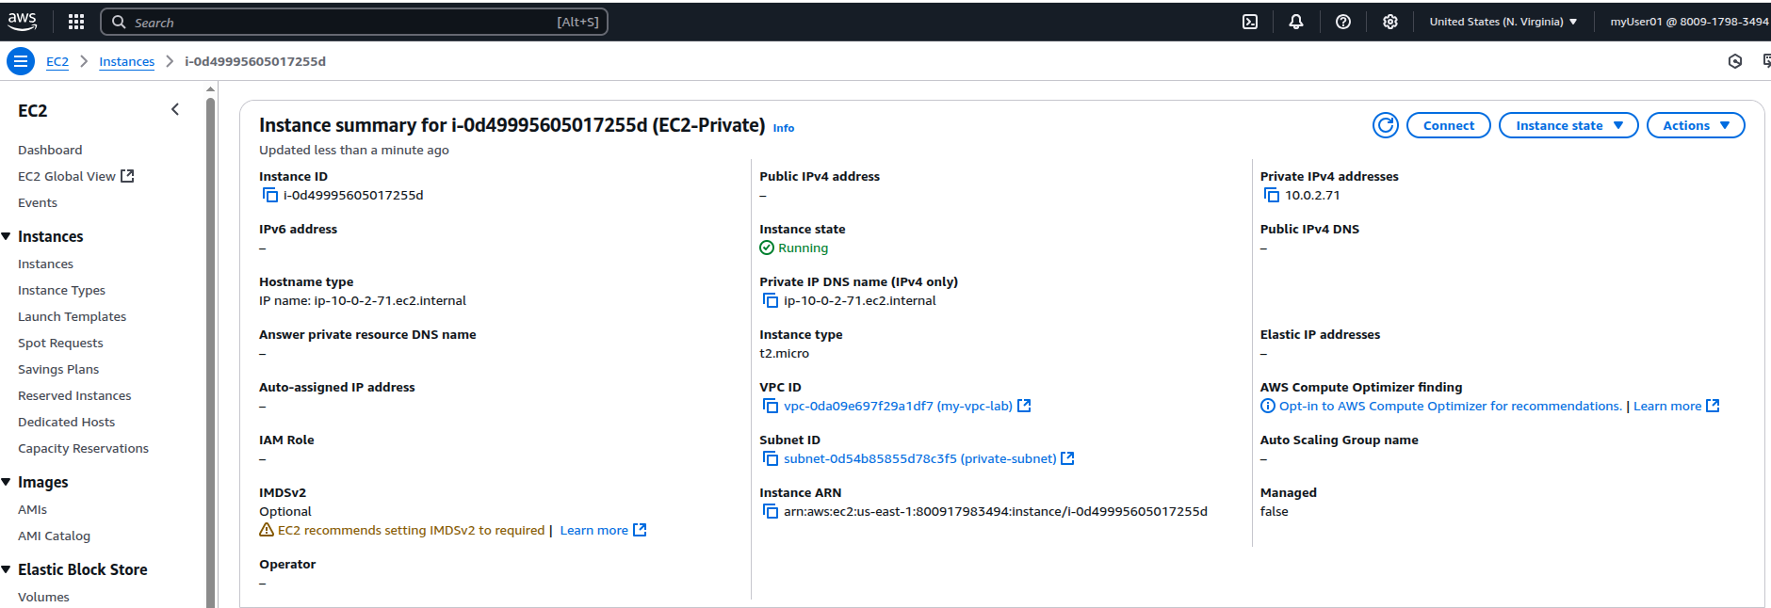
EC2 Public:

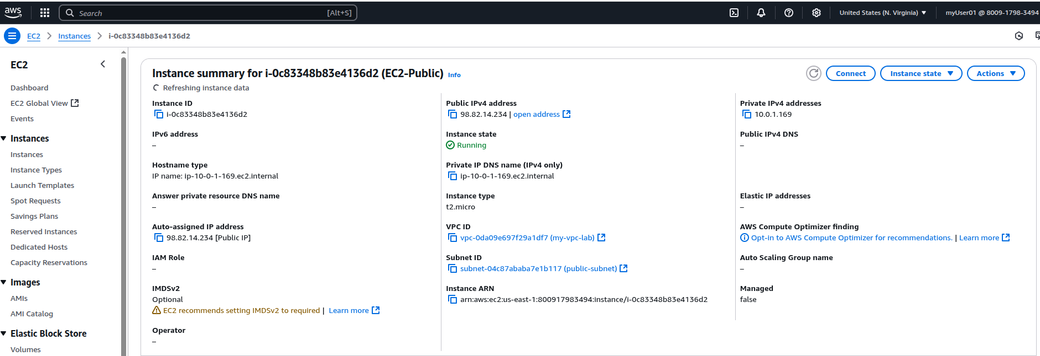

Internet GW:

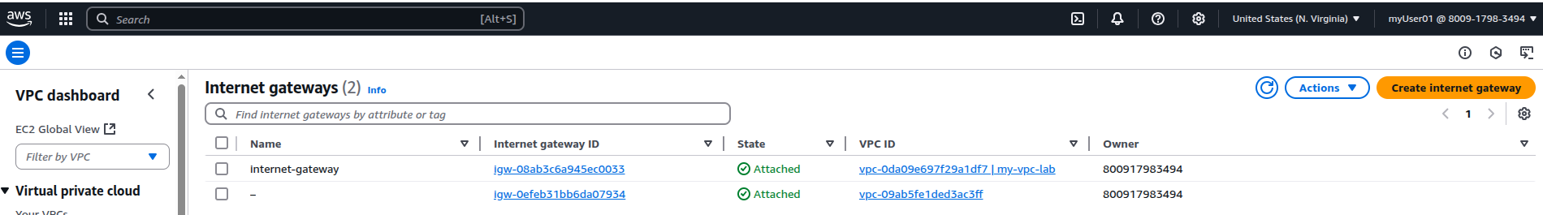
Subnet:

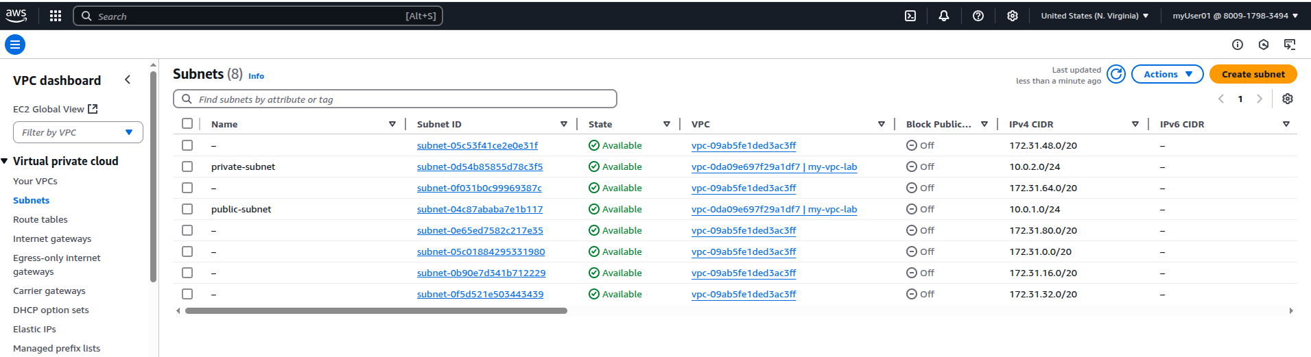
Route table:

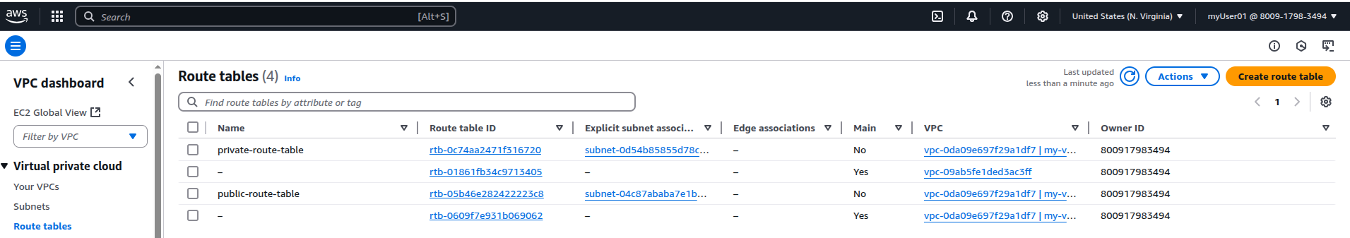
Security group:

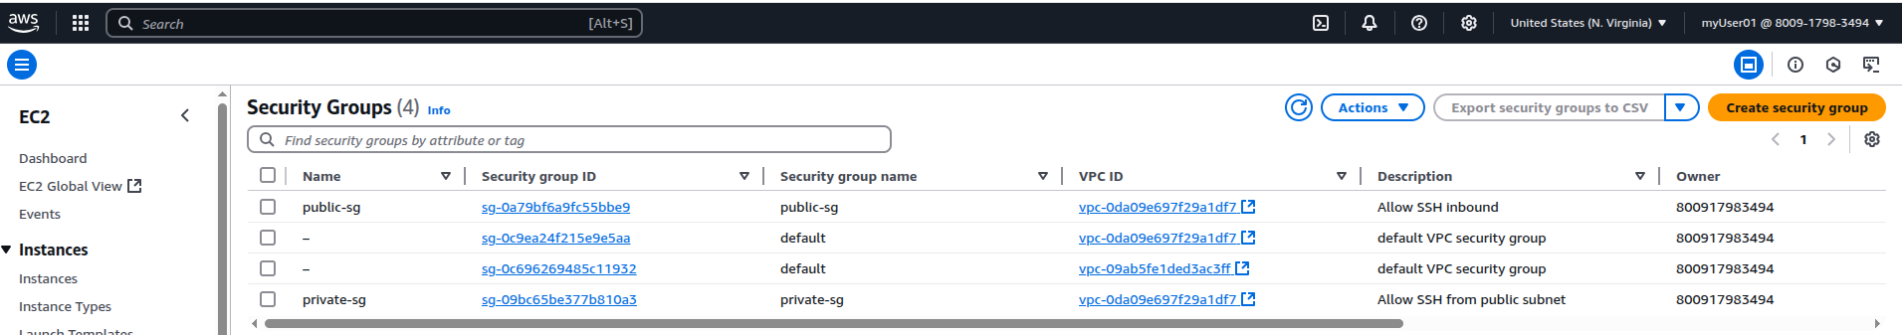
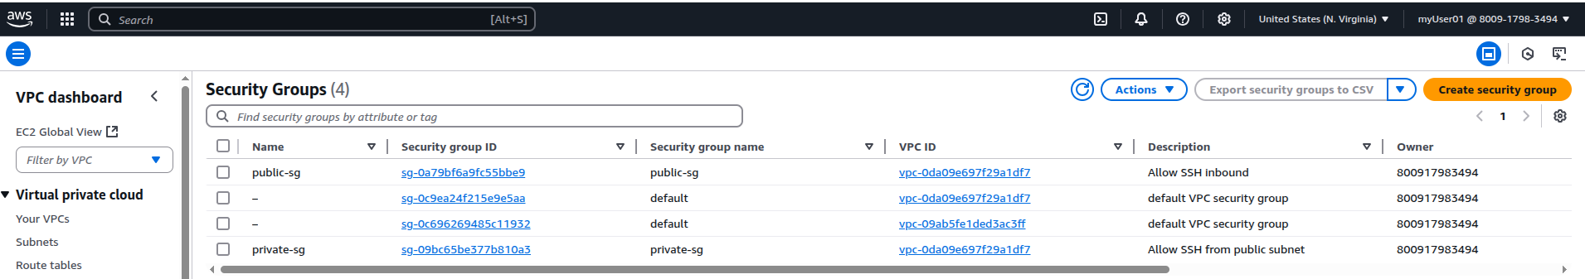

🧪 Checks performed
• SSH directly to public EC2
• SSH from public EC2 to private EC2
• Curl from private EC2 to the internet (amazon.com)
• NAT Gateway working

