Lambda:
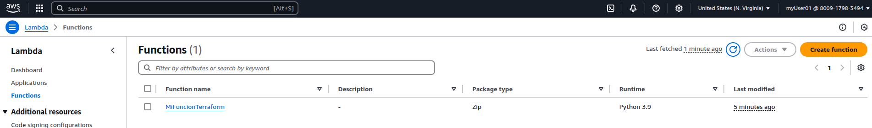
DynamoDB:
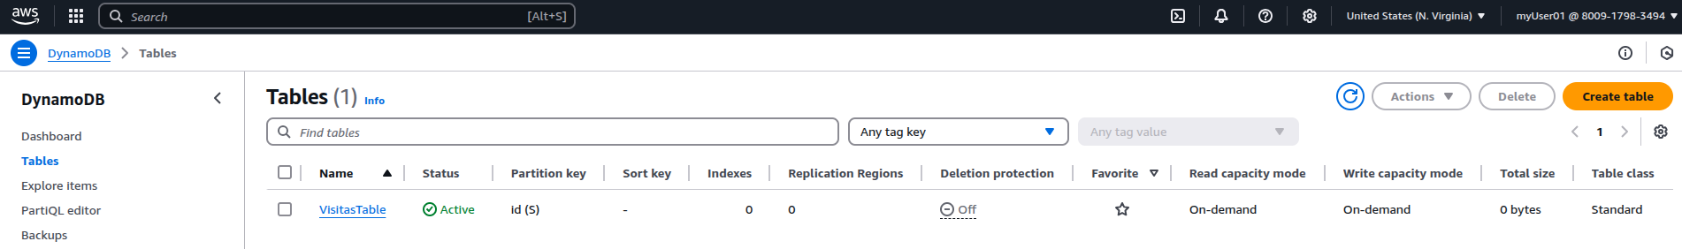
API GW:
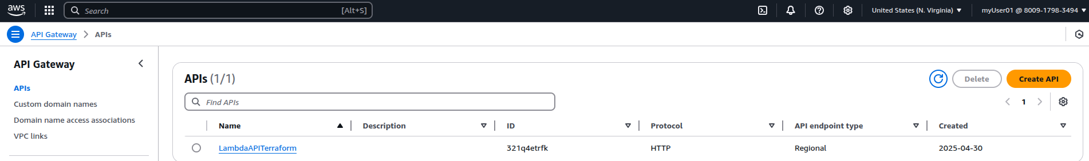
Web:
