Azure resources:

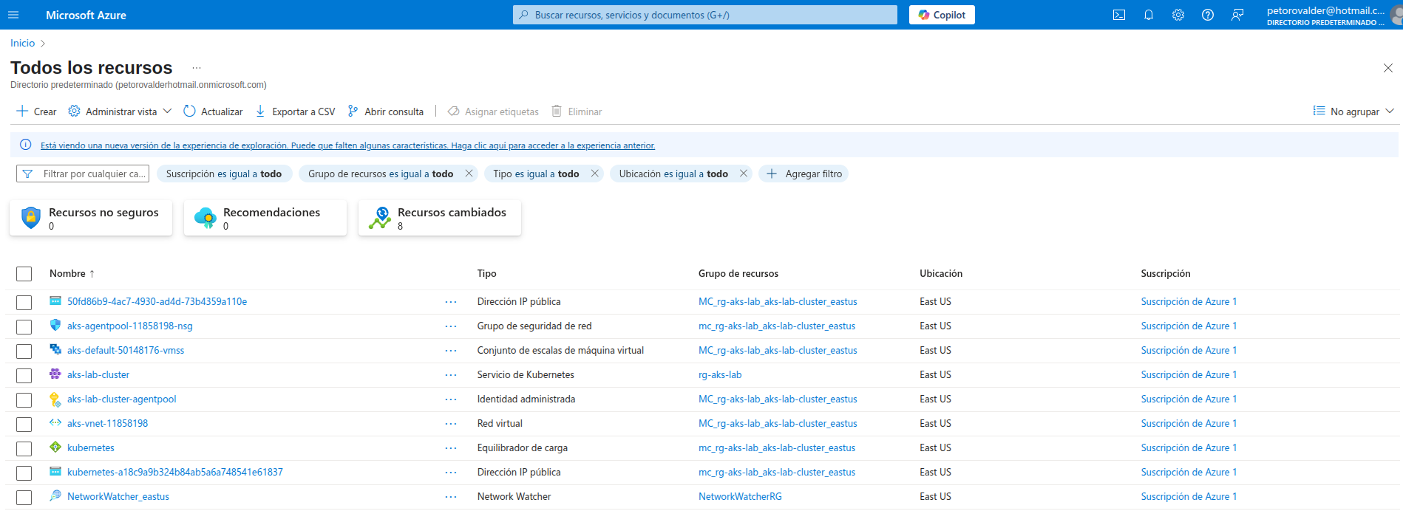
K8s cluster:
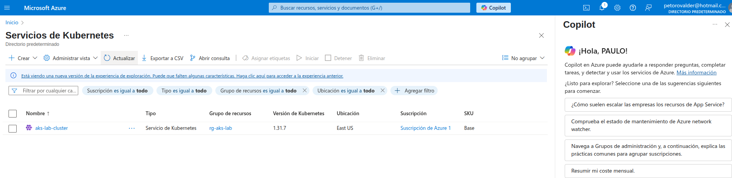
Web:

