

Infrastructure Administration
Requirements & Functional Specifications

Release 0.9
20th July 2004

eGovernments Foundation
www.egovernments.org
Copyright © 2004 eGovernments Foundation, All Rights Reserved.

Document Version History
Version | Date | Author | Comments

Legal Disclaimer
eGovernments Foundation its members, officers, directors, employees, or agents shall not be liable for any injury, loss, damages, financial or otherwise, arising from, related to, or caused by the use of this document or the specifications herein, as well as associated guidelines and schemas. The use of said specifications shall constitute your express consent to the foregoing exculpation.
Copyright
eGovernments Foundation. All rights reserved. No part of this publication may be reproduced, stored in a retrieval system, or transmitted, in any form or by any means, electronic, mechanical, photocopying, recording, or otherwise, without the prior written permission of the publisher.
Trademarks
eGovernments Foundation and eGovernments Foundation logo are trademarks or registered trademarks of "eGovernments Foundation," a non-profit organization. All other product names and company logos mentioned herein are the trademarks of their respective owners. In the best effort, all terms mentioned in this document that are known to be trademarks or registered trademarks have been appropriately recognized in the first occurrence of the term.
Table of Contents

Document Version History 2
1. Introduction 6
1.1 Assumptions 7
2. Definitions 8
3. Change Request List 9
4. Feature Matrix 10
5. Role to Functionality Mapping 11
6. Functionalities 12
6.1 Hierarchy Set up 12
6.1.1 Modules Interdependency 12
6.1.2 Validation 12
6.1.3 API’s 13
6.1.4 Tables 13
6.1.5 UI Screen Shots 13
6.2 Boundary Type for Hierarchy 13
6.2.1 Modules Interdependency 13
6.2.2 Validation 13
6.2.3 API’s 13
6.2.4 Tables 14
6.2.5 UI Screen Shots 14
6.3 City Set up/Create Root Boundary 15
6.3.1 Tables 15
6.3.2 Post Conditions 15
6.3.3 Use Case 15
6.3.4 UI Screen Shots 15
6.3.5 Modules Interdependency 17
6.4 Boundary/Field Values 17
6.4.1 Preconditions 17
6.4.2 UI Screen Shots 17
6.4.3 Modules Interdependency 19
6.4.4 Boundary Conditions if any 19
6.5 Module Set up 20
6.5.1 Use Case 20
6.5.2 UI Screen Shots 20
6.5.3 Modules Interdependency 21
6.5.4 Boundary Conditions if any 21
6.6 Action Set up 22
6.6.1 Actors and Responsibilities 22
6.6.2 Preconditions 22
6.6.3 Post Conditions 22
6.6.4 Use Case 22
6.6.5 UI Screen Shots 23
6.6.6 Modules Interdependency 23
6.6.7 Assumptions 24
6.6.8 State Transition 24
6.6.9 Boundary Conditions if any 24
6.7 Role Creation 24
6.7.1 Preconditions 24
6.7.2 Post Conditions 24
6.7.3 Use Case 24
6.7.4 UI Screen Shots 24
6.7.5 Modules Interdependency 24
6.8 Role Module and Action Mapping 24
6.8.1 Actors and Responsibilities 25
6.8.2 Preconditions 25
6.8.3 Use Case 25
6.8.4 UI Screen Shots 25
6.8.5 Modules Interdependency 25
6.8.6 State Transition 25
6.8.7 Boundary Conditions if any 26
26
6.9 Set up Department 26
6.9.1 API’s 26
6.9.2 Tables 26
6.9.3 UI Screen Shots 26
6.9.4 Modules Interdependency 26
6.9.5 Assumptions 26
6.9.6 State Transition 26
6.9.7 Boundary Conditions if any 26
6.10 Create Employee with Department/Designation and Field 26
6.11 Create Designation and Positions 27
6.11.1 Modules Interdependency 27
6.11.2 API’s 27
6.11.3 Tables 27
6.11.4 UI Screen Shots
27
6.11.5 Assumptions 27
6.12 Create Approval Object Types, Status and Transitions 27
6.12.1 Modules Interdependency 28
6.12.2 API’s 28
28
6.12.3 Tables 28
6.12.4 UI Screen Shots
28
6.13 Create/Edit Users and Assign Role to Users 29
6.13.1 Modules Interdependency 29
6.13.2 API’s 29
6.13.3 Tables 29
6.13.4 UI Screen Shots 29
6.13.5 Modules Interdependency 29
6.13.6 Assumptions 29
6.13.7 State Transition 29
29
6.14 Create Designation with Hierarchy 29
6.14.1 Modules Interdependency 30
6.14.2 API’s 30
6.14.3 Tables 30
6.14.4 UI Screen Shots 30
6.14.5 Modules Interdependency 30
6.14.6 Assumptions 30
6.14.7 State Transition 30
6.14.8 Boundary Conditions if any 30
6.15 30
6.16 Building of Menu Tree 31
6.16.1 Modules Interdependency 31
6.16.2 API’s 31
6.16.3 UI Screen Shots 31
6.16.4 Assumptions 31
6.16.5 Boundary Conditions if any 31
6.17 User Favorites 31
6.17.1 Modules Interdependency 31
6.17.2 API’s 31
6.17.3 Tables 31
6.17.4 UI Screen Shots 32
6.17.5 Assumptions 32
6.17.6 State Transition 32
6.17.7 Boundary Conditions if any 32

Introduction
The Admin Tool is a common Platform across applications to set up the eGov Suite of Applications, create users and allow
to various features in the applications. Using this module the Administrator should be able to set up the entire system using the administrative module. A single database schema should support all the applications.

This does not cover the administration of individual applications. Individual Applications would have their own administrative module managed by Application Administrators

The system will come with the seed data which will enable the Super Admin to log in and make the desired changes.

Create Employee
  - Employee Jurisdiction (multiple values) – the boundary types/values that the user can access. For instance, if the user is assigned Ward as a jurisdiction type, the list of wards he/she may have access to can be defined here. For instance, in eGov PGR, each complaint type may be assigned a role (from the administrative hierarchy) responsible for redressal of the complaint. To ensure that the complaint is routed to the right official, the user-jurisdiction mapping may be used to determine the user to whom the complaint must be routed.
  - Employee can be assigned to multiple divisions/fields/boundary
  - Field/role assignment must have a start/end date
  - Employee can belong to multiple departments

On a high level the following are the requirements of the System from the point of User administration and Role based access control are:

- The administrator must be able to define a hierarchy of boundary types. In a ULB, some cities (e.g. Delhi, Bangalore) have the following hierarchy: City ->Zone-> Ward->Block->Street etc while the smaller ULBs have City -> Ward as the boundary type.
- Once the hierarchy of boundary types is defined, the administrator user must be able to define values for each boundary type. Except for the root node (ie the top-level boundary node), the user must have the ability to define multiple values at all levels in the hierarchy. The system should support the ‘from and to date’ for each of the boundary values.
- The administrator user must be able to create Departments with the following details:
  - Department Code
  - Department Name
  - Description
- The administrator user must be able to create Role
- The administrator user must be able to create Users with the following attributes:
  - First Name
  - Middle Name
  - Last Name
  - Salutation
  - User Name
  - User Role – User can have multiple roles with a start and end date
  - User - needs to have a type: employee, contractor, citizen etc
- Administrator should be able to set up Modules and Actions with in those modules
- Administrator should be able to configure what which role can perform which actions

The following figure describes the high level flow which the Administrator would typically perform to set up the system:

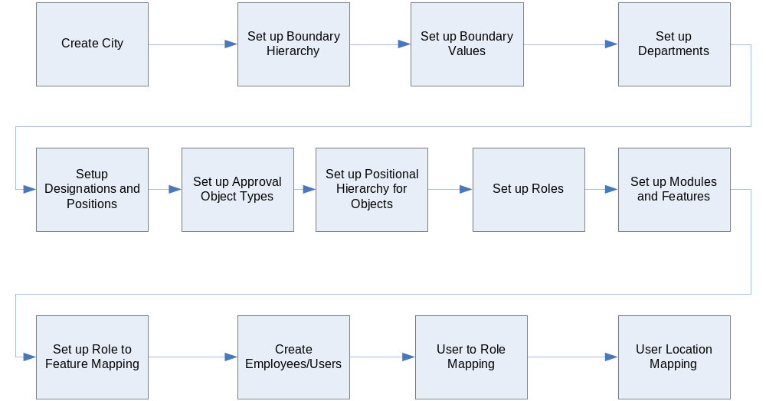

Assumptions
- Each ULB will have its own database. There will not be multiple ULB’s in the same database schema.(What in the case of Rural??)
- The database has to support all eGov applications for a given ULB.

Definitions
Super Admin: Administrator of Administrators. He will be the primary user of this system and will be responsible for set up which affects all the other applications.
Application Administrator: The administrator of the individual applications. A single Administrator may be charge of multiple Applications
ULB: Represents the ULB
Hierarchy type: The ULB can have multiple hierarchy types. Administrative, Birth and Death, Health etc
Boundary Type: The Boundary types organized in an order with in a Hierarchy. Eg: Zone, Ward etc
Boundary/Field/Division: All the above terms are used interchangeably. The Actual values of the Boundary types. Eg; Ward 2 etc
Employee: The person who is employed by ULB to do certain functions of the ULB.
Department: ULB has a set of Departments. Department has a set of Employees.
Users: The Users of the application. Users can be activated, deactivated for various points of time.
Designation: Each Employee has a given designation. Eg: Assistant Engineer, Revenue Officer etc.
Position: There are a fixed number of posts for each designation. Example: there are 4 Zonal Chief Engineers in Bangalore. West Zone Chief Engineer is one position.
Approval Objects: Some objects in the system like Payslip, C-Bill, Leave etc go through a approval cycle. These objects have been termed as Approval Objects.
Position Hierarchy: The positions in the organization have a hierarchy based on which the applications are routed. Since the routing of applications is based on the application type, multiple positional hierarchies are defined for different application types. Eg: For Purchase Order less than 50 thousand, the approval hierarchy is JE→ AE→Accountant→Commissioner. For Bills, the approval hierarchy is JE→ Accountant→ Commissioner etc.
Role: Primarily used for Access control. User can have multiple roles in the system. System can be configured to allow certain actions to a given role.
Modules: The Application eg: Financials, PGR etc. Modules can be composed of Sub modules. E.g: Financials has sub modules for Receipts, Payments etc.
Action: The various actions performed by a user. Action belongs a particular module/sub module.

Change Request List

Sl no | Change Request Number | Change requested | Date of Request | Date of Completion | Status | Release/Patch Number

Feature Matrix
The following figure describes the various modules in the system and the relation ship between the modules

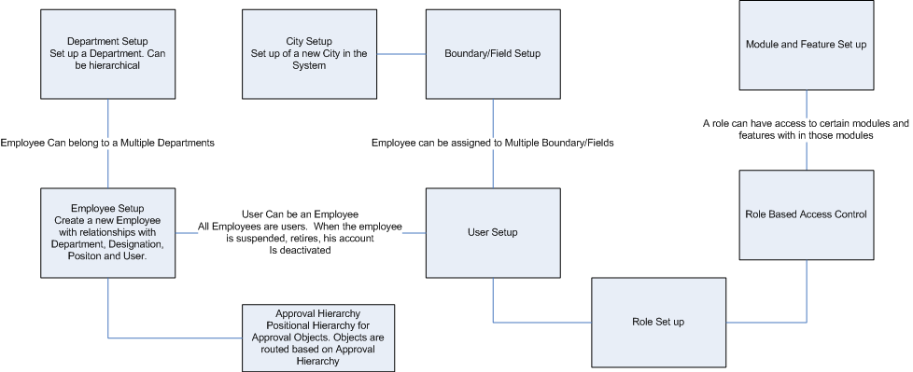

 | Module | Feature Name | Dependency | Phase | Priority
 | City Setup | Set up City Website
 | Department Setup | Create Department
 | Boundary/Field Setup | Create Hierarchy types
 |  | Create Boundary/Field Types
 |  | Create Boundary/Field Values
 | Employee Setup | Create/Edit Employee with Department/Designation and Field/Role
 |  | Activate/Deactivate Employee
 | Designation Setup | Create Designation
 | Module/Action Setup | Set up Modules, Submodules and the hierarchy
 | Role | Create new Role
 |  | Assign Roles to Actions
 | Building of Menu Tree | Build the Menu Tree of for the user based on the Users Access Permissions
 | Favorites | Set up and Edit My Favorites
 | Positional Hierarchy for Approval Objects | Set up Approval Objects
 |  | Set up the Positional Hierarchy for Approval Objects

Role to Functionality Mapping
All Functionality would be available to the Super Admin Users.
Using this module we should be able to create roles for Application Administrators who will be able to manage only their respective Modules.

Functionalities

Hierarchy Set up
Every City can have a multiple hierarchy types. Hierarchy set up is used to set up these hierarchy types. The hierarchy types can be different for different cities and different applications.
Eg: Revenue and Birth and Death have different hierarchy types

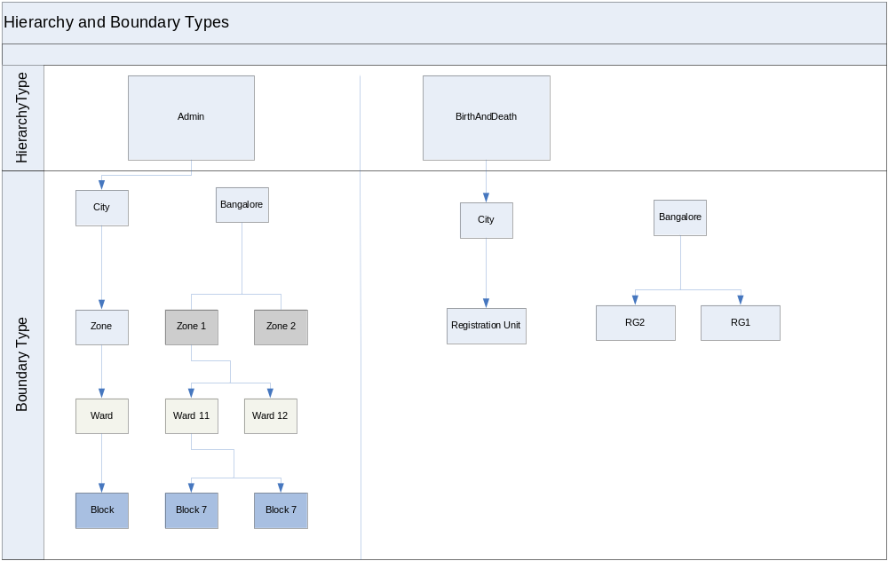

For example in the following figure the city of Bangalore has 2 hierarchy types Admin and Birth and Death. The admin hierarchy type has the following Boundary types with the parent child relationship. City→Zone→Ward→Block. Bangalore is the city having Zone 1 and Zone 2 as its children. Wards Ward 1 and Ward 2 are the children of Zone Zone 1 and so on.

Birth and Death Hierarchy type has city and registration unit as the boundary types.

Modules Interdependency
Boundary Type module depends on the Hierarchy type.

Validation
Hierarchy Type Values should be Unique.
We should not be able to delete a Hierarchy if there is any Boundary type which belongs to that hierarchy type.

API’s
List<HierarchyType> getHierarchyTypes();

Tables
EG_HEIRARCHY_TYPE

UI Screen Shots

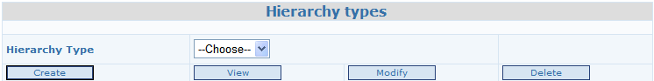

Table Name | EG_HEIRARCHY_TYPE
Label Name | Label Type | Value | Validation
Hierarchy Type Name | Textbox | Alphanumeric | Required. Unique
Hierarchy Type Code | Textbox | Alphanumeric | Required. Unique

Boundary Type for Hierarchy
In each of the Hierarchy types, we can set up a hierarchy of Boundary types. For example Admin Boundary Can be
City → 1
Zone → 2
Ward → 3
Where a city has multiple Zones and each zone has one or more wards.
Hierarchy would be automatically calculated as the next number based on the parent of this Boundary type. For Root Boundary types, the hierarchy would be 1

Modules Interdependency
Boundary depends on the Boundary type

Validation
Boundary type can be deleted only if there are no boundary values inside it

API’s
List<BoundaryType> getBoundaryTypes (String hierarchyCode)
List<BoundaryType> getBoundaryTypes (HierarchyType)

Tables
EG_BOUNDARY_TYPE

UI Screen Shots

Create Boundary Type Screen Shot when the no boundary type exists for a given hierarchy type

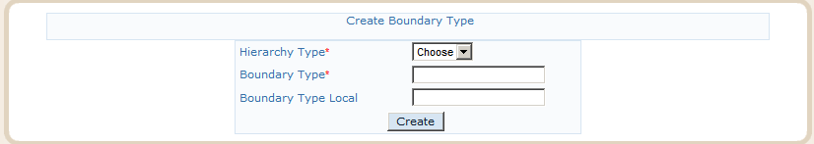

Screen to View/Modify/Add Child Boundary
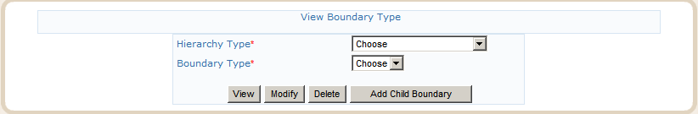

Screen to Add a child Boundary shown after clicking the Add child Boundary in the above screen

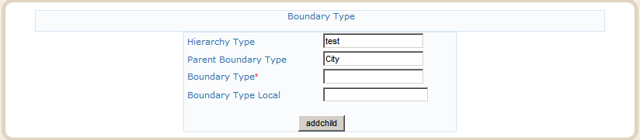

EG_BOUNDARY_TYPE
Label Name | Type | Value | Validation | Default | Remarks
Hierarchy Type | Combo Box |  | Required. Only a few hierarchy types are shown in the srop down. What is the criteria?
Boundary Type Name | Textbox | Alphanumeric | Required. Unique
Boundary Type Name Local | Textbox | Alphanumeric

We should not be able to delete any Boundary type if there are Boundaries that belong to this Boundary type.

City Set up/Create Root Boundary
This would involve setting up the City Boundary Set up in the System.

Tables
  - EG_BOUNDARY
  - EG_CITY_WEBSITE
  - COMPANYDETAIL

Post Conditions
A new city with the Name and the URL will be created.

Use Case

UI Screen Shots

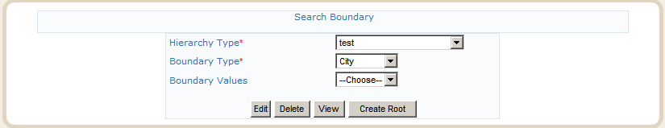
Entry Screen to create a City/Root Boundary
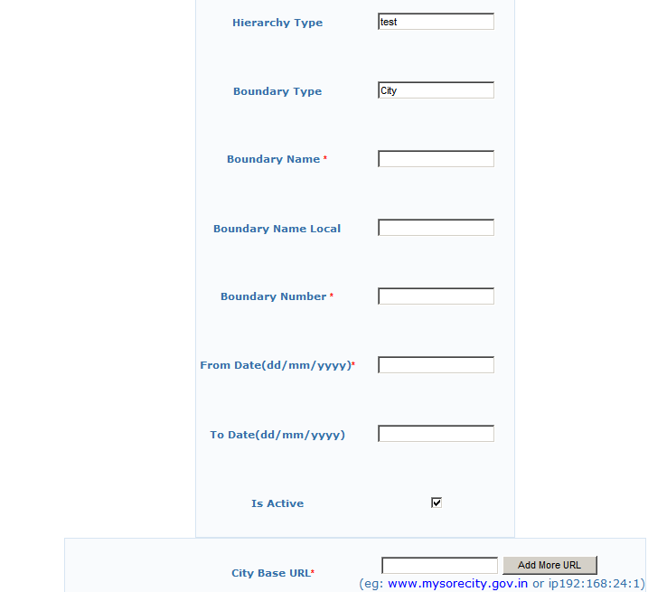
Screen to create a City/Root Boundary

Label Name | Type | Value | Validation | Notes
Hierarchy Type | Read only based on the input of entry screen |  | Required
Boundary Type | Read only based on the input of entry screen |  | Required. | Root Boundary type for the chosen Hierarchy type
Boundary Name | Text Box | Alphanumeric | Required and Unique | The Name of the city mentioned here will be used for displaying the name in the Header
Boundary Name Local | Text Box | Alphanumeric
Boundary Number | Text Box | Numeric
From Date | Text Box | Date
To Date | Text Box | Date
Is Active | Boolean |  | Required. Default Value Yes
City Base URL | Text Box | Alphanumeric | Required | There can be multiple URL's for the same city. We can also enter IP address instead of the Domain Name. The IP address needs to be entered in the format ip192:178:1:78(Should start with the word ip and then the IP address separated by ☺

Modules Interdependency
Boundary. Database connections and Hibernate Session Factory modules depend directly on this module. Based on the URL entered by the citizen, the Thread Locals are populated and Connection and Hibernate Session Factory select the target database based on the URL. The URL should also be entered in the egov_config.xml file for the Hibernate Session factory and the Database connection.

Boundary/Field Values
Each Boundary/Field type can have many values. eG; Under Hierarchy type Admin Boundary type Ward can have various Boundaries like Ward 1, Ward 2 etc. Ward 1 and Ward 2 are referred as Boundary Values.
Works are carried out in a specific or multiple Boundaries. Users are assigned to specific Boundaries.
New Boundaries might be created. Old Boundaries might be deactivated. The system should allow for this along with the dates of activation and deactivation.

Preconditions
Hierarchy, Boundary Types and the root boundaries must exist.

UI Screen Shots
The user will navigate to the View Screen of the parent for which he wants to create the boundary and click on add Child Boundaries to come to the Add Boundary Values page.

The Already existing children for that parent will be shown in a read only mode while the user can add multiple child boundaries for the selected parent.

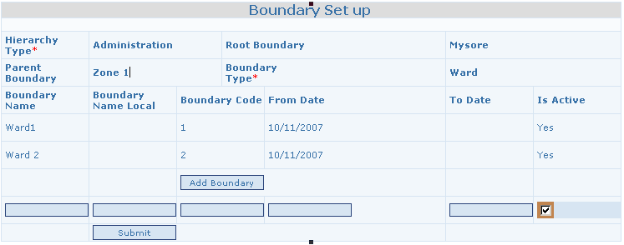

EG_BOUNDARY
Label Name | Type | Value | Validation | Default | Notes
Hierarchy Type | Label | The Hierarchy type of the parent boundary
Root Boundary | Label | The root boundary
Parent Boundary | Label | The parent boundary
Boundary Type | Label | The Boundary type being created
Boundary Name | Label/Textbox | Alphanumeric | Required
Boundary Name Local | Label/Textbox | Alphanumeric
Boundary Number |  |  | Required. Boundary Number should be unique with in the Parent Boundary selected below |  | Can we make it a number or should it be alphanumeric
From date | Label/Textbox | Date
To Date | Label/Textbox | Date
Is Active | Label/Textbox | Boolean |  | TRUE

What are the effects of a Boundary Being Inactive?

Modules Interdependency
- User Jurisdiction
- Ward Works
- Ward Information
- Birth and Death Registration
- Property Tax
- Financials

Boundary Conditions if any
What happens in the case if the boundary is deactivated when there are active items pending against that boundary? Individual

Module Set up
Each Application in the eGov Suite is called a Module. Each of these modules can be subdivided into sub-modules and the Sub-modules will have a number of features.
Module/Sub module will be enabled for a ULB from this screen.

There can be any level of Hierarchy with in the Modules.

Use Case

UI Screen Shots
The following screen shot is used to set up modules in the system

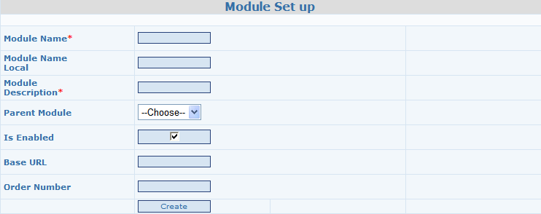

EG_MODULE
Label Name | Type | Value | Validation | Default | Remarks
Module Name | TextBox | Alphanumeric | Required |  | Application Name
Module Name Local | TextBox | Alphanumeric |  |  | Application Name
Module Description | TextBox | Alphanumeric | Required |  | Might be used for Tool Tip
Parent Module | Combo Box |  |  |  | List of All the modules in the System
IsEnabled | Check Box | Boolean | Required | Yes
Base URL | TextBox | Alphanumeric | Required |  | Is this Required?
Order Number | Text Box | Numeric | Required if Parent Module is selected |  | The order in which the Submodule should come in the menu tree

In the next phase we can have a single screen to enable/disable all the Modules instead of going to individual screen to enable/disable the modules. If the modules are already set up, then the following screen can be used to enable/disable the modules. This will be a tree like structure with Module names as nodes and features as leaves. There will be a check box at each node level and the feature level. If the checkbox is selected at the node level then all the features under it would be available. The user can also alternatively allow access to individual features by clicking on the checkbox next to leaf nodes.

Modules Interdependency
Menu Tree Build up
Role based Security

Boundary Conditions if any

Action Set up
A module/sub module can have multiple actions. They are the leaf level nodes in the menu tree or individual Action Classes and JSP’s. There should be an entry in the Action table for each and every JSP/HTML/Action class in the System. Each Action is Uniquely identified by it’s name. Action will always have a URL by which we can access it which can be broken into 3 components
- Domain name
- Base URL and
- Query Params.
Eg: http://www.egovernments.org/payment/Supplier.jsp?mode=Cheque&id=238&amount=3000&suppid=430
has
Domain Name: http://www.egovernments.org
Base URL: /payment/Supplier.jsp
and the query Params: mode=Cheque&id=238&amount=3000&suppid=430
Access to the action will be controlled on Base URL and the Query Params. Multiple Actions can have the Same Base URL but the Base URL and Query Params combination must be unique.
Base URL and Query Params will be used along with Role Action mapping to allow/disallow access to a given action for a given user.
The Query Params entered in the action can be a subset of the params in the complete URL as only params required for access control are required in the Action Set up.
What should be the default policy? Allow or disallow

Actors and Responsibilities

Preconditions
The Module/Sub Module should exist in the system.

Post Conditions
A new action is created in the system

Use Case
Whenever a new feature is released which results in the creation of new JSP/Action classes, there should be an entry in the action class and appropriate entries made in the Role Action Mapping

UI Screen Shots
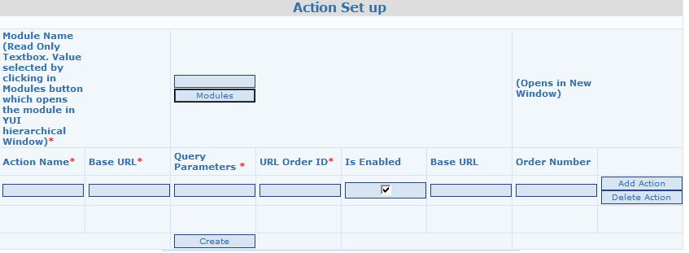
The UI can be used for setting up all the actions in a module/submodule. There will be a single row to select the module and multiple rows for setting up the actions in that module
EG_ACTION
Label Name | Type | Value | Validation |  | Default | Remarks
Module | Tree based on YUI | List of All Modules from the EG_MODULES table | Required |  |  | Foreign Key to EG_MODULES
Action Name | TextBox | Alphanumeic | Required |  |  | Application Name
Base URL | TextBox | Alphanumeic | Required |  |  | URL without the domain name
Query Params | TextBox | Alphanumeic | Required |  |  | Query Params which are unique for this action
URL Order ID |  |  | For a combination of URL and Query Params, URL Order ID should be Unique |  |  | Order Id is used to retrive the associated action. Specific matches should have higher url ordered.
Is Enabled | Checkbox | Boolean | Required | Default to true |  | Is the Action enabled for this client.
Order Number | Textbox | Number | Required |  |  | The order in which the Action would be shown in the Menu tree.
Display name | TextBox | Alphanumeic |  |  |  | Display title that appears in menu tree. If not specified, Action name is taken

Modules Interdependency
Role based security
Menu Tree Build Up

Assumptions
Create, View, Modify and Delete would be entered as different actions and would have different URL’s (at the minimum query params will be different).

State Transition

Boundary Conditions if any

Role Creation
This screen will be used to create different roles in the system. User can be assigned to multiple Roles. Roles will only be used for access control in the system.

Preconditions
The role with the given name should not exist in the system.

Post Conditions
A new role is created.
If the role is deleted from the system, then that role should be removed from all the users in the system. The entries should also be removed from the Role Action Mapping as well.

Use Case

UI Screen Shots
EG_ROLES
Label Name | Type | Value | Validation | Default | Remarks
Role Name | TextBox | Alphanumeic | Required and Unique. |  | Name of the Role

Modules Interdependency
Role based Access control
Menu Tree Creation
User Role Assignment

Role Module and Action Mapping
A Role can be given access to certain modules/actions in the system. The creation of modules/actions has been explained in the previous sections. The mapping will be used to allow access to features in the system based on the role of the logged in user.
The role can be allowed an access to an entire module in which case he will have access to all the actions under that role. Alternatively he can be allowed access to individual actions with in a given module.

The user can have multiple roles. In this case, if any role allows access to the action, the RBAC shall allow the access to the user.

The screen will be used to both view as well as editing the role to action mapping.

Actors and Responsibilities

Preconditions

Use Case

UI Screen Shots
The user will first be presented with the following screen from where he can enable/disable access to the features
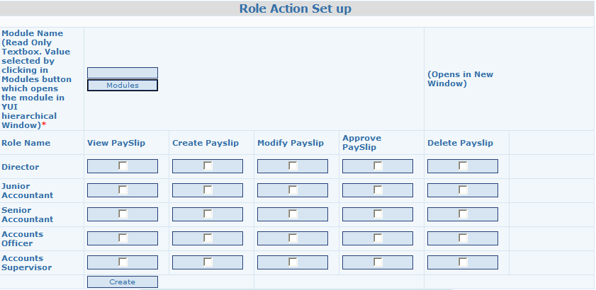

Modules Interdependency
Menu Tree
Role Based Access Control

State Transition

Boundary Conditions if any

Set up Department
Each ULB has a set of Departments. The following screen models the Department in the ULB. This screen can be used to create/modify/delate the Departments. Department once created cannot be deleted if there are any users created under the

API’s
List getDeptList()
List getUsersinDept(Department) // Returns only the current active users in the department

Tables
EG_DEPARTMENT, EG_DEPARTMENT_ADDRESS

UI Screen Shots
EG_DEPARTMENT
Label Name | Type | Value | Validation | Default | Remarks
Department Name | TextBox | Alphanumeric | Required and Unique. |  | Name of the Department
Department Address | TextBox | Alphanumeric
Department Code | TextBox | Alphanumeric | Alphanumeric
IsBillingLocation | Radio Button | Yes/No |  | No
Parent Department | Combo Box | List of All the departments in System |  |  | Not sure how will we use this?

Modules Interdependency
Employee, Location, Workflow

Assumptions

State Transition

Boundary Conditions if any

Create Employee with Department/Designation and Field
This is a part of the PIMS Specifications. All Employees would be created as users in the system.

Create Designation and Positions
A department will have a number of designations. For each designation there will be a number of positions. Each position will have a name and a number of positions.

During the employee creation phase, the employee would be assigned a designation.

Modules Interdependency
Each Employee would be assigned a position with in a Designation.
The Routing of approval objects will be based on the type of object and Position of the Employee.

API’s
CreateDesignation(Designation designation)
getNumberOfPosts(Designation)
getNumberOfBalancePosts(Designation)
getNumberOfPosts(Designation design, Position)
getNumberOfBalancePosts(Designation design, Position)

Tables
EG_DESIGNATION, EG_POSITION

UI Screen Shots
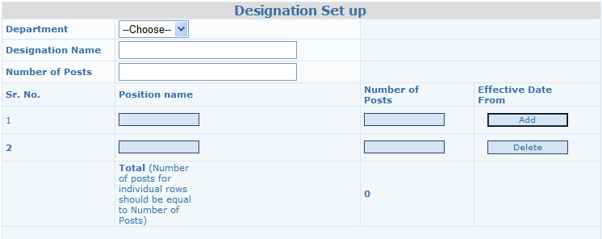
For each of the position, an entry in the master would be created with the number of positions. How do we handle Edit??

Assumptions

Create Approval Object Types, Status and Transitions
Approval Objects are the object types which will be routed through the workflow. eG; of the same are: Payslip, CBill, Leave etc. These objects have different states which are configured in JBPM. In each of there states, there will be transitions. Based on the Object type, current state and the transition, the object will be send to the next position.

Approval Objects are the object types which will be routed through the workflow. eG; of the same are: Payslip, CBill, Leave etc.

Modules Interdependency
The Routing of approval objects will be based on the type of approval object

API’s
GetReportsToApprovalPosition(Position currPosition, ApprovalObject objtype, int State, int transition);
GetReportsToUser (User userid, ApprovalObject obj);
GetReporteeUser (User userid, ApprovalObject obj);

Tables
EG_APPROVAL_OBJECT
EGWORKS_STATUS
EG_TRANSITION
EG_POSITION_APPROVAL

UI Screen Shots
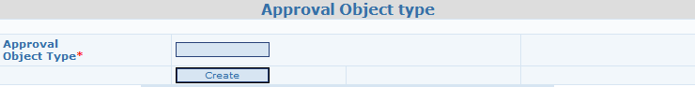
Approval Object Name should be unique.
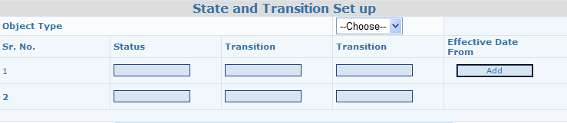
After the user selects the Object type, the user can enter the statuses and Transitions from that status. As of now only 2 Transitions are supported.
This would be used for Position based routing of Approval Objects

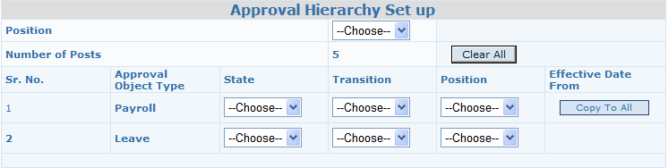
When the screen is populated, All the Approval Object types in the system would be populated. The user will select the position which he wishes to set up the hierarchy for. If the data is already set up for that position the existing data would be populated. When the user enters the first row and clicks on copy to all, then all approval object types would be populated with the same data. The user can then go to individual rows and save the data.

Create/Edit Users and Assign Role to Users
The user in the application can be created using this application (which will capture the bare minimum details) or the users can be created by individual applications by using the API’s provided by the User Module. Eg: PIMS module can create Employee as a user, Property Tax application can create citizen as a user and EGF can create Supplier as a user in the system. These modules will normally add more details as required by their respective modules and would be stored in the application scope.

The core User feature focused on the following:
- Create a user with User name, First/Middle and Last names and the password.
- The role of the user
- The field/Boundary of the user
- Making the user active/inactive and tracking the dates of active/inactive

Employee belongs to the department. User can belong to a department by the virtue of him being an employee.

Modules Interdependency
User is the basic unit on which all modules including application module depend on. Any changes to this should ensure backward compatibility to the older code base.

API’s
createUser()

Tables
EG_USER

UI Screen Shots

Modules Interdependency

Assumptions

State Transition

Create Designation with Hierarchy

Modules Interdependency

API’s

Tables

UI Screen Shots

Modules Interdependency

Assumptions

State Transition

Boundary Conditions if any

Building of Menu Tree
Menu Tree would be the fundamental way all the applications would launch individual pages. The Menu Tree would be based on the roles of the user and the actions allowed to the user. The tree would be hierarchical structure with Module as the root nodes and submodules as children and the Actions as the leaves. There can be any level of submodules. The mebutree should first show the user’s favorites if any and then build the remaining menutree.

Building Menu tree would be the service provided by this module.

Modules Interdependency
This module depends on the user, role and module & action submodules.

API’s

UI Screen Shots
Refer to the financials UI

Assumptions

Boundary Conditions if any

User Favorites
Based on the user’s primary work, s/he normally goes through the same set of links every time and it is troublesome for him/her to go through the complete hierarchy of the menu tree. There should be a facility for him to save the list of repetitive actions as favorites and these should appear at the top just below the root menu.

These actins can appear again in the normal hierarchy as well.

Modules Interdependency
Depends on the user, role and role-action mapping.

When the action is removed from the given role, then that action should also be removed from favorites of the users who have that role

API’s
List<Actions> getUserFavourites(userid)

Tables

UI Screen Shots

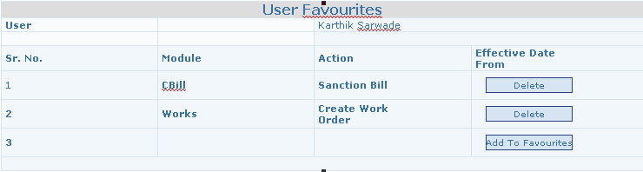

When the user comes to his Favorites screen, the existing favorites would be displayed with a facility to delete existing favorites and add new ones. When the delete button is clicked, it will delete the existing favorite. When add button is clicked, a new window should open which should show the complete menutree as it comes in the log in screen of the user (It should contain only the actions which the user can access). The user can select a given action and at that time, the details would be persisted in the db and the user Favorites screen should show the newly added Favorite.

Assumptions

State Transition

Boundary Conditions if any

