Technical Solution Description

LogiWeb

v0.1

Table of Contents

describe in a few words your system

Abstract

Business cases

Data model

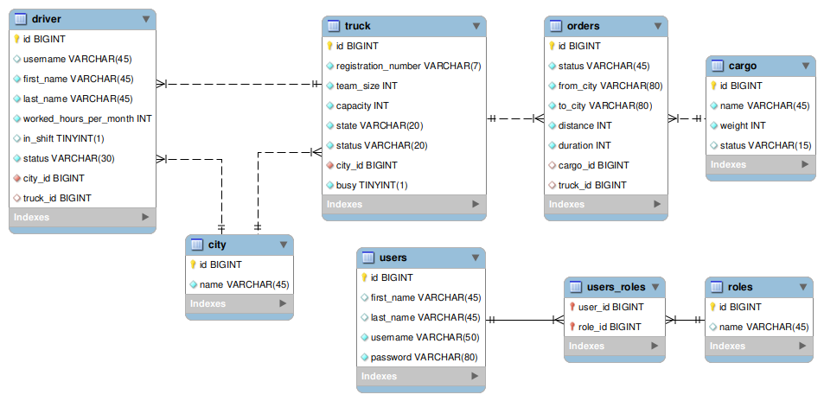

Architecture , know how

Technologies

|  |  |
| --- | --- |
| Spring Framework | |
|  |  |
|  |  |
|  |  |
|  |  |
|  |  |
|  |  |
|  |  |
|  |  |
|  |  |
|  |  |
|  |  |
|  |  |
|  |  |
|  |  |

Test

Logging

Sonar (SonarQube)

Any ideas about the improvement of the application or new features to be

implemented in the next releases

- google maps api (place autocomplete)