**CADET FOR A DAY**

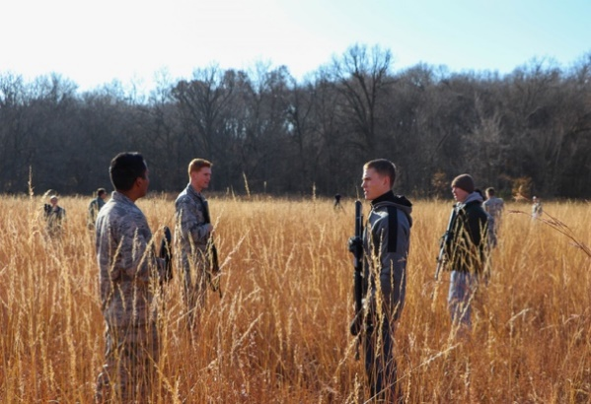

**What**: Cadet for a Day at Kansas State University is a program hosted by the cadets of Detachment 270 to offer high school students’ insight into what it's like to be a cadet!

**Who:**  Perspective high school juniors and seniors interested in Air Force ROTC and a career in the United States Air Force.

**When**: Thursday, 23 April 2020 from 8:30 a.m. - 6:30 p.m. **\* Start times are flexible! \***

**Where**: Kansas State University  
 AFROTC Detachment 270  
 108 General Richard B. Myers Hall  
 1304 N 17th Street  
 Manhattan, KS 66506-2101

**Why**: The Cadet for a Day program allows a high school student to shadow a current Detachment 270 cadet. All attempts will be made to pair the student with a cadet in their desired academic major. Students will be engaged throughout the day and see firsthand what life as an Air Force ROTC cadet looks like at Kansas State University. You will participate in various activities such as: attending a college course, touring the campus, Q&A panel with cadet leadership during lunch and end the day with our Leadership Laboratory (which will include paintballing in various field training exercises). This is a unique opportunity for all college bound students to see how Air Force ROTC and college life meet to offer a more rewarding college experience.

**\* If you are interested in participating, please contact Cadets Leonardo Dominguez or Riley Isbel, to secure your spot. Registration ends the 14th of April. \***

**Contact Information**: Cadet Leonardo Dominguez

Email: leonardo97@ksu.edu

Phone: (785) 223-7575

Cadet: Riley Isbel

Email: risbel@ksu.edu

Phone: (316) 303-7097