Team 303

Design Ideation

Team Assignment

### 1. Generate Ideas

Read the above articles on design ideation and brainstorming. Perform a product brainstorm to generate a large number of features, concepts, and ideas about what your product *COULD* be. Use sticky notes, a whiteboard, chalkboard, [*jamboard*](https://jamboard.google.com/) or similar, to generate ~100 or so brief concepts / features / ideas for your product.

There are some basic rules to brainstorming, spelled out [*here*](https://lucidspark.com/blog/4-group-brainstorming-techniques):

* Don't criticize any ideas.
* Encourage a wide variety of ideas.
* Build on each other's ideas.
* Don't be afraid to share unrealistic or unconventional ideas.

See the "[*Brainstorm Techniques*](https://embedded-systems-design.bitbucket.io/3x4/3x4-team-design-ideation/#7b9jkwk9s0hv)" links above for good ideas on how to generate more ideas.

These two articles share more information on [*successful ideation techniques*](https://uxplanet.org/whats-the-deal-with-ideation-e02324e95c8) and data on the [*effectiveness*](https://www.nngroup.com/articles/ideation-in-practice/) of ideation and brainstorming.

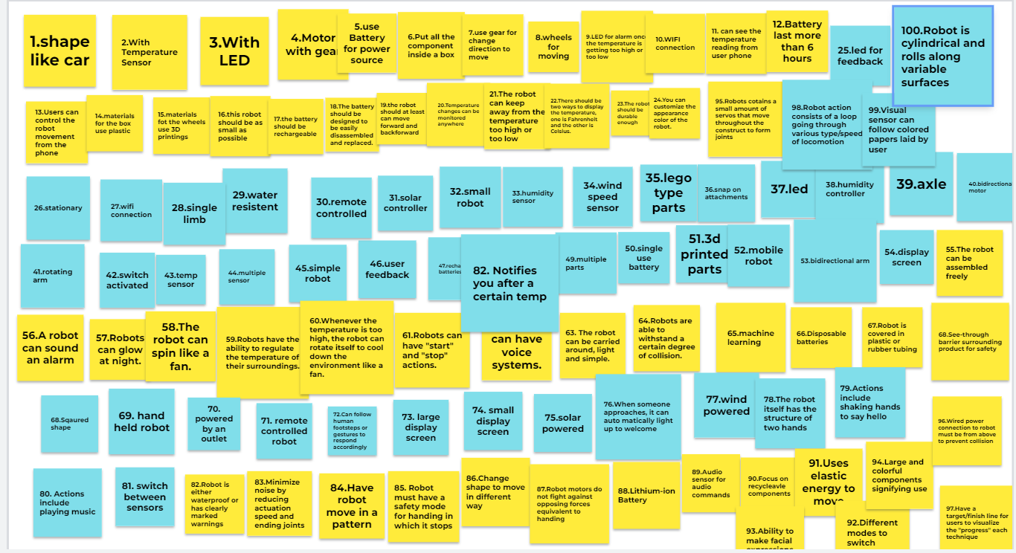

## 

### 2. Sort, Rank, and Group Design Concepts

Some of the most effective phases of ideation come ***after*** the brainstorm session. Seeing innovative patterns in the noise, grouping features in ways other products don't, and re-mixing good ideas into better ideas is often just as effective as coming up with many disjointed ideas. Take some time to discuss your brainstorm.

Next, collect features / ideas into separate bins, representing three separate design concepts. Unused features should not be disposed of, but left on a separate page / area of your board, in case you need more inspiration later. You *may* copy concepts to multiple design concepts, but challenge yourselves to make each concept unique and distinct.

## 

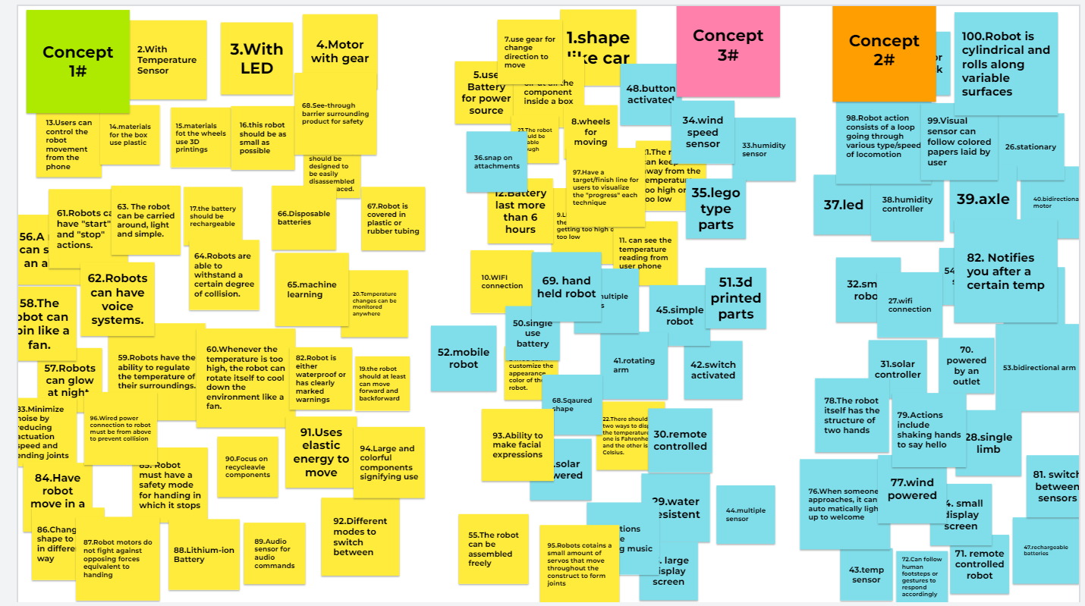

## 3. Create three product concept sketches (or similar)

## Our team sketched our three concept ideas to further understand what each design might look like and how we would implement the listed features. Concept #1-Car shape robot

## This is our team's first design concept, which is a car-shaped patrol temperature monitoring robot, which has temperature sensors, LEDs, four wheels, motors, and gears. Based on this design, it can be connected to the user with WIFI, so that the user can see the temperature change anywhere. At the same time, we hope that the user can also use the mobile phone to remotely control the direction of the car, (this is also hoped for Use the gear to change the direction or use four motors to control different directions), so that users can remotely monitor where they want to monitor, and can go to any place they want to monitor. At the same time, we also hope that users can set the "alarm" temperature by themselves, so that once the temperature reaches the alarm temperature, the LED will flash to warn the user, and an alarm will also be displayed on the mobile phone.

# 

# Concept #2 - Spinning Robot

This is our team's second concept. This concept includes a temperature sensor, an LED, a microcontroller, a motor, and a battery. This design will be connected to the user through WiFI and the user would be able to turn on the robot through a mobile device. When the user turns on the robot, the user will be able to turn the top piece to the direction of their choice. The LED will show if the system is on and reading the temperature sensor.



Concept #3- The Box.

This is our team’s third design, The Box. Just like the previous designs, this design also consists of a temp sensor, a LED, a motor module, a microcontroller and an LED display. The main goal of this design is to make sure that the device is compatible and easy to carry. In this design you can see two different layers. On the outside, the LED, Temp sensor and the microcontroller is present. On the left side, you can see the LED display that displays the amount of temperature, read by the temp sensor and when we go deep inside, we can notice the motor module and the battery module. The battery module also works as a power bank, the can save up energy when charged to be used later. The battery is charged by the power module which is mentioned as a charging port in the diagram and present at the bottom of the device. In the right view, we can see different types of ports which are used to connect to any device to read the temperature. This design also has the feature of connecting to WIFI and bluetooth when needed.

