# Luke’s Importing IFD In Class Exercise Solution

## General flow

There are four primary “documents”…Enter Purchase, Enter Shipment, View/Track Shipment, and Receive Shipment.

## IFD

### Enter a New Purchase

Assume that the document used to enter a new purchase requires entering the following information: the purchasing agent, the store name, the purchase date/time (assumed but not specified in the requirements), the purchase method (i.e., in store, online, etc.), and a list of items purchased.

The requirements indicate that the procurement system will include the purchasing agents employed at Luke Importing, the stores at which purchases are made, and the items purchased.

Assume that the purchasing agent will be selected using a drop down list. Populating the drop down list of purchasing agents requires a View Purchasing Agents task.

Assume that the store will be selected using a drop down list. If the store is new and, hence, not in the list, assume there is some external (or separate) mechanism to add the store to the system so that it will appear in the drop down list after refreshing the screen OR assume that new stores can be submitted and then added by the Create Purchase task (this could be a question for Nathan). Populating the drop down list of stores requires a View Stores task.

Assume that purchased items are selected using a list that contains names and descriptions of all items that have been purchased in the past. If the item being purchased is a new item then assume there is some external (or separate) mechanism to add the item to the system so it that it will appear in the drop down list after refreshing the screen OR assume that new items can be submitted and then added by the Create Purchase task (again…confirm with Nathan). [Initially there was a thought that items would be filtered by the selected store, but that would mean that the procurement system would need to maintain an inventory for all the stores in the system. This would not typically NOT be a function of a system maintained by a customer of a store.] Populating the list of items requires a View Items task.

Once the purchasing agent, the store, the purchase date/time, the purchase mechanism, and all items purchased have been entered on the form, then the Create Purchase task should be called to add the purchase to the system.

### Enter a New Shipment

Assume that the document used to enter a new shipment requires entering the following information: the shipper, a shipment ID (or tracking number), the date the shipment was shipped, the purchased items contained in the shipment, and an insured value for each of the items. Since all shipments go to Luke Importing there is no need to capture the shipping destination address on this form.

The requirements indicate that the procurement system will include the shippers used and shipments made by those shippers.

Assume that the shipper will be selected using a drop down list. If the shipper is new and, hence, not in the list, assume there is some external (or separate) mechanism to add the shipper to the system so that it will appear in the drop down list after refreshing the screen OR assume that new shippers can be submitted and then added by the Create Shipment task (again…confirm with Nathan). Populating the drop down list of stores requires a View Shippers task.

Assume that purchased items that are part of the shipment are selected using a list of purchased items that have not yet been shipped. Populating the list of items requires a View Purchased Items task that allows items to be filtered by whether or not they have already been shipped. When purchased items are added to the shipment an insured value will need to be specified for each. This will either require an Update Purchased Item task OR a sub task within the Create Shipment task that updates the insured value of all the purchased items contained in the shipment.

Once the shipper, the shipment ID (a tracking number?), the shipment date, and a list of all items contained in the shipment (along with insured values) have been entered on the form, then the Create Shipment task should be called to add the shipment to the system.

### View/Track Shipment

Assume the document used to view/track shipments has three different ways to find the shipment of interest: by shipper, by shipment ID (or tracking number), or by purchased item.

Assume that the shipments can be selected either by using a drop down list of shipments that are in route OR by typing in a shipment ID (or tracking number). Populating the drop down list of shipments requires a View Shipments task.

Assume that the shipper can be selected using a drop down list. Populating the drop down list of shippers requires a View Shippers task. Each shipper should have a list of shipments that are in route that can be used to identify a specific shipment that can then be viewed using the View Shipments task.

Assume that purchased items can be selected by using a drop down list of purchased items that are in route. Populating the drop down list of purchased items in route requires a View Purchased Items task that allows items to be filtered by whether or not they are in route. Each purchased item should have a shipment attribute that can be used to identify a specific shipment that can then be viewed using the View Shipments task.

If there is a requirement to update the shipment status, then there would need to be a task to Update Shipment. This is not part of the current requirements.

### Update/Receive Shipment

Assume the document used to update a shipment upon arrival requires entering the following information: the receiving clerk, the arrival date/time, and the condition of each item received.

The requirements indicate that the procurement system will include the receiving clerks employed at Luke Importing.

Assume that the shipment being received will be selected using a drop down list. Populating the drop down list of shipments requires a View Shipments task that allows shipments to be filtered by whether or not they are in route.

Assume that the receiving clerk will be selected using a drop down list. Populating the drop down list of receiving clerks requires a View Receiving Clerks task.

Assume that the received date/time is entered using a standard date/time widget.

Assume that the list of items contained in the shipment is populated once the shipment is selected with a textbox to enter each item’s condition upon arrival. Population of the list of items will require that either the View Shipment task provides the list OR that there is a separate View Shipment Items task (it would make sense to have a separate View Shipment Items task so that the data required to populate the list of shipments in route is minimized).

Updating the arrival condition of each item will either require an Update Purchased Item task OR a sub task within the Update Shipment task that updates the arrival condition of all the purchased items contained in the shipment.

Once the shipment, the arrival date/time, the receiving clerk, and the condition of each item have been entered on the form, then the Update Shipment task should be called to update the system.

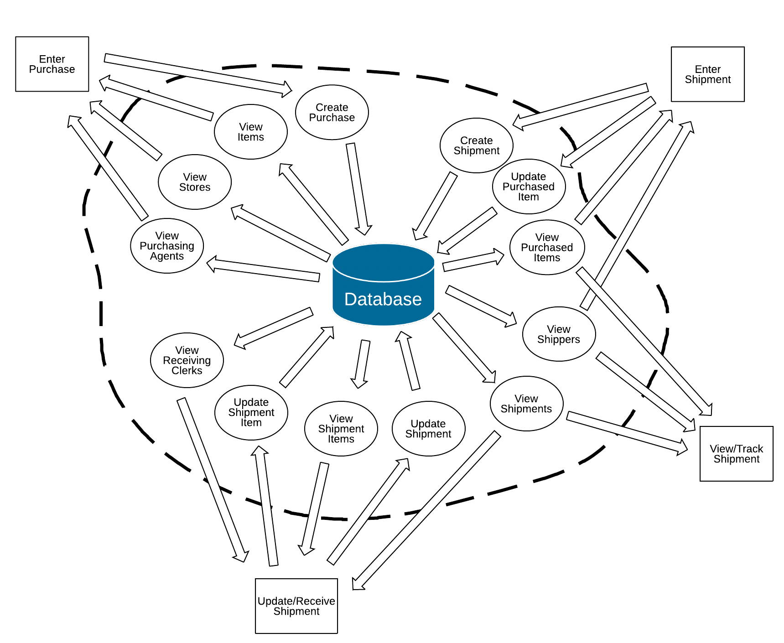

Figure . Information Flow Diagram (IFD)