**Evaluación del algoritmo**

**GraphPartitionGA**

**Caso test0**

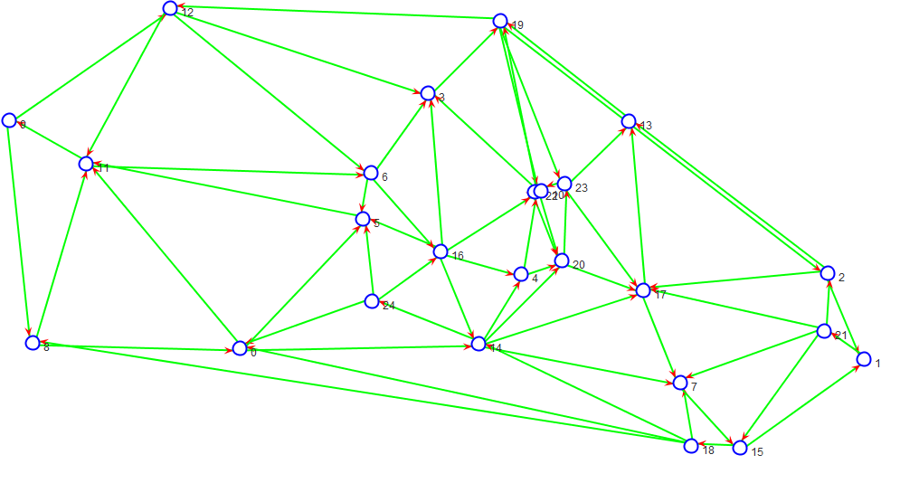

**Separador**

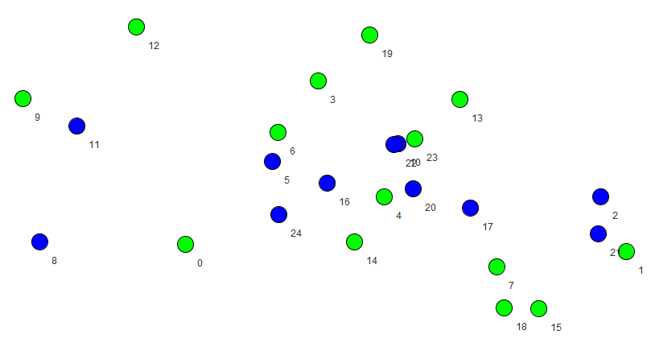Graph: 25 64 0.05333333333333334

Separator: 11 0.44 2

Detail of components:

C0: 7

C1: 7

Media: 7.0

Balanced: 0.0

Time (ms): 45217

**Caso test1**

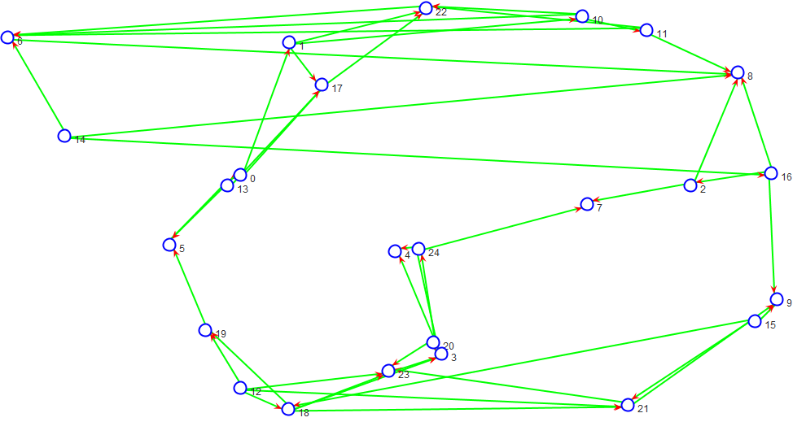

**Separador**

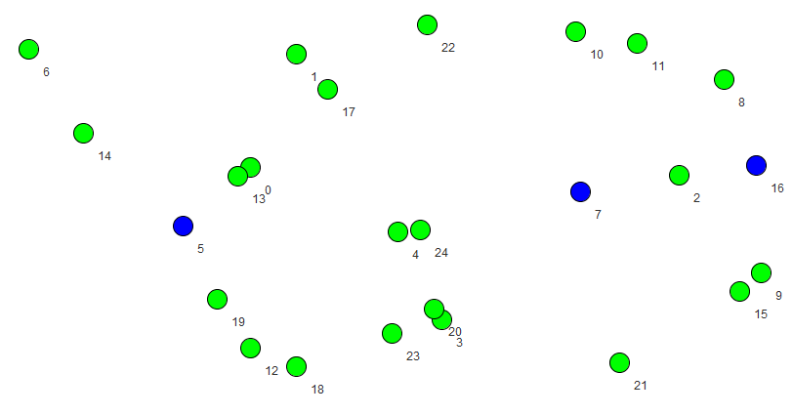Graph: 25 48 0.04

Separator: 3 0.12 2

Detail of components:

C0: 11

C1: 11

Media: 11.0

Balanced: 0.0

Time (ms): 52928

**Caso test2**

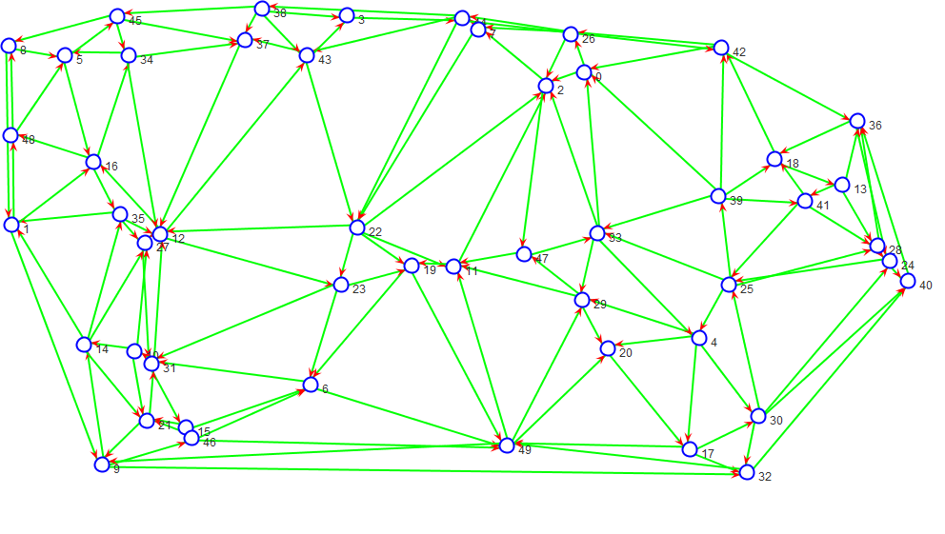

**Separador**

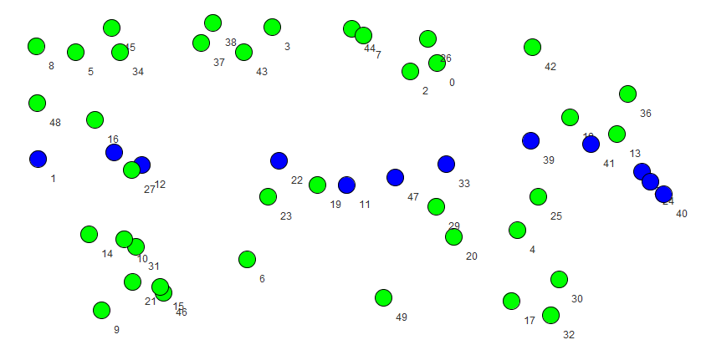

Graph: 50 137 0.027959183673469386

Separator: 12 0.24 2

Detail of components:

C0: 19

C1: 19

Media: 19.0

Balanced: 0.0

Time (ms): 120091

**Caso test3**

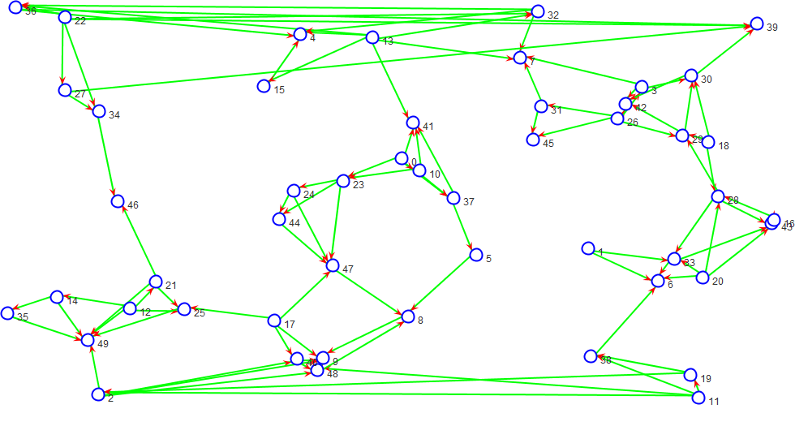

**Separador**

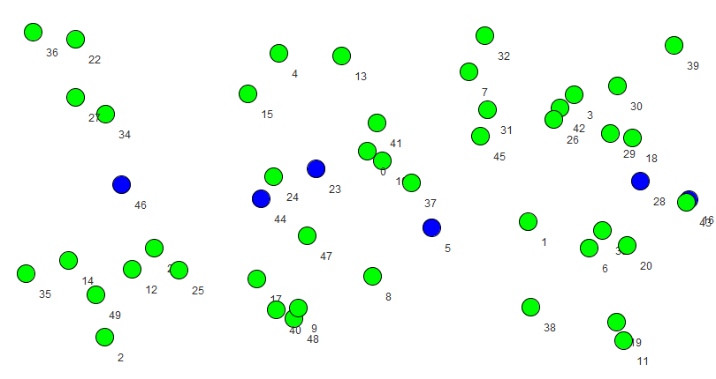

Graph: 50 98 0.02

Separator: 6 0.12 2

Detail of components:

C0: 22

C1: 22

Media: 22.0

Balanced: 0.0

Time (ms): 123543

**Caso test4**

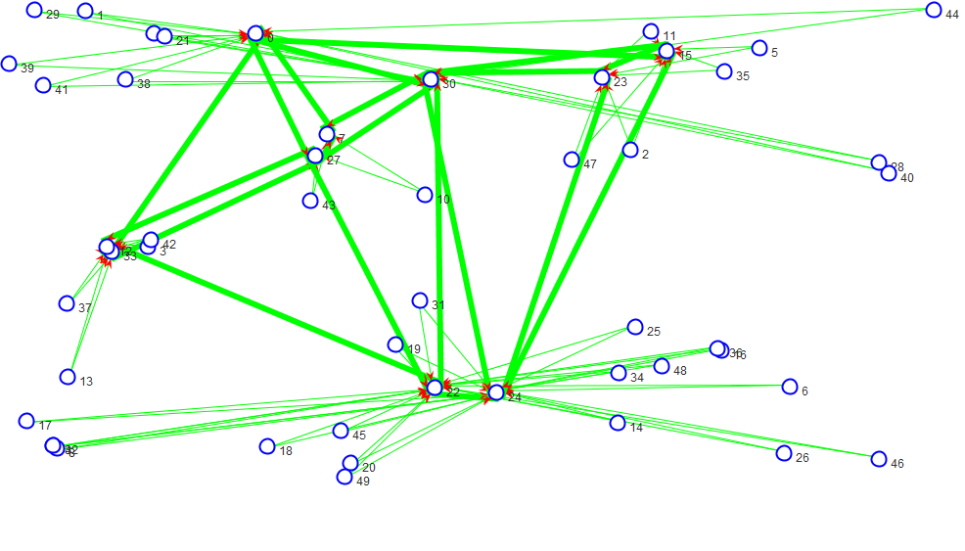

**Separador**

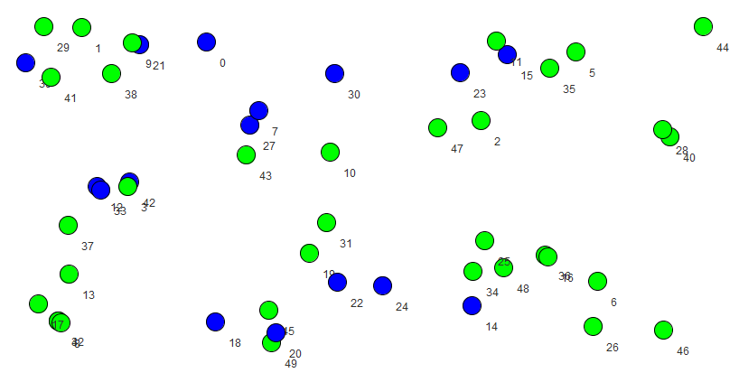

Graph: 50 101 0.020612244897959184

Separator: 16 0.32 34

Detail of components:

C0: 1

C1: 1

C2: 1

C3: 1

C4: 1

C5: 1

C6: 1

C7: 1

C8: 1

C9: 1

C10: 1

C11: 1

C12: 1

C13: 1

C14: 1

C15: 1

C16: 1

C17: 1

C18: 1

C19: 1

C20: 1

C21: 1

C22: 1

C23: 1

C24: 1

C25: 1

C26: 1

C27: 1

C28: 1

C29: 1

C30: 1

C31: 1

C32: 1

C33: 1

Media: 1.0

Balanced: 0.0

Time (ms): 71190

**Caso test5**

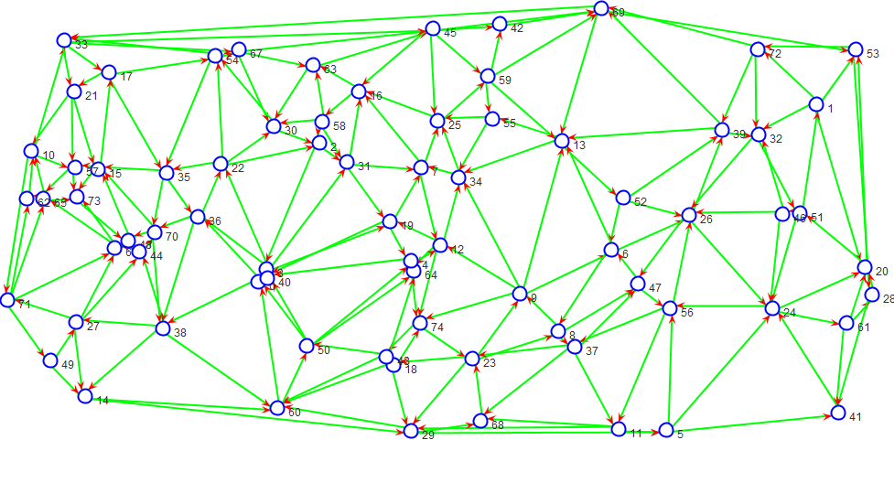

Separador

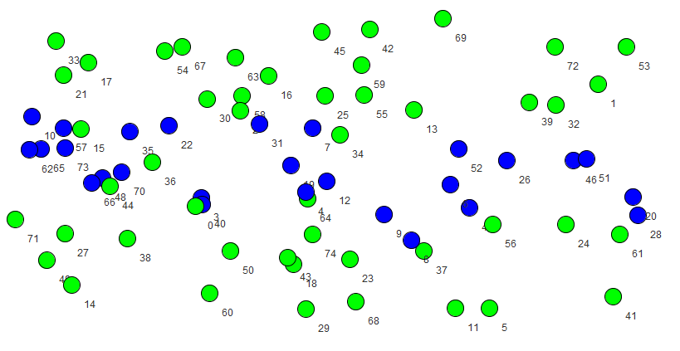

Graph: 75 211 0.01900900900900901

Separator: 27 0.36 2

Detail of components:

C0: 24

C1: 24

Media: 24.0

Balanced: 0.0

Time (ms): 163349

**Caso test6**

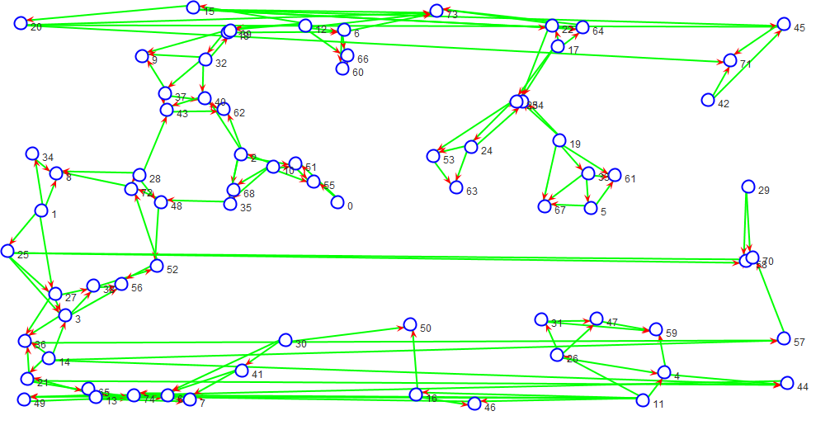

**Separador**

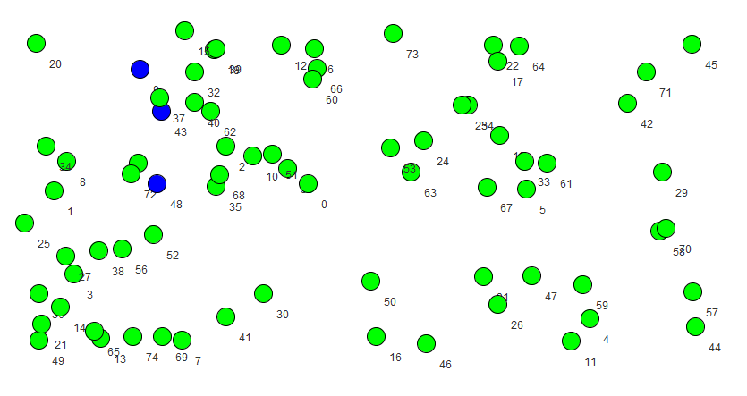

Graph: 75 148 0.013333333333333334

Separator: 3 0.04 2

Detail of components:

C0: 36

C1: 36

Media: 36.0

Balanced: 0.0

Time (ms): 192306**Caso test7**

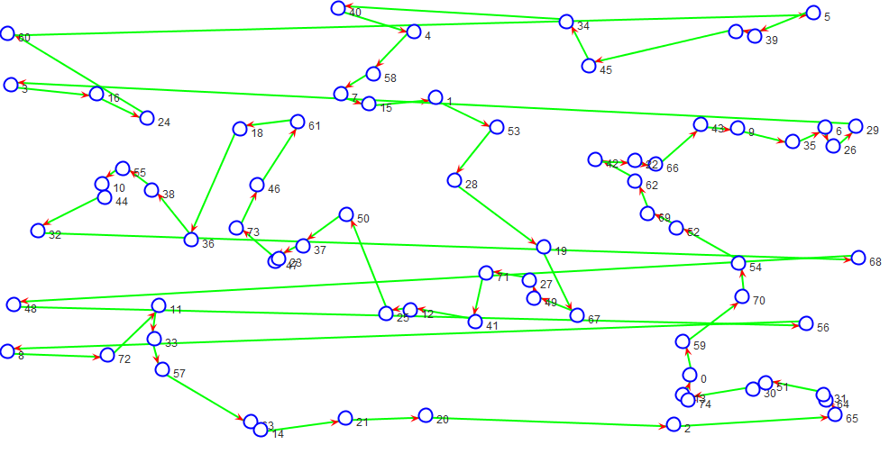

**Separador**

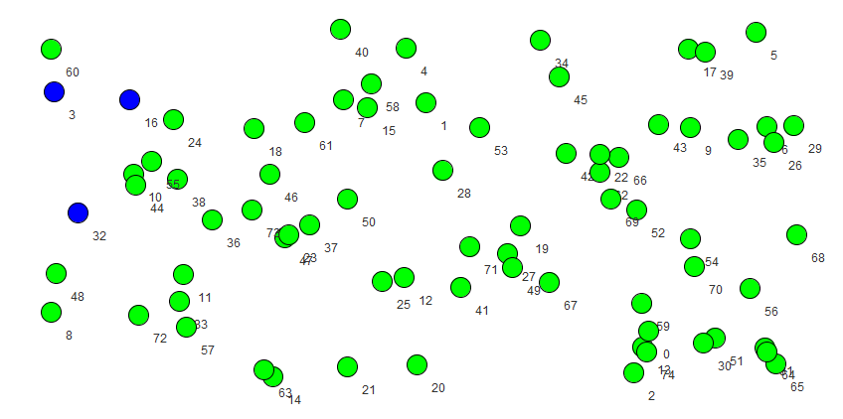

Graph: 75 75 0.006756756756756757

Separator: 3 0.04 2

Detail of components:

C0: 36

C1: 36

Media: 36.0

Balanced: 0.0

Time (ms): 142328

**Caso test8**

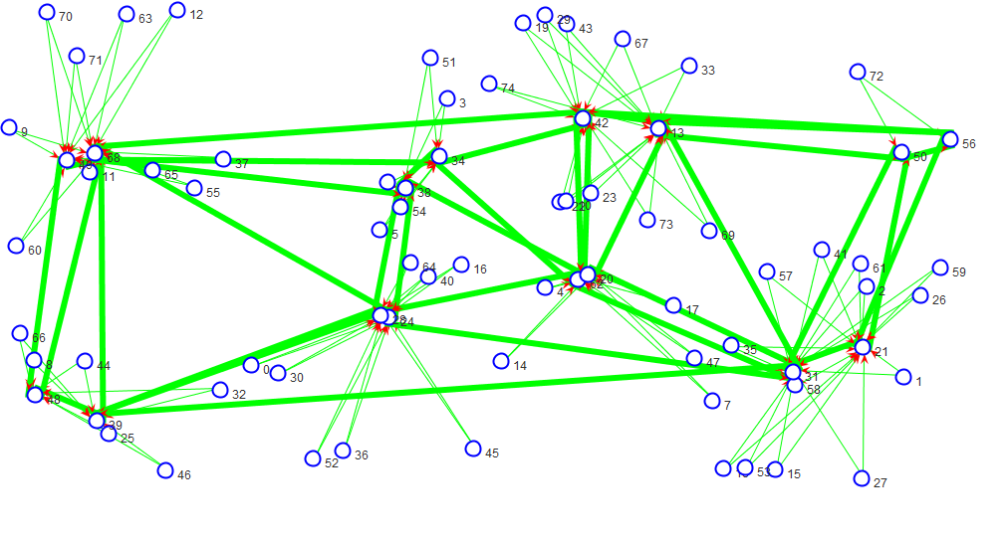

**Separador**

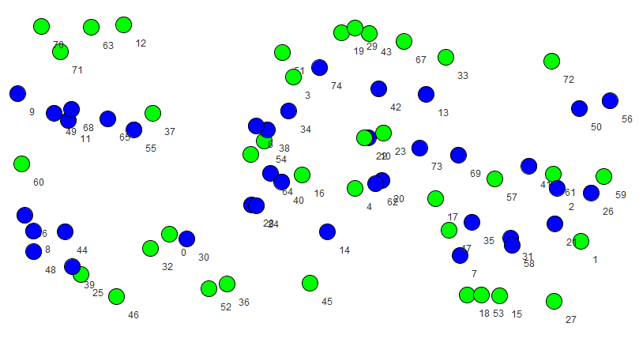

Graph: 75 155 0.013963963963963964

Separator: 38 0.5066666666666667 37

Detail of components:

C0: 1

C1: 1

C2: 1

C3: 1

C4: 1

C5: 1

C6: 1

C7: 1

C8: 1

C9: 1

C10: 1

C11: 1

C12: 1

C13: 1

C14: 1

C15: 1

C16: 1

C17: 1

C18: 1

C19: 1

C20: 1

C21: 1

C22: 1

C23: 1

C24: 1

C25: 1

C26: 1

C27: 1

C28: 1

C29: 1

C30: 1

C31: 1

C32: 1

C33: 1

C34: 1

C35: 1

C36: 1

Media: 1.0

Balanced: 0.0

Time (ms): 105030

**Caso test9**

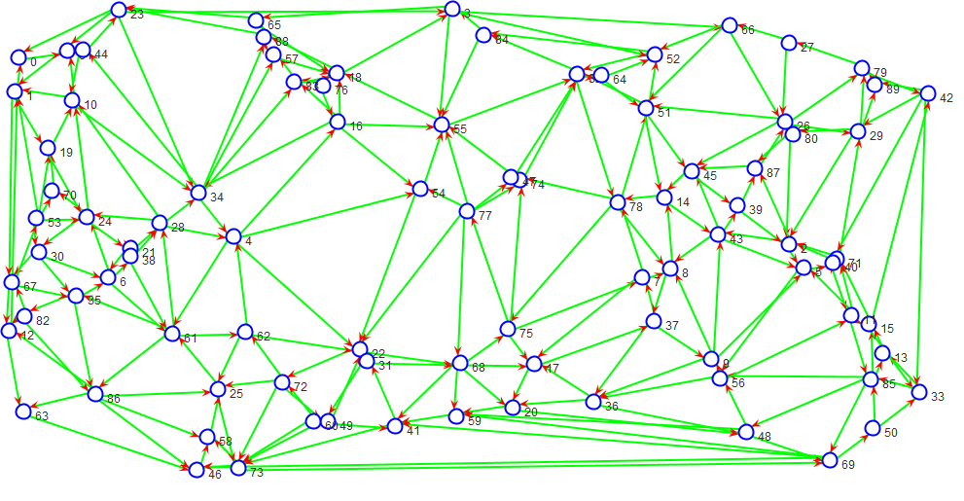

**Separador**

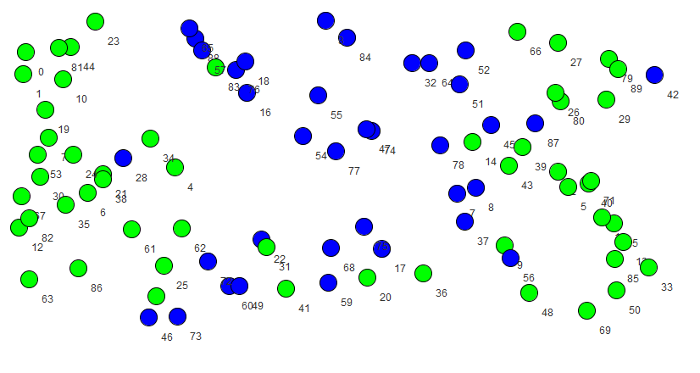Graph: 90 253 0.015792759051186017

Separator: 36 0.4 2

Detail of components:

C0: 27

C1: 27

Media: 27.0

Balanced: 0.0

Time (ms): 194044

**Caso test10**

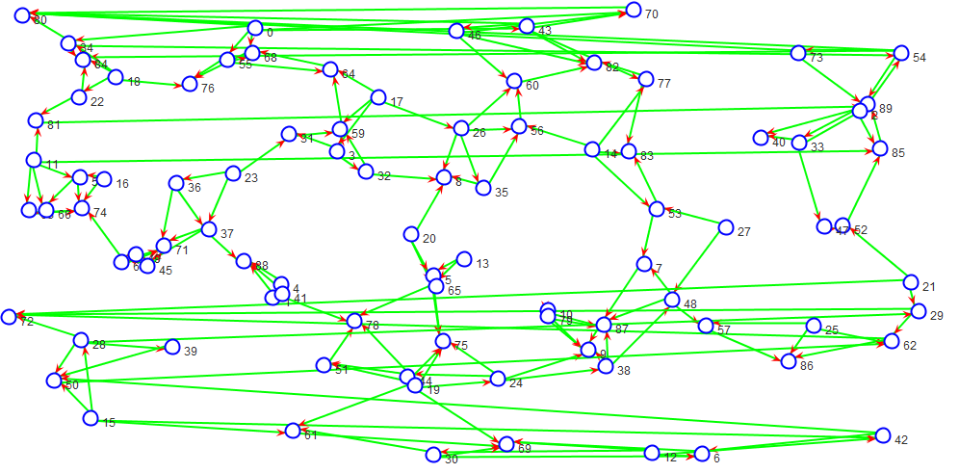

**Separador**

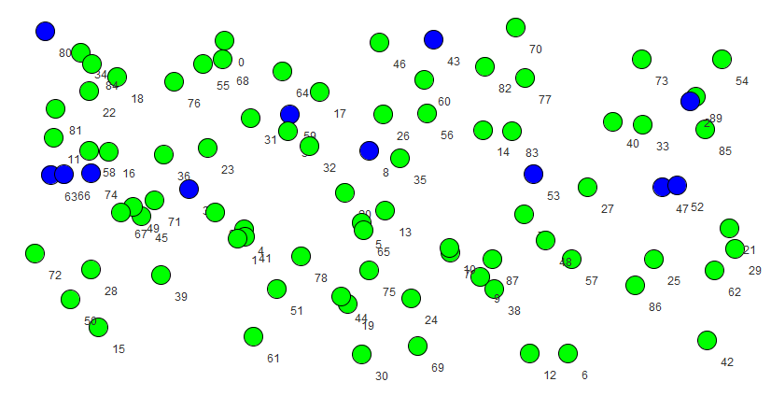

Graph: 90 178 0.011111111111111112

Separator: 12 0.13333333333333333 2

Detail of components:

C0: 39

C1: 39

Media: 39.0

Balanced: 0.0

Time (ms): 213491

**Caso test11**

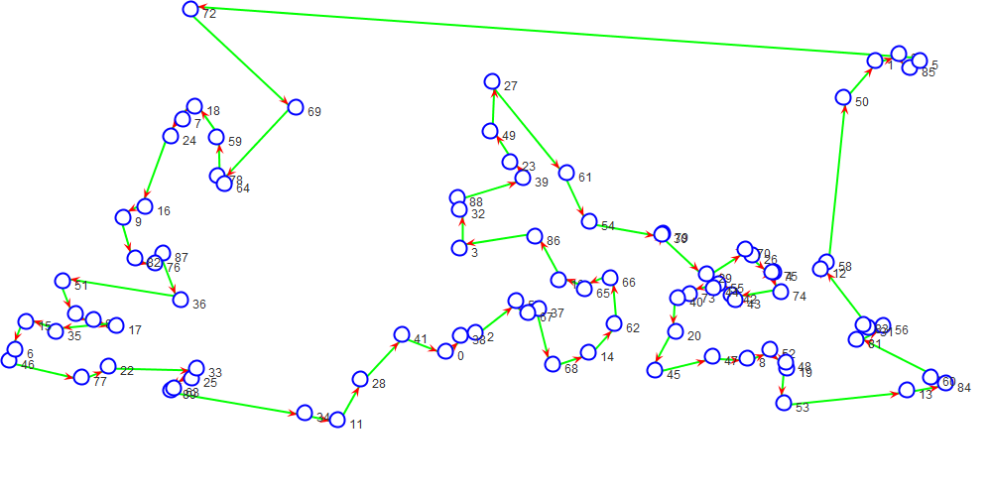

**Separador**

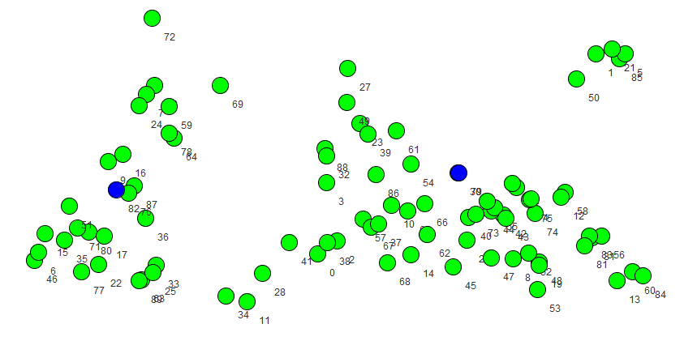

Graph: 90 90 0.0056179775280898875

Separator: 2 0.022222222222222223 2

Detail of components:

C0: 44

C1: 44

Media: 44.0

Balanced: 0.0

Time (ms): 173121

**Caso test12**

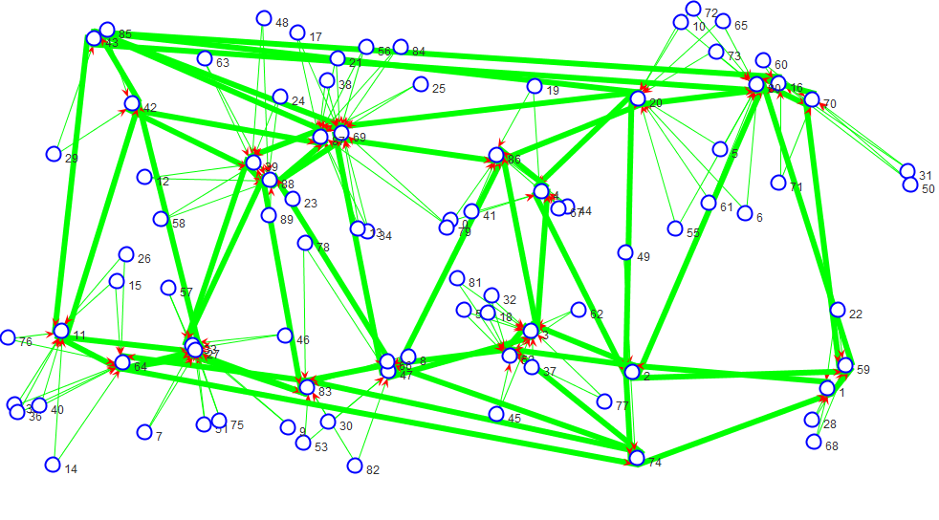

**Separador**

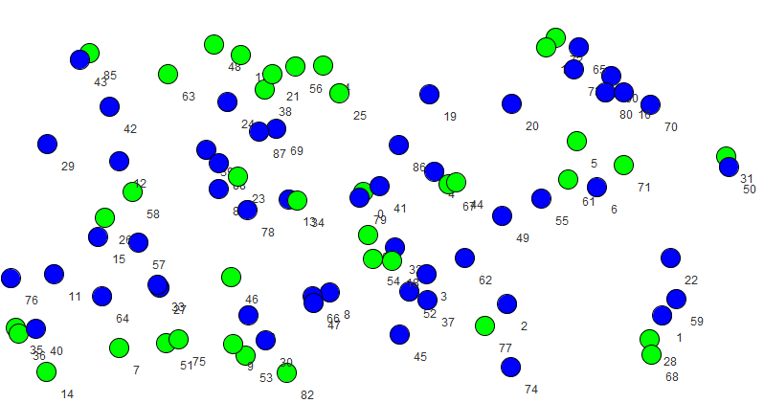

Graph: 90 193 0.012047440699126092

Separator: 52 0.5777777777777777 38

Detail of components:

C0: 1

C1: 1

C2: 1

C3: 1

C4: 1

C5: 1

C6: 1

C7: 1

C8: 1

C9: 1

C10: 1

C11: 1

C12: 1

C13: 1

C14: 1

C15: 1

C16: 1

C17: 1

C18: 1

C19: 1

C20: 1

C21: 1

C22: 1

C23: 1

C24: 1

C25: 1

C26: 1

C27: 1

C28: 1

C29: 1

C30: 1

C31: 1

C32: 1

C33: 1

C34: 1

C35: 1

C36: 1

C37: 1

Media: 1.0

Balanced: 0.0

Time (ms): 122633

**Caso test13**

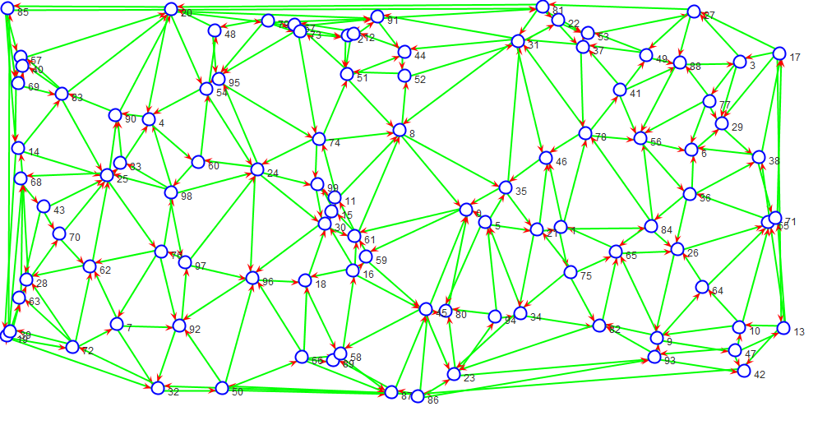

**Separador**

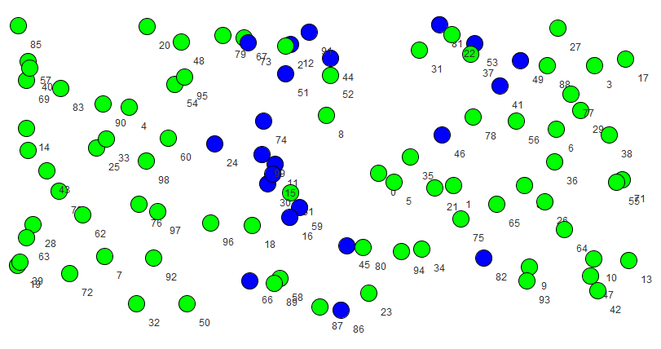Graph: 100 288 0.014545454545454545

Separator: 22 0.22 2

Detail of components:

C0: 39

C1: 39

Media: 39.0

Balanced: 0.0

Time (ms): 243727

**Caso test14**

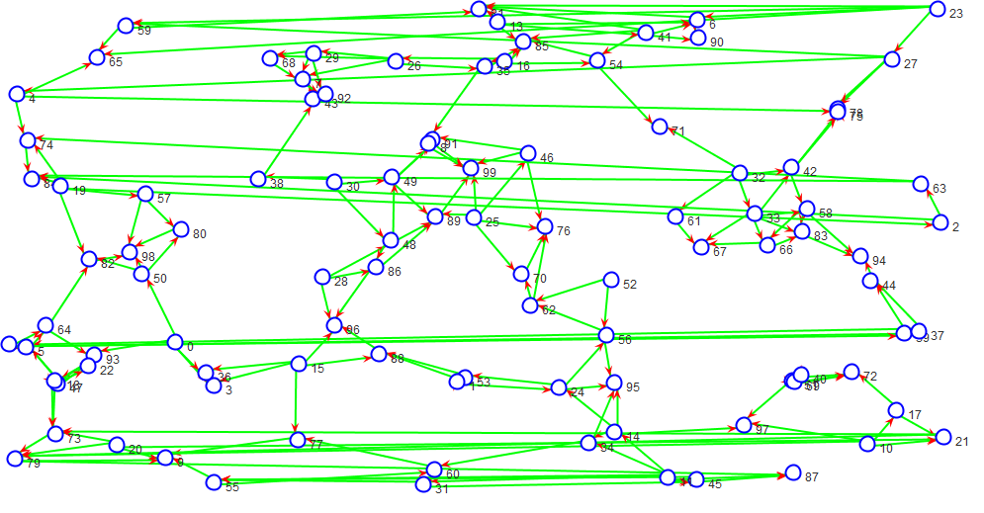

**Separador**

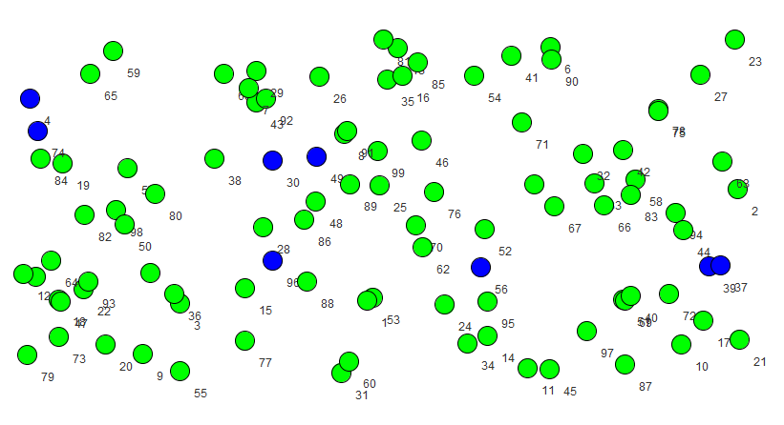

Graph: 100 198 0.01

Separator: 8 0.08 2

Detail of components:

C0: 46

C1: 46

Media: 46.0

Balanced: 0.0

Time (ms): 247339