**Evaluación del algoritmo Bisection_GRASP**

**Caso test0**

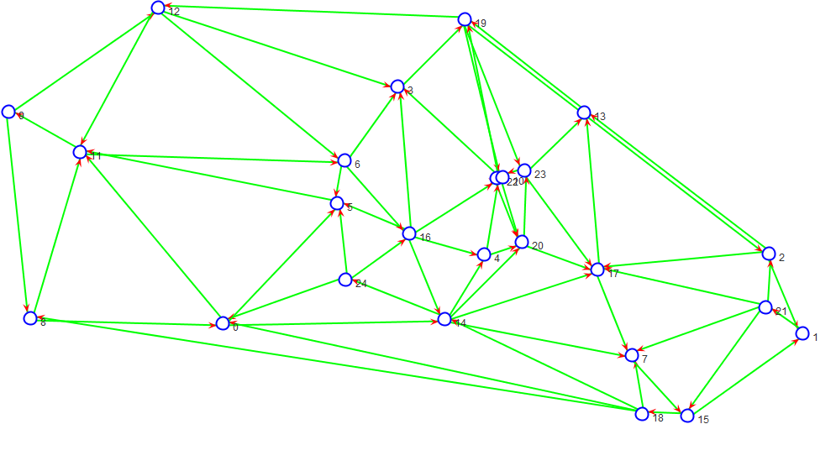

**Separador**

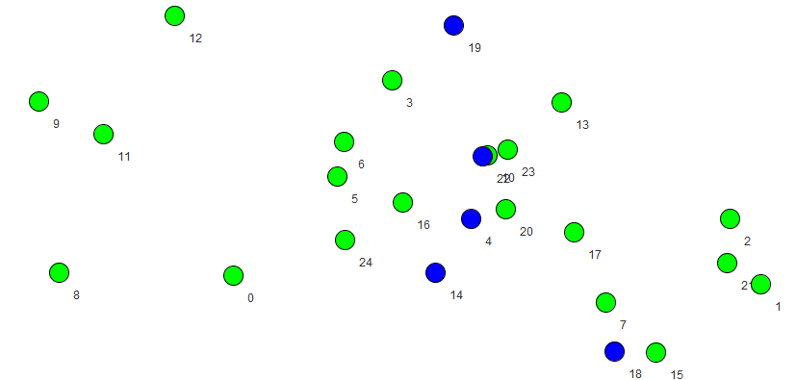

Graph: 25 64 0.05333333333333334

Separator: 5 0.2 2

Detail of components:

C0: 10

C1: 10

Media: 10.0

Balanced: 0.0

Time (ms): 2215

**Caso test1**

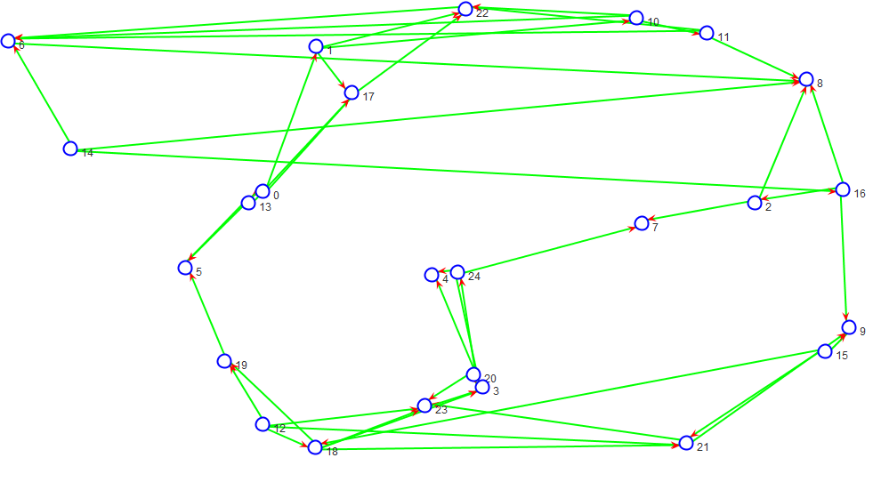

**Separador**

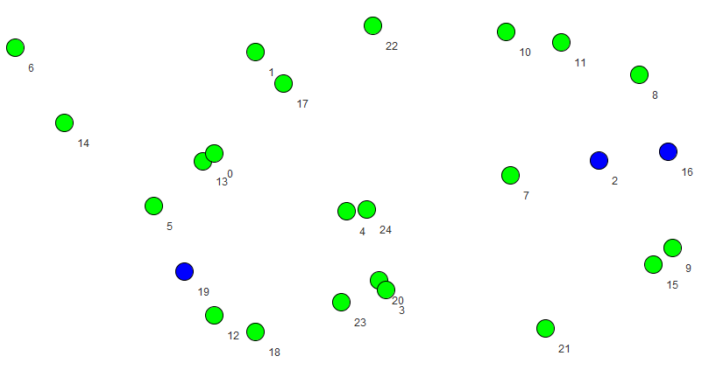

Graph: 25 48 0.04

Separator: 3 0.12 2

Detail of components:

C0: 11

C1: 11

Media: 11.0

Balanced: 0.0

Time (ms): 2332

**Caso test2**

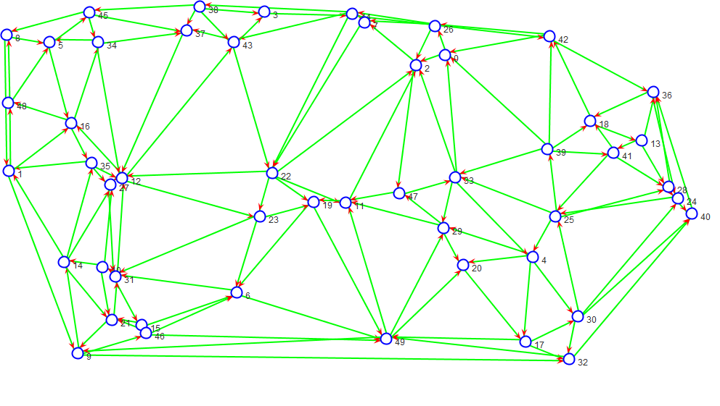

**Separador**

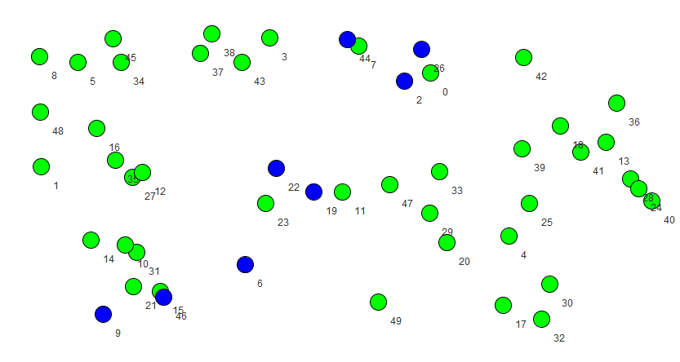

Graph: 50 137 0.027959183673469386

Separator: 8 0.16 3

Detail of components:

C0: 20

C1: 21

C2: 1

Media: 14.0

Balanced: 26.0

Time (ms): 9316

**Caso test3**

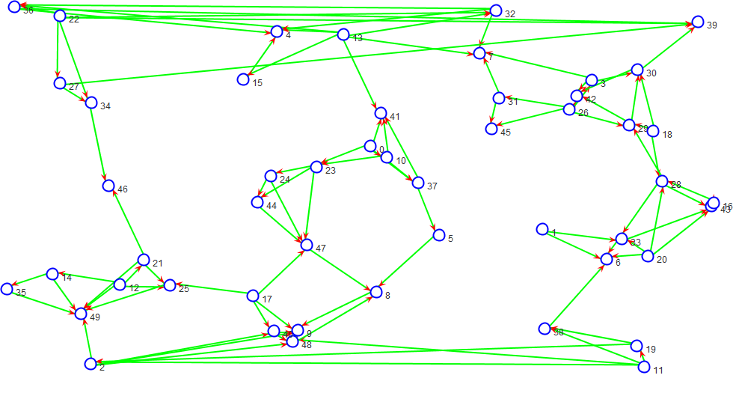

**Separador**

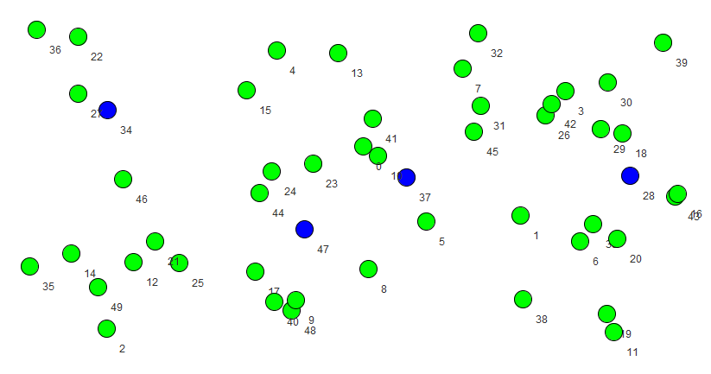

Graph: 50 98 0.02

Separator: 4 0.08 2

Detail of components:

C0: 23

C1: 23

Media: 23.0

Balanced: 0.0

Time (ms): 10105

**Caso test4**

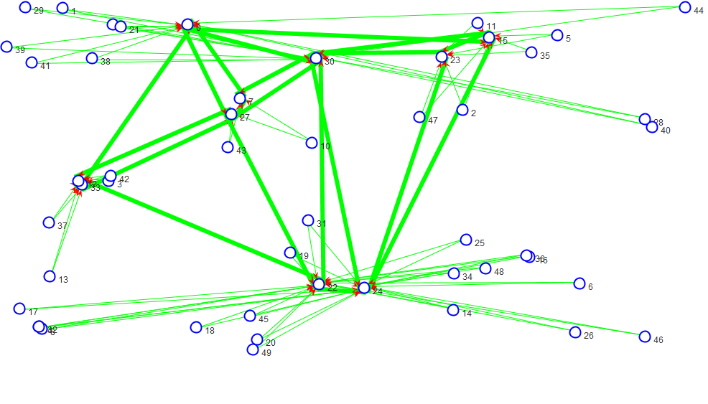

**Separador**

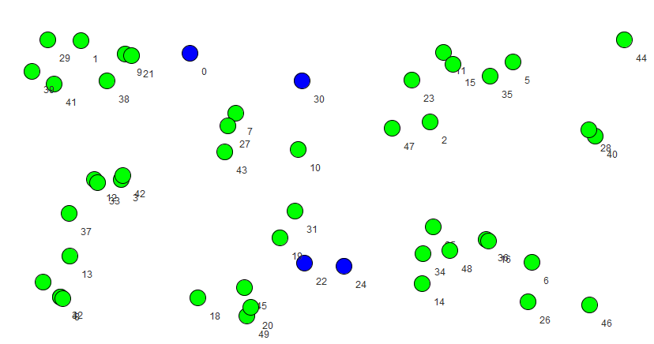

Graph: 50 101 0.020612244897959184

Separator: 4 0.08 31

Detail of components:

C0: 7

C1: 1

C2: 10

C3: 1

C4: 1

C5: 1

C6: 1

C7: 1

C8: 1

C9: 1

C10: 1

C11: 1

C12: 1

C13: 1

C14: 1

C15: 1

C16: 1

C17: 1

C18: 1

C19: 1

C20: 1

C21: 1

C22: 1

C23: 1

C24: 1

C25: 1

C26: 1

C27: 1

C28: 1

C29: 1

C30: 1

Media: 1.4838709677419355

Balanced: 28.06451612903227

Time (ms): 11585

**Caso test5**

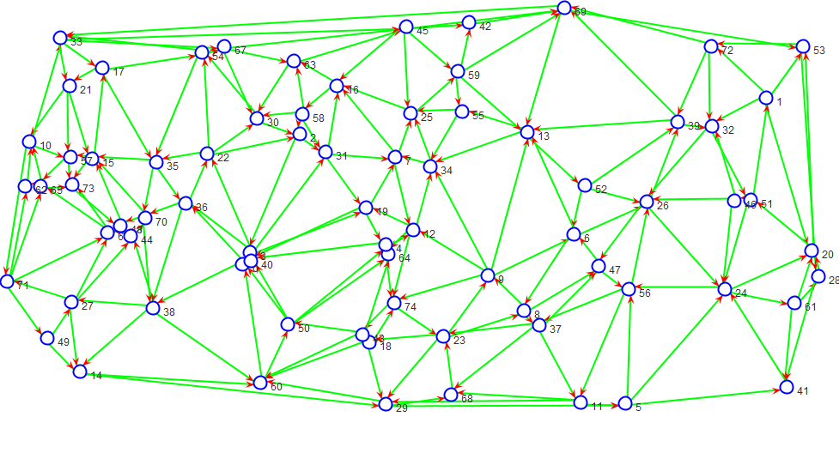

Separador

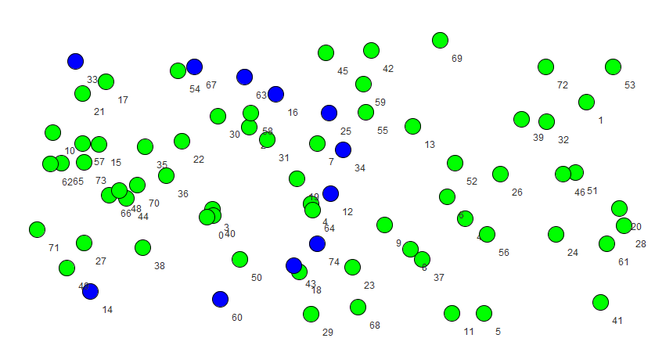

Graph: 75 211 0.01900900900900901

Separator: 11 0.14666666666666667 2

Detail of components:

C0: 32

C1: 32

Media: 32.0

Balanced: 0.0

Time (ms): 24684

**Caso test6**

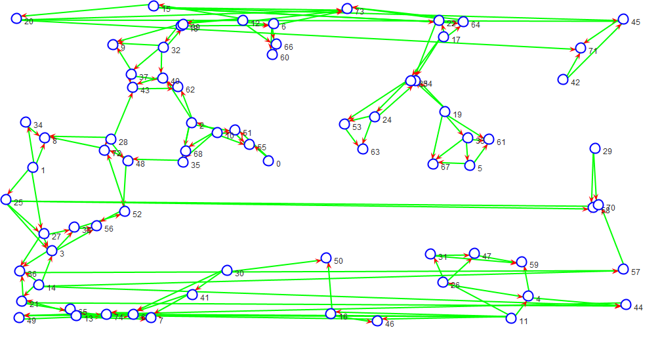

**Separador**

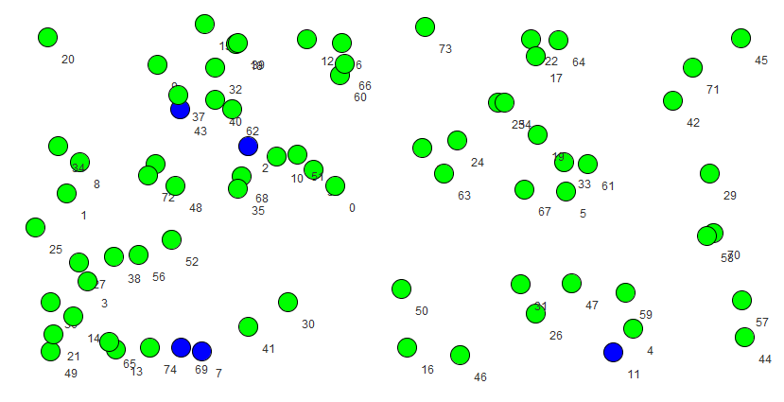

Graph: 75 148 0.013333333333333334

Separator: 5 0.06666666666666667 3

Detail of components:

C0: 35

C1: 30

C2: 5

Media: 23.333333333333332

Balanced: 36.66666666666667

Time (ms): 28822

**Caso test7**

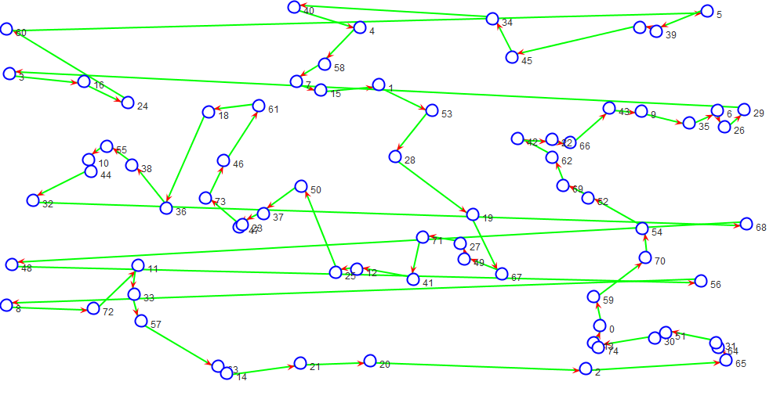

**Separador**

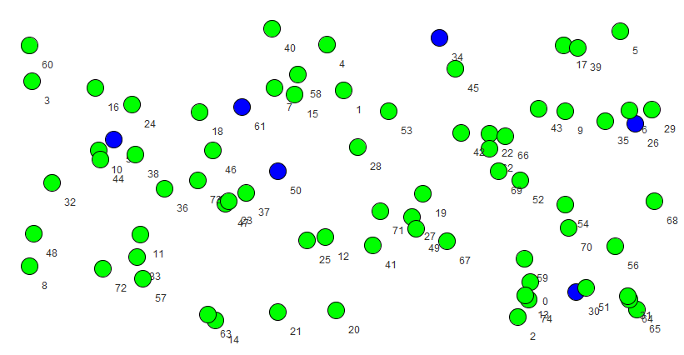

Graph: 75 75 0.006756756756756757

Separator: 6 0.08 6

Detail of components:

C0: 3

C1: 9

C2: 5

C3: 16

C4: 20

C5: 16

Media: 11.5

Balanced: 35.0

Time (ms): 33133

**Caso test8**

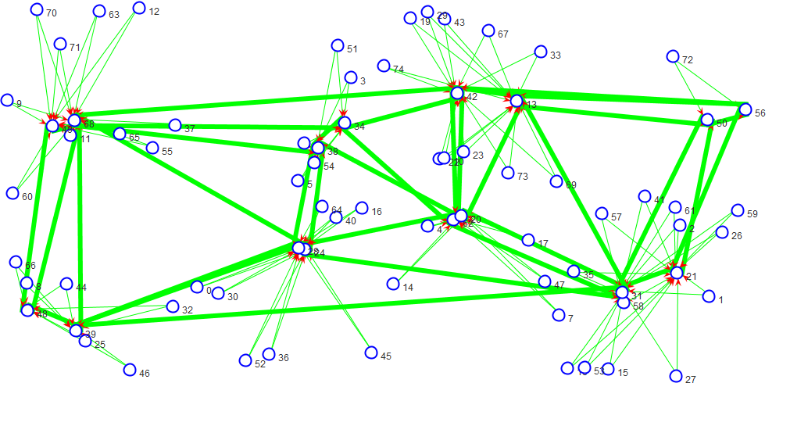

**Separador**

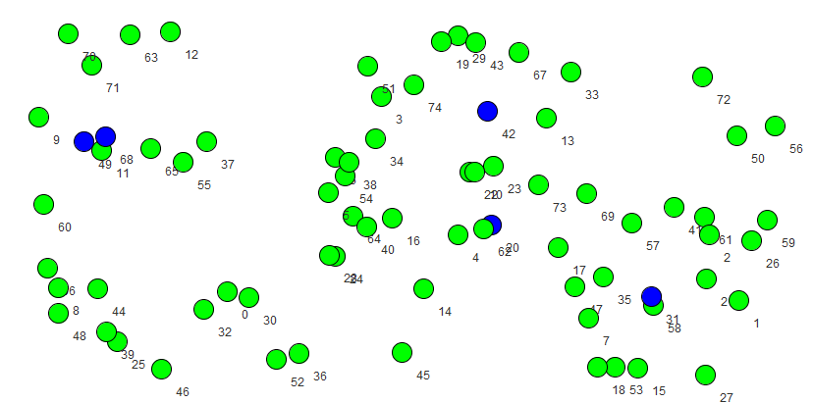

Graph: 75 155 0.013963963963963964

Separator: 5 0.06666666666666667 12

Detail of components:

C0: 29

C1: 1

C2: 1

C3: 31

C4: 1

C5: 1

C6: 1

C7: 1

C8: 1

C9: 1

C10: 1

C11: 1

Media: 5.833333333333333

Balanced: 96.66666666666664

Time (ms): 33162

**Caso test9**

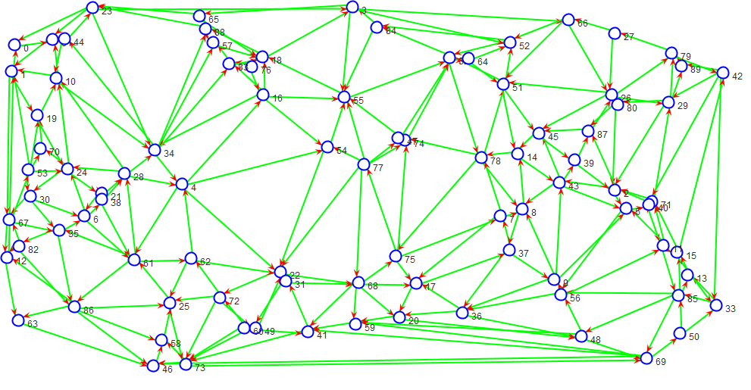

**Separador**

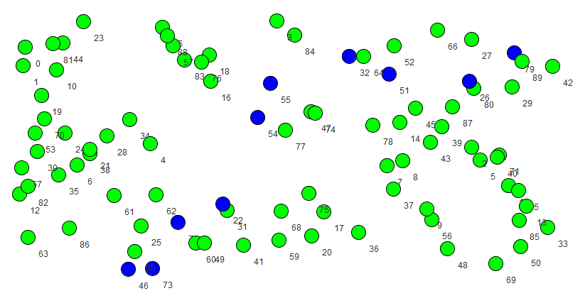

Graph: 90 253 0.015792759051186017

Separator: 10 0.1111111111111111 2

Detail of components:

C0: 40

C1: 40

Media: 40.0

Balanced: 0.0

Time (ms): 40813

**Caso test10**

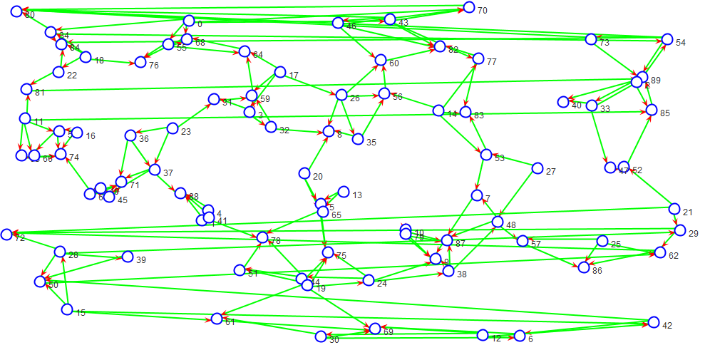

**Separador**

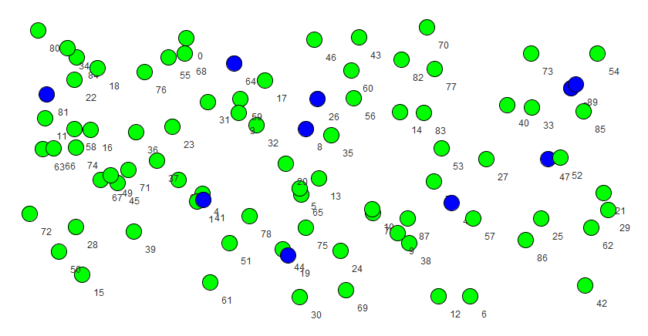

Graph: 90 178 0.011111111111111112

Separator: 10 0.1111111111111111 3

Detail of components:

C0: 40

C1: 38

C2: 2

Media: 26.666666666666668

Balanced: 49.33333333333333

Time (ms): 47097

**Caso test11**

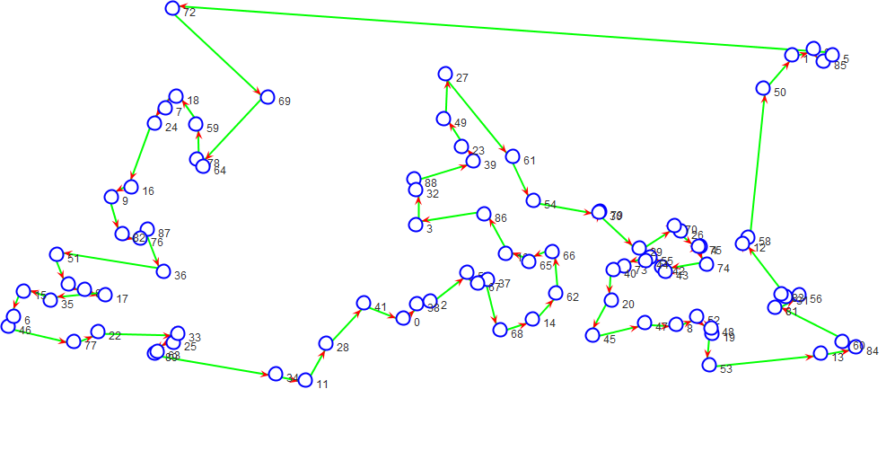

**Separador**

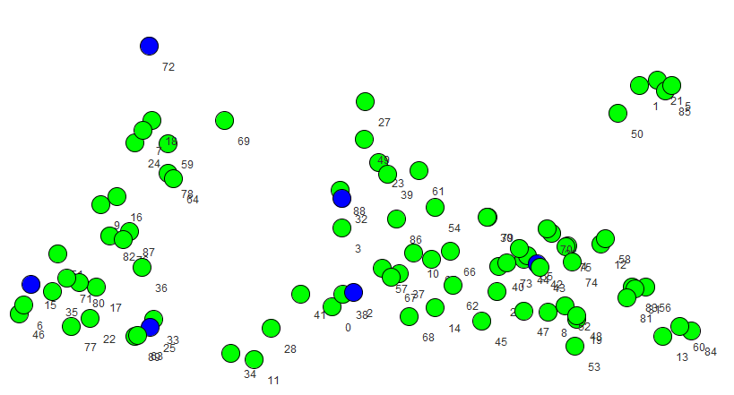

Graph: 90 90 0.0056179775280898875

Separator: 6 0.06666666666666667 6

Detail of components:

C0: 26

C1: 18

C2: 8

C3: 16

C4: 5

C5: 11

Media: 14.0

Balanced: 36.0

Time (ms): 53994

**Caso test12**

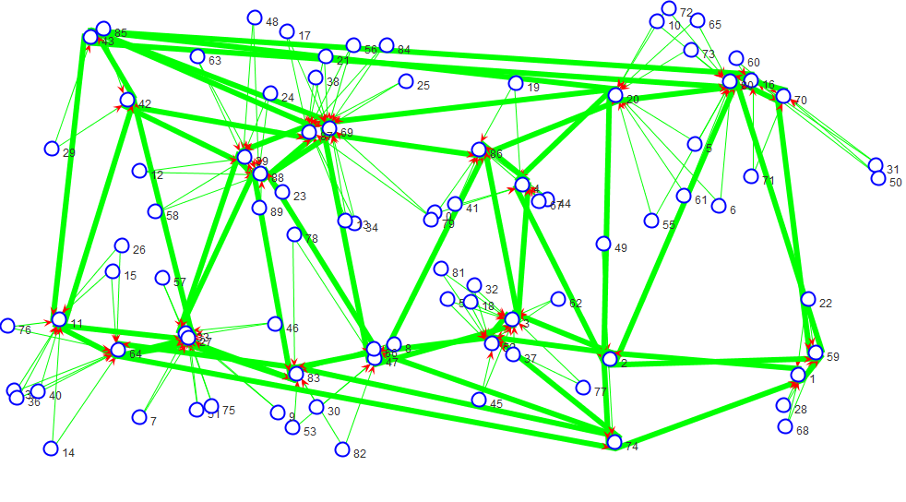

**Separador**

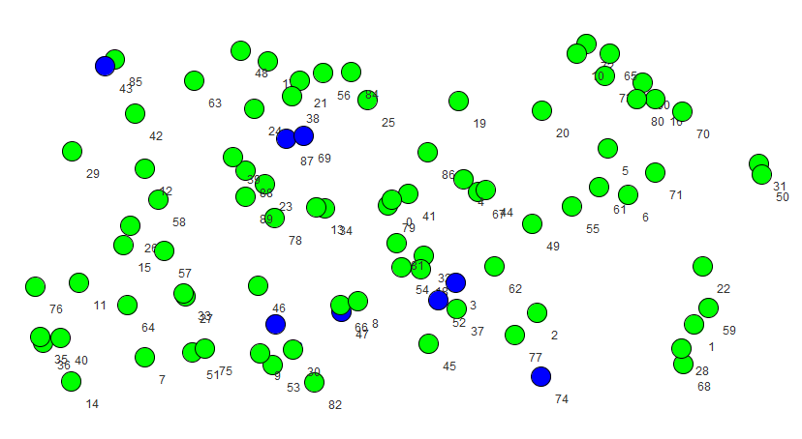

Graph: 90 193 0.012047440699126092

Separator: 8 0.08888888888888889 25

Detail of components:

C0: 30

C1: 29

C2: 1

C3: 1

C4: 1

C5: 1

C6: 1

C7: 1

C8: 1

C9: 1

C10: 1

C11: 1

C12: 1

C13: 1

C14: 1

C15: 1

C16: 1

C17: 1

C18: 1

C19: 1

C20: 1

C21: 1

C22: 1

C23: 1

C24: 1

Media: 3.28

Balanced: 104.88000000000002

Time (ms): 51398

**Caso test13**

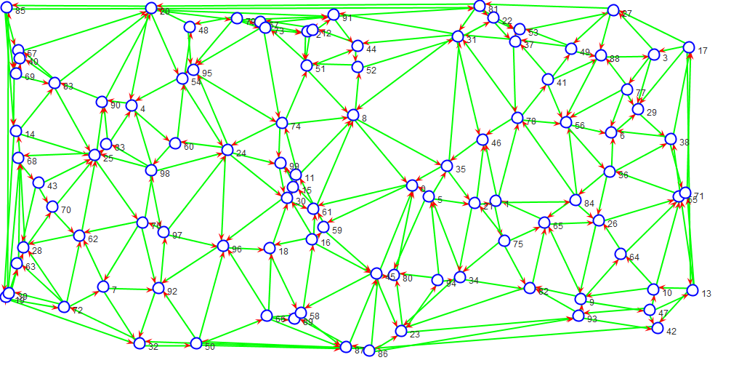

**Separador**

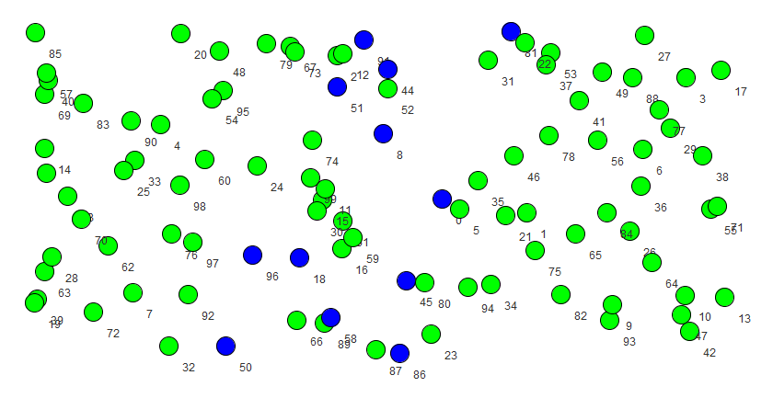

Graph: 100 288 0.014545454545454545

Separator: 12 0.12 3

Detail of components:

C0: 3

C1: 41

C2: 44

Media: 29.333333333333332

Balanced: 52.66666666666667

Time (ms): 53262

**Caso test14**

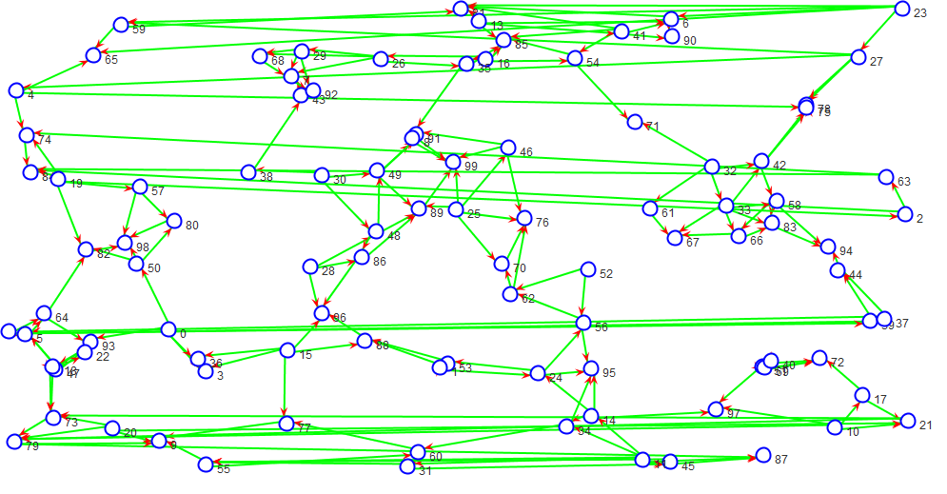

**Separador**

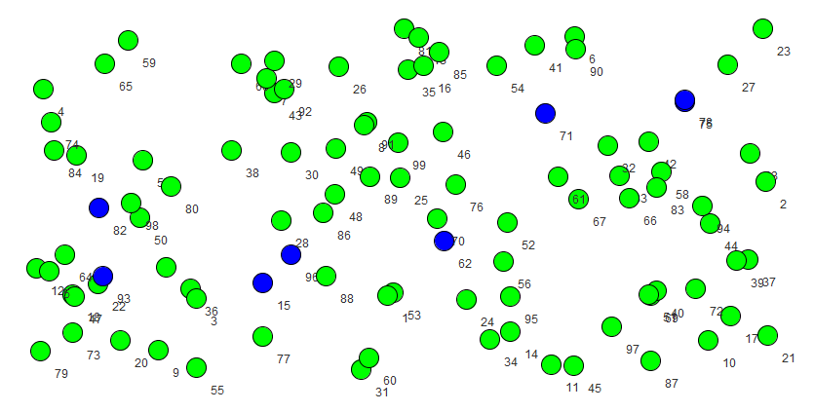

Graph: 100 198 0.01

Separator: 8 0.08 2

Detail of components:

C0: 46

C1: 46

Media: 46.0

Balanced: 0.0

Time (ms): 61540