MSDS 460 Decision Analytics

Assignment 03

Brandon Moretz

Problem 1:

The Tiny Toy Company makes three types of new toys: the tiny tank, the tiny truck, and the tiny turtle.

Plastic used in one unit of each is 1.5, 2.0 and 1.0 pounds, respectively.

Rubber for one unit of each toy is 0.5, 0.5, and 1.0 pounds, respectively.

Also, each tank uses 0.3 pounds of metal and the truck uses 0.6 pounds of metal during production.

The average weekly availability for plastic is 16,000 pounds, 9,000 pounds of metal, and 5,000 pounds of rubber.

It takes two hours of labor to make one tank, two hours for one truck, and one hour for a turtle.

The company allows no more than 40 hours a week for production (**priority #1**).

Finally, the cost of manufacturing one tank is $7, 1 truck is $5 and 1 turtle is $4; a target budget of $164,000 is initially used as a guideline for the company to follow.

1. Minimize over-utilization of the weekly available supply of materials used in making the toys and place twice as much emphasis on the plastic (**priority #2**).
2. Minimize the under and over-utilization of the budget. Maximize available labor hour usage (**priority #3**).

Solution:

**Goals:**

|  |  |  |  |
| --- | --- | --- | --- |
| **Priority** | **Goal** | **Rank** | **Weight** |
| #1 | Min over-utilization of hours | 3 | .35 |
| #2 | Min over-utilization of plastic | 2 | .24 |
| #3 | Min over-utilization of rubber | 1 | .12 |
| #4 | Min over-utilization of metal | 1 | .12 |
| #5 | Min over-utilization of budget | .5 | .05 |
| #6 | Min under-utilization of budget | .5 | .06 |
| #7 | Min under-utilization of labor | .5 | .06 |

**Decision Variables**:

Let,

X1, = Number of Tiny Tanks produced

X2 = Number of Tiny Trucks produced

X3 = Number of Tiny Turtles produced

Oi = Amount over the right side of the goal i (for all i in 1, 2, 3, 4, 5)

Ui = Amount under the right side of the goal i (for all i in 1, 2, 3, 4, 5)

**Objective Function**:

Min Z = (.24O1 + .12O2+ .12O3 + 0.35O4 +.06O5 + .006U4 +.06U5)

s.t,

1.5X1 + 2X2 + X3 + U1 – O1 = 16,000

.5X1 + .5X2 + X3 + U2 – O2 = 5,000

.3X1 + .62 + U3 – O3 = 9,000

2X1 + 2X2 + X3 + U4 – O4 = 40

7X1 + 5X2 + 4X3 + U5 – O5 = 164,000

**All non-negative constraints**:

X1, X2, X3, Oi, Ui >= 0

Problem 2:

XYZ Company is planning an advertising campaign for its new product. The media considered are television and radio. Rated exposures per thousand dollars of advertising expenditure are 10,000 for TV and 7,500 for radio. Management has agreed that the campaign cannot be judged successful if total exposures are under 750,000. The campaign would be viewed as superbly successful if 1 million exposures occurred.

In addition, the company has realized that the two most important audiences for its product are persons 18 to 21 years of age and persons 25 to 30 years of age. The following table estimates the number of individuals in the two age groups expected to be exposed to advertisements per $ 1,000 of expenditures:

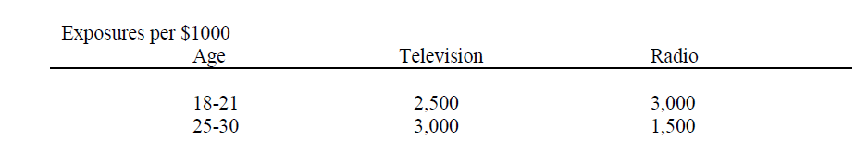

Management has rank ordered five goals it wishes to achieve, arranged from highest to lowest priorities.

a) Achieve total exposures of at least 750,000 persons.

b) Avoid expenditures of more than $100,000.

c) Avoid expenditures of more than $70,000 for television advertisements.

d) Achieve at least 1 million total exposures.

e) Reach at least 250,000 persons in each of the two age groups, 18-21 and 25-30 years. In addition, management realizes and wishes to account for the fact that the purchasing power of the 25-30 age group is twice that of the 18-21 age group.

Solution:

Let x be thousands of dollars on TV advertisements and y be thousands of dollars on Radio advertisements.

**Total Exposure** = 10,000x + 7,500y >= 750,000

**Total Expenditure** = $1000x + $1000y

**Total Expenditure Television <= $70,000** = 1,000x <= 70,000

**Total Expenditure >= $1,000,000**: =10,000x + 7,500y >= 1,000,000

**Both age groups**: (2,500 + 3,000)x + (3,000 + 1,500)y = 5,500x + 4,500y

**Exposure 18-21**: 2,500x + 3,000y >= 250,000

**Exposure 25-30**: 3,000x + 1,500y >= 250,000

**Total Purchasing Power:**

3,000x + 1,500y = 2x(2,500x + 3,000y)

3,000x + 1,500y = 5,000x + 6,000y

5,000x – 3,000x + 6,000y – 1,500y = 0

2,000x + 4,500y = 0

4x – 9y = 0

**Objective Function:**

Min Z = 1,000x + 1,000y

s.t.,

10,000x + 7,500y >= 750,000

1,000x + 1,000y <= 100,000

10,000x <= 70,000

5,500x + 4,500y >= 1,000,000

2,500xx + 3,000y >= 250,000

3,000x + 1,500y >= 250,000

6x – 9y = 0

**All non-negative constraints**:

x, y >= 0