INTERNATIONAL CONFERENCE ON HEALTH AND

DISEASE MANAGEMENT (ICHDM 2026)

HOSTED BY

SASTRA DEEMED TO BE UNIVERSITY, KUMBAKONAM.

TITLE

Design, Development, and Preliminary Evaluation of Concentric Foam-Supported Kneecap Brace for Chronic Knee Pain and Posterior Cruciate Ligament–Related Instability

AUTHORS
Ragavi Natarajan, Dr. R. Venkatesan

SUPERVISOR

VENKATESAN R

ASSOCIATE PROFESSOR

DEPARTMENT OF BIOMEDICAL ENGINEERING

Batch No: T902

Mode: Offline

Venue: V.S. SRINIVASA SASTRI HALL (Ground Floor Auditorium) @SASTRA UNIVERSITY

Session & Time: I & 10:30 AM-12:30 PM

Design, Development, and Preliminary Evaluation of Concentric Foam-Supported Kneecap Brace for Chronic Knee Pain and Posterior Cruciate Ligament–Related Instability
Ragavi Natarajan , Dr. R. Venkatesan
PG Student, SASTRA University, Thanjavur, Tamil Nadu, India.
Department of Biomedical Engineering, E.G.S.Pillay Engineering College (Autonomous), Nagapattinam, Tamil Nadu, India.
Abstract
Chronic knee pain and dynamic instability are frequently observed in conditions such as early osteoarthritis, patellofemoral disorders, and ligamentous injuries, often leading to reduced mobility and diminished quality of life. Although conventional knee braces can alleviate pain and instability, their bulkiness, poor anatomical targeting, and discomfort frequently limit long-term compliance. This study presents the design and preliminary evaluation of a soft knee brace that incorporates a concentric viscoelastic foam support positioned beneath the posterior aspect of the tibia, addressing both generalised knee pain and posterior cruciate ligament (PCL) related instability. The proposed brace integrates a compression sleeve with adjustable straps and a contoured foam module designed to redistribute contact forces and provide a gentle anteriorly directed support to the tibia during functional movement. A prototype was fabricated and evaluated in a pilot study involving adults with chronic knee pain, including a subgroup exhibiting clinical signs of PCL insufficiency. Participants performed basic functional tasks while wearing either a standard soft knee brace or the proposed concentric foam-supported brace, and subsequently rated pain, perceived stability, comfort, and ease of use using numerical rating scales and structured questionnaires. Compared with the standard brace, the prototype demonstrated reduced activity-related pain and improved perceived knee stability, with participants reporting superior comfort and wearability. User feedback indicated that the concentric foam support enhanced posterior tibial support without adding excessive bulk around the knee crease, suggesting improved suitability for prolonged use. These preliminary findings indicate that the proposed design may offer a low-cost, modular solution for managing chronic knee pain while providing targeted mechanical support for PCL-related instability. Further biomechanical analyses and larger-scale clinical studies are warranted to validate its effects on knee kinematics and long-term functional outcomes.
Keywords: Chronic Knee Pain, Knee Instability, Posterior Cruciate Ligament (PCL), Knee brace, Rehabilitation, PCL tear, Knee injuries

CONFRIMATION MAIL :
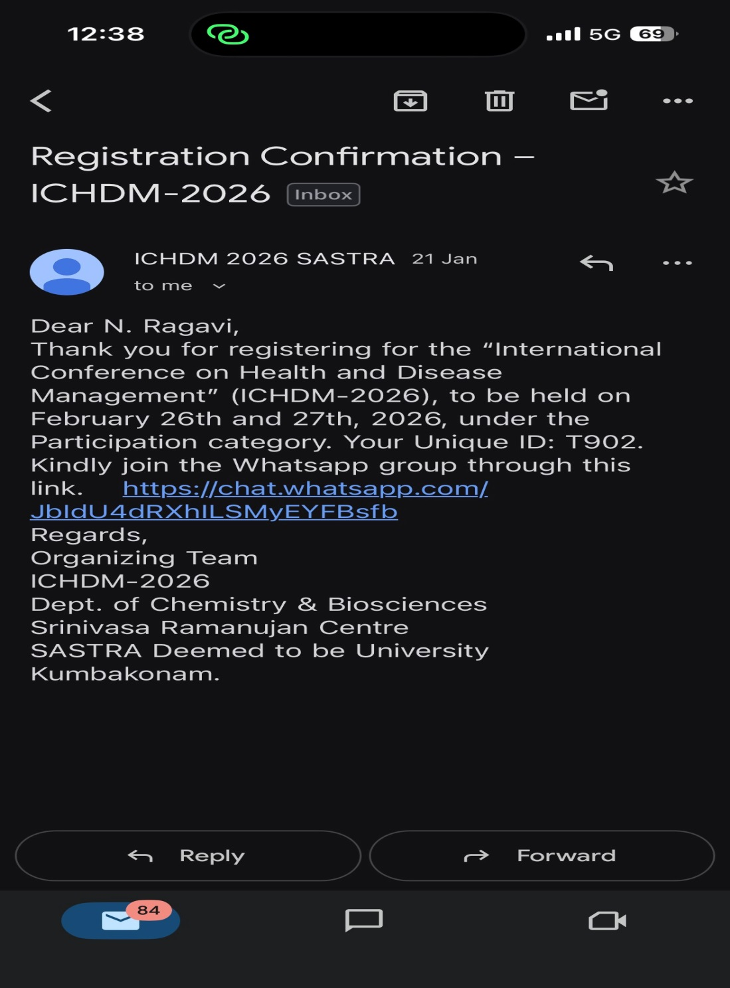



PRESENTATION @ ICHDM 2026
