INTERNATIONAL CONFERENCE ON HEALTH AND

DISEASE MANAGEMENT (ICHDM 2026)

HOSTED BY

SASTRA DEEMED TO BE UNIVERSITY, KUMBAKONAM.

TITLE

Design and Optimization of Nano Hand-Held Nebulizer for Effective Lung Penetration of Medication in Aerosolized Form Focusing on Enhanced Patient Care

AUTHORS
Yalini G, Venkatesan R

SUPERVISOR

VENKATESAN R

ASSOCIATE PROFESSOR

DEPARTMENT OF BIOMEDICAL ENGINEERING

Batch No: T903

Mode: Online

Venue: Google Meet

Session & Time: I & 10:30 AM-12:30 PM

Design and Optimization of Nano Hand-Held Nebulizer for Effective Lung Penetration of Medication in Aerosolized Form Focusing on Enhanced Patient Care
Yalini G¹, Venkatesan^{1*}
¹ Department of Biomedical Engineering, E. G. S. Pillay Engineering College, Nagapattinam, Tamil Nadu, India – 611002
Corresponding author email id: vengatesan.r@egspec.org
ABSTRACT
Respiratory diseases such as asthma, Chronic Obstructive Pulmonary Disease (COPD) and other chronic pulmonary diseases require direct delivery of medication to the lungs. Nebulizer are essential in the treatment of those respiratory conditions by delivering the medication directly into the lungs in the form of mist. Existing technologies such as Vibrating mesh nebulizer, Ultrasonic nebulizer and Jet nebulizer which uses compressed air or ultrasonic waves exhibit several limitations such as medication loss through tubing, overheating, mask contamination from the equipment on clinical site, noise discomfort, particularly in pediatric patients, dependence on continuous power source/battery backup, sedimentation on mesh, heating effects from high-frequency operation and power consumption which affect effective patient care. However, these limitations can be overcome by optimizing the design. The Handheld Nebulizer is engineered using Bernoulli’s principle, which consist of a compact nano-atomization chamber and a low-resistance airflow system that delivers the liquid medication in the form of aerosol and it includes a rechargeable lithium-ion battery which enhance availability and portability of device while travelling. This device reduces wastage of medication on the delivering tube and also consists of a detachable mask system reduces risk of mask contamination and device damage during transport or travel. As a result, the nano hand-held nebulizer offers a user-friendly, clinically relevant solution in a portable, battery operated, cordless and optimized droplet performance which contributes to the enhancement of therapeutic outcome and optimization of drug delivery to patient with respiratory disease.
KEYWORDS: Nebulizer, Bernoulli’s Principle, Respiratory Care, Aerosolization, Deep Lung Deposition, COPD

ICHDM - 2026 Registration Confirmation


ICHDM 2026 SASTRA <ichdm2026@sastra.ac.in>

to me

Dear Yalini G,
Thank you for registering for the “International Conference on Health and Disease Management” (ICHDM-2026), to be held on February 26th and 27th, 2026, under the Oral Presentation category. Your Unique ID: T903. Kindly join the WhatsApp group through this link:https://chat.whatsapp.com/JbIdU4dRXhILSMyEYFBsfb

Regards,
Organizing Team
ICHDM-2026

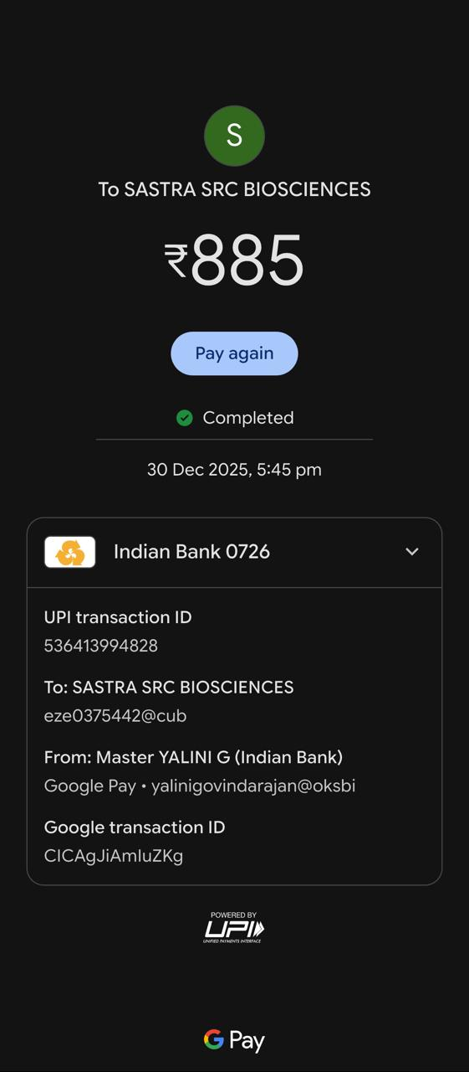
PRESENTATION @ ICHDM 2026

