INTERNATIONAL CONFERENCE ON HEALTH AND

DISEASE MANAGEMENT (ICHDM 2026)

HOSTED BY

SASTRA DEEMED TO BE UNIVERSITY, KUMBAKONAM.

TITLE

Eco-Friendly Synthesis of Copper Oxide Nanoparticles from Leucas Aspera Extract for Faster Antimicrobial Wound Healing

AUTHORS
Mohamed Harees M, Venkatesan R, Arun K, Sivaneshwaran S

SUPERVISOR

VENKATESAN R

ASSOCIATE PROFESSOR

DEPARTMENT OF BIOMEDICAL ENGINEERING

Batch No: T904

Mode: Online

Venue: Google Meet

Session & Time: I & 10:30 AM-12:30 PM

Eco-Friendly Synthesis of Copper Oxide Nanoparticles from Leucas Aspera Extract for Faster Antimicrobial Wound Healing

Mohamed Harees M¹, Venkatesan R^{1*}, Arun K¹, Sivaneshwaran S¹
¹ Department of Biomedical Engineering, E. G. S. Pillay Engineering College, Nagapattinam, Tamil Nadu, India – 611002
Corresponding author email id: vengatesan.r@egspec.org

Abstract
This study explores the green synthesis of copper oxide nanoparticles (CuO NPs) utilizing toluene-soluble Leucas Aspera leaf extract as a stabilizing agent, aiming to develop sustainable antimicrobial textiles for biomedical use. Comprehensive characterization techniques, including UV-Visible spectroscopy, X-ray diffraction (XRD), scanning electron microscopy (SEM), transmission electron microscopy (TEM), and energy-dispersive X-ray analysis (EDAX), confirmed the successful formation and stabilization of CuO NPs. The synthesized nanoparticles were applied to colored cotton fabrics, resulting in uniform nanoparticle adsorption and significant enhancement of antibacterial properties. Antimicrobial assays against pathogens such as Staphylococcus, E. coli, Corynebacterium, Micrococcus, and Brevibacterium demonstrated strong and sustained antibacterial activity, with inhibition zones up to 28 mm. The synergistic effect of bioactive compounds from Leucas Aspera extract contributed further to the antimicrobial efficacy, while SEM imaging revealed effective nanoparticle distribution without compromising fabric porosity or flexibility. The modified cotton’s improved resistance to microbial colonization and its potential to promote tissue regeneration underscore its suitability for wound healing applications. This research highlights the promise of green nanotechnology in developing next-generation wound care materials. Future directions include optimizing nanoparticle concentration and release, assessing in vivo efficacy, and integrating smart, responsive features for personalized healthcare. The approach also offers scalability for industrial production and adaptability for various antimicrobial medical textiles, providing an eco-friendly, cost-effective solution for infection control and advanced wound management.

Keywords: Eco-friendly synthesis, Copper oxide nanoparticles, Leucas aspera leaf extract, Green synthesis, Antimicrobial cotton, Wound healing.

ICHDM - 2026 Registration Confirmation

ICHDM 2026 SASTRA <ichdm2026@sastra.ac.in> | Fri 6 Feb, 17:01
to me

Dear Mohamed Harees M,
Thank you for registering for the “International Conference on Health and Disease Management” (ICHDM-2026), to be held on February 26th and 27th, 2026, under the Oral Presentation category. Your Unique ID: T904. Kindly join the WhatsApp group through this link:https://chat.whatsapp.com/JbIdU4dRXhILSMyEYFBsfb

Regards,
Organizing Team
ICHDM-2026

TRANSACTION DETAILS:

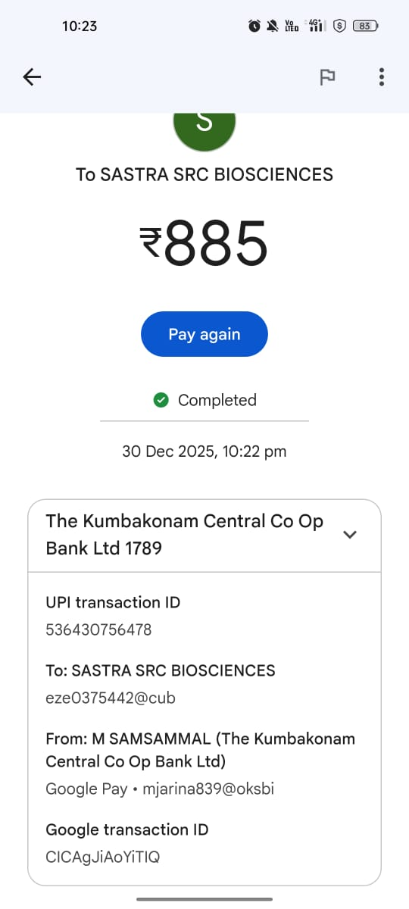

PRESENTATION @ ICHDM 2026

