

Diseño, verificación y validación de sistemas digitales.

Practica 2: Modulo de multiplicación, División y raíz cuadrada .

Abisai Ramírez

Integrantes:

Alberto Contreras.

Eric Guedea.

Technical design specifications

**Introduction:**

The system is an arithmetic module that calculate the multiplication and division of an signed decimal number, due to technical difficulties the system is unable to perform the square root operation or the multiplication and division together.

Scope: In the following document, the project development will be shown, the problems encountered will be explained and the documentation will show the general understanding of the problem in general.

**Methodology**

We used booth’s algorithm for multiplication and divided the problem in different modules to facilitate the restrictions given, for division we used an restoring division algorithm form unsigned numbers and for the incomplete square root we decided to use a non-restoring square root algorithm.

**Context diagram**

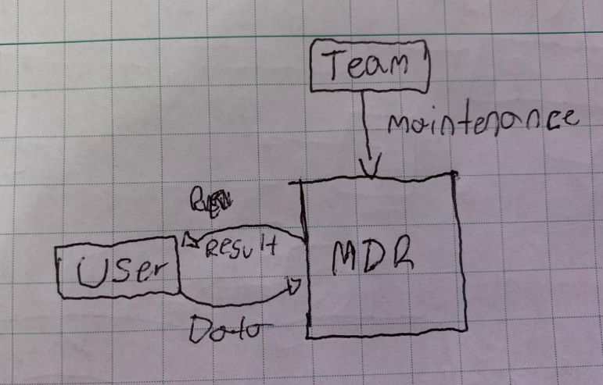

**User requirements**

|  |  |
| --- | --- |
| U-1 | 16 bits of data input. |
| U-2 | Division is done separately |
| U-3 | Multiplication is done separately |
| U-4 | Register every input and output. |

**Functional requirements**

* Validate inputs.
* Use the booth algorithm for multiplication.
* Be able to perform a division.
* Register inputs and outputs
* 7-segment display for results
* Use of packages for definitions

**Interface requirements**

* An Altera DE-115 FPGA
* A personal computer

**Hardware Interfaces**

* An Altera DE-115 FPGA

**Software Interfaces**

* Quartus II ver. 14.1

**Communications Interfaces**

* JTAG
* USB

**Hardware/Software Requirements**

* An Altera DE-115 FPGA
* A personal computer capable of running Quartus II
* USB blaster drivers

**Microarchitecture**

**Logic elements multiplication**

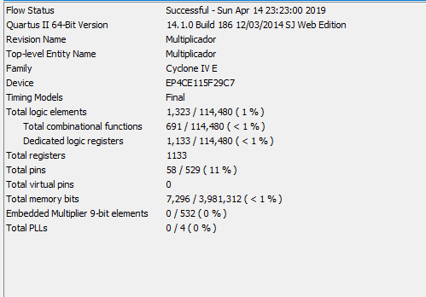

**Logic elements division**

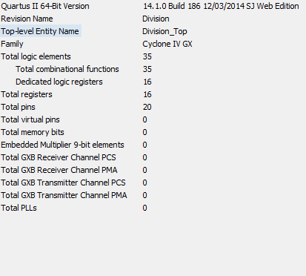

**RTL multiplication and proposed architecture**

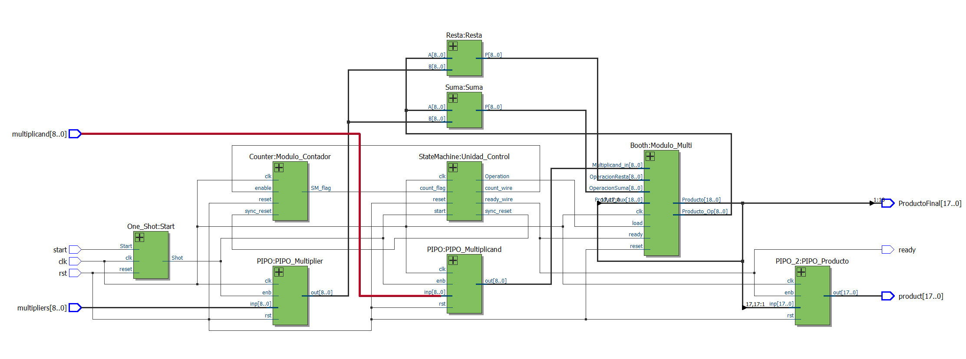

**RTL for division**

