Github Link:
https://github.com/eguitar/cs580-f25-project-notia
Part #1
updated Class UML for Project Notia
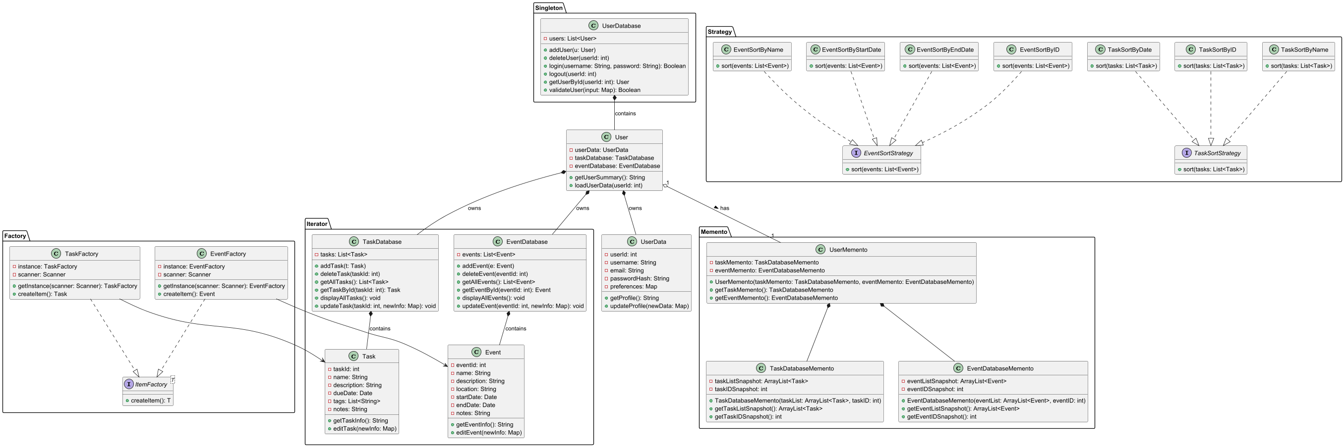



Design Patterns Utilized:
- Singleton: Only a singular user database allowed
- Factory: Responsible for creation of task and event objects
- Iterator: Displaying each task and event through simple iteration
- Memento: Managing copy of task and event database for undoing changes
- Strategy: Sorting for the view display order for task and events of each user

Part #2
Task Delegation

Eric Trinh
- Testing:
  - Everything
- Implementation:
  - all User / Client related classes

Bill Kim
- Implementation:
  - Task & TaskDatabase classes

Talha Ahmed
- Implementation:
  - Event & EventDatabase classes

Part #3 - Demo
YouTube Link:

