Github Link:
https://github.com/eguitar/cs580-f25-project-notia
Part #1
updated Class UML for Project Notia
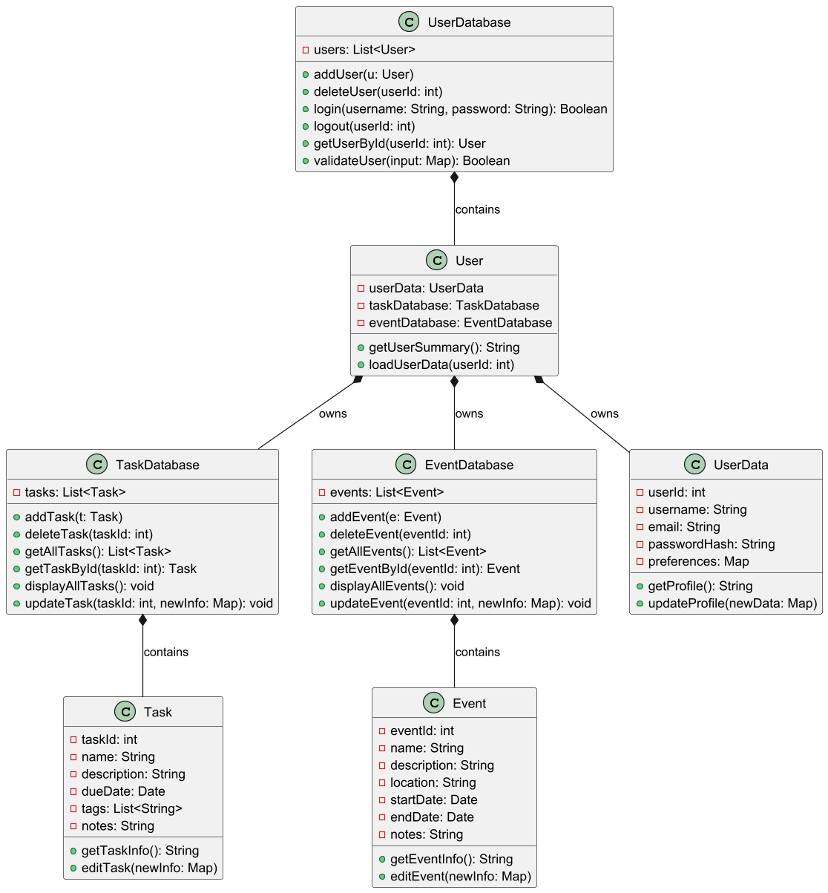

Mapping Unit Tests to Class/Methods/MemberVariables Involved
Unit Test Mapping to User Class
Test Name | Member Variables | Methods Tested | Description
testUserValidInitialization | userData, taskDatabase, eventDatabase | constructor | Valid initialization of all owned components
testUserInvalidInitialization | userData, taskDatabase, eventDatabase | constructor | Invalid/null initialization handling
testLoadUserDataValidId | userData | loadUserData(int) | Loads existing user data correctly
testLoadUserDataInvalidId | userData | loadUserData(int) | Handles invalid userId gracefully
testGetUserSummary | userData, taskDatabase, eventDatabase | getUserSummary() | Returns correct summary string
testUserAddTaskTaskDatabase | taskDatabase | addTask(Task) | Delegates add task to TaskDatabase
testUserDeleteTaskTaskDatabase | taskDatabase | deleteTask(int) | Delegates delete task to TaskDatabase
testUserGetAllTasksFromTaskDatabase | taskDatabase | getAllTasks() | Retrieves all tasks from TaskDatabase
testUserUpdateTaskTaskDatabase | taskDatabase | updateTask(int, Map) | Delegates task update to TaskDatabase
testUserAddEventEventDatabase | eventDatabase | addEvent(Event) | Delegates add event to EventDatabase
testUserDeleteEventEventDatabase | eventDatabase | deleteEvent(int) | Delegates delete event to EventDatabase
testUserGetAllEventsFromEventDatabase | eventDatabase | getAllEvents() | Retrieves all events from EventDatabase
testUserUpdateEventEventDatabase | eventDatabase | updateEvent(int, Map) | Delegates event update to EventDatabase
testUserTaskDatabaseOwnership | taskDatabase | — | Confirms User owns TaskDatabase
testUserEventDatabaseOwnership | eventDatabase | — | Confirms User owns EventDatabase
testUserDataGetProfile | userData | getProfile() | Accesses user profile through UserData
testUserDataUpdateProfile | userData | updateProfile(Map) | Updates profile via UserData
testUserNullTaskDatabase | taskDatabase | — | Handles null TaskDatabase reference
testUserNullEventDatabase | eventDatabase | — | Handles null EventDatabase reference

Unit Test Mapping to UserData Class
Test Name | Member Variables | Methods Tested | Description
testUserDataValidInitialization | username, email, passwordHash, preferences | constructor | Valid user data setup
testUserDataInvalidInitialization | username, email, passwordHash | constructor | Handles invalid/null field values
testGetProfileReturnsCorrectFormat | username, email, preferences | getProfile() | Returns formatted user info
testUpdateProfileWithValidData | username, email, preferences | updateProfile(Map) | Successfully updates profile fields
testUpdateProfileWithInvalidData | username, email, preferences | updateProfile(Map) | Handles invalid update data
testUsernameIsSetCorrectly | username | constructor | Username properly assigned
testPasswordHashIsSetCorrectly | passwordHash | constructor | Password hash stored correctly
testPreferencesAreEmptyByDefault | preferences | constructor | Preferences default to empty
testUpdatePreferences | preferences | updateProfile(Map) | Updates preferences map
testNullEmailHandling | email | constructor | Handles null email correctly

Unit Test Mapping to UserDatabase Class
Test Name | Member Variables | Methods Tested | Description
testAddUserWithValidUser | users | addUser(User) | Adds valid user to list
testAddUserWithNullUser | users | addUser(User) | Handles null user input
testDeleteUserValidId | users | deleteUser(int) | Deletes existing user
testDeleteUserInvalidId | users | deleteUser(int) | Handles invalid ID safely
testLoginWithValidCredentials | users | login(String,String) | Authenticates valid user
testLoginWithInvalidCredentials | users | login(String,String) | Rejects wrong credentials
testLogoutValidUserId | users | logout(int) | Logs out existing user
testLogoutInvalidUserId | users | logout(int) | Handles invalid logout
testGetUserByIdValidId | users | getUserById(int) | Retrieves correct user
testGetUserByIdInvalidId | users | getUserById(int) | Returns null for bad ID
testValidateUserValidInput | users | validateUser(Map) | Valid user input returns true
testValidateUserInvalidInput | users | validateUser(Map) | Invalid input handled
testAddDuplicateUser | users | addUser(User) | Prevents duplicates
testDeleteUserFromEmptyDatabase | users | deleteUser(int) | Handles empty list
testUsersListNotNull | users | constructor | Users list initialized properly

Unit Test Mapping to Task Class
Test Name | Member Variables | Methods Tested | Description
testGetTaskInfoIncludesAllKeyFields | taskId, name, description, dueDate, tags, notes | getTaskInfo() | Ensures all key fields appear
testEditTaskUpdatesOnlyProvidedFieldsAndPreservesOthers | name, description, dueDate, tags | editTask(Map) | Updates only provided fields
testEditTaskUpdatesDatesAndHandlesUnknownKeysGracefully | dueDate | editTask(Map) | Updates date, ignores unknown keys
testEditTaskNullValueClearsOptionalFieldLikeNotes | notes | editTask(Map) | Clears notes on null input

Unit Test Mapping to TaskDatabase Class
Test Name | Member Variables | Methods Tested | Description
testAddTask_thenGetById_andGetAllTasks | tasks | addTask(Task), getTaskById(int), getAllTasks() | Add and retrieve tasks
testDeleteTask_removesTask_without_affectingOthers | tasks | deleteTask(int) | Removes target task only
testUpdateTask_appliesChanges_onExistingTask | tasks | updateTask(int, Map) | Updates specific task fields
testDisplayAllTasks_printsAllTasks | tasks | displayAllTasks() | Prints all tasks correctly
testUpdateTask_delegatesToTaskEdit_andMutatesSharedInstance | tasks | updateTask(int, Map) | Delegates updates to Task
testDeleteTask_removesFromContainer_andFromDisplay | tasks | deleteTask(int), displayAllTasks() | Removes and verifies removal
testGetTaskById_returnsSameInstance_thatWasAdded | tasks | getTaskById(int) | Ensures instance identity preserved

Unit Test Mapping to Event Class
Test Name | Member Variables | Methods Tested | Description
testEventValidInitialization | eventId, name, date, tags | constructor | Initializes valid event data
testEventInvalidInitialization | eventId, name, date | constructor | Handles invalid input
testSetTitleValid | name | editEvent(Map) | Updates title correctly
testSetTitleInvalid | name | editEvent(Map) | Handles invalid title input
testSetDateValid | date | editEvent(Map) | Updates date correctly
testSetDateInvalid | date | editEvent(Map) | Handles invalid date
testSetTagsValid | tags | editEvent(Map) | Updates tags properly
testSetTagsInvalid | tags | editEvent(Map) | Handles invalid tags
testGetTitle | name | getEventInfo() | Retrieves correct title
testGetDate | date | getEventInfo() | Retrieves correct date
testGetTags | tags | getEventInfo() | Retrieves correct tags
testEditEventWithValidData | name, date, tags | editEvent(Map) | Applies valid event edits
testEditEventWithInvalidData | name, date | editEvent(Map) | Handles bad event updates
testNullTitleException | name | constructor | Throws on null title
testNullDateException | date | constructor | Throws on null date
testEventOwnershipInEventDatabase | — | — | Confirms event belongs to EventDatabase

Unit Test Mapping to EventDatabase Class
Test Name | Member Variables | Methods Tested | Description
testEventDatabaseValidInitialization | events | constructor | Proper initialization
testEventDatabaseInvalidInitialization | events | constructor | Handles invalid/null data
testAddEventValid | events | addEvent(Event) | Adds valid event
testAddEventDuplicate | events | addEvent(Event) | Handles duplicates
testAddEventInvalid | events | addEvent(Event) | Rejects invalid input
testDeleteEventValidId | events | deleteEvent(int) | Removes valid event
testDeleteEventInvalidId | events | deleteEvent(int) | Handles invalid ID
testGetAllEventsValid | events | getAllEvents() | Retrieves all events
testGetAllEventsEmpty | events | getAllEvents() | Handles empty list
testGetEventByIdValid | events | getEventById(int) | Fetches correct event
testGetEventByIdInvalid | events | getEventById(int) | Returns null for bad ID
testUpdateEventValidId | events | updateEvent(int, Map) | Updates event correctly
testUpdateEventInvalidId | events | updateEvent(int, Map) | Handles invalid ID
testUpdateEventWithNullData | events | updateEvent(int, Map) | Handles null updates
testUpdateEventOwnership | events | updateEvent(int, Map) | Confirms database ownership link
testEventIntegrationWithUser | events | — | Confirms event-user relationship
testNullEventListException | events | constructor | Handles null event list
Part #2
Integration Test Mapping in Client / Main
Test Name | Member Variables | Methods Tested | Description
testMainRunsWithoutError | all modules | main() | Ensures main entry runs without runtime errors
testStartupInitializesCorrectly | userDb, eventDb, taskDb | Application startup/constructor | Verifies correct system and dependency initialization
testCliUserRegisterFlow | userDb | cliRegisterUser(), saveUser() | Confirms new user registration workflow
testCliUserLoginFlow | userDb, session | cliLoginUser(), loadUser(), session.start | Checks login workflow and session init
testCliUserLogoutFlow | session | cliLogoutUser(), session.end | Verifies user logout and session teardown
testCliAddTaskFlow | taskDb, userDb | cliAddTask(), saveTask(), assignUser | Integrates full new task creation and user assignment
testCliViewAllTasks | taskDb | cliViewAllTasks(), getAllTasks | Ensures task list retrieval via CLI
testCliViewSingleTask | taskDb | cliViewTaskById(), getTaskById | Validates fetch and CLI display of single task
testCliUpdateTask | taskDb | cliUpdateTask(), updateTask | Confirms update/edit workflow for a selected task
testCliDeleteTask | taskDb | cliDeleteTask(), deleteTask | Tests removal of a task via CLI
testCliAddEventFlow | eventDb, userDb | cliAddEvent(), saveEvent(), assignUser | Covers event creation and assignment to user
testCliViewAllEvents | eventDb | cliViewAllEvents(), getAllEvents | Retrieves all events via CLI interface
testCliViewSingleEvent | eventDb | cliViewEventById(), getEventById | Shows single event access from CLI
testCliUpdateEvent | eventDb | cliUpdateEvent(), updateEvent | Handles event update requests
testCliDeleteEvent | eventDb | cliDeleteEvent(), deleteEvent | Ensures deletion/removal of event
testCliInvalidInputHandling | all modules | all CLI commands | Tests invalid input scenarios across system
testCliAccessControlForTasks | userDb, taskDb | CLI commands, permission checks | Checks user access/ownership for task operations
testCliAccessControlForEvents | userDb, eventDb | CLI commands, permission checks | Checks user access/ownership for event operations
testCliViewUserSummary | userDb, taskDb, eventDb | cliViewSummary(), aggregation | Aggregates user data for dashboard/summary
testCliExitFlow | all modules | cliExit(), resource cleanup | Confirms clean shutdown from CLI
testCliHandlesEmptyTaskList | taskDb | getAllTasks(), CLI display | Handles edge case: no tasks to show
testCliHandlesEmptyEventList | eventDb | getAllEvents(), CLI display | Handles edge case: no events to show
testTaskAndEventLifecycleIntegration | eventDb, taskDb, userDb | CLI commands for task+event | Integrates full lifecycle: add/edit/delete/view of both

Eric Trinh
- Testing:
  - Client related tests
  - all User related classes + Integration between classes
    - ex. Tests for User’s Managing Task and Event Database
    - ex. Main.java functionality
- Implementation:
  - all User / Client related classes

Bill Kim
- Testing:
  - modular unit tests for Task & TaskDatabase classes
- Implementation:
  - Task & TaskDatabase classes

Talha Ahmed
- Testing:
  - modular unit tests for Event & EventDatabase classes
- Implementation:
  - Event & EventDatabase classes

