**CHAPTER 1**

**INTRODUCTION**

**1.0 Introduction**

**1.1 Background of the Study**

Tell something about the General Concepts of the System in IT

With automation or automatic control, organizations can perform processes with little to no human assistance. Automation controls equipment and completes processes for a large range of objects and manufacturing environments around the globe. Automation can increase efficiency, quality, and effectiveness. In addition, it is often all but invisible to the average user.

In its simplest form, automation involves a controller that compares a measured state to a list of ideal values, adjusting the measured state to maintain the desired values or conditions.

In its general application, automation has both detracted from and contributed to the well-being of individuals and the environment. It reduces accidents, save energy, and lower heating and power consumption through its optimum use.

Tell something about the company

Cagayan Inc. is involved in poultry business for 15 years now under its owner Mr. and Mrs. Reyes. Their company is a main distributor of poultry products like chicken meat and eggs to markets within Nueva Ecija.

They have 10,000 chickens laying egg at around 5000 per day inside their 5 poultry apartments.

Tell something about the manual or existing system

The poultry staff manually feeds their chicken thrice a day including providing water.

The poultry apartment was ventilated through windows and electric fan. They add electric fans during hot season.

**1.2 Statement of the Problem**

**1.2.1 General Problem**

The Cagayan Inc. is experiencing problems in managing the feeding volume and schedule and ventilating the poultry apartment that affects the health conditions of the chickens. This is due to the difficulties in monitoring and scheduling of feeding and ventilation.

**1.2.2 Specific Problems**

1. Lot of feeds go to waste due to inaccurate distribution of feeds throughout the poultry apartment
2. Missed schedule for feeding due to the busy schedule of the staff
3. Lack of monitoring tool to view the status of the feeding and ventilation schedule
4. Inaccurate monitoring of air condition inside the poultry
5. Inefficient feeding and ventilation

**1.3 Objectives of the Study**

**1.3.1 General Objective**

The main objective of this study is to conduct research on the poultry feeding and ventilation of Cagayan Inc. to design and develop the Poultry Feeding and Ventilation System that will be used to monitor and manage the feeding and ventilation of the poultry.

**1.3.2 Specific Objectives**

1. Develop a module that will regulate and automate the schedule the distribution of feeds throughout the poultry apartment
2. Develop a module that will display schedules of feeding with notifications of upcoming feeding and completion
3. Develop a module that will be used to monitor the status of the feeding and ventilation schedule
4. Develop a module that will be used to monitor the air condition inside the poultry
5. Develop a module to efficiently distribute the feeds and control the ventilation in the poultry apartment

**1.4 Significance of the Study**

1. **Owner**

This study will provide the owner with a clear data affecting their poultry and gain insights on the factors resulting to the problems in feeding and ventilation. This study also provides a computerized system that will be used in improving the efficiency of feeding and ventilation.

1. **Staff**

The staff will benefit from the automated system in monitoring and scheduling the feeding and ventilation in the poultry avowing waste of feeds and water and inaccurate monitoring of air condition inside the poultry apartment.

1. **Industry**

This study will provide a tool that will improve the health and condition of the poultry thus increasing the quality and volume of the production of poultry products.

1. **Proponents**

This study provides the proponents opportunities to apply the lessons learned from IT classes and gain personal experience in problem solving, solution development and system development. Such experiences is very important in developing our personality, knowledge and skills and communication.

1. **Researchers**

For future researchers, this study will provide the necessary background information about this area of study and the necessary works done to develop the system. This also provide data in the poultry industry and system development that can be used as a reference in future related studies.

1. **College**

This study will produce new system that can be used as a portfolio for Capstone program of the College. The study also provides important information in the application of the theories and concepts taught in the College thus expanding the knowledge learned from individual IT classes.

1. **University**

This study is a manifestation of the quality and standard of the University that will promote the quality of BSIT graduates. This is also the culmination of the 4 year degree program of BSIT and embodiment of the curriculum for the degree of BSIT.

**1.5 Scope and Limitation**

**1.5.1 Scope**

1. **Admin**
2. Login
3. Profile
4. Settings
5. Help
6. Manage Feeding Schedule
7. Manage Ventilation Settings
8. Monitor Feeding Status
9. Control Ventilation Schedule
10. **Staff**
    1. Login
    2. Profile
    3. Change Profile and Password
    4. Settings
    5. Help
    6. Monitor Feeding Schedules
    7. Feeding Notifications
    8. Control Feeding Mechanism
    9. Control Ventilation Mechanism

**1.5.2 Limitation**

1. The system is not accessible online
2. The system only runs on PC and Android platform
3. The system is implemented to only one poultry apartment
4. Defination of Terms
5. for clearer and better understanding, the following terms were conceptually and
6. operationally defined:
7. Computerization. It is a system that makes the manual process of enrollment of
8. Kabankalan Catholic College to be computerized and upgraded.

**1.6 Definition of Terms**

For clearer and better understanding, the following terms were conceptually and operationally defined:

**Computerization**. It is a system that makes the manual process of enrollment of College to be computerized and upgraded.

**Database**. Is a type of storage where in all the information of the students, staff, teacher are saved this will be secured to avoid hacking.

**Enrollment System**. Is a system in which the manual process of enrollment of College will be computerized to minimize the time of the students and staff to manage an enrollment processes.

**Hardware**. These are tools used in performing the Computerized Enrollment System on the computer.

**CHAPTER 2**

**REVIEW OF RELATED LITERATURES**

**2.0 Review of Related Literature**

**2.1 Related Literatures**

Tell something about the related technologies

**Computer-Assisted Instruction**

Computer-Assisted Instruction (CAI) refers to the use of computers to present drills, practice exercises, and tutorial sequences to the student.

One extensive type of CAI system is the PLATO [RALS1993]. It was developed by a group of engineers and educators in the Computer-based Education Laboratory at the University of Illinois, Urbane.

**Intelligent Computer-Aided Instruction**

Computer-Assisted Instruction (CAI) refers to the use of computers to present drills, practice exercises, and tutorial sequences to the student. One extensive type of CAI system is the PLATO [RALS1993]. It was developed by a group of engineers and educators in the Computer-based Education Laboratory at the University of Illinois, Urbane.

Add more related technologies used that can be found in textbooks e.g. automation, control systems, languages, DB, AI, SQL, platforms, etc. but make it sure to relate these technologies to what you are studying in this Capstone.

**2.2 Related Studies**

Tell something about the related capstone studies

Automation of the system proves that it generates speed and accuracy, lessen the errors done by manual means and eliminate wasted time that will result for a better service that will cater the company and the employee as well. These systems cover every aspects of programming from educational to database programming and from financial application to developing programming components that is also useful for students. They prepare students for entry level positions in computerized accounting procedures and applications, gain theoretical knowledge and practical experience in gathering information, ideas of how data are gathered and also knowing the importance on how network flow and what will be the best network topologies or other related network studies. According to Peter Norton in his book Introduction to Computers he stated that computers are very fundamental in our society as quoted, “Computers are so fundamental to our society that without them our economy would grind to a halt whether or not you work in an office, the way business use computers almost every day.”

**Automating School Fees Transactions in Nigerian Universities and Tertiary Institutions: A Systems Engineering and System Management Approach**

This project uses system engineering and system management principles to analyze the problem of transactions in Nigerian universities and tertiary institutions. System management principles shall be used to highlight the imperfections in the transaction method currently in use especially between the bank and the institutions using their services. It will explore other payment systems available in the country. This project will provide a recommendation of how to implement a better payment option through automating the process of school payments by using a system with cloud-based educational software at the school bursary office and through the online payment processing on the school website. The system software will enable cashiering and payment management: centralized data, automated reports, and inventory controls. It will generate automatic invoices and receipts (Aladi, 2020). This literature is relevant to our study because students don’t need to deposit/pay cash directly into the school but they will pay it using their debit cards.

Add more related capstone related to your study.

**2.3 Related Systems**

Tell something about the related system already used as of today

**UML Modeling and Black Box Testing Methods in the School Payment Information System**

The payment information system enables the entry of cash transaction data to SMA Teluk Panji through administrative staff (TU). The TU maintains the money payment reports that the students pay. This approach is useful and allows students to know more about the money they have to spend. This approach gives students complete knowledge in paper form. Useful reports to discover how much they charged and students who did not pay. Model UML is a visual language for modeling and designing information systems or applications. As support for the development of this information system, UML uses diagrams and text. Any significant modeling influences the design of useful applications. The system must meet its specifications and be capable of converting data into usable and efficient users. The black box evaluation method serves as a software assessment. The method operates from inside the unknown. When the system testers test this system as designed and focused on the school payment information system, the information system software is appropriately controlled by the external control mechanism. The prototyping method aims to summarize the application developed during these phases (Nasution et al., 2020). This literature is relevant to our study because it maintains the money payment reports that the students pay and this system is designed and focused on the school payment information system.

**Online Program Accreditation System for State Universities and Colleges in the Philippines**

The research aims to provide a computerized system of the program accreditation process in the Philippines state universities and colleges. The system involves having a central database for filing and accessing of evidence of each area of performance for accreditation, thus providing a central index for cross-referencing of the documents satisfying the same requirements for an area. Additionally, it will also facilitate the self-assessment of each area and the actual evaluation of accreditors. The system is developed following the iterative waterfall model utilizing object-oriented programming language, specifically PHP. It is tested using the ISO 9126 software quality evaluation form (Magno, 2019). This is relevant to our study because it provides a computerized system using PHP.

Add more existing system related to your study.

**2.3 Synthesis**

Indicate gaps in the existing literature and studies and what your system can provide to fill the gaps.

The literatures, studies and systems mentioned above, focused on finding out the importance, impact of the system to improving the maintenance and management of poultry.

The review also provided existing technologies and methodologies that can be used to develop our system.

During the review, it was also discovered that there are limitations to the existing studies and system that our system will be able to provide.

It may also further note that the use of automated system in managing and maintaining poultry is new to the Philippines and not many poultry owners are using it to improve their tasks.

In addition, from the literatures, systems and studies reviewed, it was evident that, the proposed system will be able to contribute to the industry of poultry and will have a great impact on the quality of poultry management.

Cite more about limitations of existing studies and emphasize how your capstone fills-in the said limitations

**CHAPTER 3**

**SYSTEM ARCHITECTURE AND METHODOLOGY**

**3.0 System Architecture and Methodology**

**3.1 Research Framework Design**

State the type of research you will conduct

The researchers employed quantitative methods to seek understanding of various factors that affects the feeding and ventilation processes in the poultry and gain understanding of the problems experienced by the owner and staff.

The researchers have constructed of a single event (Creswell, 2007; Creswell & Plano Clark, 2007; Merriam, 1998/2009). “The goal of Constructivist research is to rely as much as possible on the participant’s views

of the situation” (Creswell, 2007, p. 20).

The researchers gained deeper understanding of the research question by interpreting the owner and staff descriptive perspectives regarding their problems and needs.

Specifically, a case study approach was chosen as best fit for its thorough in-depth inquiry to describe an individual’s experiences in order to understand the study’s research phenomena (Creswell, 2007; Merriam, 2009; Yin, 1993).

The study was reflective of both descriptive and interpretive approaches to case study analysis.

In addition to describing data, my case study also intended to interpret data to suggest relationships among the multiple factors that affect the feeding and ventilating processes (Merriam, 1998).

**3.2 Data Gathering Tools, Techniques and Timeline**

Provide the instruments you will use to gather information as well as your timeline to finish the study.

The data will be gathered sequentially over three phases. This allows data from earlier phases of the study to determine the line of inquiry for remaining phases (Creswell, 2007).

Multiple data collection sources provided triangulation of data (Merriam, 2009) due to the ability to compare rich description from multiple and varied sources (Patton, 2002; Yin, 1993).

An interview will be conducted with the owner and staff to determine the processes involved in feeding and ventilating the poultry apartment including the problems and needs they experienced.

Some instruments for data collection will be employed like

an online questionnaire, an in-person focus group, two in-person interviews, two college work artifacts, member checks of their three interview transcripts, a reflective journal, and as needed, follow-up questions via E-mail.

List and describe the data gathering tools you will use

**Project Schedule using GANTT Chart**

|  |  |  |  |  |  |  |  |  |  |
| --- | --- | --- | --- | --- | --- | --- | --- | --- | --- |
| ACTIVITIES | **6/19** | **6/26** | **7/3** | **7/10** | **7/17** | **…** | **12/18** | **12/25** | **1/8** |
| Project Planning |  |  |  |  |  |  |  |  |  |
| <subtask1> |  |  |  |  |  |  |  |  |  |
| <subtask2>… |  |  |  |  |  |  |  |  |  |
| System Analysis |  |  |  |  |  |  |  |  |  |
| <subtask1> |  |  |  |  |  |  |  |  |  |
| <subtask2>… |  |  |  |  |  |  |  |  |  |
| System Designing |  |  |  |  |  |  |  |  |  |
| <subtask1> |  |  |  |  |  |  |  |  |  |
| <subtask2>… |  |  |  |  |  |  |  |  |  |
| System Programming |  |  |  |  |  |  |  |  |  |
| <subtask1> |  |  |  |  |  |  |  |  |  |
| <subtask2>… |  |  |  |  |  |  |  |  |  |
| **System Testing** |  |  |  |  |  |  |  |  |  |
| <subtask1> |  |  |  |  | |  |  | | --- | --- | |  |  | |  |  |  |  |
| <subtask2>… |  |  |  |  |  |  |  |  |  |
| **System Implementation** |  |  |  |  |  |  |  |  |  |
| <subtask1> |  |  |  |  |  |  |  |  |  |
| <subtask2>… |  |  |  |  |  |  |  |  |  |

**3.3 Software Methodology**

State the software methodology you will adopt in the development of the system or application.

The formal methodologies are any of the software engineering systems analysis and design methodologies:

1. Waterfall model or Software Development Life Cycle (SDLC) Model
2. Prototyping
3. The Spiral Model
4. 4th Generation Techniques
5. Agile Applications Development
6. Rapid Application Development (RAD)
7. Joint Application Development (JAD)

The most suitable and appropriate software development methodology for the Capstone project is the waterfall software development model, which gave us a clear view about our software and helped us to achieve our goal.

Provide description of each stages of the model

**The SDLC Waterfall**

Small and medium size software are usually divided into six stages that are interrelated with each other in a top-down approach named as waterfall. The input of one speciﬁc stage is the output of previous stage which initializes the next stage. At every step or stage of the model some additional information is also added up into the input of that stage and generating the results. But that additional information is restricted in scope and previous stages are

directly traceable from that stage.

**Planning.** The ﬁrst stage of the waterfall model is planning stage in which the most critical task is to clearly mention the high-level requirements or goals of the software. It helps to make feasibility and risks associated with the project and also provides the basic project structure.

**Requirements Analysis.** The next stage is the requirement analysis that takes goals as input from the planning stage and then these goals are deﬁned into a set of one or more requirements. Major functionalities, initial data entities and the operational data areas are deﬁned under this stage.

**Design.** The input of the design stage is the output of the requirement analysis stage which is an approved requirements documentation. In this stage the design elements are deﬁned with the help of interviews, prototypes and workshops conducted. These design elements consist of functional hierarchy, business process diagrams, pseudo code and entity-relationship diagram. These design elements provide detail description about the software and each element is related to a speciﬁc requirement.

**Development.** The development stage is initialized by the previous design stage. At this stage the code for the design elements of software is written and it provides the functional software components.

**Testing.** Integration and test stage is provided the output of the development stage. At this stage the diﬀerent software functioning components developed in the previous stage are integrated with each other to provide full ﬂedge software project which is providing all the high-level requirements. This software is also passed through diﬀerent test cases to check the validity, correctness, completeness and hence enables us to achieve our goals regarding our project.

**Implementation.** Finally, the installation and acceptance stage arrives. The software is loaded to the server at site of customers and tested with diﬀerent test cases once again to check the correct working. If all this shows adequate results satisfying the customer then the software is handed over to the customer formally.

**Reasoning for choosing the SDLC Waterfall Model**

Provide justification for using the model

As in this model all the phases are in a sequence and are dependent with one another, therefore a phase cannot be started until the previous phase is completed and fully documented. This approach is most appropriate for our project, because all the requirements and goals of our project are very clear.

Secondly, it is easy to do work in components and waterfall model is providing this approach. After the completion of all the phases individually, they are integrated together. This model is very economical and risk free due to its sequential approach.

Planning

Requirements Analysis

Designing

Programming

Testing

Implementation

Figure 3.3.1 SDCL Waterfall Model

**3.4 Conceptual Framework**

Provide all concepts related to the study

Input PROCESS OUTPUT

* Feeding and Ventilating System
* Efficient feeding and ventilation
* Conduct research study
* Develop the system
* Processes
* User Tasks
* User problems
* User needs
* Technologies
* Design Principles and Standards
* Feedback

Evaluation

Figure 3.4.1 Conceptual Framework

**3.5 Data Analysis**

State the system development tools as well as statistical tools you will use to analyze your data.

The data gathered will be process using various statistical tools to describe the data like average, total, standard deviation.

And to interpret the result of the data gathered, t-Test will be used to determine any significant improvement on the performance between the existing system and proposed system.

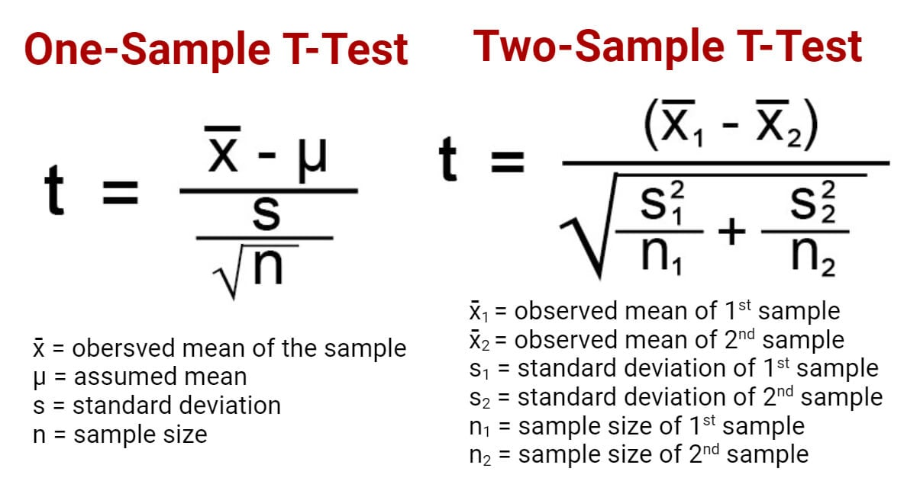

Figure 3.5.1 T-Test

Provide more details about the statistical tools you will use.

**3.6 Description of the Existing System**

Provide necessary information on the current situation/system such as its nature, its description, users/beneficiaries, etc.

* + 1. **Description of Current System**

Describe the existing system.

In the existing setup, the feeding was done manually by pouring feeds to the tray. The number of feeds is based on the size of the pale. They are feeding the chickens 3 times a day.

Provide more details how the people involved are doing their tasks.

* + 1. **Hardware Setup**

Describe the hardware used.

In feeding, the staff is only using physical materials like pale, water hose and electric fans in feeding and ventilating the poultry.

There is no computers to control the feeding and ventilation.

Provide more details on the materials they are using in the manual system.

* + 1. **Software and Applications being used**

Describe the software used (if any).

In feeding and ventilating, the owner and staff are not using any computerized system or programs.

Provide more details on the software they are using in the manual system (if any).

* + 1. **Personnel**

List the people involved in the manual system and describe their tasks.

The owner is mainly taking charge on the feeding schedules and assigning tasks to the staff. It is his duty to monitor and manage the tasks performed by the staff.

The staff feeds the chicken and turn-on or turn-off the fans used to ventilate the poultry. The staff follows the schedules set by the owner.

Provide more people involved in the existing system and describe their tasks.

* + 1. **Organizational Structure**

List the people and their position.

Owner: Mr. Reyes

Staff: Dondon, Gina and Mario

Provide more people involved in the existing system and state their position.

* + 1. **Sample Forms and Reports**

Provide photocopy of forms and reports.

**Schedule Sheet**

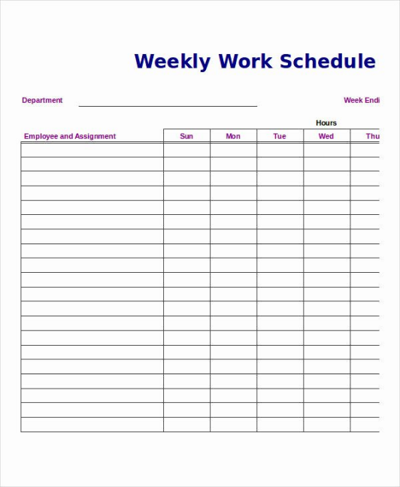

**Figure 3.6.6.1 Weekly Work Schedule**

* 1. **Proposed System**

Provide models that depict information (data and control) flow and content, partition the system functionally and behaviorally, and depict the essence of what must be built.

* + 1. **System Architecture**

**Front-end Technologies**

List the technology stack used for front end

* + - **Web Platform**
      * **HTML** – is used to organize information
      * **CSS** – is used to create stylesheet
      * **Javascript** – is used to create interactive features
    - **Mobile Platform**
      * **Android Java and XML** – are used to create a mobile app

Add more if you used other front-end techs

**Back-end Technologies**

List the technology stack used for back end

* + - **Dynamic Scripting**
      * **PHP** – is used to access and manage database records
    - **Database**
      * **MySQL** – is used to store and manage database records

Add more if you used other front-end techs

**Middleware/API**

List the technology stack used for middleware/API

* + - **Data Object Notation**
      * **JSON** – is used to store and manage database records
    - **Controller/Backend**
      * **PHP** – is used to implement CRUD on records in the database

Add more if you used other front-end techs

* + 1. **Context Diagram**

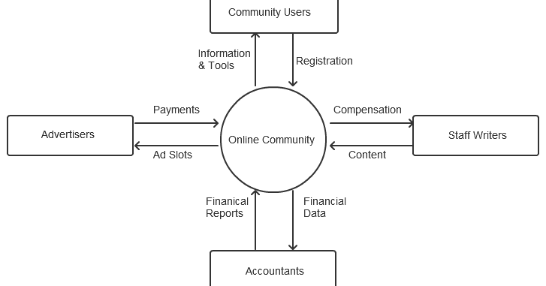

**Figure 3.7.1.1 Context Diagram**

In Context Diagram, you can only see these

- Entity (rectangle) – people using the system

- Arrow line – data input (pointing-out) and data

output (pointing in). Write the data on the line.

- System (Circle)

* + 1. **Data Flow Diagram**

For level 1, you will only add the following:

- User (rectangle) – performing the task

- Task (rounded corner square) – the major tasks to perform

- Data flow (arrow line) - showing the direction of the flow). Write data along the line.

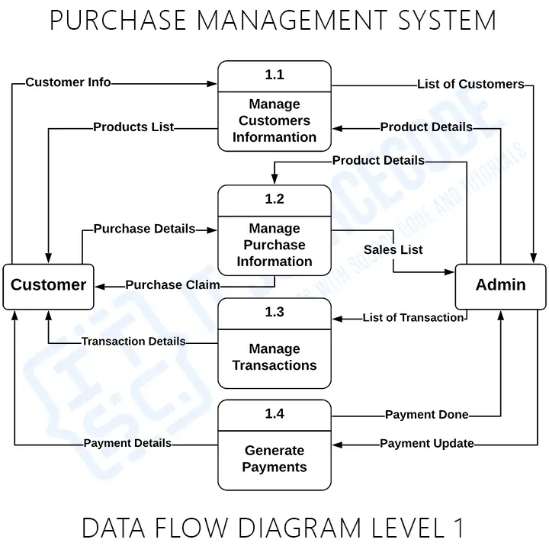

Figure 3.7.3.1 DFD for Purchasing Process

For level 2, you will expand each of the major task in DFD Level 1. It will have the following:

- User (rectangle) – performing the task

- Task (rounded corner square) – the major tasks to perform

- Data flow (arrow line) - showing the direction of the flow). Write data along the line.

- Data store (rectangle with one end open) – indicate the table to store and read the records

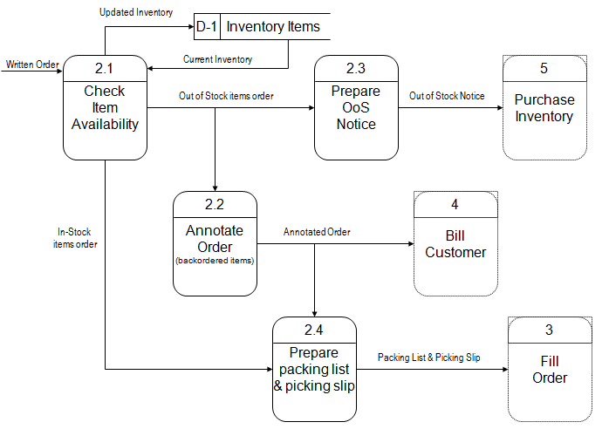

Figure 3.7.3.2 DFD for Purchase Order

* + 1. **Entity-Relationship Diagram (ERD)**

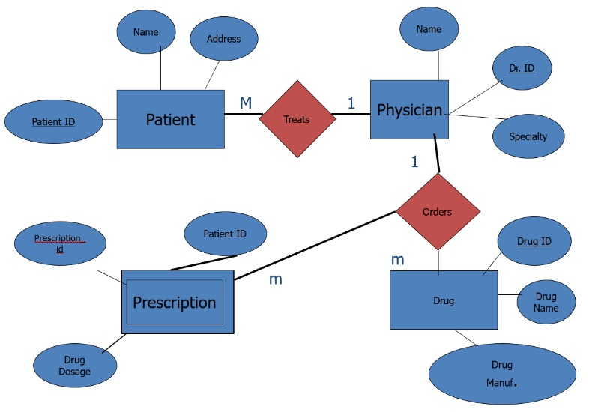

Figure 3.7.4.1 Entity-Relationship Diagram

* + 1. **Modules Specification**

**A. User Modules**

|  |  |
| --- | --- |
| **Module Name** | **Description** |
| verify.php | Verify the user id and password |

**B. Product Modules**

|  |  |
| --- | --- |
| **Module Name** | **Description** |
| product_save.php | Save the product details |
| get_products.php | Fetch products record |

**C. Order Modules**

|  |  |
| --- | --- |
| **Module Name** | **Description** |
| save_order.php | Save the ordered products |
| get_products.php | Fetch products record |

List all modules used in the system

* + 1. **Hardware Requirements**

**A. Front-end Hardware**

- **PC and Laptop**: At least Core Duo, 4GB Memory, 250 GB HDD, 1080px by 972px 15” LCD, USB Mouse and Keyboard.

- **Tablet and Smart Phone:** Multicore, 6” LCD HD Screen, 2GB Memory and 64GB Storage capacity.

List all minimum hardware specs used in the system

**B. Back-end Hardware**

- **Server:** Multicore, 15” LCD HD Screen, 16GB Memory and 1TB Storage capacity.

List all minimum hardware specs used in the system

* + 1. **Software Requirements**

**A. Front-end Software**

- Operating System: Windows, Linux, OSX

- Browser: Chrome, Edge, Firefox, Opera

- IDE: VS Code, Sublime

- Markup Language: HTML

- Stylesheet: CSS

- Scripting Language: Javascript

- Data Object Model, Notation: Javascript

List all minimum software used in the front-end

**B. Back-end Software**

- Operating System: Azure, Linux

- Browser: Chrome, Edge, Firefox, Opera

- IDE: VS Code, Sublime

- Dynamic Scripting Language: PHP

- Query Language: SQL

List all minimum software used in the back-end

* + 1. **Human Resource Requirements**

List all people needed to run the system

1. **Owner** – performs the duties of the system admin in charge of managing users and products records
2. **Staff** – performs the encoding and processing orders of the customers
3. **System Maintenance Staff** – performs maintenance tasks to ensure optimal and efficient performance of the system
   1. **Testing Activities**
      1. **Testing Plans**

After developing the system, testing must be performed to find and remove errors from a program.

List all test you will perform

The system will be tested in the following levels:

1. **Unit** – Each module will be tested to identify bugs and errors
2. **Integration** – Several modules will be tested together to determine proper integration including access to database and APIs
3. **User Acceptance Test** – The developed system will be tested with the intended users to determine acceptability and gather feedback from the users.
   1. **Implementation**
      1. **Installation Process**

List all test you will perform

The following implementation plan and activities will be conducted to convert the existing system into the new system.

These approaches will be used in converting to the new system: A step-by-step changeover or a parallel system changeover.

Each module will be implemented one at a time and monitor its performance for possible slow-down or bugs until all modules are integrated and running.

The whole system will be monitored and evaluated for possible revisions and corrections.

A user’s manual will be written to help the users in using the system. Coinciding to the issuance of user’s manual, a users’ training will be conducted to orient and train the users on the features and uses of the system.

After the beta period, the system will be evaluated to determine the improvement of the processes between the existing system and the new system.