Screenshots

APIs which are having ADMIN & Manager as follows

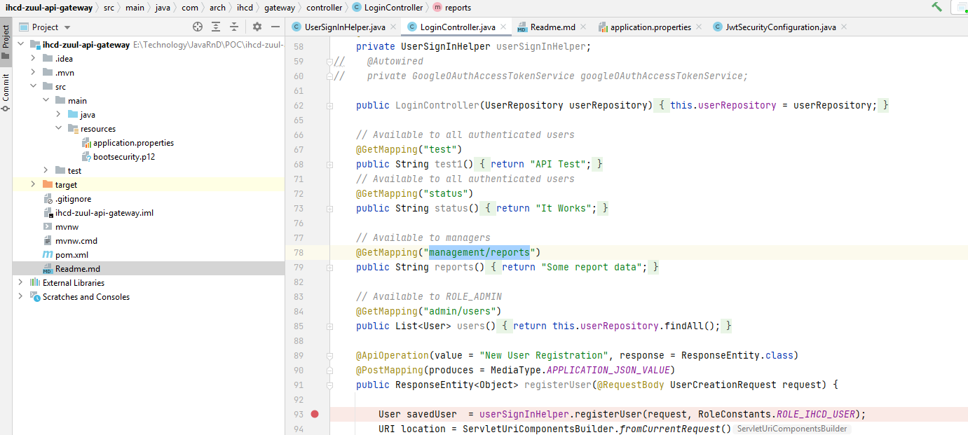

User signup

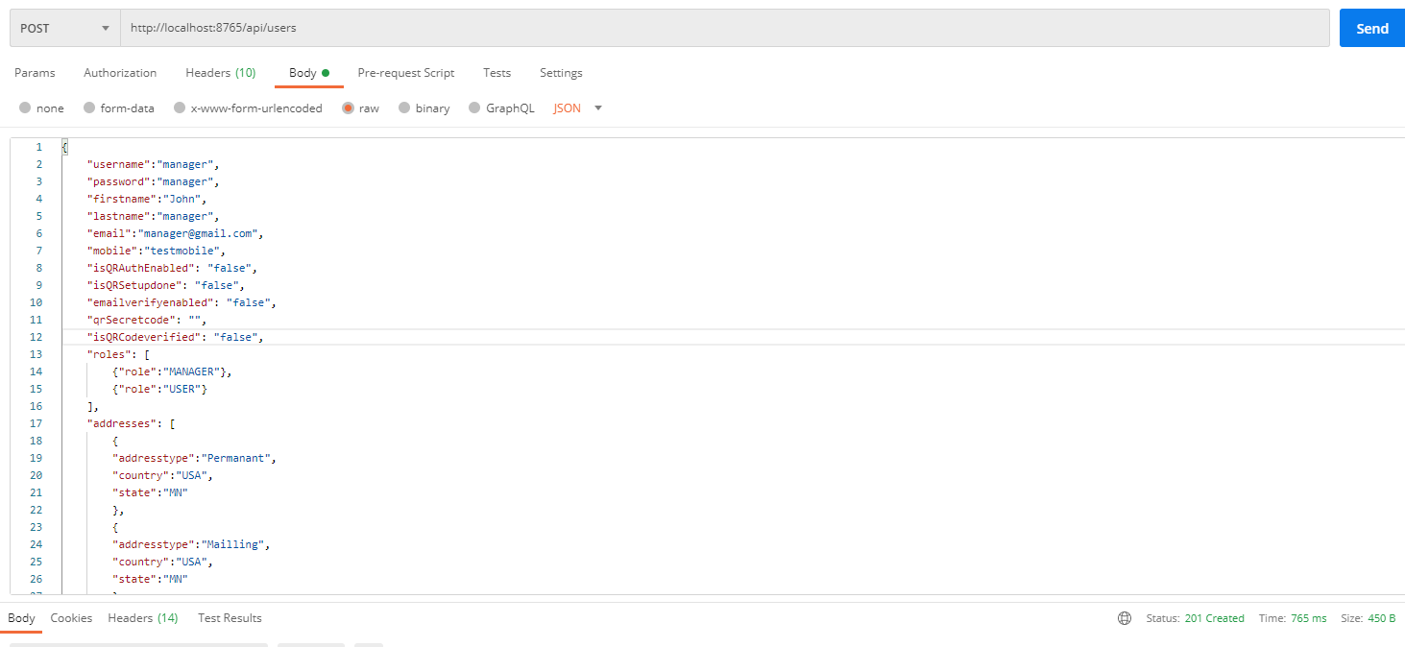

{

    "username":"manager",

    "password":"manager",

    "firstname":"John",

    "lastname":"manager",

    "email":"manager@gmail.com",

    "mobile":"testmobile",

    "isQRAuthEnabled": "false",

    "isQRSetupdone": "false",

    "emailverifyenabled": "false",

    "qrSecretcode": "",

    "isQRCodeverified": "false",

    "roles": [

        {"role":"MANAGER"},

        {"role":"USER"}

    ],

    "addresses": [

        {

        "addresstype":"Permanant",

        "country":"USA",

        "state":"MN"

        },

        {

        "addresstype":"Mailling",

        "country":"USA",

        "state":"MN"

        }

    ]

}

User sign in

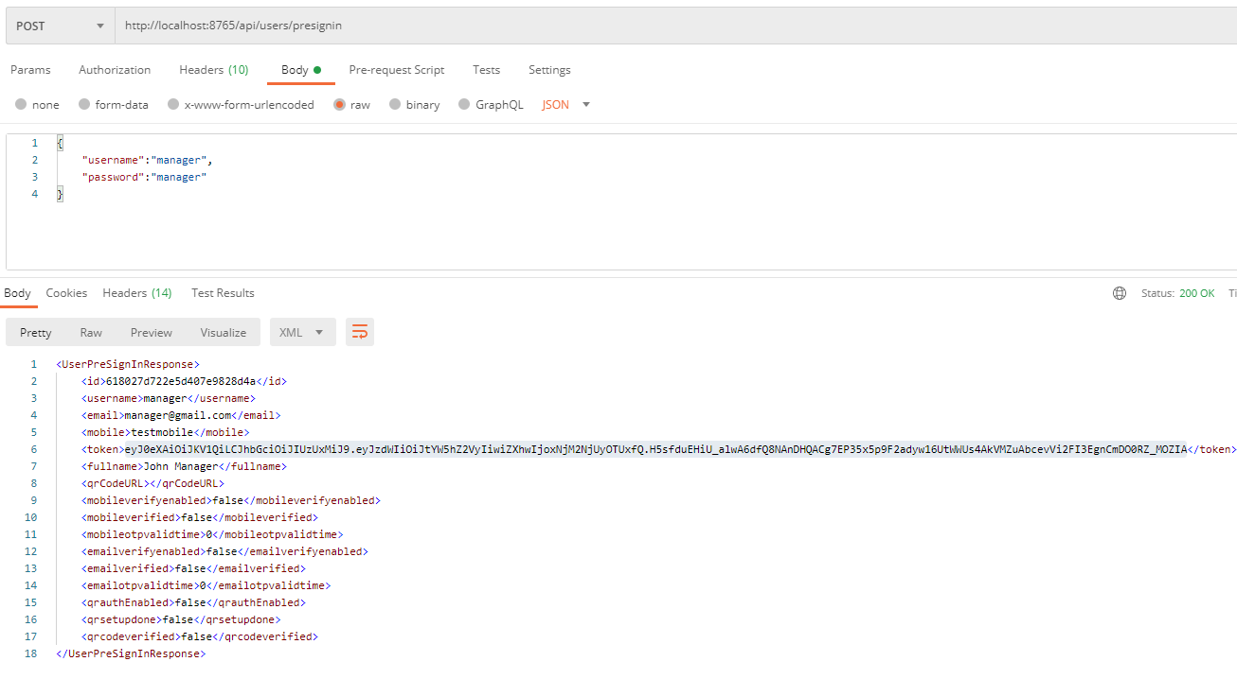

Validate MANGER role success API, by sending above token in Authorization header

Response: 200

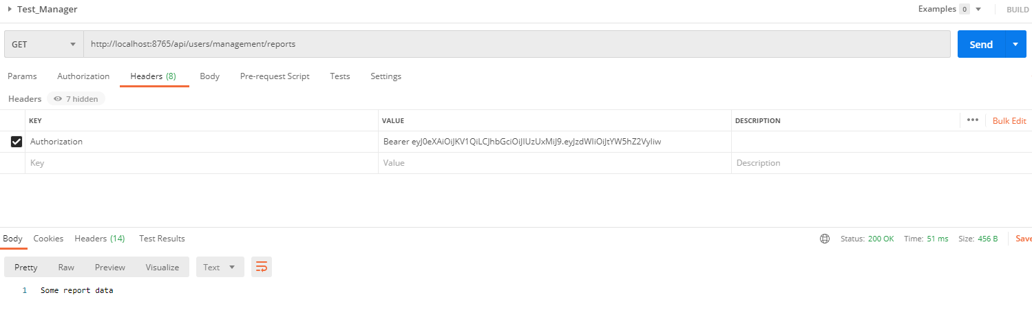

Validate MANGER role failure API which doesn’t has access, by sending above token in Authorization header

Response: 403 Forbidden

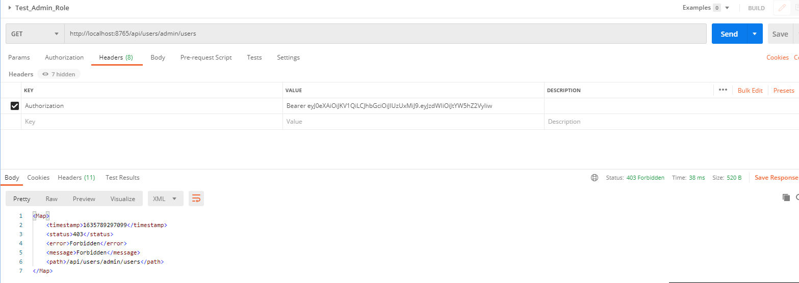

Repeat the Same for ADMIN user