Word 2000 and Word 2002 Comparison
SoDA uses the Word comment feature to store the arguments SoDA needs to extract and display information in a SoDA report.
• A Word comment represents a SoDA command.
• A SoDA command is the logic that SoDA uses to extract information for a report or document.
NOTE: Whichever Word version you use, you should never alter the "contents" of a Word comment in a SoDA template.
Because comments have a different appearance and different behavior in the two versions of Word, you interact with the comment feature differently in the two versions of Word. The table below illustrates these differences.

Word 2000 | Word 2002
The comment indicator, called comment text, is represented like this: | The comment indicator, called the comment marker, is represented by a vertical bar:  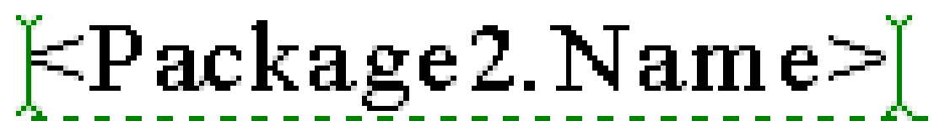
Comment text indicates:  • The presence of a comment  • The type of SoDA command the comment contains, such as OPEN, DISPLAY, or REPEAT. | A comment marker indicates:  • The presence of a comment  There is no indication of what type of SoDA command a marker represents.  However, SoDA provides a representation of a native Word 2000 comment that you toggle from the SoDA menu.  The SoDA command name has no programmatic function; it is simply a display-only convenience to help you recognize the command logic when you build and format the template in Word 2002.  Note that when the SoDA command is shown, the Word comment marker is difficult to see unless you use the Word Zoom feature to enlarge the view:  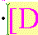
Word formats comment text as hidden text. | Word 2002 does not treat comment markers as text. These markers have no text properties such as hidden text.
You control the display of comment text by toggling either:  • hidden text  • the comment/comment text display (with View > Comment) | A comment marker and a SoDA command representation are independent elements. Neither is formatted as hidden text or controlled by the display of hidden text.  • To toggle the display of the SoDA command, click SoDA > Show/Hide Commands  (a SoDA command).  • To toggle the display of the vertical bar that is the comment marker, click View > Markup  (a Word command).

