**Eduardo Guzman, Assignment 2, CSC-155, Section 2, Spring 2023**

1. 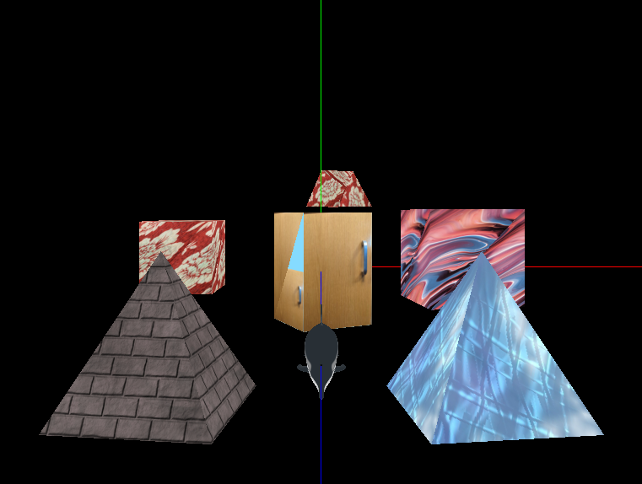
2. **Description of my hand-made Object:**
   * I created two hand made objects: one is trapezium like object that is also wrapped with my custom floral_sheet texture.
   * I also created a 3D rectangle model for my csc165 class project, and I included an additional texture that makes it look like it is a drawer
3. **Object Characteristic Descriptions:**
   * **Moving Object(s):­**
     1. The dolphin will move on the Z (N vector) axis back and forth and will face the direction it is moving.
     2. We also have two cubes with different textures that will move vertically
     3. The cubes use a y axis offset that gets merged with the model matrix at runtime to ensure the proper location
   * **Rotating Object(s):**
     1. The two pyramids closest to the camera are the rotating objects and they rotate in opposite direction from each other.
        + They are currently using brick and ice textures.
   * **Tiling Object(s):**
     1. The manual food station world object that was added to my scene has tiling implemented and I went with the border clamp approach.
     2. It uses a nice blue color as the border color
4. **Incomplete Program Requirements:** None
5. **Source information for files:**
   * **Textures (at least three textures align properly!)**
     1. **assets/textures/Dolphin_HighPolyUV.png** – CSC165 TAGE assets to wrap around the dolphin
        + The dolphin texture is aligned properly with the dolphin
     2. **assets/textures/brick1.jpg** – retrieved from the book source code
        + used by a pyramid and is aligned properly with the object
     3. **assets/textures/ice.png** – retrieved from the book source code
        + used by the second pyramid and texture coordinates were created to align the ice texture to the pyramid
     4. **assets/textures/floral_sheet.png** – created by Eduardo Guzman in CSC165
        + Added to one of the cubes and my custom model that appears like a trapezium
     5. **assets/textures/Drawer_Door.jpg** – created by Eduardo Guzman in CSC165
     6. **assets/textures/pexels-anni-roenkae.jpg** *(referred to artsyTexture in my code)*
        + image page: <https://www.pexels.com/photo/photo-of-acrylic-paint-2832432/>
        + “All photos and videos on Pexels can be downloaded and used for free.” – statement from the site linked above
        + free license explanation: <https://www.pexels.com/license/>
        + *name of creator kept in filename*
        + this texture is aligned to the object with the same texture type on each face, but the texture was manipulated to give a more trippy texture to the object.
   * **Models**
     1. **Dolphin** – retrieved from the CSC165 TAG-related files.
     2. **Pyramid(s)** – model pulled from the CSC-155 textbook.
        + *Called pyr1, pyr2 in the code*
     3. **Cube(s)** – model used from the CSC-155 textbook.
        + *Called cube1, cube2 in the code*
     4. **CustomModel**– created by me Eduardo Guzman using drawings on a tablet note taking app
        + Looks like a trapezium
     5. **ManualFoodStation** – created by Eduardo Guzman in CSC 165.
6. **Name of RVR-5029 Computers:**
   * METALSLUG

**SCREENSHOT PROOF OF WEB SOURCE:**

